UNIT 3: ALLIED FUNGI
What is Allied Fungi
Two fungi sharing space and colonizing together in mutualism, one gives more shade and humidity to the community, the other surely is a more capable saprophytic and predigests more easily the substrate they are sharing.

GENERAL CHRACTERISTIC OF SLIME MOLDS (MYXOMYCETES)
- They are true nucleated heterotrophs.
- Slime molds inhabit the moist decaying lignocellulosic substratum like fallen leaves, twigs, wooden logs, decaying animal dung, sometimes on the surface of garden plants tree trunks, and act as decomposers of complex polysaccharides into simple sugars like fungi.
- Slime molds somatic structure is coenocytic as in the coenocytic fungi.
- Slime molds plasmodium (vegetative thallus) absorbs and assimilates its nutrition in the soluble form by direct contact of the plasma membrane with substratum.
- Slime molds possess reserve food material as fat droplets and glycogen particles.
- They reproduce asexually by amoeboid cells(motile or non motile) which during favourable conditions divide mitotically several times and parennate as microcysts or spherules during unfavourable conditions and remain viable for very long period in the soil.
- They produce sexual meiotic spores in the fruiting bodies. The Spores are thin walled, hyaline surrounded by definite cell wall of cellulosic in nature but not chitinous as in other fungi and mode of dispersal is like fungi by wind, water and by insectal movements.
- The pattern of life cycle slime molds follow is same like fungi.
- Slime molds produce sclerotia during unfavourable conditions same like fungi.
STATUS OF SLIME MOLDS
Slime mold or slime mould is an informal name given to several kinds of unrelated eukaryotic organisms that can live freely as single cells, but can aggregate together to form multicellular reproductive structures. Slime molds were formerly classified as fungi but are no longer considered part of that kingdom. Although not forming a single monophyletic group, they are grouped within the paraphyletic group referred to as kingdom Protista.
More than 900 species of slime mold occur globally. Their common name refers to part of some of these organisms' life cycles where they can appear as gelatinous "slime". This is mostly seen with the Myxogastria, which are the only macroscopic slime molds. Most slime molds are smaller than a few centimeters, but some species may reach sizes up to several square meters and masses up to 20 kilograms. Many slime molds, mainly the "cellular" slime molds, do not spend most ofϖ their time in this state. When food is abundant, these slime molds exist as single-celled organisms. When food is in short supply, many of these single celled organisms will congregate and start moving as a single body. In this state they are sensitive to airborne chemicals and can detect food sources. They can readily change the shape and function of parts and may form stalks that produce fruiting bodies, releasing countless spores, light enough to be carried on the wind or hitch a ride on passing animals.
OCCURANCE
They feed on microorganisms that live in any type of dead plant material. They contribute to the decomposition of dead vegetation, and feed on bacteria, yeasts, and fungi. For this reason, slime molds are usually found in soil, lawns, and on the forest floor, commonly on deciduous logs. In tropical areas they are also common on inflorescences and fruits, and in aerial situations (e.g., in the canopy of trees). In urban areas, they are found on mulch or in the leaf mold in rain gutters, and also grow in air conditioners, especially when the drain is blocked.
ECONOMIC IMPORTANCE OF ALLIED FUNGI (SLIME MOLDS)
Useful importance
- They feed on some bacteria, protozoa, spores and some other micro-organisms.
- Physarum cinereum forms some colonies on grassy lawn, which sometimes add beauty and sometimes it cause death of the grass.
- It is used as ideal tool for experimental studies on mitotic cycle, morphogenesis, physiology of protoplasm, the chemical changes governing reproduction by cytologist, biochemist and biophysicist.

Harmful importance
- Sometimes they live as parasites causing damage to the other organisms.
- Plasmodiophora brassicae attacks the roots of cabbage and other members of Cruciferae, causing a disease called club-root.
- Spongofera subterranea is a parasitic slime mold which cause ‘Powdery-scab’ which attack potato tuber and tomato roots.

TYPES OF PLASMODIA
Plasmodium, in fungi, a mobile multinucleate mass of cytoplasm without a firm cell wall. A plasmodium is characteristic of the vegetative phase of true slime molds (Myxomycetes).
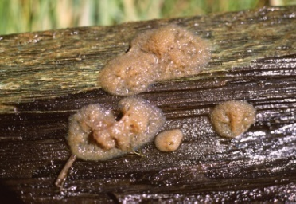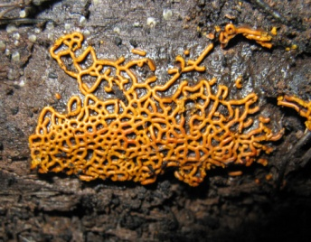
Fig. Types of plasmodia
TYPES OF PLASMODIA
There are three distinct plasmodial types generally recognized (Gray and Alexopoulos,¬ 1968; Keller and Braun, 1999):
- The protoplasmodium, characteristic of the Echinosteliales,
- The aphanoplasmodium, characteristic of the Stemonitales,
- The phaneroplasmodium, characteristic of the Physarales.
A fourth type intermediate between the aphano and phaneroplasmodium is termed as the trichiaceous plasmodium (Keller, 1971), and is characteristic of the Trichiales.
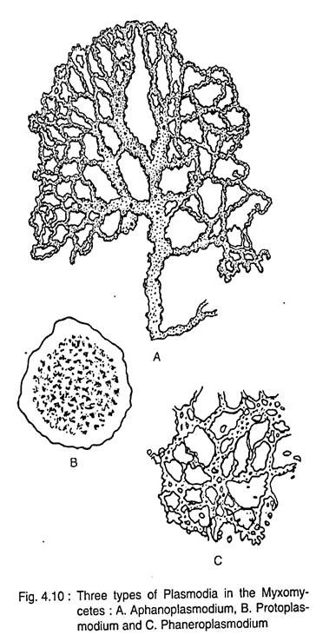

All of these plasmodial types are capable of movement as they feed, migrating different distances, and producing different types and numbers of fruiting bodies under optimal environmental conditions.

- Protoplasmodium

The protoplasmodium (Order Echinosteliales) remains microscopic throughout its development and migrates for short distances, usually less than 1mm. It has a plate-like shape that fails to develop advancing fans and trailing vein-like reticulate strands seen in other plasmodial types. Each tiny protoplasmodium gives rise to a single, tiny sporangium (usually less than 1mm), often occurring on the bark surface of living trees and vines. Species of Echinostelium and Clastoderma develop this type of plasmodium (Keller and Braun, 1999).

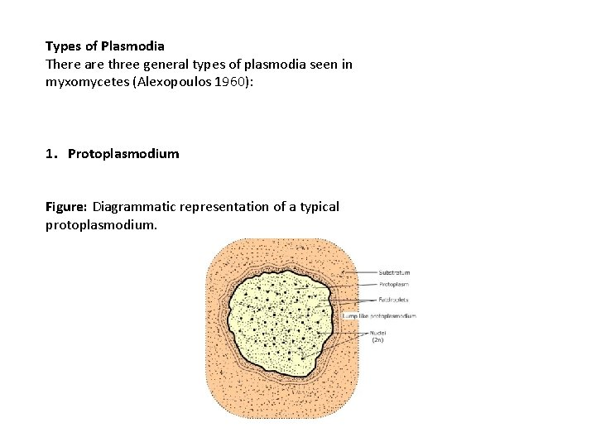

- Phaneroplasmodium
The phaneroplasmodium (Order Physarales) is the largest and often most colorful′ and frequently seen plasmodial type in the field. Polarity and directional movement at maturity result in an advancing, fan-shaped, anterior, feeding edge and a network of posterior trailing veins. Protoplasmic flow moves toward the anterior end of the plasmodium, slows, then stops, then reverses direction, flowing toward the posterior end. The entire plasmodium has a raised, three dimensional appearance with definite margins capable of covering and migrating up to 8m to drier sites.

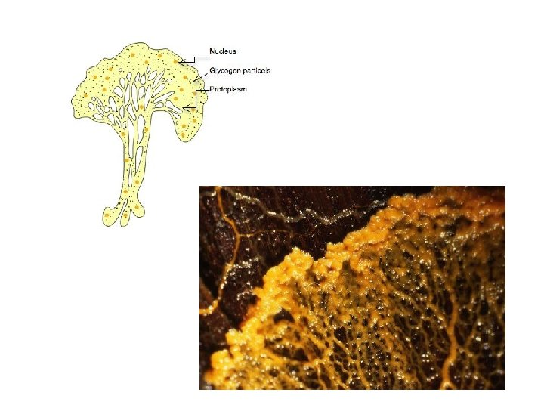

- Aphanoplasmodium
The aphanoplasmodium (Order Stemonitales) is characterized early in its development by a′ network of flattened, transparent threads, lack of polarity, and affinity for growing submerged in free water or under wet conditions. Young veins lack a distinct region of ectoplasm and endoplasm that facilitates movement through the interstices of decaying wood suddenly appearing overnight as hundreds of stalked sporangia in situ as in species of Stemonitis (Keller and Snell, 2002). Mature aphanoplasmodia on decaying leaves exhibit polarity and morphology typical of phaneroplasmodia and may migrate over short distances up to 10cm. Stemonitis flavogenita Echinostelium jahn in agar cultures migrates across the surface as immature stalked sporangia and, when fully mature, sporulates on the sides and lids of plastic Petri dishes (Keller, personal observations).

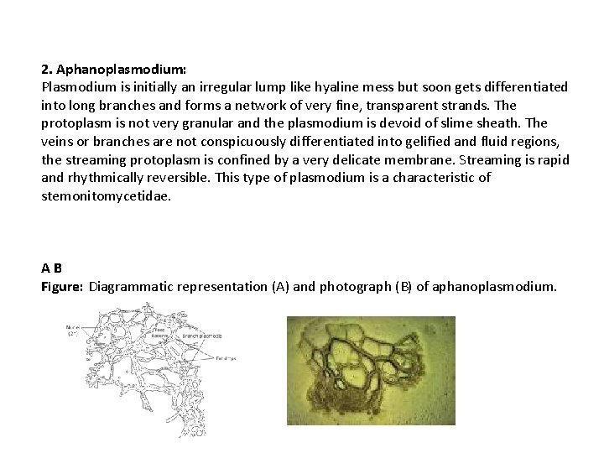

- Trichiaceous plasmodium

The trichiaceous plasmodium (Order Trichiales) combines morphological features′ of both the aphano- and phaneroplasmodial types. Perichaena depressa Lib. and P. quadrata T. Macbr. are examples of myxomycetes with this kind of plasmodium (Keller,1971; Keller and Eliasson, 1992). The anterior-posterior polarity of an advancing fan and trailing veins is established early in development. Although the advancing fan is the active growth center for forward movement, the mass of the plasmodium forms fruiting bodies in situ without migrating over long distances. Numerous fruiting bodies often develop from a single plasmodium on decaying wood or leaves, but not on living plants. The early stages of trichiaceous plasmodial development are extremely flattened and inconspicuous, and require free water in agar culture, otherwise sclerotization ensues.

TYPES OF FRUIT BODIES

Sporangium: sporangium is usually stalked and crowded or scattered on the substratum. Stalk varies in langth, size and colour. Sporangium is surrounded by Peridium and a thin hypothallus from which sporangium arise. Sometimes they are without stalk. For example: Stemonitis, Acryria, Comatricha etc

Aethelium: Aethelium are sessile, large or small, sometimes massive and cushion shaped. It is consist of several fused sporangia. The entire body is enclosed in a peridium. For example: species of Lycogala, Fugilo etc.

Plasmodiocarp: this type is sessile and branched, plasmodium like structure. During its development, the protoplasm of the plasmodium contracts around some of the veins and secretes a membrane around itself, forming the plasmodiocarp. For example: Species of Hemitrichia.

In some cases, a mixed type of fruiting body is noted. It is a mixture of sessile sporangia and plasmodiocarp. For example, Diderma testaceum.

Classification of Fungi

MYXOMYCOTINA (MYXOMYCETES or SLIME MOLD) 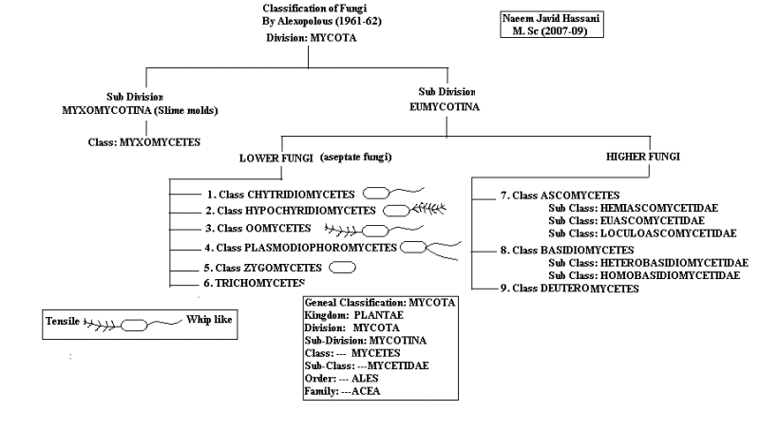

Classification of Division Myxomycota (Myxomycotina):
The classification of Myxomycota by Ainsworth (1973) is:
A. Class: Acrasiomycetes:
Acrasiomycetes are commonly known as cellular or amoeboid slime molds, and are found profusely in the upper layer of humus in deciduous forests and also in cultivated lands.
The characteristic features are:
1. Somatic phase commonly consists of amoeboid cells or myxamoebae.
2. Myxamoebae aggregate to form a pseudoplasmodium, which develops fruit body.
3. Lack of flagellated cells, except in Pocheina rosea.
4. Spore wall contains cellulose.
5. Fruit bodies may be sorocarps (in Dictyostelium) or sporocarp (in Protostelium).
B. Class: Hydromyxomycetes:
This group shows uncertain affinities. The thallus forms net plasmodium or filoplasmodium. They are commonly aquatic and saprobic, but rarely parasitic.
The characteristic features are:
1. The thallus consists of uninucleate spindle shaped cells, forming extensive filaments.
2. The filaments are tubular and form net-like structure, the net-plasmodium or filoplas- modium.
3. Reproduction by cyst formation, zoospore formation or by congregation.
The class consists of two orders Hydro- myxales and Labyrinthulales. But Hawksworth et al. (1983) excluded Hydromyxales from fungi and included it in Protozoans. The members of Labyrinthulales are parasitic on higher plants and also on marine algae. Labyrinthula macrocystis is a very common species, found as parasite on Zostera marina, the eel-grass.
C. Class: Myxomycetes:
This group is commonly known as true slime molds or plasmodial slime molds. They are commonly found in damp places, especially on old wood and other decomposing plant parts.
The characteristic features are:
1. The vegetative body is a free-living plasmodium.
2. They feed on yeast cells, protozoa, fungal spores and other substances.
3. Reproduction takes place by asexual and sexual means.
(a) Asexual reproduction takes place by fragmentation of plasmodium or binary fission in myxamoebae.
(b) Sexual reproduction takes place by fusion between flagellated zoospores or myxamoeba to form zygote, from which multinucleate plasmodium develops by mitotic divisions. They develop different types of fructification. These are sporangium, aethalium and plasmodiocarp. Meiosis takes place during spore formation in the fructification.

