DISEASE: Early blight of potato
PATHOGEN: Alternaria solani
HOSTS: Tomato (Lycopersicon esculentum), Potato (Solanum tuberosum)
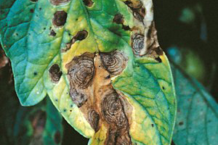
Alternaria solani on tomato foliage.
(Courtesy W.R. Stevenson)

Symptoms
Symptoms of early blight occur on fruit, stem and foliage of tomatoes and stem, foliage and tubers of potatoes. Initial symptoms on leaves appear as small 1-2 mm black or brown lesions and under conducive environmental conditions the lesions will enlarge and are often surrounded by a yellow halo Lesions greater than 10 mm in diameter often have dark pigmented concentric rings. This so-called “bullseye” type lesion is highly characteristic of early blight. As lesions expand and new lesions develop entire leaves may turn chlorotic and dehisce, leading to significant defoliation. Lesions occurring on stems are often sunken and lens-shaped with a light center, and have the typical concentric rings. On young tomato seedlings lesions may completely girdle the stem, a phase of the disease known as “collar rot,” which may lead to reduced plant vigor or death.

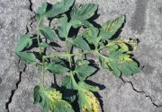  Figure 2 | 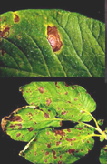  Figure 3
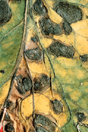  Figure 4 | 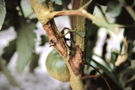  Figure 5
Infection of both green and ripe tomato fruit normally occurs through the calyx with lesions sometimes reaching a considerable size. The lesions appear leathery and may have the characteristic concentric rings. Infected fruit will frequently drop prematurely. Symptoms on potato tubers are characterized by sunken, irregular lesions , which are often surrounded by a raised purple border. Beneath the surface of the lesion the tuber tissue is leathery or corky with a brown discoloration. Early blight lesions on tubers tend to be dry and are less prone to invasion by secondary organisms than lesions of other tuber rots. After prolonged storage severely diseased tubers may become shriveled.
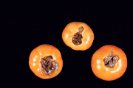  Figure 6 | 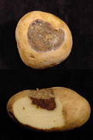  Figure 7

Pathogen biology
The causal pathogen of early blight is the fungus Alternaria solani. There is no known sexual stage and hence it is classified as a Deuteromycete. The genus Alternaria is a large and important group of pathogenic fungi, which cause a significant number of important diseases.
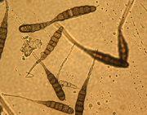
Figure 8

Disease Cycle and Epidemiology
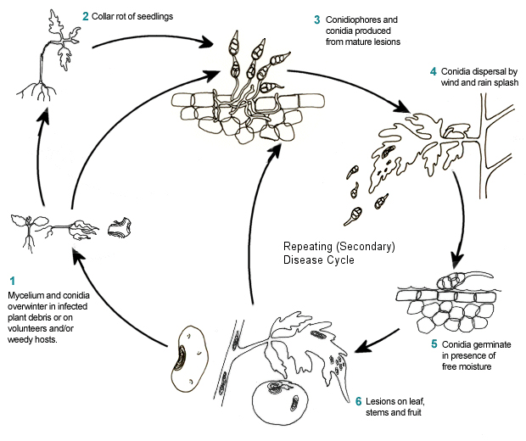
Alternaria solani overwinters primarily on infected crop debris. The dark pigmentation of the mycelium increases resistance to lysis which extends the survival time in the soil to several years. Thick-walled chlamydospores have been reported, but they are found infrequently. In mild climates the pathogen can survive from season to season on volunteer tomato and potato plants as well as other weedy Solanaceous hosts such as horsenettle and nightshade.
Warm, humid (24-29°C/ 75-84°F) environmental conditions are conducive to infection. In the presence of free moisture and at an optimum of 28-30°C (82-86°F), conidia will germinate in approximately 40 min. Desiccated germ tubes are able to renew growth when re-wetted, and, hence, infection can occur under conditions of alternating wet and dry periods. Germ tubes penetrate the leaf epidermis directly or enter through stomata. Infection of potato tubers usually occurs through wounds in the tuber skin inflicted during harvest. Wet conditions at harvest provide a favorable environment for spore germination as well as causing swollen lenticels on the tubers which are easily invaded.
Time from initial infection to appearance of foliar symptoms is dependent on environmental conditions, leaf age, and cultivar susceptibility. Early blight is principally a disease of aging plant tissue. Lesions generally appear quickly under warm, moist conditions on older foliage and are usually visible within 5-7 days after infection.
A long wet period is required for sporulation but it can also occur under conditions of alternating wet and dry periods. Conidiophores are produced during wet nights and the following day light and dryness induce them to produce spores, which emerge on the second wet night.
Secondary spread of the disease results from conidia being dispersed mainly be wind and occasionally by splashing rain or overhead irrigation. Early blight is considered polycyclic with repeating cycles of new infection. This is the period when the disease has the potential to spread rapidly and build up to damaging levels in the crop.

Disease Management

Cultural practices
- In many cases employing sound cultural practices that maintain potato and tomato plants in good health will keep early blight losses below economic levels.
- Controlling volunteers and weeds, such as nightshade and horsenettle which serve as alternative hosts for the disease, prior to planting the new crop will help to reduce the risk of transmission of disease.
- Ensuring seed or transplants are pathogen free before placing out in the field and rotating fields to a non susceptible host crop will also help to reduce buildup of inoculum in the soil.
- Optimal tuber maturity is the most important factor for control of tuber infection.
- Tubers harvested before maturing are susceptible to wounding and infection.
- Tuber infection can be reduced by careful handling during harvest to minimize wounding as well as avoiding harvesting during wet conditions if possible.
- Tubers should be stored at 50 to 55 F, at high relative humidity and with plenty of aeration to promote wound healing which will reduce the amount and severity of tuber infections that develop in storage.
- Proper irrigation schedules should minimize the duration of leaf wetness in the crop
- Avoid irrigation in cool, cloudy periods or late in evening when foliage may stay wet for extended periods.
- Selecting fields with good drainage and an absence of natural impediments to air flow over the crop, e.g. rows of trees, will reduce periods of leaf wetness.
- Maintenance of adequate soil fertility levels is also critical for managing early blight. The disease is often associated with crops suffering from a lack of nitrogen.
- Fungicides with protectant and curative properties are registered for use against early blight on tomato and potato The cheaper protectant fungicides such as mancozeb and chlorothalonil are the foundation of most early blight management programs
- The so-called Quinone Outside Inhibitors (QoI) class of fungicides (FRAC code #11) which inhibit fungal respiration are highly active against Alternaria species.

