Unifying features of archegoniates
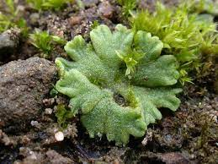
Archegoniate
- The archegoniates are a small group of primitive land dwellers. They have leafy or thalloid, green plant body which is small in structure.
- The vegetative body is completely adapted to the land habit. However they still rely on water for sexual reproduction.
- The plant body lacks true roots, stem or leaves. It is relatively simple thallus like. It grows prostrate on the ground and is attached to the substratum by delicate, unbranched, unicellular hair-like organs called rhizoids.
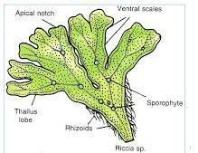
- The most conspicuous phase in the life cycle is the gametophyte. It is independent and concerned with sexual reproduction.
- Archegoniates lack vascular tissue.
- Sexual reproduction is of oogamous type. The sex organs are jacketed and multicellular.
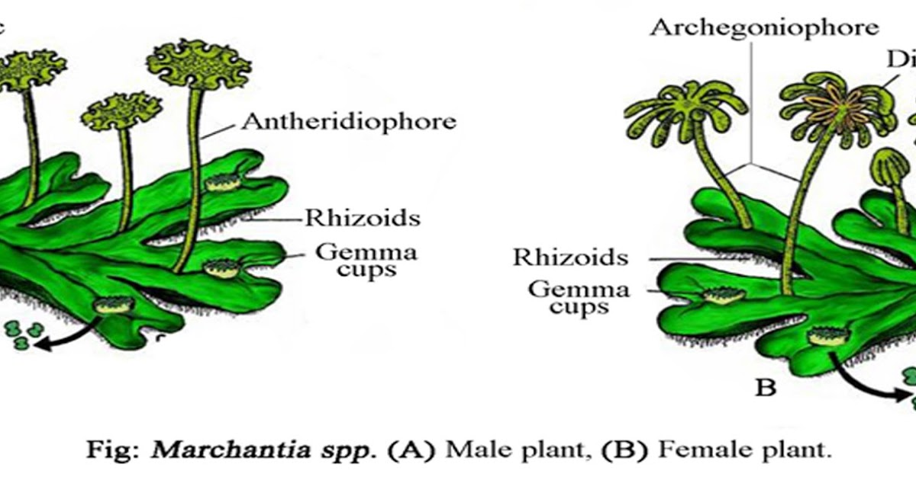
- Female sex organ are in the form of an archegonium.
- The sperms are biflagellate. Both the flagella are of whiplash type.
- Fertilization takes place in the presence of water.
- The fertilized egg is retained within the venter of the archegonium
- Zygote undergoes repeated division to form an undifferentiated, multicellular structure called embryo.
- The venter wall enlarges with the developing embryo to form a protective, multicellular envelope, the calyptras.
- The embryo by further division and differentiation produces a relatively small spore producing structure called sporogonium.
- The sporophyte is without differentiation into stem and leaves. It is rootless and consists of a foot, a seta and a capsule.
- The sporophyte is simpler than gametophyte and is attached to the parent gametophyte throughout its life.
- The sporogonium is concerned with the production of wind-disseminated , non-motile, cutinized spores which belong to the category of gonospore or meiospores.
- Morphologically the meiospores in a given species are of one kind. Thus archgoniates are known as homosporous.
- Each spore on falling on a suitable soil germinates to give rise to the gametophyte plant either directly or indirectly as a lateral bud from the protonrema.
- The occurance of heterologous type life is a constant feature.

