CCIII: MYCOLOGY AND PHYTOPATHOLOGY
UNIT 3: Oomycota (common name: watermolds)
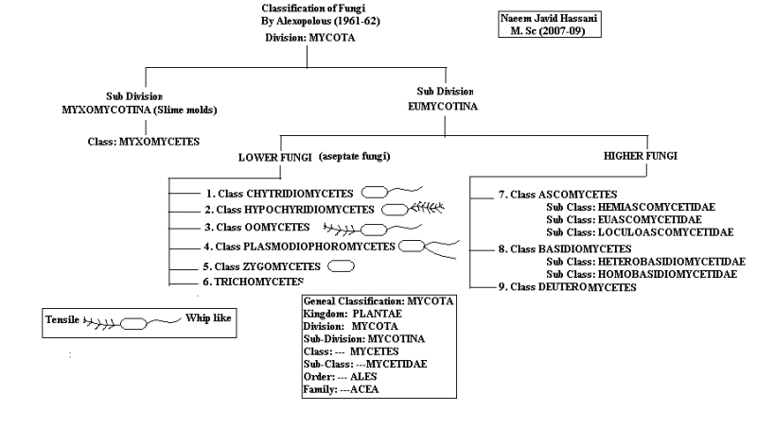
Oomycetes (a term used to refer to organisms in the phylum Oomycota) are a group of fungus-like organisms that rely on water for completion of their life cycle. The members are either free-living or parasitic. As they live in water they are called as “water molds”.
General characteristics
- The Oomycota have long been considered fungi because they obtain their nutrients via absorption and many of them produce the filamentous threads known as mycelium characteristic of many fungi. The Oomycota now are classified as a distinct group based on a number of unique characteristics.
- All members of the Oomycota undergo oogamous reproduction, meaning that diploid oospores are produced as zygotes following fertilization of haploid gametes. These oospores may be large and solitary or smaller and numerous inside the oogonium.
- When oomycetes produce swimming stages, they usually have two flagella of different types — a whiplash flagellum and a tinsel flagellum, the latter of which is decorated with small hairs. These hairs give the tinsel flagellum greater and reverse thrust, dragging spores through the water.
- They produce bi-flagellate zoospores and are of two kinds- Pear shaped or pyriform and Reniform or kidney shaped

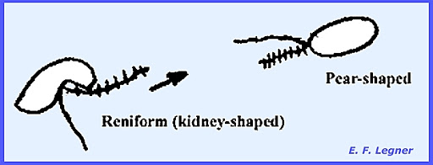

- The vegetative stages of oomycetes are generally either diploid or polyploid, including the egg-like resting spores, oospores, from which the name oomycetes is derived.
- An advanced type of oogamous reproduction takes place by the passage of gametic nuclei.
- Meiosis is gametangial rather than zygotic and the vegetative thallus is diploid.
- In addition, oomycetes differ in various physiological and chemical characteristics from fungi; for example, by having a cell wall containing glucan and cellulose, producing a different storage polysaccharide, and by utilizing different pathways to synthesise lysine and sterols.
- Members cause diseases on different economically important plant like- Phytophthora, saprolegnia, Phaerenospora, Aphanomyces etc.

MAJOR DIFFERNECE OF OOMYCOTA AND TRUE FUNGI
Table 1. Major distinctions between the Oomycota and the true Fungi

Character | Oomycota | True Fungi
Sexual reproduction | Heterogametangia. Fertilization of oospheres by nuclei of oospores. | Oospores not produced; sexual reproduction results in zygospores, ascospores or basidiospores
Nuclear state of vegetative mycelium | Diploid | Haploid o
Type of flagella on zoospores, if produced | Heterokont, of two types, one whiplash, directed posteriorly, the other fibrous, ciliated, directed anteriorly | If flagellum produced, usually of only one type: posterior, whiplash
Mitochondria | With tubular cristae | With flattened cristae
Cell wall | composed of beta glucans and cellulose | composed of chitin.

ECOLOGY OF OOMYCOTA
There are more than 500 species in the Oomycota these include the so-called water molds and downy mildews. They are filamentous protists which must absorb their food from the surrounding water or soil, or may invade the body of another organism to feed. As such, oomycetes play an important role in the decomposition and recycling of decaying matter. Other parasitic species have caused much human suffering through destruction of crops and fish.
Oomycetes live literally everywhere. They are among the most widespread eukaryotic life forms and thrive on all continents, including Antarctica, and can be found in ecosystems as diverse as tundra, rainforests, oceans and deserts.
Saprotrophic oomycetes remains of other organisms for their nutrition. They are often the first settlers on remains of other organisms in water and play an important role in the decomposition cycle, making organic material accessible for secondary colonisers. However, most known oomycete species are pathogens of eukaryotes, affecting animals, diatoms, dinoflagellates, fungi, plants, seaweeds, and even other oomycetes. The poorly studied oomycete parasites of diatoms and other planktonic organisms might be important in the breakdown of algal blooms. The majority of known oomycete species depend on living cells of flowering plants from which they absorb nutrients through specialised structures called haustoria. Some oomycetes cause only weak symptoms, if any, but are transmitted to the next generation of their hosts by entering the seeds. Other oomycetes kill their host in order to degrade and feed on it, either after a biotrophic phase or immediately.
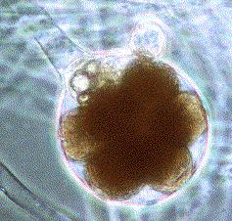
"Oomycota" means "egg fungi," and refers to the large round oogonia, or structures containing the female gametes, as shown in this picture of the common "water mold" Saprolegnia. Oomycetes are oogamous, producing large non-motile gametes called eggs, and smaller gametes called sperm. They may grow on the scales or eggs of fish, or on amphibians. The water mold Saprolegnia causes lesions on fish which cause problems when the water is rather stagnant, as in aquaria or fish farms, or at high population densities, such as when salmon swim upstream to spawn. Other species of Saprolegnia are parasitic on aquatic invertebrates such as rotifers, nematodes, and arthropods and on diatoms.
Their greatest impact on humans, however, comes from the many species of water mold which are parasites on flowering plants. These include root rotting fungi, seedling dampening mold, blister rusts, white rusts (Albugo), and the downy mildews that affect grapes, lettuce, corn, cabbage, and many other crop plants. Two of these disease-causing Chromists have had a major impact on world history--- Plasmopara viticola, the downy mildew of grapes and Phytophthora infestans, the late blight of potato.
CLASSIFICATION
kingdom: | Heterokonta
Phylum: | Oomycota  Arx, 1967^{[1]}
Class: | Oomycetes  G. Winter, 1880
Orders and families
- Lagenidiales
  - Lagenidiaceae
  - Olpidiosidaceae
  - Sirolpidiaceae
- Leptomitales
  - Leptomitaceae
- Peronosporales
  - Albuginaceae
  - Peronosporaceae
  - Pythiaceae
- Rhipidiales
  - Rhipidaceae
- Saprolegniales
  - Ectrogellaceae
  - Haliphthoraceae
  - Leptolegniellaceae
  - Saprolegniaceae

Classification[edit]
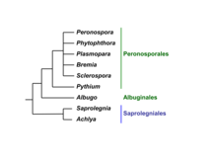
Simplified phylogeny.
Asexual structures (sporangia) in Saprolegniales, Albuginales and Peronosporales
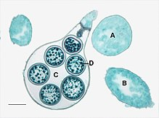
Sexual structures (only oogonia, antheridia not shown) of Saprolegnia

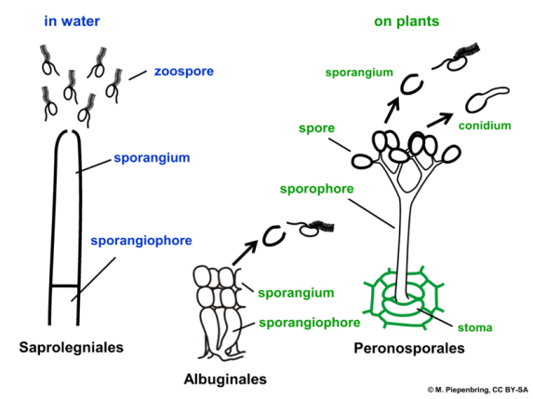

Previously the group was arranged into six orders.
- The Saprolegniales are the most widespread. Many break down decaying matter; others are parasites.
- The Leptomitales have wall thickenings that give their continuous cell body the appearance of septation. They bear chitin and often reproduce asexually.
- The Rhipidiales use rhizoids to attach their thallus to the bed of stagnant or polluted water bodies.
- The Albuginales are considered by some authors to be a family (Albuginaceae) within the Peronosporales, although it has been shown that they are phylogenetically distinct from this order.
- The Peronosporales too are mainly saprophytic or parasitic on plants, and have an aseptate, branching form. Many of the most damaging agricultural parasites belong to this order.
- The Lagenidiales are the most primitive; some are filamentous, others unicellular; they are generally parasitic.
However more recently this has been expanded considerably.

Another classification of oomycetes
- Anisolpidiales Dick 2001
  - Anisolpidiaceae Karling 1943
- Lagenismatales Dick 2001
  - Lagenismataceae Dick 1995
- Salilagenidiales Dick 2001
  - Salilagenidiaceae Dick 1995
- Rozellopsidales Dick 2001
  - Rozellopsidaceae Dick 1995
  - Pseudosphaeritaceae Dick 1995
- Ectrogellales
  - Ectrogellaceae
- Haptoglossales
  - Haptoglossaceae
- Eurychasmales
  - Eurychasmataceae Petersen 1905
- Haliphthorales
  - Haliphthoraceae Vishniac 1958
- Olpidiopsidales
  - Sirolpidiaceae Cejp 1959
  - Pontismataceae Petersen 1909
  - Olpidiopsidaceae Cejp 1959
- Atkinsiellales
  - Atkinisellaceae
  - Crypticolaceae Dick 1995
- Saprolegniales
  - Achlyaceae
  - Verrucalvaceae Dick 1984
  - Saprolegniaceae Warm. 1884 [Leptolegniaceae]
- Leptomitales
  - Leptomitaceae Kuetz. 1843 [Apodachlyellaceae Dick 1986]
  - Leptolegniellaceae Dick 1971 [Ducellieriaceae Dick 1995]
- Rhipidiales
  - Rhipidiaceae Cejp 1959
- Albuginales
  - Albuginaceae Schroet. 1893
- Peronosporales [Pythiales; Sclerosporales; Lagenidiales]
  - Salisapiliaceae
  - Pythiaceae Schroet. 1893 [Pythiogetonaceae; Lagenaceae Dick 1994; Lagenidiaceae; Peronophythoraceae; Myzocytiopsidaceae Dick 1995]
  - Peronosporaceae Warm. 1884 [Sclerosporaceae Dick 1984]

Taxonomic Tree
Domain: Eukaryota
Kingdom: Chromista
Phylum: Oomycota
Class: Oomycetes
Order: Peronosporales
Family: Peronosporaceae
Genus: Phytophthora
Species: Phytophthora infestans

Phytophthora infestans is an oomycete or water mold, a fungus-like microorganism that causes the serious potato and tomato disease known as late blight or potato blight.
The first of these is Phytophthora infestans, the organism which causes late blight of potato. The potato is native to North America, but once it was introduced to Europe, it quickly became an important food crop. Late blight did not follow its host plant across the Atlantic until much later; the disease organism grows into the stem and leaf tissues, causing death, and may also infest the tubers, which are the part of the plant that is eaten. The disease spreads rapidly under cool and damp conditions, which are common in western Europe. In one week during the summer of 1846, this diease wiped out almost the entire potato crop of Ireland, a crop which was the primary food of the poor at that time. Nearly a million Irish died in the Great Famine, and an additional one-and-a-half million emigrated to other countries, including America. Thus, if you are an American with Irish ancestry, it was probably the oomycetes that brought your family here. Other species of Phytophthora destroy eucalyptus, avocado, pineapples, and other tropical crop plants.

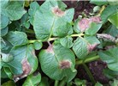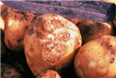

- Phytophthora cause late blight of potato.
- The mycelium is coenocytic, intercellular with haustoria.
- The zoospores are produced within the vesicle.
- The protoplasm moves towards the vesicle and then zoospore are produced
- The zoospore are released from the sporangium through the exit at the point of Papilla
- The zoospores are laterally biflagellate and uninucleate
- Zoospore swims, come to rest, encyst and germinate by means of germ tube.
- The term tube produces an appresorium, at its point of contact with the host tissue.
- Sexual reproduction by means of antheridia and oogonia of opposite mating type

BIOLOGY AND ECOLOGY
P. infestans exists as an asexual organism it is essentially an obligate parasite. It requires a living host (crop debris or solanaceous weeds) for long-term survival. Whereas sporangia may survive days or weeks in soil, they cannot overwinter or overseason. Mycelium of the fungus cannot survive in the absence of a living host cell. However, in locations where sexual reproduction occurs, the resulting oospore can survive for months or years in the absence of living hosts (Drenth et al., 1995).
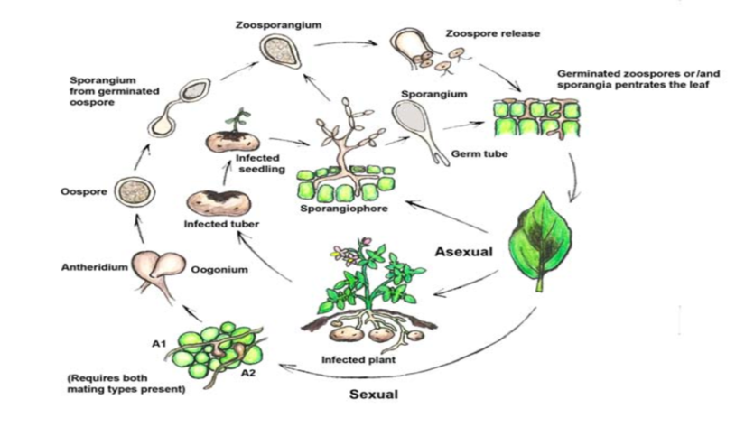

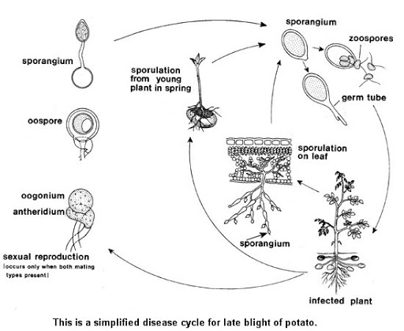

Systematic position of Albugo candida
Domain: Eukaryota
Kingdom: Chromista
Phylum: Oomycota
Class: Oomycetes
Order: Peronosporales
Family: Albuginaceae
Genus: Albugo
Species: Albugo candida

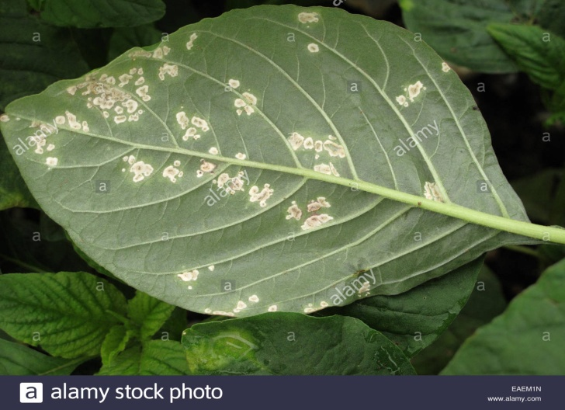

Characteristic feature

- The family has a genus Albugo, which is pathogenic in mature.
- Albugo candida cause white rust on cruciferous plants (Brassicaceae).
- White dust like powder on the leaves is the identifying character of this genus, so they are called white rust.
- The mycelium is intercellular forming small knob-like haustoria which penetrates the host cells.
- The mycelium grows and ramifies in the host tissues and produce short, club-shaped sporangiophores from the tips of many hyphal branches when a certain stage of maturity is reached.
- The sporangia are formed below epidermis in chains
- The pressure of the developing chains of sporangia raises the host epidermis and finally rupture it.
- The sporangia are then exposed to the outside environment and appear as a white powdery mass.
- The sporangia germinate by germ tube or by producing biflagellate zoospore
- The zoospore are produced in sessile vesicle.
- After a period of motility the biflagellate zoospore become spherical, encyst and then form germ-tube which enter the host.
- Sexual reproduction may follow the asexual reproduction.
- Sex organ are produced from the tips of the hyphae in the intercellular spaces of the infected tissues.

LIFE CYCLE OF Albugo candida
