Discovery of gibberellins
A young scientist Kurosawa had been trying to find out why the rice seedlings infected by the fungus Gibberella fujikuroi grew taller and turned very thin pale. These are the symptoms of Backanae disease which is known to Japanese for over a century. In1926, he succeeded in obtaining a filtered extract of this fungus which could cause symptoms of the Backanae disease in healthy rice seedlings. In 1935, Yabuta, isolated the active substance which was quite heat stable and gave it the name gibberellin.
Yabuta and Sumiki (1938) isolated gibberellins in crystalline from and identified gibberellin-A and gibberellin-B from their original preparation. In fact, these were the mixtures of different gibberellins which could not be separated at that time due to lack of suitable technique. Later work showed that gibberellins-A was probably a mixture of 3 biologically active and gibberellins-B a mixture of one biologically active and one inactive gibberellins. The biological activity of gibberellins and their effect on different development processes of the plants were also studied by Japanese workers.
It was only in 1950 when Mitchell at the Biological Welfare Centre U.S.A and Stodola (1955) at the U.S. Dept. of Agriculture were engaged along with team of workers to isolate this substance on commercial basis, that the importance of gibberellins was realised by western scientists. In England, Brain et al (1955) at the Imperial chemical Laboratories independently obtained pure sample of a single gibberellins which was named as gibberellic acid. Later on, its structure was established by cross et al (1961).
That there are different types of gibberllins had already been indicated by the work of Yabuta & Sumiki. Apart from fungal source, the gibberellins were then found to be present in wide variety of higher plants. The first higher plant gibberellins (GA) was isolated from immature bean seeds (Phaseolus coccineus) in 1958 which was later shown by MacMillan (1960) to be identical with GA₁ earlier isolated from G. fujikuroi.
It is now known that there are over 125 different gibberellins (GAs) which have been isolated and chemically characterized. However, not more than 15 different GAs have been detected from any single species of higher plant.

Physiological roles of gibberellins
- Seed germination
Certain light sensitive seeds e.g. lettuce and tobacco show poor germination in dark. Germination starts vigorously if these seeds are exposed to light or red light. This requirement of light is overcome if the seeds are treated with gibberellic acid in dark.
- Dormancy of buds
In temperate regions the buds formed in autumn remain dormant until next spring due to severe colds. This dormancy of buds can be broken by gibberellic treatment.
In potatoes also, there is a dormant period after harvest, but the application of gibberellic sprouts the eyes vigorously.
- Root growth
Gibberellins have little or no effect on growth. At higher concentration in some plants however, some inhibition of root growth may occur. The ignition of roots is markedly inhibited by gibberellins in isolated cuttings.
- Elongation of the internodes
Most pronounced effect of gibberellins on plant growth is the elongation of the internodes, so much so that in many plant such as dwarf pea, dwarf maize etc., they overcome the genetic dwarfism. For instance, the light grown dwarf pea plants have short internodes and expanded leaves. But, when treated with gibberellins the internodes elongate markedly and they look like tall plants.
It is considered that in such dwarf plants i) the gene for producing gibberellins is missing, or ii) the concentration of the natural inhibitors is higher. When external gibberellins are applied the deficiency of the endogenous gibberellins is made good or the external gibberellins overcomes the effect of natural inhibitors which fall short.
- Bolting and flowering
In many herbaceous plants the early period of growth shows rosette-habit with short stem and cauline leaves. Under short days the rosette habit is retained while under long days bolting occurs i.e. the stem elongates rapidly and is converted into floral axis bearing flower primordial. This bolting can also be induced by the application of gibberellins even under non-inductive short days.
- Parthenocarpy
Germination of pollen grains is stimulated by gibberellins. Likewise the growth of the fruit and the formation of parthenocarpic fruits can be induced by gibberellins treatment. In many cases e.g., pome and stone fruits where auxins have failed to induced parthenocarpy the gibberellins have proven to be successful. Seedless and fleshy tomatoes and large sized grapes are produced by gibberellins treatment on commercial scale.
- Light inhibited stem growth
It is common observation that the dark grown plants become etiolated and have taller, thinner and pale stems while the light grown plants have shorter, thicker and green stems and it may be concluded that light has inhibitory effect on stem etiolation treatment of light grown plants with gibberellins also stimulates the stem growth and they appear to be dark brown. In such cases the protein content of the stem falls while soluble nitrogen content increases probably due to breakdown proteins than their synthesis.
It is considered that the light in some way lowers the level of endogenous gibberellins and inhibits the stem growth
- De novo synthesis of the enzyme-α-amylase
One of the important function of the gibberellins is to cause de novo synthesis of the enzyme α-amylase in the aleurone layer surrounding the endosperm of cereal grains during germination. This enzyme brings about hydrolysis of starch to form simple sugars which are than translocated to growing embryo to provide energy source.
Characteristics of gibberellins
GA are characterized by the following features
- Prevention of genetic and physiological dwarfism
- Breaking dormancy
- Induction of flowering in long day plants
- Increase of amylase activity
- Substitute for chilling effect

Biosynthesis of gibberellins in plants
The GA which are chemically related to terpenoids are thought to formed by the condensation of a 5-C precursor- an isoprenoid unit called as isopentenyl pyrophosphate (IPP) through a number of intermediates to give rise to GA. The primary precursor for the formation of this isoprenoid unit and synthesis of GA is however, acetate.
In plants GAs are biosynthesized in apical tissues and there are three main sites of their biosynthesis, i) developing seeds and fruits, ii) young leaves of developing apical buds and elongating shoots and iii) the apical regions of roots.
The pathway of GA biosynthesis can be divided into three stages each of which is accomplished in a different cellular compartment
- Stage I. Formation of terpenoid precursors and ent-kaurene in plastids
GA biosynthesized from a 5-C precursor of IPP the IPP may be synthesized either in plastids or cytosol.
From IPP, 10-C (GPP) 15-C (FPP) and 20_C (GGPP) precursor of terpenoids are formed by condensation of 5-C units(IPP). After the formation of GGPP, the pathway becomes specific for GAs.
GGPP is converted by two cyclization reactions through copalyl pyrophosphate into ent-kaurene. These reactions are catalysed by the enzymes cyclises which are located in proplastids and not in mature chloroplasts and infact constitute the first step that is specific for GAs. This step of GA biosynthesis is inhibited by compounds such as Amo-1618, PhosphonD and CCC
- Stage II. Oxidation to form GA₁₂ and GA ₅₃ on ER through GA₁₂ aldehyde
The ent-kaurene is transported from plastids to ER. Noew a methyl group on ent-kaurene an 19th carbon position is oxidised to carboxylic group whicjh is followed by concentration ring B from 6-C to 5-C ring structure to form GA₁₂-aldehyde. GA₁₂-aldehyde is subsequently oxidised to give GA₁₂ which is precursor to all other GAs in plants. Hydroxylation of GA₁₂ at C-13 results in the formation of GA₅₃.
The enzymes catalysing the above oxidation reactions are mono-oxygenases which are located on ER and utilize cytochome P450 in these reactions. Activity of thses enzymes are inhibited by paclobutrazol and other inhibitors before GA₁₂ - aldehyde
- Stage III. Formation of all other GAs from GA₁₂ or GA₅₃ in cytosol
All other steps in the biosynthesis of GAs from GA₁₂ or GA₅₃ are carried out in cytosol by soluble enzyme is called dioxygenases. These enzymes require molecular O₂ and 2-oxoglutarate as cosubstrates and ferrous iron (Fe⁺⁺) and ascorbic acid as cofactors. Activity of these enzymes is inhibited by cyclohexanetriones.

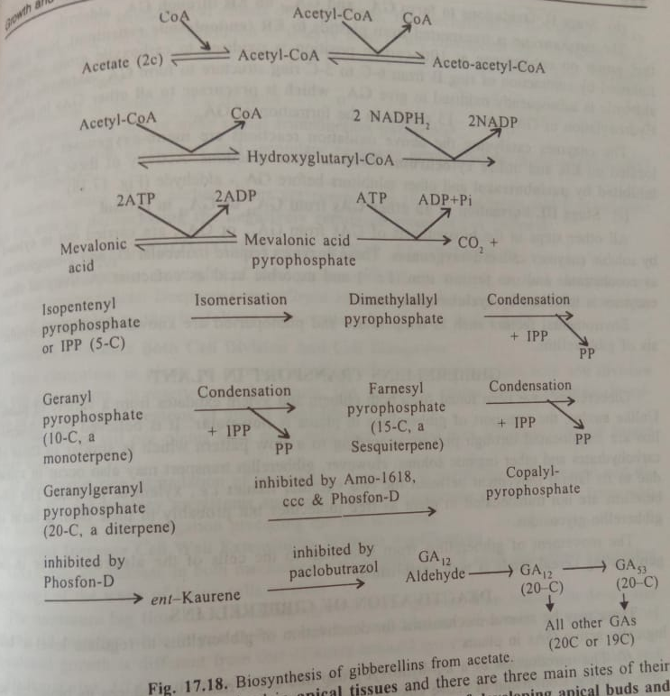

Gibberellins transport in plant
GA have been found from both phloem and xylem exudates from the variety of plants. Unlike auxins, the transport of GA in plants is non-polar. It is believed that GA are translocated through phloem according to flow pattern which is similar to those of carbohydrates and other organic solutes. However, GA transport may also occur in xylem due to its lateral movement between the two vascular tissue i.e. xylem & phloem. The GA are not translocated in plant as free molecules but probably in their bound form as gibberellins-glycosides.
The movement of GA from scutellum to the cells of the aleurone layer in the germinating cereal seeds is well established.

Mechanism of gibberellins action
GAs are very active molecule even at very low concentrations. Responses of GA in stem elongation of rice seedlings at concentrations of 10⁻¹⁰ g (0.1ng) or even lower have been obtained. Obviously efficient mechanisms in responding cells must be present for amplification of hormonal signal at very low concentrations.
Out of so many physiological effects of GA, the mechanism of two of the effects,i) stem elongation and mobilaztion of reserve food in the endosperm are extensively studied and better known. In both cases, the sequences of events are similar and envisaged on the following lines
- Binding of hormone to a receptor
- Activation of one or more signal transduction pathways
- Transcription of primary and secondary response genes leading to the physiological response.
However, some of the earlier events are common to all GA responses and it is believed that GA acts by derepressing the negatively regulated genes of GA response.

