Measurement of Growth
Growth in plant can be measured in terms of either
- An increase in length or girth in case of stem and root
- An increase in weight
- An increase in volume or area as in case of fruits and leaves respectively.
The following methods are usually employed for the measurement of growth in length
- Direct method
This is the simplest rather crude method of measurement of growth in which the length of growing part is measured just by the help of a scale after intervals
- Horizontal microscope
In this method a point is marked near the stem or the root tip and is focussed by horizontal microscope which sliders over a graduated vertical stand. After some time the same point is again focussed either by raising (in case of stem tip) or lowering (in case of root tip) the horizontal microscope. The difference of the initial and final readings on the graduated vertical stand measures the growth of stem or the root tip in length.
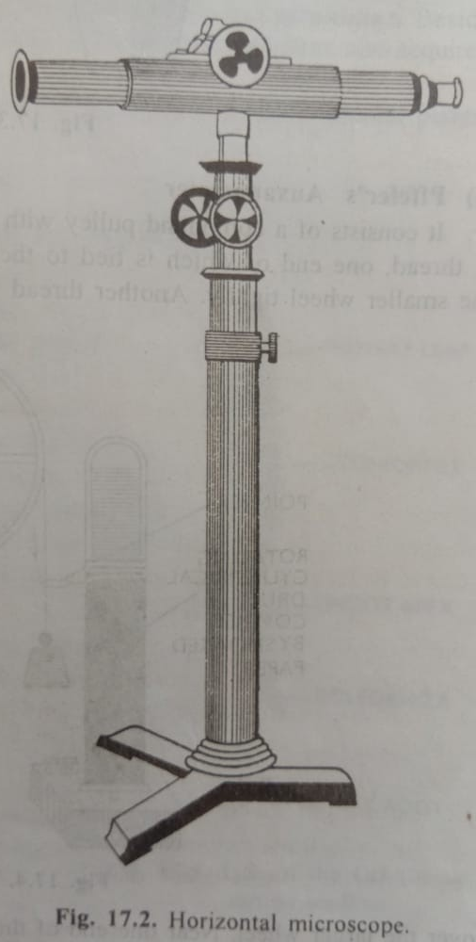
- Auxanometer-
Two types of auxanometer are in use for measuring growth
- Arc Auxanometer
The increase in length of the stem tip can easily measured by an arc auxanometer which consists of a small pulley to the axil of which is attached a long pointer sliding over a graduated arc. A thread, one end of which is tied to the stem tip and the other end to a weigth passes over the pulley. As soon as the stem tip increases in length, the pulley moves and the pointer slides over the graduated arc. The reading is taken. Actual increase in length of the stem is then calculated by knowing the length of the pointer and the diameter of the pulley. If the diameter of the pulley is 4” and the length of the pointer 20”, growth is magnitude ten times on the graduated arc.

- Pffeffer’ Auxanometer
It consists of a compound pulley with a small and a large wheel both having the same axil. A thread, one end of which is tied to the stem tip and the other end to a weight passes over the smaller wheel tightly. Another thread whose both ends are tied with weights tightly passes over the larger wheels. Near one end of this thread is attached to a pointer which remains in touch with a rotating cylindrical drum covered by a smoaked paper. As soon as the stem tip increases in length, the wheels of the pulley move so that pointer also moves downward and traces a special white marking on the smoaked paper which gives an idea of the growth in the stem tip. Actual increase in length of the stem can be calculated by knowing the radii of larger and smaller wheels and the rate of rotation of the drum.

- Bose’s erescograph
It is a very sensitive apparatus based on a system of compound levers. It can magnify growth one thousand to ten thousand times and can record its progress by minutes and even by seconds on a plate which oscillates to and fro at regular intervals.
- Space marker disc
By space marker disc the area of a leaf is measured and marked at regular intervals and recorded to calculate the rate of growth.

Factors affecting Growth
Growth is affected by the factors which affect the activity of the protoplasm. It is affected by a large number of factors both environmental and physiological factors such as absorption of water, minerals, photosynthesis, respiration etc. and environmental factors including climatic and edaphic both. The effect of these factors on one region of the plant are also transmitted to the other region. In fact, the number of factor affecting growth is such that the principle of limiting factors is always to be kept in mind while studying a factor and it is not possible to discuss them all. However, a few important ones are discussed here.
- Food supply- the supply of food is directly proportional to the rate of growth and with deficient food supply to the growing region the rate of growth decreases and ultimately stops. It affects the rate of growth firstly because it provides potential energy to the growing region.
- Water supply- the supply of water has a direct relationship with the rate of growth because it is necessary for all metabolic activities of the protoplasm and for increasing the turgidity of the cell for cell enlargement.
- Oxygen supply- Oxygen increases growth because it helps in respiration by converting potential energy into kinetic energy needed for vital activities of the plant including growth. It has been reported that oxygen plays some important role during G1 stage of cell division.
- Temperature – Temperature also affects growth directly or indirectly. Though growth occurs between the two rigours,4°C-45°C, optimum activity takes place between 28-33°C. the amount of water present inside the cell and the condition of protoplasm are closely related with its resistance to extremes temperatures. The values for three cardinal temperature –minimum, optimum and maximum- vary for plants of arctic, temperature and tropical zones. The optimum temperature needed for the growth of plant is much dependent on the stages of development. Low temperature during nights reduces the rate of respiration and high temperature during day time increases the photosynthesis and accumulated photosynthate also increase growth. Due to very low temperature (cold), plants are injured because desiccation, chilling and freezing while at temperature above 45°C enzymes are denatured. Both these conditions affect adversely.
- Light- lights affects variously, e.g. light intensity, quality and periodicity.
- Intensity of light- in general, intense light retards growth in plants. High light intensities induce dwarfening of the plant. Plants at hill tops are short whereas those of a valley are quite tall. Very weak light reduces the rate of overall growth and also photosynthesis. Development of chlorophyll is dependent on light and its absence etiolin compound is formed which gives yellow colour to the plant. The phenomenon is called etiolation. Similarly high light intensity affecting indirectly increases the rate of water loss and reduces the rate of growth.
- Quality of light- the different colour (different wave lengths) affect the growth of plant. In blue violet colour of light internodal growth and leaf size of the lamina become pronounced while green colour light reduces the expansion of leaves as compared to complete spectrum of visible light. The red light favors elongation of leaves but they resemble etiolated plants. Infrared and ultra violet are detrimental to growth. However the ultra violet rays are necessary for development of anthocyanin pigments in flowers.
- Duration of light- there is remarkable effect of the duration of the lighton the growth of vegetative as well as reproductive structures. The induction and suppression of flowering are dependent on duration
- Growth hormones- within the last few years it has been well established that the growth of a plant is controlled by certain organic compounds present in exceedingly minute quantities. These compounds are called hormones, phytohormones or growth promoting substances.

