TELOME THEORY

A number of theories on land-plant evolution exists of which the Telome theory of Walter Zimmermann (1930, 1952) is the most comprehensive. This theory is based on fossil record and synthesises the major steps in the evolution of vascular plants.
According to this theory, all vascular plants evolved —either directly or indirectly — from a simple leafless Rhynia type ancestral form made up of sterile and fertile axes (the telomes). Evolutionary modification of its parts produce more advanced vascular plants with roots, stems, leaves, more complex vascular systems and protected sporangia.

Meaning of Telome Theory:
A telome is defined as “the single-nerved ultimate terminal portion (at base or apex) of a dichotomising axis” i.e., it is the point of the most distal dichotomy to the tip of a branch. The connecting axes between dichotomies are called mesomes (Fig. 7.134). Functionally, telomes are of two types viz., fertile telome and sterile telome.
If the ultimate branch is terminated by a sporangium then it is a fertile telome (Fig. 7.134), whereas those terminal branches without sporangia are called sterile (vegetative) telomes (Fig. 7.134). Several telomes, either fertile or sterile, becomes grouped together by connecting mesomes to form a more complex structure, called syntelome or telome truss (Fig. 7.134).
A syntelome is designated as phylloid truss if composed of only sterile or vegetative telomes, or as fertile truss when composed of only fertile telomes, or a mixed telome truss when composed of both sterile and fertile telomes.

Telome and the evolution of the independent sporophyte among pteridophytes:

Processes of Telome Theory:
According to Zimmermann, these telomes or telome trusses of primitive Rhynia type of vascular plants have been subjected to certain evolutionary processes in varying degrees among the various taxonomic groups.

These evolutionary processes are:
(i) Overtopping
(ii) Reduction,
(iii) Plantation,
(iv) Syngenesis or webbing, and
(v) Curvation.
(a) Overtopping:

In this process, one of the two dichotomising branches of the primitive axis produced by the apical meristem outgrows or overgrows the other. The larger axis thus produced becomes the stem, while the shorter or overtopped branches represent the beginnings of lateral branches or leaves (Fig. 7.135A-C). Now the earlier dichotomy will be transformed to pseudomonopodial branch.
(b) Reduction:
In this process, the activity of terminal meristem of each telome of the truss becomes suppressed resulting into much shorter branches by decreasing the length of telomes and mesomes (Fig. 7.135B, C). This process is responsible for the formation of microphyllous leaves of the Lycopsida and Sphenopsida as well as the needle-like leaves of conifers.
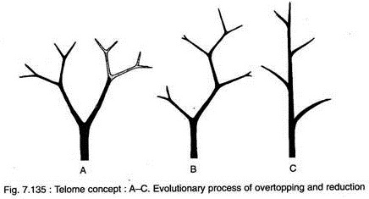

(c) Planation:
The process of planation caused the telomes and mesomes of the truss to shift from a three-dimensional pattern (cruciate dichotomy) to a single plane (fan-shaped dichotomy) (Fig. 7.136A, B).
The process of infilling with photosynthetic and other tissues between the planated branches is called webbing which have led to the evolution of flattened leaf-like structure with a dichotomously veined lamina.
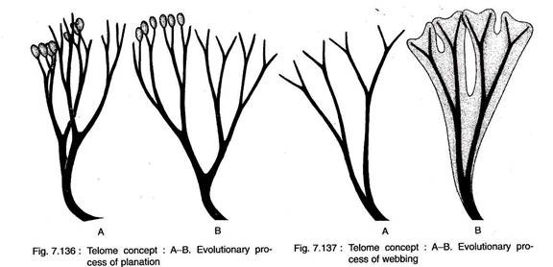

(d) Syngenesis:
This is an evolutionary process where tangential fusion of mesomes and telomes takes place (Fig. 7.137A, B). The lateral fusion of sterile vegetative telomes and mesomes resulted into complex anastomosing vascular systems in stem (e.g., polystelic condition in Selaginella).
The fusion of fertile trusses with their terminal sporangia resulted in the formation of synangia of Psilotum. The closed or reticulate venation pattern of some ferns, gymnosperm and many flowering plants are the result of syngenesis of the dichotomising veins of the primitive leaf.
(e) Curvation:
This evolutionary process is caused due to the unequal growth of the tissues on two opposite flanks of the telome.

It has two sub-processes:
(i) Recurvation:
In this sub-process the telome bends inward toward an axis (Fig. 7.138A, B). The inward-projecting sporangia on a sporangiophore of Equisetum (Sphenopsida) is the result of this sub-process.
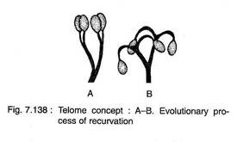
(ii) Incurvation:
In this sub-process, the fertile telome bends downward resulting in the downward shifting of the sporangia from terminal to the ventral surface of the leaf. This sub-process is responsible for the formation of ventral position of the sporangia in fern (Pteropsida) leaf.

Concept of Telome Theory:
The telome concept has been used in understanding the origin and evolution of the following major groups of plants:
1. Psilopsida:
The telome theory can be applied to interpret the evolution of a synangium of Psilotum. The overtopping, reduction and syngenesis have combined to produce a synangium of Psilotum (Fig. 7.139A-D).
Initially, the overtopping occurred in the aerial branch of Rhynia- type plant to form a pseudomonopodial branching system with laterals having 3-dimensional dichotomously branched fertile and sterile telome trusses.
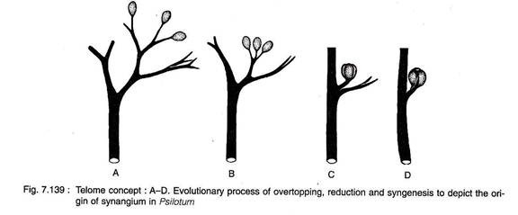
Then, due to the continuous reduction in both the telome trusses, the sporangia were placed in a condensed cluster and became proximal to the main axis. Then the further reduction had occurred in the fertile telome which allowed sporangia to come in close contact with each other and, again, allowing syngenesis to occur resulting in the formation of a synangium.
The bifid appendage which subtends a synangium in Psilotum is a product of reduction of vegetative telome truss associated with fertile telomes.
2. Pteropsida:
A megaphyllous leaf of Pteropsida originates following the three steps overtopping, planation and webbing (Fig. 7.140A-D). By overtopping, the original dichotomous branching system changed to pseudomonopodial branch with a main stem and lateral branches.
Now, the lateral telomes and mesomes of the truss, which were originally 3-dimensional (cruciate) type, became planted (one-dimensional). The planted telomes which have come closer became a flattened leaf-like structure with a number of tree-ending veins by webbing through the infilling with photosynthetic and other tissues between the planted telomes and mesomes.
Further, a reticulate venation pattern was obtained in some Pteropsida due to the syngenesis of the dichotomising veins.
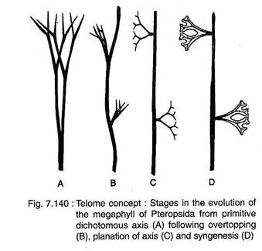
3. Sphenopsida:
The chief trends in the origin of sporangiophore in Sphenopsida were recurvation and syngenesis resulting in a pellate structure with reflexed sporangia (Fig. 7.141 A-C). Here the fertile telome truss followed recurvation which has been evidenced in many fossil members of Sphenopsida like Hyenia, Calamophyton, etc.
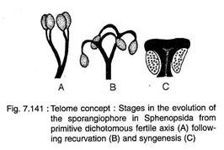
Subsequently, a pellate sporangiospore with reflexed sporangia had evolved due to syngenesis. The nature of sporangiophore of Calamites and Equisetum provides examples of such process. However, the leaf of sphenopsida had evolved following planation and reduction.
4. Lycopsida:
The origin of microphyllous leaf of Lycopsida can also be demonstrated in the light of telome concept following overtopping and reduction (Fig. 7.142A-C). Here the lateral branch of pseudomonopodial branch system followed successive reduction to form a linear, unbranched microphyll.
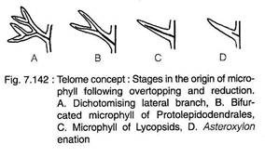
Thus, the pentafid (Leclercquia), trifid (Colpodexylon) and bifid (Protolepidodendron) leaves and sporophylls are the intermediate forms. However, the stages of successive reduction of leaves do not coincide with the ages of the fossil plants.
Say for example, the microphylls of Upper Devonian lycopods are reported later in spite of their prim- itiveness than the much reduced enation (advanced) of Lower Devonian Zosterophyllopsida. Hence, the Telome theory is ‘misfit’ for interpreting the origin and evolution of microphylls in Lycopsida.
Enation Theory:
This theory was propounded by F. O. Bower (1935). The enation theory seems to be more convincing than the telome theory for explaining the origin of microphyllous leaves (Fig. 7.143A-D). According to Enation theory, the microphylls were initiated as nonvascularised spine-like outgrowths (enations) on the shoot of primitive vascular plants (e.g., Zosterophyllopsida).
These spine-like enations were not arranged in a definable pattern. Initially, tooth-like enations were arranged in vertical rows on opposite sides of the axes (e.g., Crenaticaulis, Serrulacaulis).
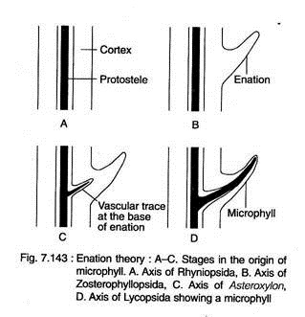
However, in Sawdonia, irregularly disposed tapered and pointed spine-like enations are reported on the axes. In zosterophylls, enations are devoid of any vasculature (first step). However, in the next step (second step) as exemplified by Asteroxylon, a trace of vascular tissue arises directly from the protostele of the axis and enters the base of the enation. Here enations are spirally arranged on the axes.
In the final step, the enations become elongated, flattened and leaf-like and the vascular trace grew up to the tip of the leaf. In this way, a microphyllous leaf (a single unbranched leaf trace arises directly from the protostele) evolved in the Lower Devonian.
The further elaboration of the microphyll (with branched tips) in early herbaceous lycopods (Leclercquia, Protolepidodendron, Estinnophyton) can only be explained by telome theory.

Significance of Telome Theory:
(i) The telome theory portrays the origin and evolution of the sporophytes in the earliest known land plants.
(ii) The theory is based mostly on account of the comparative study of the fossil as well as living genera of the vascular plants. It actually explains the phylogenetic relationship between the fossil and the living plants.
(iii) The five elementary processes like overtopping, reduction, planation, recurvation and syngenesis give a unified concept of the manner in which evolution might have proceeded in the land plants. These processes explain in a simple and lucid way as to how the primitive land plants led to the evolution of both the simple and the complex land plants of today.
Moreover, these processes provide a basis of interpretation in solving the morphological controversies of different organs in the vascular plants such as:
(a) The nature of the aerial portion of the plant body of the Ophioglossaceae,
(b) Anatomy of some species of the Medullosaceae,
(c) Nature of the plant body un the Coenopterid forms,
(d) Evolution of the vegetative and reproductive structure of Cordaitales and early conifers,
(e) Phyllogeny and origin of stamens and carpels.
The theory explains in a satisfactory manner that the entire sporophyte is an axis that has an underground portion called the root and an aerial part called the shoot. The appendages of the shoot that is the sporophylls, sporangia and sterile leaves are nothing but modified parts of the shoot.

