Mechanism of translocation through phloem
Various theories have been put forward to explain the mechanism of phloem conduction but they are not fully satisfactory. Among them Munch’s (1930) hypothesis is most convincing
Pressure flow model/ Munch’s flow hypothesis
According to this hypothesis put forward by Munch (1930) and elaborated by Craft (1938) and others, the translocation of organic solutes takes place en mass through phloem along a gradient of turgor pressure from the region of higher concentration of soluble solutes i.e. supply end to the region of lower concentration i.e. consumption end.

The principle hypothesis can be explained by a simple physical system.
Two membranes X and Y permeable only to water and dipping in water are connected by a tube T to form a closed system. Membrane X contains more concentrated sugar solution than in membrane Y.
Due to higher osmotic pressure of the concentrated sugar solution in membrane X, water enters into it so that its turgor pressure is increased. The increase in the turgor pressure results in mass flow of sugar solution to membrane Y through the tube T till the concentration of Sugar solution in both the membrane is equal.
If in the above system it could be possible to maintain continuous supply of sugars in membrane X and its utilization or conversion into soluble form in membrane Y, the flow of sugar solution from X to Y will continue indefinitely.
According to Munch’s hypothesis, a similar analogous system for the translocation of organic solutes exists in plants. As a result of photosynthesis, the mesophyll cells in the leaves contain higher concentration of organic food material in them in soluble form and correspond to membrane X or supply end. The cells of stem and roots where the food material is utilized or converted into soluble form correspond to membrane Y or consumption end. While sieve tube in phloem which are placed end to end correspond to the tube T.
Mesophyll cells draw water from the xylem of the leaf due to higher osmotic pressure and suction pressure of their sap so that their turgor pressure is increased. The turgor pressure in the cells of stem and roots is comparatively low and hence, the soluble organic solutes begin to flow en mass from mesophyll through phloem down to the cells of stem and the roots under the gradient of turgor pressure. In the cells of stem and the roots of the organic solutes are either consumed or converted into insoluble form and the excess water is released.

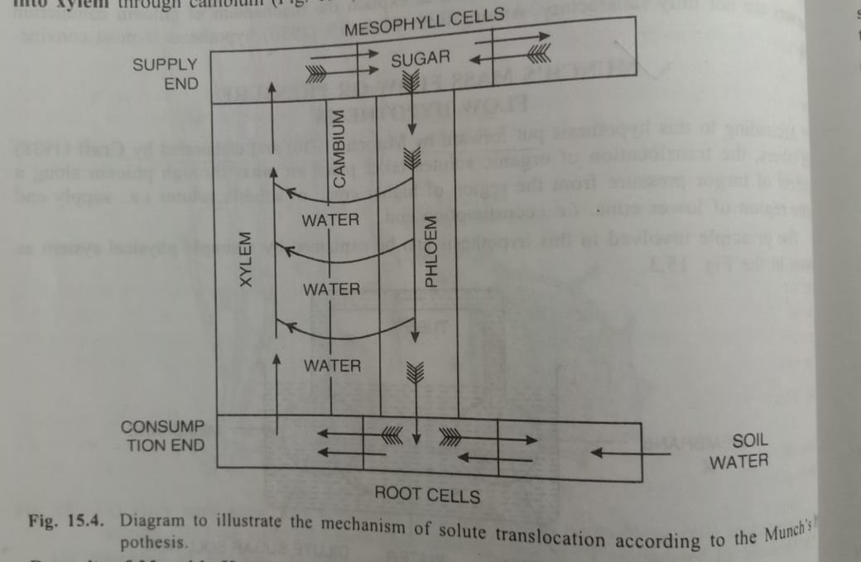

Demerits of Munch’s hypothesis
- This hypothesis accounts for the translocation in only one direction at a time, although there may be simultaneous upward and downward translocation of solutes.
- There is considerable doubt regarding the magnitude of the turgor pressure at the supply end which may not be sufficient enough to overcome the resistance offered by the sieve plates in the translocation of solutes through sieve tubes.
- Turgor pressure may not always be higher at the supply end
- This hypothesis is based on purely physical assumption and does not take into account the fact that whole of the translocation process is dependent upon the plant’s metabolism and the metabolic energy.

Phloem loading and unloading
Translocation of organic solutes such as sucrose (i.e. photosynthates) takes place through the sieve tube elements of phloem from the supply end (or source) to consumption end ( or sink). But, before this translocation of sugar could proceed, the soluble sugars must be transferred from mesophyll cells to sieve tube elements of respective leaves. This transfer of sugars from mesophyll cells to sieve tube elements in the leaf is called as phloem loading. On the other hand, the transfer of sugars from sieve tube elements to the receiver cells of the consumption end is called as phloem unloading. Both are energy requiring process.
Phloem loading
As a result of photosynthesis, the sugar such as sucrose produced in mesoophyll cells move to the sieve tubes of smallest veins of the leaf either directly or through only 2-3 cells depending upon the leaf anatomy. Consequently, the concentration of sugar increase in sieve tubes in comparison to surrounding mesophyll cells.
The movement of sugars from mesophyll cells to sieve tubes of phloem may occur either through symplast (i.e. cell to cell through plasmodesmata, remaining in the cytoplasm) or the sugars may enter the apoplast (i.e. cell walls outside the protoplast) at some point en route to phloem sieve tubes. In the later case, the sugars are actively loaded from apoplast tosieve by an energy driven transport located in the plasmamembrane of these cells. The mechanism of phloem loading in such case has been called as sucrose-H⁺ symport or cotransport mechanism. According to this mechanism protons (H⁺) are pumped out through the plasmamembrane using energy from ATP and an ATPase carrier enzyme so that concentration of H⁺ becomes higher outside (in apopast) than inside the cell. Spontaneous tendency toward equilibrium causes protons to diffuse back into the cytoplasm through plasmamembrane coupled with transport of sucrose from apoplast to cytoplasm through sucrose-H⁺ symporter located in the plasmamembrane.

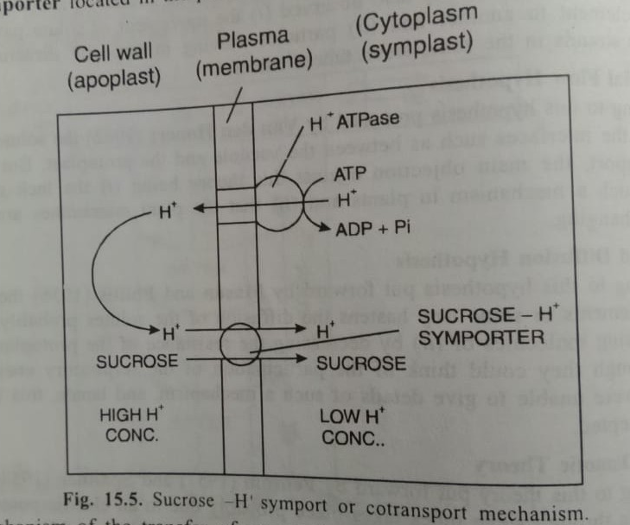

The mechanism of transfer of sugars (sucrose) from mesophyll cells to apoplast is however not known.
Phloem loadiing is specific and selective for transport sugars.
Both symplastic and apoplastic pathways of phloem loading are used in plants but in different species. In some species however, phloem loading may occur through both the pathways in the same sieve tube elements or in different sieve tube elements of the same vein nor in sieve tubes in veins of different sizes.
Experimental findings have revealed certain patterns in apoplastic and symplastic loading of sugars in phloem, which appears with the type of sugar transported to phloem, type of companion cells (ordinary, transfer or intermediary) and number of plasmodesmata (few or abundant) connecting the sieve tubes (including the companion cells) to surrounding cells in smaller veins.
To some extent, phloem loading is also correlated with the family plant, its habit (trees, shrubs, veins or herbs) and climate such as temperate, tropical or arid climate.

Patterns in apoplastic and symplastic phloem loading
 | apoplastic loading | symplastic loading
Type of sugar transported | Sucrose | Sugra + other oligosaccharides
Type of companion cells in the small veins | Ordinary or transfer cells | Intermediary cells
Number of plasmodesmata connecting the sieve tubes (including companion cells) to surrounding cells | Fewer | Abundant

Phloem unloading
It occurs in the consumption end or sink organs (such as developing roots, tubers, reproductive structures etc.). Sugars move from sieve tubes to receiver cells in the sink involving following steps
- Sieve element unloading- In this process, sugars imported from the source) leave sieve elements of sink tissues.
- Short distance transport- The sugars are now transported to cells in sink by a short distance pathway which has also been called as post sieve element transport.
- Storage and metabolism- Finally, sugars are stored or metabolized in the cells of the sink.
As with the phloem loading process, sucrose unloading also occurs through symplast via plasmodesmata or through apoplast at some point en route to sink cells.
Phloem unloading is typically symplastic in growing and respiring sinks such as meristems, roots and young leaves etc. in which sucrose can be rapidly metabolised (young leaves acts as sink until their photosynthesis machinery is fully developed, at which point they become sources.)
Usually the storage organs such as fruits (grape, orange etc.) roots (sugar beet) and stems (sugarcane), sucrose unloading is known to occur through apoplast. However, according to Oparka (1986), phloem unloading in potato tubers from sieve elements to cortical cells is a symplastic passive process.
Because, there are wide varieties of sink in plants which differ in structure and function, no one scheme of phloem unloading is available.

