Composition of phloem sap
The structure of phloem tissue is well modified for conduction of solutes. Phloem tissue of an angiosperm consists of sieve tubes, companion cells, several kinds of parenchyma cells, fibres and scleroids. Of these sieve tubes are involved in sugar translocation. Sieve tubes are elongated cells arranged longitudinally end to end. Parenchyma cells are closely associated with them and remain connected through fine cytoplasmic threads called plasmodesmata. Certain parenchyma cells referred to as companion cells arise from parent meristematic cells along with sieve tubes, i.e. meristematic cell divides longitudinally to produce a companion cell and a sieve tube. Companion cells provide energy to sieve tube and participate in loading and unloading of assimilates.
During maturation of a sieve tube, the cell wall undergoes certain distinctive changes. It develops pores in its transverse wall. Each pore has a single strand of cytoplasm extending the protoplast of the adjoining sieve tube. These pores may also be present lateral walls in certain cases. In general, these sieve areas (pores) are localised on the end walls (sieve plates). The border of each pores becomes impregnated at maturity with callose (a polysaccharide) and thus cytoplasmic strand with the pore remains encased in a cylinder of callose.

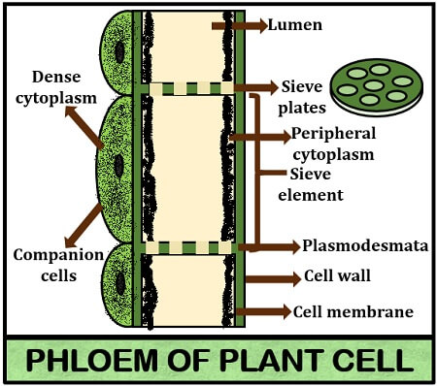

In addition to changes in the cell wall, the protoplast of sieve element also undergoes remarkable changes during maturation. Nucleus, tonoplast and vacuole undergo disintregation and disappear. Esau (1966) believes that incase of mature sieve tubes, the cytoplasm and vacuole become one system called mycotoplasm. Murmais and Evart (1966) reported that ribosome and dictyosomes also disappear. Mitochondria, however remain present but they differ from that of parenchyma in having fewer cristae. A proteinaceous component called P-protein (phloem protein) makes its appearance. In the cytoplasm of young sieve tube as discrete slime bodies. The slime bodies consist of thread like filaments. These tend to fuse with one another during maturation. Later, the slime spreads out and disperses throughout the sieve tube (Walker and Thaine, 1971)
Though these changes are distinctively seen in a sieve tube, how these facilitate translocation of solute and how new structural changes promote it are not clear.

