Caliphate
Islamic history
Caliphate, the political-religious state comprising the Muslim community and the lands and peoples under its dominion in the centuries following the death (632 CE) of the Prophet Muhammad. Ruled by a caliph (Arabic khalīfah, “successor”), who held temporal and sometimes a degree of spiritual authority, the empire of the Caliphate grew rapidly through conquest during its first two centuries to include most of Southwest Asia, North Africa, and Spain. Dynastic struggles later brought about the Caliphate’s decline, and it ceased to exist as a functioning political institution with the Mongol destruction of Baghdad in 1258.
This article covers the history of the original caliphal state based in Arabia, the Levant, and Mesopotamia in the 7th–13th century. See caliph for a general discussion of the titular position that heads a caliphate; see also Fāṭimid dynasty and Caliphate of Córdoba for other historical examples of caliphates.

Leadership after Muhammad
The urgent need for a successor to Muhammad as political leader of the Muslim community was met by a group of Muslim elders in Medina who designated Abū Bakr, the Prophet’s father-in-law, as caliph. According to the majority of Muslims, the Prophet himself had left no instructions for the selection of a leader after him, although a small minority—the precursors of the group later known as the Shiʿah—advocated for ʿAlī’s claim to the Caliphate. It would be anachronistic to assume that this early group supported ʿAlī because he was a cousin and son-in-law of the Prophet. Rather, the early literature indicates that the legitimate caliph was expected to have been an early convert to Islam (precedence in converting to Islam was termed sābiqah in Arabic) and to possess a constellation of moral excellences (faḍāʾil in Arabic), such as truthfulness, generosity, courage, and, above all, knowledge. The caliph’s authority was largely epistemic—that is to say, based on his superior knowledge of both religious and worldly affairs.
Later, during the Umayyad period (661–750), there was a growing emphasis on kinship to the Prophet as a criterion of legitimate leadership, likely because the Umayyads wished to thereby compensate for their lack of sābiqah, having accepted Islam late during the Prophet’s lifetime. In response, supporters of the claim to leadership of ʿAlī and his descendents emphasized their lineal descent from the Prophet’s family as a marker of their legitimacy. By the 10th century the orthodox Sunni majority had also come to acknowledge kinship as a factor by understanding legitimate leadership to inhere in descent from the Quraysh, Muhammad’s natal tribe, to which the first four caliphs also belonged.
Although the reigns of the first four caliphs—Abū Bakr, ʿUmar I, ʿUthmān, and ʿAlī—were marred by political upheaval, civil war, and assassination, the era was remembered by later generations of Muslims as a golden age of Islam, and the four caliphs were collectively known as the “rightly guided caliphs” because of their close personal associations with Muhammad. The rightly guided caliphs largely established the administrative and judicial organization of the Muslim community and directed the conquest of new lands. In the 630s Syria, Jordan, Palestine, and Iraq were conquered, Egypt was taken from Byzantine control in 645, and frequent raids were launched into North Africa, Armenia, and Persia.

The Umayyads
The assassination of ʿUthmān and the troubled caliphate of ʿAlī that followed sparked the first sectarian split in the Muslim community. By 661 ʿAlī’s rival Muʿāwiyah I, a fellow member of ʿUthmān’s Umayyad clan, had wrested away the caliphate, and his rule established the Umayyad dynasty, which lasted until 750. Despite the largely successful reign of Muʿāwiyah, tribal and sectarian disputes erupted after his death. The majority of Muslims regarded the Umayyads as nominally Muslim at best, given their worldly and opulent lifestyles. They were also unpopular on account of their having established dynastic rule by force. Their reign is contemptuously referred to in later sources as mere “kingship” (mulk)—in contrast to the caliphate, which was supposed to be based on the superior personal merits of the ruler and established through a process of consultation with the people. In a conscious effort to confer legitimacy on themselves and to acquire a religious aura, the Umayyads chose the title khalīfat allāh, “the deputy of God,” in contradistinction to the first two caliphs in particular, who are said to have deliberately shunned such a self-aggrandizing title.
There were three Umayyad rulers between 680 and 685, and only by nearly 20 years of military campaigning did the next one, ʿAbd al-Malik, succeed in reestablishing the authority of the Umayyad capital of Damascus. ʿAbd al-Malik is also remembered for building the Dome of the Rock in Jerusalem. Under his son al-Walīd (705–715), Muslim forces took permanent possession of North Africa, converted the native Berbers to Islam, and overran most of the Iberian Peninsula as the Visigothic kingdom there collapsed. Progress was also made in the east with settlement in the Indus River valley. Umayyad power had never been firmly seated, however, and the Caliphate disintegrated rapidly after the long reign of Hishām (724–743). A serious rebellion broke out against the Umayyads in 747, and in 750 the last Umayyad caliph, Marwān II, was defeated in the Battle of the Great Zab by the followers of the Abbasid family.

The Abbasid caliphate
The Abbasids, descendants of an uncle of Muhammad, owed the success of their revolt in large part to their appeal to various pietistic, extremist, or merely disgruntled groups and in particular to the aid of the Shiʿah, who held that the Caliphate belonged by right to the descendants of ʿAlī. That the Abbasids disappointed the expectations of the Shiʿah by taking the Caliphate for themselves left the Shiʿah to evolve into a sect, permanently hostile to the Sunni majority, that would periodically threaten the established government by revolt. The first Abbasid caliph, al-Saffāḥ (749–754), ordered the elimination of the entire Umayyad clan; the only Umayyad of note who escaped was ʿAbd al-Raḥman, who made his way to Spain and established an Umayyad dynasty that lasted until 1031.

The period 786–861, especially the caliphates of Hārūn (786–809) and al-Maʾmūn (813–833), is accounted the height of Abbasid rule. The eastward orientation of the dynasty was demonstrated by al-Manṣūr’s removal of the capital to Baghdad in 762–763 and by the later caliphs’ policy of marrying non-Arabs and recruiting Turks, Slavs, and other non-Arabs as palace guards. Under al-Maʾmūn, the intellectual and artistic heritage of Iran (Persia) was cultivated, and Persian administrators assumed important posts in the Caliphate’s administration. After 861, anarchy and rebellion shook the empire. Tunisia and eastern Iran came under the control of hereditary governors who made token acknowledgment of Baghdad’s suzerainty. Other provinces became less-reliable sources of revenue. The Shiʿah and similar groups, including the Qarmaṭians in Syria and the Fāṭimids in North Africa, challenged Abbasid rule on religious as well as political grounds.

Competing claims
Abbasid power ended in 945, when the Būyids, a family of rough tribesmen from northwestern Iran, took Baghdad under their rule. They retained the Abbasid caliphs as figureheads. The Samanid dynasty that arose in Khorāsān and Transoxania and the Ghaznavids in Central Asia and the Ganges River basin similarly acknowledged the Abbasid caliphs as spiritual leaders of Sunni Islam. On the other hand, the Fāṭimids proclaimed a new caliphate in 920 in their capital of Al-Mahdiyyah in Tunisia and castigated the Abbasids as usurpers; the Umayyad ruler in Spain, ʿAbd al-Raḥmān III, adopted the title of caliph in 928 in opposition to both the Abbasids and the Fāṭimids. Nominal Abbasid authority was restored to Egypt by Saladin in 1171. By that time the Abbasids had begun to regain some semblance of their former power, as the Seljuq dynasty of sultans in Baghdad, which had replaced the Būyids in 1055, itself began to decay. The caliph al-Nāṣir (1180–1225) achieved a certain success in dealing diplomatically with various threats from the east, but al-Mustaʿṣim (1242–58) had no such success and was murdered in the Mongol sack of Baghdad that ended the Abbasid line in that city. A scion of the family was invited a few years later to establish a puppet caliphate in Cairo that lasted until 1517, but it exercised no power whatsoever. From the 13th century onward a variety of rulers outside Cairo also included caliph among their titles, although their claims to universal leadership of the Muslim community seem to have been more notional than real.

The caliphate in the modern era
The concept of the caliphate took on new significance in the 18th century as an instrument of statecraft in the declining Ottoman Empire. Facing the erosion of their military and political power and territorial losses inflicted in a series of wars with European rivals, the Ottoman sultans, who had occasionally styled themselves as caliphs since the 14th century, began to stress their claim to leadership of the Islamic community. This served both as means of retaining some degree of influence over Muslim populations in formerly Ottoman lands and as means of bolstering Ottoman legitimacy within the empire. The caliphate was abolished in 1924, following the dissolution of the Ottoman Empire and the rise of the Turkish Republic.
In the 20th century the reestablishment of the caliphate, although occasionally invoked by Islamists as a symbol of global Islamic unity, was of no practical interest for mainstream Islamist groups such as the Muslim Brotherhood in Egypt. It did, however, figure prominently in the rhetoric of violent extremist groups such as al-Qaeda. In June 2014 an insurgent group known as the Islamic State in Iraq and the Levant (ISIL; also known as the Islamic State in Iraq and Syria [ISIS] and the Islamic State [IS]), which had taken control of areas of eastern Syria and western Iraq, declared the establishment of a caliphate with the group’s leader Abu Bakr al-Baghdadi as caliph. Outside extremist circles, the group’s claim was widely rejected.

.

ʿUmar II: Umayyad caliph
ʿUmar II, in full ʿUmar ibn ʿAbd al-ʿAzīz, (born 682/683, Medina, Arabia [now in Saudi Arabia]—died February 720, near Aleppo, Syria), pious and respected caliph who attempted to preserve the integrity of the Muslim Umayyad caliphate (661–750) by emphasizing religion and a return to the original principles of the Islamic faith.
His father, ʿAbd al-ʿAzīz, was a governor of Egypt, and through his mother he was a descendant of ʿUmar I (second caliph, 634–644). He received a traditional education in Medina and won fame for his piety and learning. In February or March 706, ʿUmar was appointed governor of the Hejaz. During his tenure of office, he initiated policies that later characterized his reign, particularly his creation of a consultative body of pious men to aid him in his rule.
ʿUmar was elevated to the caliphate by the will of his predecessor, the caliph Sulaymān, in September or October 717. At his accession the stability of the Umayyad caliphate was threatened by the discontent of the Mawālī (non-Arab Muslims) and the “pious opposition,” who resented the Umayyads allegedly for putting political interests ahead of established religious principles. ʿUmar, who was mainly interested in home affairs, attempted no major military conquests, and soon after his accession he lifted his predecessor’s disastrous siege of Constantinople (now Istanbul). Initiating a policy of internal consolidation, he dismissed unpopular governors, reformed the taxation system, and granted the Mawālī the same fiscal rights as Arab Muslims.
Although many of his policies seemed untenable, ʿUmar attempted to arrest the disintegration of the Umayyad caliphate by appealing to a broad segment of the Muslim population. He, alone of the Umayyads, was respected by the later ʿAbbāsid dynasty and was highly regarded even among the Shīʿites, schismatic followers of Muhammad’s son-in-law ʿAlī.

ʿAbd al-Muʾmin: Almohad caliph

ʿAbd al-Muʾmin, in full ʿAbd al-Muʾmin ibn ʿAli, (born c. 1094, Tagra, Kingdom of the Ḥammādids—died 1163, Rabat, Almohad Empire), Berber caliph of the Almohad dynasty (reigned 1130–63), who conquered the North African Maghrib from the Almoravids and brought all the Berbers under one rule.

Life
ʿAbd al-Muʾmin came from a humble family: his father had been a potter. He seems to have been well instructed in the Muslim faith and must have had a good knowledge of Arabic, for he wished to continue his studies at one of the centres of Muslim learning in the East. A chance meeting with Ibn Tūmart, a Berber religious reformer, made him abandon this idea and begin his brilliant career.
Around 1117, Ibn Tūmart, the founder of the Almohad movement, was returning from a long stay in the East. He landed at Mahdīyah in Tunisia and began a journey to southern Morocco, his native country. Wherever he stopped along the way, he proclaimed a twofold message: strict adherence to the doctrine of the oneness of God (hence the name Almohads or al-Muwaḥḥidūn, Unitarians) and scrupulous observance of Islāmic law. ʿAbd al-Muʾmin heard Ibn Tūmart preach at Mellala, near Bejaïa, Algeria. He was an attentive listener and from that time attached himself to the man who had revealed to him the true doctrine.
ʿAbd al-Muʾmin does not seem to have played any special role among Ibn Tūmart’s disciples during the slow journey that took them to Marrakech. But when his master declared his opposition to the ruling Almoravid regime, proclaimed himself the mahdī (“divinely guided one”), and took refuge in the remote High Atlas region, ʿAbd al-Muʾmin went with him. Ibn Tūmart won a following in the mountains and founded a small Almohad state there, centred on the village of Tinmel. When al-Bashīr, the reformer’s second in command, was killed in an attack on Marrakech, ʿAbd al-Muʾmin took his place and became Ibn Tūmart’s designated successor. The mahdī died in 1130. His death was kept secret at first to allow ʿAbd al-Muʾmin—a stranger to the High Atlas—time to win support from the Almohad leaders. When he was proclaimed leader of the Almohads, he assumed the prestigious title of caliph.
His first task was to carry on the struggle against the Almoravids. Learning from the failure at Marrakech, he realized that he must conquer Morocco from the mountains. On the plains, the Christian knights who served the Almoravids could easily repulse the Almohads’ Berber infantry. He spent the next 15 years winning control of the High Atlas, Middle Atlas, and Rif regions, finally moving into his native country, north of Tlemcen.
Near that town, the Almoravids, having suffered the loss of Reverter, the leader of their Catalan mercenaries, were defeated by ʿAbd al-Muʾmin in open battle in 1145. The Almohad forces then moved west, subjugating Morocco’s Atlantic coastal plain. They then laid siege to Marrakech and took it by storm in 1147, massacring the Almoravid inhabitants.
Arab historians have left a description of the man who had now become master of Northwest Africa. He was a sturdy Berber of medium height, with dark hair and regular features. A good soldier, with great courage and endurance, he was at the same time learned in Islām and a gifted orator. Although he had personal charm and could, when necessary, show patience and moderation, he was at times as harsh as his master, Ibn Tūmart. When a revolt broke out in the Atlantic plain area following the capture of Marrakech, he conducted a methodical purge there in which more than 30,000 people were executed.
ʿAbd al-Muʾmin left neither memoirs nor a political testament; his ideas must be deduced from his actions. His newfound power and his very success raised problems that demanded immediate solutions.
The capture of Marrakech posed the moral question of whether to abandon this city founded by the Almoravid heretics, whom he had exterminated without pity. He contented himself with destruction of their palace and mosques and retained Marrakech as the capital of his new empire.
Soon he had to choose between two imperial policies: to complete the conquest of North Africa or to concentrate his energies on Spain, where the Christians were threatening the former Almoravid domains. Showing good judgment as well as feeling for his native country, he gave priority to North Africa.
In 1151 he subjugated the area around Constantine and on his way home fought a battle near Sétif against a powerful coalition of Arab tribes that had been wandering over the Berber country for a century, gradually destroying its simple, pastoral, and sedentary way of life. ʿAbd al-Muʾmin was victorious, but instead of punishing these people who had showed themselves to be the worst enemies of the Berbers and the Almohad government, he came to rely on them to strengthen his dynasty against internal opposition from the family of Ibn Tūmart. He also wished to use the Arab cavalry in his holy war against the Christians in Spain.
In 1158–59 ʿAbd al-Muʾmin conquered Tunisia and Tripolitania. This marked the zenith of Berber power in Islām: a Berber caliph reigned over all of North Africa west of Egypt, and his authority was acknowledged by most of Muslim Spain as well.

ʿAbd al-Muʾmin’s government
Even while he was pursuing his conquest, ʿAbd al-Muʾmin had established a central government for his empire. To the traditional clan organization of the Maṣmudah and other Berber peoples supporting the Almohads he added an organization to promote the spread of Almohad doctrine and a central administration (the makhzan) modeled on those of Muslim Spain, which was staffed largely by Spanish Muslims. A government land registry was improvised to assure the dynasty regular revenue. ʿAbd al-Muʾmin fully accepted the responsibilities of an art patron, but remembering the puritanical austerity of Ibn Tūmart, he sometimes imposed on the mosques built for him by Andalusian artisans a plainness that became more precious than the prevailing elaborate ornamentation.
ʿAbd al-Muʾmin died in 1163. His work, faithfully carried on by his successors Abū Yaʿqūb Yūsuf (reigned 1163–84) and Abū Yūsuf Yaʿqūb al-Manṣūr (1184–99), was maintained for more than half a century. Disturbances caused by the rebellious Arab tribes impoverished the country without endangering the dynasty. After their defeat by the Spanish Christians at Las Navas de Tolosa in 1212, however, the Almohads began to decline, and their empire soon disintegrated.
Though in the long run ʿAbd al-Muʾmin’s successors proved unable to perpetuate his achievements, he himself had written one of the most glorious chapters in the history of the Muslim West.

ʿAbbasid caliphate
ʿAbbasid caliphate, second of the two great dynasties of the Muslim empire of the caliphate. It overthrew the Umayyad caliphate in 750 CE and reigned as the Abbasid caliphate until it was destroyed by the Mongol invasion in 1258.

Islamic world: The third fitnah

The name is derived from that of the uncle of the Prophet Muhammad, al-ʿAbbās (died c. 653) of the Hashemite clan of the Quraysh tribe in Mecca. From about 718, members of his family worked to gain control of the empire from the Umayyads and, by skillful propaganda, won much support, especially from Shiʿi Arabs and Persians in Khorāsān. Open revolt in 747, under the leadership of Abū Muslim, led to the defeat of Marwān II, the last Umayyad caliph, at the Battle of the Great Zab River (750) in Mesopotamia and to the proclamation of the first Abbasid caliph, Abū al-ʿAbbās al-Saffāḥ.
Under the Abbasids the caliphate entered a new phase. Instead of focusing, as the Umayyads had done, on the West—on North Africa, the Mediterranean, and southern Europe—the caliphate now turned eastward. The capital was moved to the new city of Baghdad, and events in Persia and Transoxania were closely watched. For the first time, the caliphate was not coterminous with Islam. In Egypt, North Africa, Spain, and elsewhere, local dynasties claimed caliphal status. With the rise of the Abbasids, the base for influence in the empire became international, emphasizing membership in the community of believers rather than Arab nationality. Since much support for the Abbasids came from Persian converts, it was natural for the Abbasids to take over much of the Persian (Sasanian) tradition of government. Support by pious Muslims likewise led the Abbasids to acknowledge publicly the embryonic Islamic law and to profess to base their rule on the religion of Islam.
Between 750 and 833 the Abbasids raised the prestige and power of the empire, promoting commerce, industry, arts, and science, particularly during the reigns of al-Manṣūr, Hārūn al-Rashīd, and al-Maʾmūn. Their temporal power, however, began to decline when al-Muʿtaṣim introduced non-Muslim Berber, Slav, and especially Turkish mercenary forces into his personal army. Although these troops were converted to Islam, the base of imperial unity through religion was gone, and some of the new army officers quickly learned to control the caliphate through assassination of any caliph who would not accede to their demands.
Get a Britannica Premium subscription and gain access to exclusive content.Subscribe Now
The power of the army officers had already weakened through internal rivalries when the Iranian Būyids entered Baghdad in 945, demanding of al-Mustakfī (944–946) that they be recognized as the sole rulers of the territory they controlled. This event initiated a century-long period in which much of the empire was ruled by local dynasties. In 1055 the Abbasids were overpowered by the Seljuqs, who took what temporal power may have been left to the caliph but respected his position as the titular leader, restoring the authority of the caliphate, especially during the reigns of al-Mustarshid (1118–35), al-Muqtafī, and al-Nāṣir. Soon after, in 1258, the dynasty fell during a Mongol siege of Baghdad.
The Editors of Encyclopaedia BritannicaThis article was most recently revised and updated by Adam Zeidan, Assistant Editor.

Learn More in these related Britannica articles:

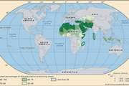
Islamic world: The third fitnah
…particularly ambitious Hāshimite family, the ʿAbbāsids. The ʿAbbāsids, who were kin but not descendants of Muhammad, claimed also to have inherited, a generation earlier, the authority of one of ʿAlī’s actual descendants, Abū Hāshim. Publicly Abū Muslim called for any qualified member of Muhammad’s family to become caliph, but privately…

Islamic world: First Mongol incursions
The ʿAbbāsid line continued, however, until 1517; the Mamlūk sultan Baybars I, shortly after his defeat of the Mongols, invited a member of the ʿAbbāsid house to “invest” him and to live in Cairo as spiritual head of all Muslims.…

Islamic arts: Early period: the Umayyad and ʿAbbāsid dynasties
Of all the recognizable periods of Islamic art, this is by far the most difficult one to explain properly, even though it is quite well documented. There are two reasons for this difficulty. On the one hand, it was a formative period, a…

HISTORY AT YOUR FINGERTIPS
Sign up here to see what happened On This Day, every day in your inbox!

Email address
By signing up, you agree to our Privacy Notice.

ʿAbbasid caliphate
DATE
- 750 - 1258
KEY PEOPLE
- al-Ma'mun
- Harun al-Rashid
- al-Mansur
- Mongke
- al-Mutawakkil
- al-Mu'tadid
- Abu al-Abbas al-Saffah
- al-Nasir
- al-Muqtafi
- al-Muktafi
MAJOR EVENTS
- Zanj rebellion
ABU AL-ABBAS AL-SAFFAH
ENCYCLOPEDIA ARTICLE
- Introduction & Quick Facts
ADDITIONAL INFO
- More Articles On This Topic
- Contributors
- Article History
HomePolitics, Law & GovernmentWorld LeadersOther Politicians

Abu al-Abbas al-Saffah
ʿAbbāsid caliph
Print Cite Share More
WRITTEN BY
The Editors of Encyclopaedia Britannica
Encyclopaedia Britannica's editors oversee subject areas in which they have extensive knowledge, whether from years of experience gained by working on that content or via study for an advanced degree....
See Article History
Alternative Title: Abū al-ʿAbbās al-Saffāḥ
Abu al-Abbas al-Saffah, also spelled Abū al-ʿAbbās al-Saffāḥ, (born 722—died 754, Anbar [Iraq]), Islamic caliph (reigned 749–54), first of the ʿAbbāsid dynasty, which was to rule over the eastern Islamic world for approximately the next 500 years. The ʿAbbāsids were descended from an uncle of Muhammad and were cousins to the ruling Umayyad dynasty. The Umayyads were weakened by decadence and an unclear line of succession, and they enjoyed little popular support, prompting the ʿAbbāsids to declare open revolt in 747. When Abu al-Abbas assumed the caliphate in 749, he began a campaign of extermination against the Umayyads, the ʿAlids, other ʿAbbāsid leaders who had become too popular, and all other claimants to power. He named himself al-Saffah, “the blood-shedder,” because of his savage attacks. He established a firm legal and dynastic base for the ʿAbbāsids. His successor moved the caliphate to Baghdad.
The Editors of Encyclopaedia BritannicaThis article was most recently revised and updated by Adam Zeidan, Assistant Editor.

Learn More in these related Britannica articles:

Islamic world: The third fitnah
…head of the ʿAbbāsid family, Abū al-ʿAbbās al-Saffāḥ, who now subordinated the claims of the party of ʿAlī to those of his own family and who promised to restore the unity of the ummah, or jamāʿah. The circumstances of his accession reconfigured the piety-minded opposition that had helped bring him…

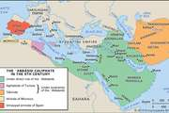
Caliphate: The Abbasid caliphate
The first Abbasid caliph, al-Saffāḥ (749–754), ordered the elimination of the entire Umayyad clan; the only Umayyad of note who escaped was ʿAbd al-Raḥman, who made his way to Spain and established an Umayyad dynasty that lasted until 1031.…

Barmakids: Khālid ibn Barmak.
Under the ʿAbbāsid caliph Abū al-ʿAbbās as Saffāḥ, Khālid shared ministerial authority with Abū al-Jahm and was entrusted with the army and the collecting of the land tax.…

HISTORY AT YOUR FINGERTIPS
Sign up here to see what happened On This Day, every day in your inbox!

Email address
By signing up, you agree to our Privacy Notice.

Abu al-Abbas al-Saffah
QUICK FACTS
BORN
722
DIED
754 (aged 32)
al-Anbar, Iraq
TITLE / OFFICE
- Caliph, Caliphate (749-754)
CALIPH
ENCYCLOPEDIA ARTICLE
- Introduction & Quick Facts
ADDITIONAL INFO
- More Articles On This Topic
- Contributors
- Article History
HomePhilosophy & ReligionReligious Beliefs

Caliph
Islamic title
Print Cite Share More
WRITTEN BY
Asma Afsaruddin
Professor, Department of Near Eastern Languages and Cultures, Indiana University. Her publications include Striving in the Path of God: Jihad and Martyrdom in Islamic Thought (2013) and The...
See Article History
Alternative Titles: calif, khalīfah
Caliph, Arabic khalīfah (“successor”), in Islamic history the ruler of the Muslim community. Although khalīfah and its plural khulafāʾ occur several times in the Qurʾān, referring to humans as God’s stewards or vice-regents on earth, the term did not denote a distinct political or religious institution during the lifetime of the Prophet Muhammad. It began to acquire its later meaning and to take shape as an institution after Muhammad’s death (June 8, 632 CE), when Abū Bakr, a companion of the Prophet and an early convert to Islam, was elected by a majority of Muslims as the leader of the Muslim community and assumed the title khalīfat rasūl Allāh, “successor of the messenger of God.” Abū Bakr’s successor, ʿUmar ibn al-Khaṭṭāb, is said to have first assumed the title khalīfat Abī Bakr (“successor to Abū Bakr”), because the title khalīfat khalīfat rasūl Allāh (“the successor to the successor of the messenger of God”) would have been cumbersome. ʿUmar also designated himself amīr al-muʾminīn, “the commander of the faithful,” which became an additional customary title for succeeding rulers.

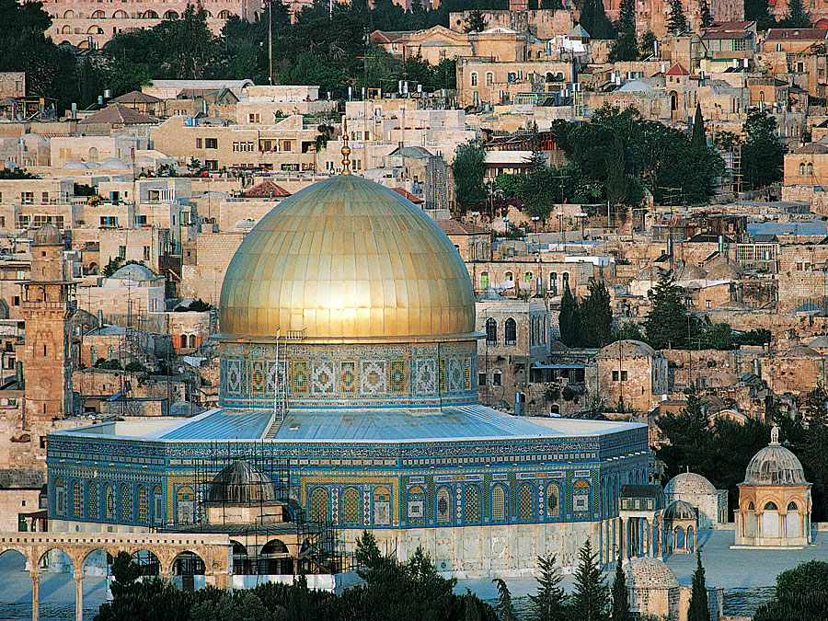
BRITANNICA QUIZ
Caliphs and Caliphates
What does the word caliph mean? What caliph’s murder caused a civil war? Test your knowledge of caliphs and caliphates in this quiz.

Abū Bakr and his three immediate successors are known as the “perfect” caliphs or the “rightly guided caliphs” (al-khulafāʾ al-rāshidun), whose combined rule is idealized by the majority of Muslims for having been based on the concepts of shūrā (consultation), ijmāʿ (consensus) of Muslims, and bayʿah (allegiance). In contrast, subsequent rulers of the Muslim polity instituted dynastic rule, which violated the concept of shūrā and, therefore, was largely regarded as illegitimate, although it was often grudgingly accepted in a pragmatic vein.
Nevertheless, the title of caliph was borne by the 14 Umayyad rulers of Damascus and subsequently by the 38 ʿAbbāsid caliphs of Baghdad, whose dynasty fell before the Mongols in 1258. There were titular caliphs of ʿAbbāsid descent in Cairo under the Mamlūks from 1258 until 1517, when the last caliph was captured by the Ottoman sultan Selim I. The Ottoman sultans then claimed the title and used it until it was abolished by the Turkish Republic on March 3, 1924.
After the fall of the Umayyad dynasty at Damascus (750), the title of caliph was also assumed by the Andalusian branch of the family who ruled in Spain at Córdoba (755–1031; see also Caliphate of Córdoba), and it was also assumed by the Fāṭimid rulers of Egypt (909–1171), who claimed to descend from Fāṭimah (a daughter of Muhammad) and her husband, ʿAli.
Get a Britannica Premium subscription and gain access to exclusive content.Subscribe Now
According to the Shiʿahs, who call the supreme office the “imamate,” or leadership, no caliph is legitimate unless he is a lineal descendant of the Prophet Muhammad. Later, Sunni scholars insisted that the office belonged to the tribe of Quraysh, to which Muhammad himself belonged, but this condition would have vitiated the claim of the Ottoman sultans, who held the office after the last ʿAbbāsid caliph of Cairo transferred it to Selim I.
This table provides a list of the primary caliphs.
Primary caliphs*
caliph | reign
"Perfect" caliphs
*When Muhammad died, Abū Bakr, his father-in-law, succeeded to his political and administrative functions. He and his three immediate successors are known as the "perfect" or "rightly guided" caliphs. After them the title was borne by the 14 Umayyad caliphs of Damascus and subsequently by the 38 ʿAbbāsid caliphs of Baghdad. ʿAbbāsid power ended in 945, when the Būyids took Baghdad under their rule. The Fāṭimids, however, proclaimed a new caliphate in 920 in Tunisia, and it lasted until 1171. ʿAbbāsid authority was partially restored in the 12th century, but the caliphate ceased with the Mongol destruction of Baghdad in 1258.
Abū Bakr | 632–634
ʿUmar I | 634–644
ʿUthmān ibn ʿAffān | 644–656
ʿAlī | 656–661
Umayyad caliphs (Damascus)
Muʿāwiyah I | 661–680
ʿAbd al-Malik | 685–705
al-Walīd | 705–715
Hishām | 724–743
Marwān II | 744–750
ʿAbbāsid caliphs (Baghdad)
al-Saffāh | 749–754
Hārūn al-Rashīd | 786–809
al-Maʾmūn | 813–833
Fāṭimid caliphs (Al-Mahdiyyah)
al-Mahdī | 909–934
al-Qāʾim | 934–946
al-Manṣūr | 946–953
al-Muʿizz | 953–975
al-Ḥākim | 996–1021
al-Mustanṣir | 1036–94
al-Mustaʿlī | 1094–1101
ʿAbbāsid caliph (Baghdad)
al-Nāṣir | 1180–1225
Asma Afsaruddin

Learn More in these related Britannica articles:

Islam: The state
…the office of the Sunni caliph (khalīfah, one who is successor to the Prophet Muhammad in rulership) is religious, this does not imply any functions comparable to those of the pope in Roman Catholicism. The caliph has no authority either to define dogma or, indeed, even to legislate. He is…

Egypt: The Arab conquest
…had from conquering Egypt, the caliph ʿUmar I, according to some sources, showed reluctance to detach ʿAmr’s expedition from the Syrian army and even tried to recall the mission once it had embarked; but ʿAmr, with or without the caliph’s permission, undertook the invasion in 639 with a small army…

Egypt: Religious affairs
Later the caliph—purportedly the last of the Abbasid line—returned to Egypt, where he died in the reign of Süleyman. The claim that the caliph had transferred his authority to the Ottoman sultan is generally considered an 18th-century invention.…

HISTORY AT YOUR FINGERTIPS
Sign up here to see what happened On This Day, every day in your inbox!

Email address
By signing up, you agree to our Privacy Notice.

Caliph
QUICK FACTS
KEY PEOPLE
- Al-Māwardī
AL-HĀDĪ
ENCYCLOPEDIA ARTICLE
- Introduction & Quick Facts
ADDITIONAL INFO
- More Articles On This Topic
- Contributors
- Article History
HomePhilosophy & ReligionReligious Personages & Scholars

Al-Hādī
ʿAbbāsid caliph
Print Cite Share More
WRITTEN BY
The Editors of Encyclopaedia Britannica
Encyclopaedia Britannica's editors oversee subject areas in which they have extensive knowledge, whether from years of experience gained by working on that content or via study for an advanced degree....
See Article History
Alternative Titles: Mūsā al-Hādī, al-Hādī Ila al-Ḥaqq
Al-Hādī, in full al Hādī Ila al Ḥaqq, also called Mūsā al-Hādī, (died 786), fourth caliph of the ʿAbbāsid dynasty (reigned 785–786).
Al-Hādī’s persecution of the ʿAlids, representatives of the Shīʿīte sect of Islām, precipitated revolts in Medina, Egypt, and Iraq, all of which were put down brutally. Throughout his short reign, he struggled with the question of succession, attempting to annul the rights of his brother, Hārūn ar-Rashīd, who was later to become one of the most famous rulers of the ʿAbbāsid dynasty. At the time of al-Hādī’s death, which may have been a murder, ar-Rashīd was imprisoned and then later was released to assume the caliphate.

Learn More in these related Britannica articles:

Hārūn al-Rashīd: Family and early life
The elder prince, al-Hādī, was four when Hārūn was born. The princes were brought up in the court at Baghdad and educated in the Qurʾān (the holy book of Islam), poetry, music, anecdotes about the Prophet Muhammad, early Islamic history, and current legal practice. Hārūn had as tutor…

Barmakids: Yaḥyā
…in succession after his brother Mūsā, but a little later—and due to al-Khayzurān’s and Yaḥyā’s influence—the Caliph intended to deprive Mūsā of his rights as an heir apparent but died before accomplishing his scheme. Hārūn decided not to put up any opposition to the new caliph Mūsā al-Hādī. This wise…

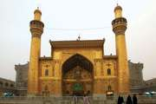
Shiʿi
Shiʿi, member of the smaller of the two major branches of Islam, the Shiʿah, distinguished from the majority Sunnis.…

HISTORY AT YOUR FINGERTIPS
Sign up here to see what happened On This Day, every day in your inbox!

Email address
By signing up, you agree to our Privacy Notice.

Al-Hādī
QUICK FACTS
DIED
786
TITLE / OFFICE
- Caliph, Caliphate (785-786)
MIDDLE EAST
ENCYCLOPEDIA ARTICLE
- Introduction & Quick Facts
MEDIA
- Images
ADDITIONAL INFO
- More Articles On This Topic
- Contributors
- Article History
HomeGeography & TravelGeographic Regions

Middle East
region, Asia, Africa, and Europe
Print Cite Share More
WRITTEN BY
The Editors of Encyclopaedia Britannica
Encyclopaedia Britannica's editors oversee subject areas in which they have extensive knowledge, whether from years of experience gained by working on that content or via study for an advanced degree....
See Article History
Middle East, the lands around the southern and eastern shores of the Mediterranean Sea, encompassing at least the Arabian Peninsula and, by some definitions, Iran, North Africa, and sometimes beyond. The central part of this general area was formerly called the Near East, a name given to it by some of the first modern Western geographers and historians, who tended to divide what they called the Orient into three regions. Near East applied to the region nearest Europe, extending from the Mediterranean Sea to the Persian Gulf; Middle East, from the Persian Gulf to Southeast Asia; and Far East, those regions facing the Pacific Ocean.
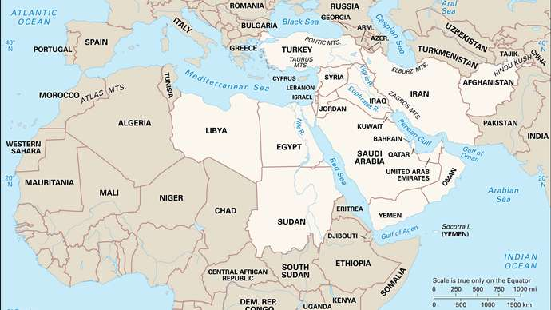
Middle EastEncyclopædia Britannica, Inc.

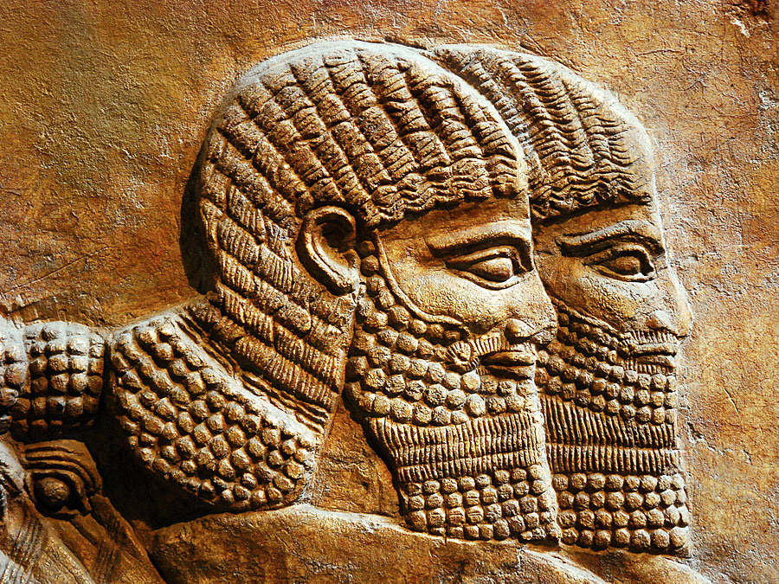
BRITANNICA QUIZ
The Middle East: Fact or Fiction?
Is the literacy rate in Afghanistan very high? Does Yemen take its name from the Arabic word meaning "northerly?" Sort through the facts in this quiz of Syria, Iraq, and other countries of the Middle East.

The change in usage began to evolve prior to World War II and tended to be confirmed during that war, when the term Middle East was given to the British military command in Egypt. By the mid-20th century a common definition of the Middle East encompassed the states or territories of Turkey, Cyprus, Syria, Lebanon, Iraq, Iran, Israel, the West Bank, the Gaza Strip, Jordan, Egypt, Sudan, Libya, and the various states and territories of Arabia proper (Saudi Arabia, Kuwait, Yemen, Oman, Bahrain, Qatar, and the Trucial States, or Trucial Oman [now United Arab Emirates]). Subsequent events have tended, in loose usage, to enlarge the number of lands included in the definition. The three North African countries of Tunisia, Algeria, and Morocco are closely connected in sentiment and foreign policy with the Arab states. In addition, geographic factors often require statesmen and others to take account of Afghanistan and Pakistan in connection with the affairs of the Middle East.
Occasionally, Greece is included in the compass of the Middle East because the Middle Eastern (then Near Eastern) question in its modern form first became apparent when the Greeks rose in rebellion to assert their independence of the Ottoman Empire in 1821 (see Eastern Question). Turkey and Greece, together with the predominantly Arabic-speaking lands around the eastern end of the Mediterranean, were also formerly known as the Levant.
Use of the term Middle East nonetheless remains unsettled, and some agencies (notably the United States State Department and certain bodies of the United Nations) still employ the term Near East.
Get a Britannica Premium subscription and gain access to exclusive content.Subscribe Now
The Editors of Encyclopaedia BritannicaThis article was most recently revised and updated by Adam Augustyn, Managing Editor, Reference Content.

Learn More in these related Britannica articles:

20th-century international relations: The Cold War in the Middle East and Asia
Islāmic and South Asian nationalism, first awakened in the era of the first World War, triumphed in the wake of the second, bringing on in the years 1946–50 the first great wave of decolonization. The British and…

20th-century international relations: The Middle East
The war between Iraq and Iran, which began in 1980, also reached a conclusion. The war had been conducted with the utmost ferocity on both sides. The Iraqi leader, Hussein, employed every weapon in his arsenal, including Soviet…

20th-century international relations: The Middle East
At least two abiding conflicts did seem ripe for resolution in the wake of the Cold War and the Persian Gulf War. In the Middle East mutually reinforcing changes on the international, regional, and domestic fronts breathed new life into the peace process.…

HISTORY AT YOUR FINGERTIPS
Sign up here to see what happened On This Day, every day in your inbox!

Email address
By signing up, you agree to our Privacy Notice.

SIMILAR TOPICS
- Levant
- Silicon Valley
- Scandinavia
- Southeast Asia
- New England
- Oceania
- Palestine
- Kurdistan
- Kashmir
- Caucasus
AL-MUʿTAḌID
ENCYCLOPEDIA ARTICLE
- Introduction & Quick Facts
ADDITIONAL INFO
- More Articles On This Topic
- Contributors
- Article History
HomePolitics, Law & GovernmentWorld LeadersOther Politicians

Al-Muʿtaḍid
ʿAbbāsid caliph [died 902]
Print Cite Share More
WRITTEN BY
The Editors of Encyclopaedia Britannica
Encyclopaedia Britannica's editors oversee subject areas in which they have extensive knowledge, whether from years of experience gained by working on that content or via study for an advanced degree....
See Article History
Al-Muʿtaḍid, (died 902), one of the greatest of the ʿAbbāsid caliphs (reigned 892–902), known especially for his ruthless skill in dealing with competing provincial dynasties, sects, and factions.
The son of al-Muwaffaq, al-Muʿtaḍid was coregent, with al-Muʿtamid, in his father’s last years. He became caliph on al-Muʿtamid’s death in 892, having forced him to disinherit his own son. As caliph, al-Muʿtaḍid reorganized the administration and reformed finances. He concluded a peace with the Ṭūlūnids by marrying their caliph’s daughter and dealt cruelly with many other factional dynasties that had appeared, including the Dulafids, Ṣaffārids, and ʿAlids. By playing factions against each other, he increased the influence of the Hamdānids and Sāmānids. But al-Muʿtaḍid’s troops were defeated by the Qarmaṭians, a schismatic sect and political movement, and he soon died. He was, according to some sources, poisoned in a palace intrigue.

Learn More in these related Britannica articles:

Iraq: The ʿAbbāsid Caliphate
During the reigns of al-Muʿtaḍid (892–902) and his son al-Muktafī (902–908), Iraq was united under ʿAbbāsid control. Once more Baghdad was the capital, although the caliphs had largely abandoned the Round City of al-Manṣūr on the west bank, and the centre of government now lay on the east bank…

chronology: Muslim
…work of the ʿAbbāsid caliph al-Muʿtaḍid, who brought the Nowrūz (Persian New Year’s Day) back to date in keeping with the agricultural activities of the community. Maḥmūd Ghāzān introduced the Khānian era in Persia in ah 701, which was a reversion to the regnal chronologies of antiquity. It continued in…

Caliph
Caliph, in Islamic history the ruler of the Muslim community. Although khalīfah and its plural khulafāʾ occur several times in the Qurʾān, referring to humans as God’s stewards or vice-regents on earth, the term did not denote a distinct political or religious institution during the lifetime of the…

HISTORY AT YOUR FINGERTIPS
Sign up here to see what happened On This Day, every day in your inbox!

Email address
By signing up, you agree to our Privacy Notice.

Al-Muʿtaḍid
QUICK FACTS
DIED
902
ʿUTHMĀN IBN ʿAFFĀN
ENCYCLOPEDIA ARTICLE
- Introduction & Quick Facts
ADDITIONAL INFO
- Additional Reading
- More Articles On This Topic
- Contributors
- Article History
HomePhilosophy & ReligionReligious Personages & Scholars

ʿUthmān ibn ʿAffān
Muslim caliph
Print Cite Share More
WRITTEN BY
Asma Afsaruddin
Professor, Department of Near Eastern Languages and Cultures, Indiana University. Her publications include Striving in the Path of God: Jihad and Martyrdom in Islamic Thought (2013) and The...
See Article History
ʿUthmān ibn ʿAffān, (died June 17, 656, Medina, Arabian Peninsula), third caliph to rule after the death of the Prophet Muhammad. He centralized the administration of the caliphate and established an official version of the Qurʾān. ʿUthmān is critically important in Islamic history because his death marked the beginning of open religious and political conflicts within the Islamic community (see fitnah).

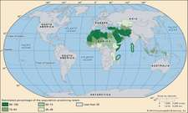
READ MORE ON THIS TOPIC
Islamic world: Discontent in ʿUthmān’s reign
This phase of conquest ended under ʿUthmān and ramified widely. ʿUthmān may even have sent an emissary to China in 651; by the end of the...

ʿUthmān was born into the rich and powerful Umayyad clan of Mecca, and he became a wealthy merchant. When Muhammad began preaching in Mecca about 615 CE, he soon aroused the hostility of the Umayyads, but about five years later ʿUthmān accepted Muhammad and thus became the first convert of high social and economic standing. Muhammad valued this contact with the Meccan aristocracy, and he allowed ʿUthmān to marry one of his daughters. ʿUthmān rarely displayed energy or initiative, however, and his role in the first years of Islamic history was passive.
ʿUmar, the second caliph, died in 644, and ʿUthmān was elected successor by a council named by ʿUmar before his death. Apparently ʿUthmān was selected as a compromise, when the more powerful candidates cancelled each other out. He also represented the Umayyad clan, which had suffered a partial eclipse during the Prophet’s lifetime but was now reasserting its influence.
00:0003:12
As caliph ʿUthmān promulgated an official recension of the Qurʾān, which had existed in various versions. ʿUthmān followed the same general policies as ʿUmar but had a less forceful personality than his predecessor. He continued the conquests that had steadily increased the size of the Islamic empire, but the victories now came at a greater cost and brought less wealth in return. ʿUthmān tried to create a cohesive central authority to replace the loose tribal alliance that had emerged under Muhammad. He established a system of landed fiefs and distributed many of the provincial governorships to members of his family. Thus much of the treasure received by the central government went to ʿUthmān’s family and to other provincial governors rather than to the army. As a result of his policies, ʿUthmān was opposed by the army, and he was often dominated by his relatives—unlike ʿUmar, who had been strong enough to impose his authority on the governors, whatever their clan or tribe.
Get a Britannica Premium subscription and gain access to exclusive content.Subscribe Now
By 650 rebellions had broken out in the provinces of Egypt and Iraq. In 655 a group of Egyptian malcontents marched upon Medina, the seat of caliphal authority. ʿUthmān, however, was conciliatory, and the rebels headed back to Egypt. Shortly thereafter, however, another group of rebels besieged ʿUthmān in his home, and, after several days of desultory fighting, he was killed.

