Scientific Revolution

Scientific Revolution, drastic change in scientific thought that took place during the 16th and 17th centuries. A new view of nature emerged during the Scientific Revolution, replacing the Greek view that had dominated science for almost 2,000 years. Science became an autonomous discipline, distinct from both philosophy and technology, and it came to be regarded as having utilitarian goals. By the end of this period, it may not be too much to say that science had replaced Christianity as the focal point of European civilization. Out of the ferment of the Renaissance and Reformation there arose a new view of science, bringing about the following transformations: the reeducation of common sense in favour of abstract reasoning; the substitution of a quantitative for a qualitative view of nature; the view of nature as a machine rather than as an organism; the development of an experimental, scientific method that sought definite answers to certain limited questions couched in the framework of specific theories; and the acceptance of new criteria for explanation, stressing the “how” rather than the “why” that had characterized the Aristotelian search for final causes.
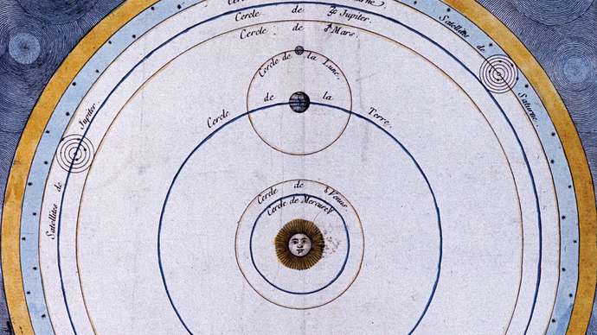
Copernican system
Copernican system, 18th-century French engraving.

The growing flood of information that resulted from the Scientific Revolution put heavy strains upon old institutions and practices. It was no longer sufficient to publish scientific results in an expensive book that few could buy; information had to be spread widely and rapidly. Natural philosophers had to be sure of their data, and to that end they required independent and critical confirmation of their discoveries. New means were created to accomplish these ends. Scientific societies sprang up, beginning in Italy in the early years of the 17th century and culminating in the two great national scientific societies that mark the zenith of the Scientific Revolution: the Royal Society of London for Improving Natural Knowledge, created by royal charter in 1662, and the Académie des Sciences of Paris, formed in 1666. In these societies and others like them all over the world, natural philosophers could gather to examine, discuss, and criticize new discoveries and old theories. To provide a firm basis for these discussions, societies began to publish scientific papers. The old practice of hiding new discoveries in private jargon, obscure language, or even anagrams gradually gave way to the ideal of universal comprehensibility. New canons of reporting were devised so that experiments and discoveries could be reproduced by others. This required new precision in language and a willingness to share experimental or observational methods. The failure of others to reproduce results cast serious doubts upon the original reports. Thus were created the tools for a massive assault on nature’s secrets.

Astronomy
The Scientific Revolution began in astronomy. Although there had been earlier discussions of the possibility of Earth’s motion, the Polish astronomer Nicolaus Copernicus was the first to propound a comprehensive heliocentric theory equal in scope and predictive capability to Ptolemy’s geocentric system. Motivated by the desire to satisfy Plato’s dictum, Copernicus was led to overthrow traditional astronomy because of its alleged violation of the principle of uniform circular motion and its lack of unity and harmony as a system of the world. Relying on virtually the same data as Ptolemy had possessed, Copernicus turned the world inside out, putting the Sun at the centre and setting Earth into motion around it. Copernicus’s theory, published in 1543, possessed a qualitative simplicity that Ptolemaic astronomy appeared to lack. To achieve comparable levels of quantitative precision, however, the new system became just as complex as the old. Perhaps the most revolutionary aspect of Copernican astronomy lay in Copernicus’s attitude toward the reality of his theory. In contrast to Platonic instrumentalism, Copernicus asserted that to be satisfactory astronomy must describe the real, physical system of the world.
Nicolaus Copernicus: The reception of Copernican astronomy amounted to victory by infiltration. By the time large-scale opposition to the theory had developed in the church and elsewhere, most of the best professional astronomers had found some aspect or other of the new system indispensable. Copernicus’s book De revolutionibus orbium coelestium libri VI (“Six Books Concerning the Revolutions of the Heavenly Orbs”), published in 1543, became a standard reference for advanced problems in astronomical research, particularly for its mathematical techniques. Thus, it was widely read by mathematical astronomers, in spite of its central cosmological hypothesis, which was widely ignored. In 1551 the German astronomer Erasmus Reinhold published the Tabulae prutenicae (“Prutenic Tables”), computed by Copernican methods. The tables were more accurate and more up-to-date than their 13th-century predecessor and became indispensable to both astronomers and astrologers.
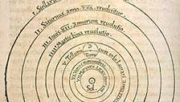
Nicolaus Copernicus: heliocentric system

During the 16th century the Danish astronomer Tycho Brahe, rejecting both the Ptolemaic and Copernican systems, was responsible for major changes in observation, unwittingly providing the data that ultimately decided the argument in favour of the new astronomy. Using larger, stabler, and better calibrated instruments, he observed regularly over extended periods, thereby obtaining a continuity of observations that were accurate for planets to within about one minute of arc—several times better than any previous observation. Several of Tycho’s observations contradicted Aristotle’s system: a nova that appeared in 1572 exhibited no parallax (meaning that it lay at a very great distance) and was thus not of the sublunary sphere and therefore contrary to the Aristotelian assertion of the immutability of the heavens; similarly, a succession of comets appeared to be moving freely through a region that was supposed to be filled with solid, crystalline spheres. Tycho devised his own world system—a modification of Heracleides’—to avoid various undesirable implications of the Ptolemaic and Copernican systems.

Tycho Brahe

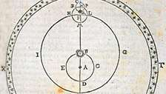
Tycho Brahe's model of Saturn's motion: At the beginning of the 17th century, the German astronomer Johannes Kepler placed the Copernican hypothesis on firm astronomical footing. Converted to the new astronomy as a student and deeply motivated by a neo-Pythagorean desire for finding the mathematical principles of order and harmony according to which God had constructed the world, Kepler spent his life looking for simple mathematical relationships that described planetary motions. His painstaking search for the real order of the universe forced him finally to abandon the Platonic ideal of uniform circular motion in his search for a physical basis for the motions of the heavens.

Johannes Kepler: In 1609 Kepler announced two new planetary laws derived from Tycho’s data: (1) the planets travel around the Sun in elliptical orbits, one focus of the ellipse being occupied by the Sun; and (2) a planet moves in its orbit in such a manner that a line drawn from the planet to the Sun always sweeps out equal areas in equal times. With these two laws, Kepler abandoned uniform circular motion of the planets on their spheres, thus raising the fundamental physical question of what holds the planets in their orbits. He attempted to provide a physical basis for the planetary motions by means of a force analogous to the magnetic force, the qualitative properties of which had been recently described in England by William Gilbert in his influential treatise, De Magnete, Magneticisque Corporibus et de Magno Magnete Tellure (1600; “On the Magnet, Magnetic Bodies, and the Great Magnet of the Earth”). The impending marriage of astronomy and physics had been announced. In 1618 Kepler stated his third law, which was one of many laws concerned with the harmonies of the planetary motions: (3) the square of the period in which a planet orbits the Sun is proportional to the cube of its mean distance from the Sun.
A powerful blow was dealt to traditional cosmology by Galileo Galilei, who early in the 17th century used the telescope, a recent invention of Dutch lens grinders, to look toward the heavens. In 1610 Galileo announced observations that contradicted many traditional cosmological assumptions. He observed that the Moon is not a smooth, polished surface, as Aristotle had claimed, but that it is jagged and mountainous. Earthshine on the Moon revealed that Earth, like the other planets, shines by reflected light. Like Earth, Jupiter was observed to have satellites; hence, Earth had been demoted from its unique position. The phases of Venus proved that that planet orbits the Sun, not Earth.
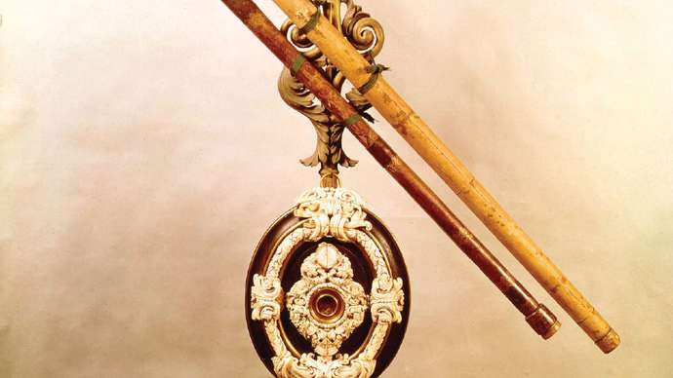
Galileo's telescopes

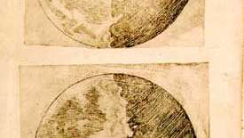
Galileo's illustrations of the Moon

Physics

Mechanics
The battle for Copernicanism was fought in the realm of mechanics as well as astronomy. The Ptolemaic–Aristotelian system stood or fell as a monolith, and it rested on the idea of Earth’s fixity at the centre of the cosmos. Removing Earth from the centre destroyed the doctrine of natural motion and place, and circular motion of Earth was incompatible with Aristotelian physics.
Galileo’s contributions to the science of mechanics were related directly to his defense of Copernicanism. Although in his youth he adhered to the traditional impetus physics, his desire to mathematize in the manner of Archimedes led him to abandon the traditional approach and develop the foundations for a new physics that was both highly mathematizable and directly related to the problems facing the new cosmology. Interested in finding the natural acceleration of falling bodies, he was able to derive the law of free fall (the distance, s, varies as the square of the time, t²). Combining this result with his rudimentary form of the principle of inertia, he was able to derive the parabolic path of projectile motion. Furthermore, his principle of inertia enabled him to meet the traditional physical objections to Earth’s motion: since a body in motion tends to remain in motion, projectiles and other objects on the terrestrial surface will tend to share the motions of Earth, which will thus be imperceptible to someone standing on Earth.
Galileo: The 17th-century contributions to mechanics of the French philosopher René Descartes, like his contributions to the scientific endeavour as a whole, were more concerned with problems in the foundations of science than with the solution of specific technical problems. He was principally concerned with the conceptions of matter and motion as part of his general program for science—namely, to explain all the phenomena of nature in terms of matter and motion. This program, known as the mechanical philosophy, came to be the dominant theme of 17th-century science.

René Descartes: Descartes rejected the idea that one piece of matter could act on another through empty space; instead, forces must be propagated by a material substance, the “ether,” that fills all space. Although matter tends to move in a straight line in accordance with the principle of inertia, it cannot occupy space already filled by other matter, so the only kind of motion that can actually occur is a vortex in which each particle in a ring moves simultaneously.
According to Descartes, all natural phenomena depend on the collisions of small particles, and so it is of great importance to discover the quantitative laws of impact. This was done by Descartes’s disciple, the Dutch physicist Christiaan Huygens, who formulated the laws of conservation of momentum and of kinetic energy (the latter being valid only for elastic collisions).
Huygens, Christiaan; The work of Sir Isaac Newton represents the culmination of the Scientific Revolution at the end of the 17th century. His monumental Philosophiae Naturalis Principia Mathematica (1687; Mathematical Principles of Natural Philosophy) solved the major problems posed by the Scientific Revolution in mechanics and in cosmology. It provided a physical basis for Kepler’s laws, unified celestial and terrestrial physics under one set of laws, and established the problems and methods that dominated much of astronomy and physics for well over a century. By means of the concept of force, Newton was able to synthesize two important components of the Scientific Revolution, the mechanical philosophy and the mathematization of nature.

Isaac Newton: The Mathematical Principles of Natural Philosophy
Newton was able to derive all these striking results from his three laws of motion:
1. Everybody continues in its state of rest or of motion in a straight line unless it is compelled to change that state by force impressed on it;
2. The change of motion is proportional to the motive force impressed and is made in the direction of the straight line in which that force is impressed;
3. To every action there is always opposed an equal reaction: or, the mutual actions of two bodies upon each other are always equal.
The second law was put into its modern form F = ma (where a is acceleration) by the Swiss mathematician Leonhard Euler in 1750. In this form, it is clear that the rate of change of velocity is directly proportional to the force acting on a body and inversely proportional to its mass.
In order to apply his laws to astronomy, Newton had to extend the mechanical philosophy beyond the limits set by Descartes. He postulated a gravitational force acting between any two objects in the universe, even though he was unable to explain how this force could be propagated.
By means of his laws of motion and a gravitational force proportional to the inverse square of the distance between the centres of two bodies, Newton could deduce Kepler’s laws of planetary motion. Galileo’s law of free fall is also consistent with Newton’s laws. The same force that causes objects to fall near the surface of Earth also holds the Moon and planets in their orbits.
Newton’s physics led to the conclusion that the shape of Earth is not precisely spherical but should bulge at the Equator. The confirmation of this prediction by French expeditions in the mid-18th century helped persuade most European scientists to change from Cartesian to Newtonian physics. Newton also used the nonspherical shape of Earth to explain the precession of the equinoxes, using the differential action of the Moon and Sun on the equatorial bulge to show how the axis of rotation would change its direction.

