Lysosomes
Lysosomes are membrane-enclosed organelles that contain a collection of enzymes capable of breaking down all types of biological polymers—proteins, nucleic acids, carbohydrates, and lipids. Now, the lysosome is a specific type of organelle that's very acidic. So that means that it has to be protected from the rest of the inside of the cell. It's a compartment, then, that has a membrane around it that stores the digestive enzymes that require this acid, low-pH environment. Those enzymes are called hydrolytic enzymes, and they break down large molecules into small molecules. For example, large proteins into amino acids, or large carbohydrates into simple sugars, or large lipids into single fatty acids. And when they do that, they provide for the rest of the cell the nutrients that it needs to... So, for example, if you can't do that, it can't break down large molecules into small molecules. You'll have storage of those large molecules, and this is a disease. There's also another type of lysosome storage disease in which the small molecules that are produced from those large molecules can't get out of the lysosome. They're stored there because the transporters for moving these small molecules out are missing genetically. And finally, one other function of the lysosome is to ingest bacteria so that the bacteria can be destroyed. So, the lysosomes also provide a function against infection, and the cell will often engorge a bacterium and put it into its lysosome for destruction. So, here's an important organelle that has function against infection and function in a way in nutrition to break down large molecules into small molecules so that they can be reutilized. Lysosomes function as the digestive system of the cell, serving both to degrade material taken up from outside the cell and to digest outdated components of the cell itself. In their simplest form, lysosomes are visualized as dense spherical vacuoles, but they can display significant variation in size and shape as a result of differences in the materials that have been taken up for digestion. Lysosomes thus represent morphologically diverse organelles but defined by the common function of degrading intracellular material.
Acid hydrolases
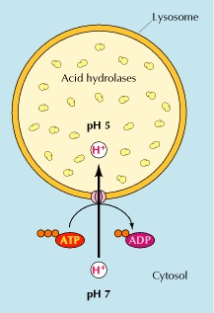
Lysosomes contain about 50 different degradative enzymes that can hydrolyse proteins, DNA, RNA, polysaccharides and lipids. Mutations in the genes that encode these enzymes are responsible for more than 30 different human genetic diseases, which are called lysosomal storage diseases because undegraded material accumulates within the lysosomes of affected individuals. Most of these diseases result from deficiencies in single lysosomal enzymes. For example, Gaucher’s disease (the most common of these disorders) results from a mutation in the gene that encodes a lysosomal enzyme required for the breakdown of glycolipids. An intriguing exception is I-cell disease, which is caused by a deficiency in the enzyme that catalyses the first step in the tagging of lysosomal enzymes with mannose-6-phosphate in the Golgi apparatus. The result is a general failure of lysosomal enzymes to be incorporated into lysosomes.
All of the lysosomal enzymes are acid hydrolases, which are active at the acidic pH (about 5) that is maintained within lysosomes but not at the neutral pH (about 7.2) characteristic of the rest of the cytoplasm. The requirement of these lysosomal hydrolases for acidic pH provides double protection against uncontrolled digestion of the contents of the cytosol; even if the lysosomal membrane were to break down, the released acid hydrolases would be inactive at the neutral pH of the cytosol. To maintain their acidic internal pH, lysosomes must actively concentrate H⁺ ions (protons). This is accomplished by a proton pump in the lysosomal membrane, which actively transports protons into the lysosome from the cytosol. This pumping requires expenditure of energy in the form of ATP hydrolysis, since it maintains approximately a hundredfold higher H⁺ concentration inside the lysosome.
Endocytosis and lysosome formation
One of the major functions of lysosomes is the digestion of material taken up from outside the cell by endocytosis. However, the role of lysosomes in the digestion of material taken up by endocytosis relates not only to the function of lysosomes but also to their formation. In particular, lysosomes are formed by the fusion of transport vesicles budded from the trans Golgi network with endosomes, which contain molecules taken up by endocytosis at the plasma membrane.
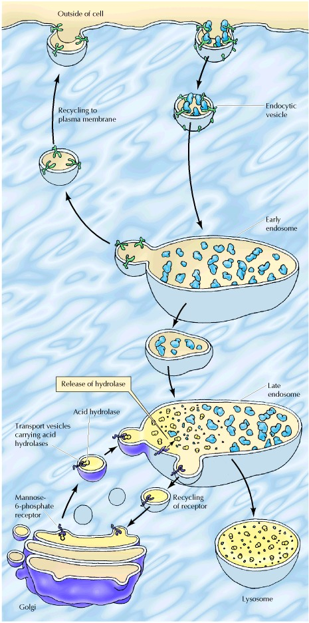
The formation of lysosomes thus represents an intersection between the secretory pathway, through which lysosomal proteins are processed, and the endocytic pathway, through which extracellular molecules are taken up at the cell surface. Material from outside the cell is taken up in clathrin-coated endocytic vesicles, which bud from the plasma membrane and then fuse with early endosome. Membrane components are then recycled to the plasma membrane and the early endosomes gradually mature into late endosomes, which are the precursors to lysosomes. One of the important changes during endosome maturation is the lowering of the internal pH to about 5.5, which plays a key role in the delivery of lysosomal acid hydrolases from the trans Golgi network.
As discussed earlier, acid hydrolases are targeted to lysosomes by mannose-6-phosphate residues, which are recognized by mannose-6-phosphate receptors in the trans Golgi network and packaged into clathrin-coated vesicles. Following removal of the clathrin coat, these transport vesicles fuse with late endosomes, and the acidic internal pH causes the hydrolases to dissociate from the mannose-6-phosphate receptor. The hydrolases are thus released into the lumen of the endosome, while the receptors remain in the membrane and are eventually recycled to the Golgi. Late endosomes then mature into lysosomes as they acquire a full complement of acid hydrolases, which digest the molecules originally taken up by endocytosis.
AUTOPHAGY
In addition to degrading molecules taken up by endocytosis, lysosomes digest material derived from two other routes: phagocytosis and autophagy. In phagocytosis, specialized cells, such as macrophages, take up and degrade large particles, including bacteria, cell debris, and aged cells that need to be eliminated from the body. Such large particles are taken up in phagocytic vacuoles (phagosomes), which then fuse with lysosomes, resulting in digestion of their contents. The lysosomes formed in this way (phagolysosomes) can be quite large and heterogeneous, since their size and shape are determined by the content of material that is being digested.
Lysosomes are also responsible for autophagy, the gradual turnover of the cell’s own components. The first step of autophagy appears to be the enclosure of an organelle (e.g., a mitochondrion) in membrane derived from the ER. The resulting vesicle (an autophagosome) then fuses with a lysosome, and its contents are digested. Autophagy is responsible for the gradual turnover of cytoplasmic organelles.