Mechanism of action (activation energy, lock and key hypothesis, induced - fit theory)
In the metabolic process, when an enzyme catalyses a substrate molecules must come in contact with specific enzyme to ensure an enzymatic reaction. To explain this enzyme substrate relationship several workers gave theories, the most accepted theories are
- Activation energy - Arrhenius first pointed out that all the molecules in a given population do not have the same kinetic energy. Some molecules due to collisions have more energy and are energy-rich molecules while others are energy-poor molecules.
In an ordinary chemical reaction only energy-rich molecules can take part at normal temperature due to an energy barrier to reaction and hence, the rate of reaction is lower. The higher is the energy barrier for a molecule, the greater is its stability (or inactiveness to take part in reaction). The energy required to hurdle molecules over this energy barrier is called as the energy of activation.
At higher temperature the rate of chemical reaction becomes faster because increased temperature bring about an increase in the number of activated molecules by increasing their movement and number of collisions due to thermal agitation.
But, in case of enzyme catalysed reactions the rate of reaction is optimum at normal body temperatures. It is because all the molecules (energy-rich and energy –poor) can combine with the active sites of enzyme to form enzyme substrate complex which later on breaks into enzyme and the product. In other words, the enzymes act by lowering the energy of activation of the reactions.
The most important role which enzymes play during reaction is that ‘they lower down the energy of activation.’ Suppose A is spontaneously getting converted into B, firstly in absence of an enzyme and secondly in presence of an enzyme, in a given number of molecules of A at a specific temperature, they have certain kinetic energy – some are poor in energy and others are rich. Before converting A B, the molecules of substrate A must surmount a required kinetic energy. The kinetic energy of A is higher than B. so only few energy-rich molecules can get converted into product B. The energy that is required for A to react and get converted into B is called the activation energy of reaction.
An enzyme will lower the activation energy of reaction. The enzyme reacts with the energy-rich and energy-poor molecules and forms an intermediate complex. This complex again breaks into product and enzyme. If the activation energy of the formation of this way activation energy is lowered by the enzyme, but in this action equilibrium is never altered. It remains the same.
- Lock and Key theory – This theory was proposed by Fischer in 1898. According to him the larger enzyme molecule comes in contact with smaller substrate molecule to form complex called “Enzyme – substrate – complex”. Enzymes bear distinct areas or sites in which specific type of substrate molecules can fit and form an intimate association. The configuration of a specific enzyme is specifically designed so as to fit the enzyme molecule, so that, the two can work together like that of a key to lock. Thus the enzyme substrate reaction can be written as

Enzyme [E] + Substrate = Enzyme-substrate-complex [E - S complex]
Or
E + S = E-S – Complex
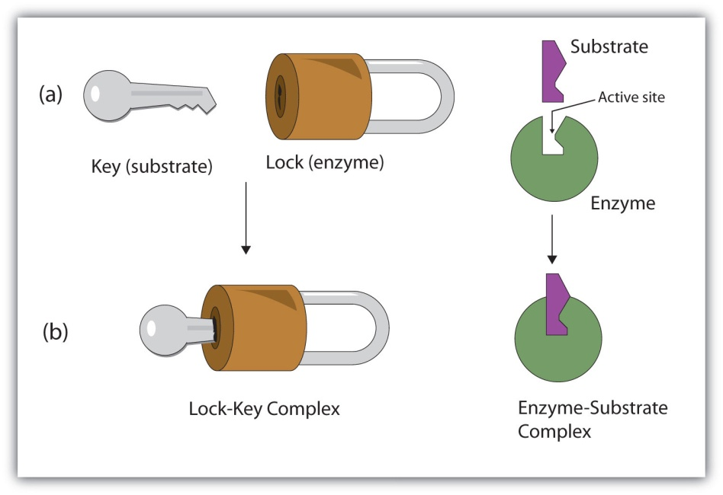
Fig : Lock and key model of enzyme action
The “enzyme-substrate complex” is believed to be much less stable than the original substrate and so, they breakdown immediately, the enzyme being again liberated. The substrate is converted into products.
Enzyme- substrate – complex [E-S complex] = Enzyme [E] + product [P]
Or
E - S – complex = E + P
According to this theory the enzyme- substrate relationship can be compared with the working of a pair of lock and key. Because particular key can fit to a particular lock to be opened and similarly a particular enzyme can fit to a particular substrate to their specificity.

- Induced - fit theory – This theory was proposed by Koshland in 1959. According to this theory, the catalytic sites or the active sites of an enzyme are not pre-shaped to fit the substrate as suggested by Fischer. Rather, the substrate molecules induce a conformational change in the enzyme. According to Koshland, the active sites of some enzymes are flexible but not rigid. The configuration of the active sites is complementary to that of the substrate only after the enzyme – substrate – complex is formed
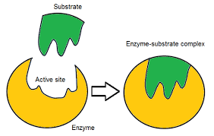
Fig : Induced Fit model of enzyme action

Significance
There are many advantage of knowing the Km values of enzyme-substrate systems,
- By knowing the Km value of a particular enzyme-substrate system, one can predict whether the cell needs more enzymes or more substrate to speed up the enzymatic reaction.
- If an enzyme can catalyse a reaction with two similar substrate (e.g., glucose and fructose) in the cell, it will prefer that substrate for which the enzyme has lower Km value.
- Km value gives an approximate measure of the concentration of substrate of the enzyme in that part of the cell where reaction is occurring. For instance, those enzymes which catalyse reactions with relatively more concentrated substrates (such as sucrose), usually have relatively high Km value. On the other hand, the enzymes that react with substrates which are present in very low concentrations (such as hormones) have comparatively lower Km values for the substrate.

Economic Importance of Enzyme
Enzymes have been found playing very important role in several industrial processes. In some cases, the hydrolytic activities of living cells have been employed while in other cases, some enzymes are extracted from living cells and then allowed to act upon certain substances. The following uses substantiate their importance in industries. These are used in
- The preparation of sizing for textile and paper.
- The removal (retting) of fibres from the stems of flax, hemp and other plants.
- The degumming of silk
- The preparation of skin for tanning
- The manufacture of glycerine
- The brewing and clarification of beer
- The clarification of syrups and pectin solutions
- The making of bread
- The cheese manufacture
- The production of syrups from sweet potato and corn
- The manufacture of soy sauce
- The fermentation of pulp to remove it from cocos seeds
- The preparation of medicinal diastase, pepsin and papain
- The processing of tea and coffee, etc.

