Renaissance Art

Renaissance art, painting, sculpture, architecture, music, and literature produced during the 14th, 15th, and 16th centuries in Europe under the combined influences of an increased awareness of nature, a revival of classical learning, and a more individualistic view of man. Scholars no longer believe that the Renaissance marked an abrupt break with medieval values, as is suggested by the French word renaissance, literally “rebirth.” Rather, historical sources suggest that interest in nature, humanistic learning, and individualism were already present in the late medieval period and became dominant in 15th- and 16th-century Italy concurrently with social and economic changes such as the secularization of daily life, the rise of a rational money-credit economy, and greatly increased social mobility.Go to Britannica Beyond
In Italy the Renaissance proper was preceded by an important “proto-renaissance” in the late 13th and early 14th centuries, which drew inspiration from Franciscan radicalism. St. Francis had rejected the formal Scholasticism of the prevailing Christian theology and gone out among the poor praising the beauties and spiritual value of nature. His example inspired Italian artists and poets to take pleasure in the world around them. The most famous artist of the proto-renaissance period, Giotto di Bondone (1266/67 or 1276–1337), reveals a new pictorial style that depends on clear, simple structure and great psychological penetration rather than on the flat, linear decorativeness and hierarchical compositions of his predecessors and contemporaries, such as the Florentine painter Cimabue and the Siennese painters Duccio and Simone Martini. The great poet Dante lived at about the same time as Giotto, and his poetry shows a similar concern with inward experience and the subtle shades and variations of human nature. Although his Divine Comedy belongs to the Middle Ages in its plan and ideas, its subjective spirit and power of expression look forward to the Renaissance. Petrarch and Giovanni Boccaccio also belong to this proto-renaissance period, both through their extensive studies of Latin literature and through their writings in the vernacular. Unfortunately, the terrible plague of 1348 and subsequent civil wars submerged both the revival of humanistic studies and the growing interest in individualism and naturalism revealed in the works of Giotto and Dante. The spirit of the Renaissance did not surface again until the beginning of the 15th century.
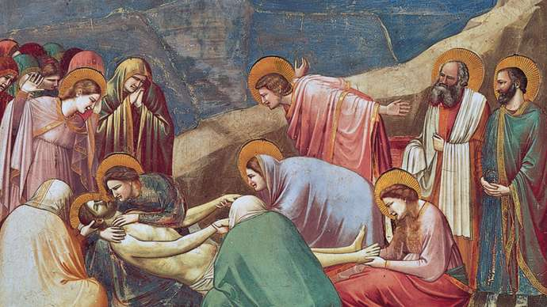
Giotto: Lamentation
Lamentation, fresco by Giotto, c. 1305–06; in the Arena Chapel, Padua, Italy.

In 1401 a competition was held at Florence to award the commission for bronze doors to be placed on the Baptistery of San Giovanni. Defeated by the goldsmith and painter Lorenzo Ghiberti, Filippo Brunelleschi and Donatello left for Rome, where they immersed themselves in the study of ancient architecture and sculpture. When they returned to Florence and began to put their knowledge into practice, the rationalized art of the ancient world was reborn. The founder of Renaissance painting was Masaccio (1404–28). The intellectuality of his conceptions, the monumentality of his compositions, and the high degree of naturalism in his works mark Masaccio as a pivotal figure in Renaissance painting. The succeeding generation of artists—Piero della Francesca, Pollaiuolo, and Andrea del Verrocchio—pressed forward with researches into linear and aerial perspective and anatomy, developing a style of scientific naturalism.
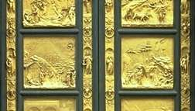
Ghiberti, Lorenzo: Gates of Paradise
Gates of Paradise, gilded bronze doors by Lorenzo Ghiberti, 1425–52; on the east side of the Baptistery of San Giovanni in Florence.

The situation in Florence was uniquely favourable to the arts. The civic pride of Florentines found expression in statues of the patron saints commissioned from Ghiberti and Donatello for niches in the grain-market guildhall known as Or San Michele, and in the largest dome built since antiquity, placed by Brunelleschi on the Florence cathedral. The cost of construction and decoration of palaces, churches, and monasteries was underwritten by wealthy merchant families.
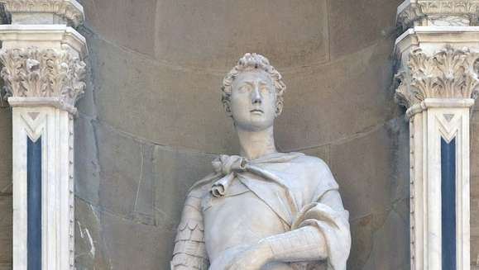
copy of Donatello's St. George
St. George, copy of a marble statue by Donatello, c. 1415.

Principal among these were the Medici, who dominated Florence from 1434, when the first pro-Medici government was elected, until 1492, when Lorenzo de Medici died. During their ascendancy the Medici subsidized virtually the entire range of humanistic and artistic activities associated with the Renaissance. Cosimo (1389–1464), made wealthy by his trading profits as the papal banker, was a scholar who founded the Neoplatonic academy and collected an extensive library. He gathered around him the foremost writers and classical scholars of his day, among them Marsilio Ficino, the Neoplatonist who served as the tutor of Lorenzo de Medici, Cosimo’s grandson. Lorenzo (1449–92) became the centre of a group of artists, poets, scholars, and musicians who believed in the Neoplatonic ideal of a mystical union with God through the contemplation of beauty. Less naturalistic and more courtly than the prevailing spirit of the first half of the Quattrocento, this aesthetic philosophy was elucidated by Giovanni Pico della Mirandola, incarnated in painting by Sandro Botticelli, and expressed in poetry by Lorenzo himself. Lorenzo also collaborated with the organist and choirmaster of the Florence cathedral, Heinrich Isaac, in the composition of lively secular choral music which anticipated the madrigal, a characteristic form of the High Renaissance.
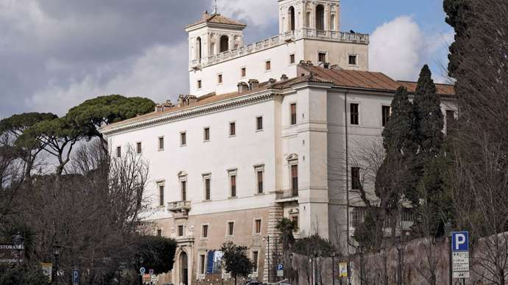
Medici, Villa
Villa Medici, Rome.

The Medici traded in all of the major cities in Europe, and one of the most famous masterpieces of Northern Renaissance art, the Portinari Altarpiece, by Hugo van der Goes (c. 1476; Uffizi, Florence), was commissioned by their agent, Tommaso Portinari. Instead of being painted with the customary tempera of the period, the work is painted with translucent oil glazes that produce brilliant jewel-like colour and a glossy surface. Early Northern Renaissance painters were more concerned with the detailed reproduction of objects and their symbolic meaning than with the study of scientific perspective and anatomy even after these achievements became widely known. On the other hand, central Italian painters began to adopt the oil painting medium soon after the Portinari Altarpiece was brought to Florence in 1476.
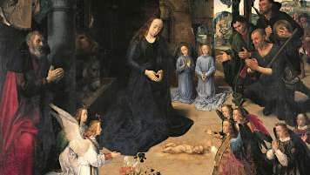
The Adoration of the Shepherds
The Adoration of the Shepherds, Uffizi Gallery, Florence.

High Renaissance art, which flourished for about 35 years, from the early 1490s to 1527, when Rome was sacked by imperial troops, revolves around three towering figures: Leonardo da Vinci (1452–1519), Michelangelo (1475–1564), and Raphael (1483–1520). Each of the three embodies an important aspect of the period: Leonardo was the ultimate Renaissance man, a solitary genius to whom no branch of study was foreign; Michelangelo emanated creative power, conceiving vast projects that drew for inspiration on the human body as the ultimate vehicle for emotional expression; Raphael created works that perfectly expressed the classical spirit—harmonious, beautiful, and serene.
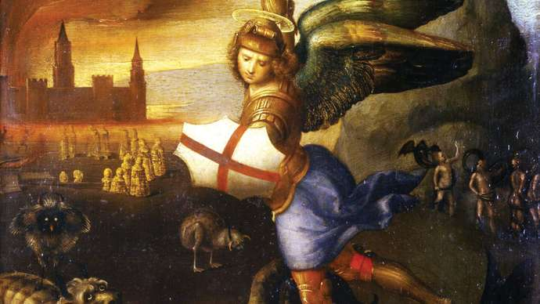
Raphael: Saint Michael Overwhelming the Demon/Oil on wood by Raphael

Although Leonardo was recognized in his own time as a great artist, his restless researches into anatomy, the nature of flight, and the structure of plant and animal life left him little time to paint. His fame rests mainly on a few completed paintings; among them are the Mona Lisa (1503–05, Louvre), The Virgin of the Rocks (1483–86, Louvre), and the sadly deteriorated fresco The Last Supper (1495–98; restored 1978–99; Santa Maria delle Grazie, Milan).
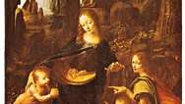
Leonardo da Vinci: The Virgin of the Rocks
The Virgin of the Rocks (also called Madonna of the Rocks), oil on panel by Leonardo da Vinci, 1483–86; in the Louvre, Paris.

Michelangelo’s early sculpture, such as the Pietà (1499; St. Peter’s, Rome) and the David (1501–04; Accademia, Florence), reveals a breathtaking technical ability in concert with a disposition to bend rules of anatomy and proportion in the service of greater expressive power. Although Michelangelo thought of himself first as a sculptor, his best known work is the giant ceiling fresco of the Sistine Chapel in the Vatican, Rome. It was completed in four years, from 1508 to 1512, and presents an incredibly complex but philosophically unified composition that fuses traditional Christian theology with Neoplatonic thought.
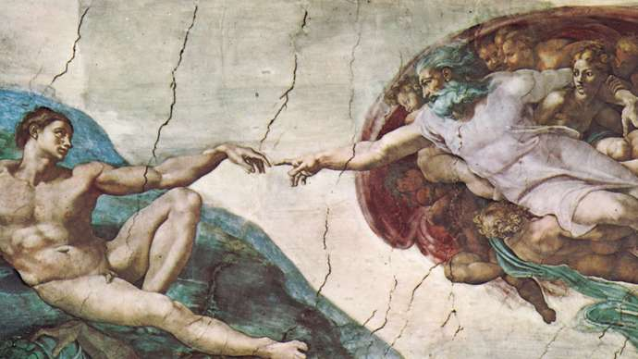
Michelangelo: The Creation of Adam
The Creation of Adam, detail of the Sistine Chapel ceiling fresco by Michelangelo, 1508–12; in Vatican City.

Raphael’s greatest work, School of Athens (1508–11), was painted in the Vatican at the same time that Michelangelo was working on the Sistine Chapel. In this large fresco Raphael brings together representatives of the Aristotelian and Platonic schools of thought. Instead of the densely packed, turbulent surface of Michelangelo’s masterpiece, Raphael places his groups of calmly conversing philosophers and artists in a vast court with vaults receding into the distance. Raphael was initially influenced by Leonardo, and he incorporated the pyramidal composition and beautifully modelled faces of The Virgin of the Rocks into many of his own paintings of the Madonna. He differed from Leonardo, however, in his prodigious output, his even temperament, and his preference for classical harmony and clarity.
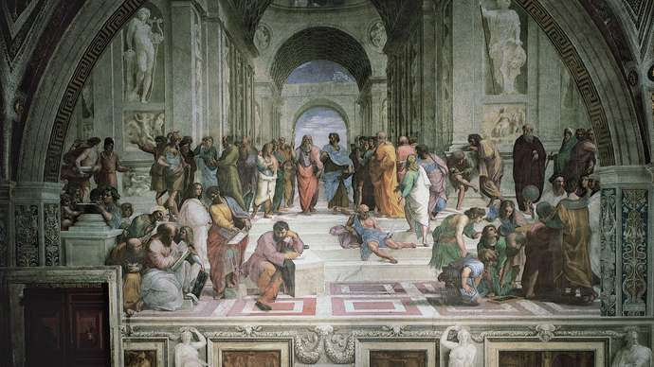
Raphael: School of Athens
Detail from School of Athens, fresco by Raphael, 1508–11; in the Stanza della Segnatura in the Vatican.

The creator of High Renaissance architecture was Donato Bramante (1444–1514), who came to Rome in 1499 when he was 55. His first Roman masterpiece, the Tempietto (1502) at S. Pietro in Montorio, is a centralized dome structure that recalls classical temple architecture. Pope Julius II (reigned 1503–13) chose Bramante to be papal architect, and together they devised a plan to replace the 4th-century Old St. Peter’s with a new church of gigantic dimensions. The project was not completed, however, until long after Bramante’s death.
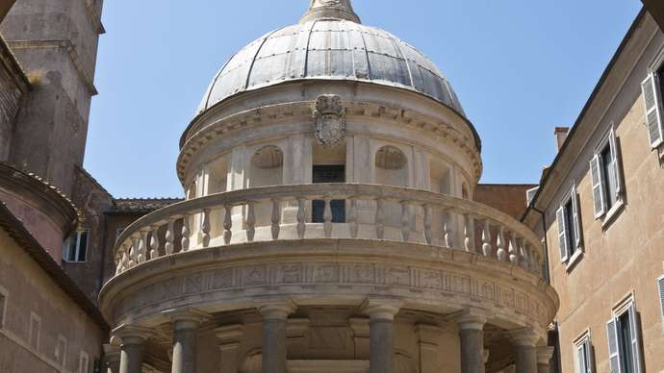
Rome: Tempietto
Tempietto, designed by Donato Bramante, 1502; in the courtyard of San Pietro in Montorio, Rome.

Humanistic studies continued under the powerful popes of the High Renaissance, Julius II and Leo X, as did the development of polyphonic music. The Sistine Choir, which performed at services when the pope officiated, drew musicians and singers from all of Italy and northern Europe. Among the most famous composers who became members were Josquin des Prez (c. 1450–1521) and Giovanni Pierluigi da Palestrina (c. 1525–94).
The Renaissance as a unified historical period ended with the fall of Rome in 1527. The strains between Christian faith and classical humanism led to Mannerism in the latter part of the 16th century. Great works of art animated by the Renaissance spirit, however, continued to be made in northern Italy and in northern Europe.
Seemingly unaffected by the Mannerist crisis, northern Italian painters such as Correggio (1494–1534) and Titian (1488/90–1576) continued to celebrate both Venus and the Virgin Mary without apparent conflict. The oil medium, introduced to northern Italy by Antonello da Messina and quickly adopted by Venetian painters who could not use fresco because of the damp climate, seemed particularly adapted to the sanguine, pleasure-loving culture of Venice. A succession of brilliant painters—Giovanni Bellini, Giorgione, Titian, Tintoretto, and Paolo Veronese—developed the lyrical Venetian painting style that combined pagan subject matter, sensuous handling of colour and paint surface, and a love of extravagant settings. Closer in spirit to the more intellectual Florentines of the Quattrocento was the German painter Albrecht Dürer (1471–1528), who experimented with optics, studied nature assiduously, and disseminated his powerful synthesis of Renaissance and Northern Gothic styles through the Western world by means of his engravings and woodcuts.
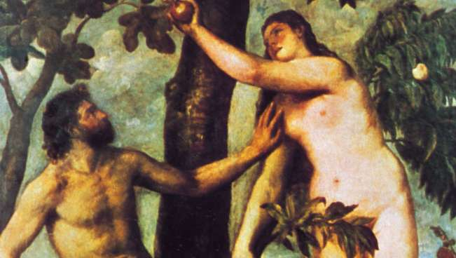
Titian: Adam and Eve
Adam and Eve, oil on panel by Titian, 1550; in the Prado, Madrid.

Vittore Carpaccio-Italian painter

Vittore Carpaccio, (born c. 1460, Venice [Italy]—died 1525/26, Venice), greatest early Renaissance narrative painter of the Venetian school.
Carpaccio may have been a pupil of Lazzaro Bastiani, but the dominant influences on his early work were those of Gentile Bellini and Antonello da Messina. The style of his work suggests he might also have visited Rome as a young man. He probably painted Salvator Mundi with Four Apostles before 1490. Other works from this early period are sometimes attributed to Carpaccio, although, because he did not sign and date his early works, there is often little proof he painted them. About 1490 he began painting a cycle of scenes from the legend of St. Ursula for the Scuola di Santa Orsola, now in the Galleries of the Academy of Venice. In these works he emerged as a mature artist of originality, revealing a gift for organization, narrative skill, and a command of light. The genre scene of the Dream of St. Ursula has been especially praised for its wealth of naturalistic detail.
Carpaccio’s later career can be charted in terms of three further narrative cycles. The first of these survives intact in the Scuola di San Giorgio degli Schiavoni, in Venice, and involves scenes from the life of St. Jerome; dating from 1502, these paintings represent the climax of Carpaccio’s art. A cycle of scenes from the life of the Virgin, executed after 1504 for the Scuola degli Albanesi, is now scattered. Also dispersed is the cycle of scenes from the life of St. Stephen, painted between 1511 and 1520, that is stylistically reminiscent of his earlier works. Carpaccio completed three notable altarpieces for Venetian churches—St. Thomas Aquinas Enthroned (1507), Presentation in the Temple (1510), and Martyrdom of the Ten Thousand (1515). His last dated works are two organ shutters for the Duomo at Capodistria (1523).
Carpaccio’s precise rendering of architecture and the luminous atmosphere of his paintings were praised by the 19th-century English critic John Ruskin. Carpaccio’s panoramic depictions of pageants, processions, and other public gatherings are notable for their wealth of realistic detail, sunny colouring, and dramatic narratives. His incorporation of realistic figures into an orderly and coherent perspectival space made him a predecessor of the Venetian painters of vedute (townscapes).
KEY PEOPLE in Renaissance Art
- François Clouet
- Charles Bordes
- Master of Flémalle
- Jacob Burckhardt
- Giorgio Vasari
- Walter Pater
- Kenneth Mackenzie Clark, Baron Clark
- Bernard Berenson
- Palomino De Castro Y Velasco
- Lodovico Zacconi

