**Humanist Thought and Spread of Humanism**

**Q: Role of Petrarch in the rise of Humanism**

Ans:

Petrarch is often called the “Father of Humanism,” both for his discovery of important classical texts and his personal commitment to the way of life found in ancient literature and philosophy.

Explain Petrarch’s contributions to the Renaissance.

* Petrarch is traditionally called the “Father of Humanism,” both for his influential philosophical attitudes, found in his numerous personal letters, and his discovery and compilation of classical texts.
* Petrarch was born in the Tuscan city of Arezzo in 1304, and spent his early childhood near Florence, but his family moved to Avignon to follow Pope Clement V, who moved there in 1309 to begin the Avignon Papacy.
* He traveled widely in Europe and, during his travels, collected crumbling Latin manuscripts, whose discovery, especially Cicero ‘s letters, helped spark the Renaissance.
* A highly introspective man, he shaped the nascent Humanist movement a great deal because many of the internal conflicts and musings expressed in his writings were seized upon by Renaissance Humanist philosophers and argued continually for the next 200 years.

**Key Points:**

* **Dark Ages**: An imprecise term of historical periodization that was once used to refer to the Middle Ages but is latterly most commonly used in relation to the early medieval period, i.e., the centuries following the collapse of the Western Roman Empire; the term was coined by Petrarch.
* **Humanism**: The study of classical antiquity, at first in Italy and then spreading across Western Europe in the 14th, 15th, and 16th centuries.
* **Avignon Papacy**: The period from 1309 to 1377, during which seven successive popes resided in Avignon, France.

**Overview**

Francesco Petrarca (July 20, 1304–July 19, 1374), commonly anglicized as Petrarch, was an Italian scholar and poet in Renaissance Italy, and one of the earliest Humanists. Petrarch’s rediscovery of Cicero’s letters is often credited for initiating the 14th-century Renaissance. Petrarch is often considered the founder of Humanism. Petrarch’s sonnets were admired and imitated throughout Europe during the Renaissance and became a model for lyrical poetry. In the 16th century, Pietro Bembo created the model for the modern Italian language based on Petrarch’s works.

Petrarch was born in the Tuscan city of Arezzo in 1304. Petrarch spent his early childhood in the village of Incisa, near Florence. He spent much of his early life at Avignon and nearby Carpentras, where his family moved to follow Pope Clement V, who moved there in 1309 to begin the Avignon Papacy. Petrarch studied law at the University of Montpellier (1316–1320) and the University of Bologna (1320–23); because his father was in the profession of law he insisted that Petrarch and his brother study law also. Petrarch, however, was primarily interested in writing and Latin literature, and considered these seven years wasted.

He traveled widely in Europe, served as an ambassador, and has been called “the first tourist” because he traveled just for pleasure. During his travels, he collected crumbling Latin manuscripts and was a prime mover in the recovery of knowledge from writers of Rome and Greece. He encouraged and advised Leontius Pilatus’s translation of Homer from a manuscript purchased by Boccaccio, although he was severely critical of the result. In 1345 he personally discovered a collection of Cicero’s letters not previously known to have existed, the collection *ad Atticum.*

Disdaining what he believed to be the ignorance of the centuries preceding the era in which he lived, Petrarch is credited or charged with creating the concept of a historical “Dark Ages.”

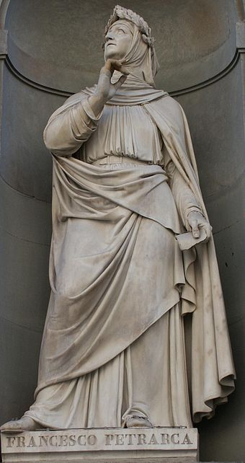

**Francesco Petrarca:** Statue of Petrarch on the Uffizi Palace, in Florence.

**Petrach: Father of Humanism**

Petrarch is traditionally called the “Father of Humanism,” and considered by many to more generally be the “Father of the Renaissance.” This honorific is so given both for his influential philosophical attitudes, found in his numerous personal letters, and his discovery and compilation of classical texts.

In his work *Secretum meum* he points out that secular achievements did not necessarily preclude an authentic relationship with God. Petrarch argued instead that God had given humans their vast intellectual and creative potential to be used to their fullest. He inspired Humanist philosophy, which led to the intellectual flowering of the Renaissance. He believed in the immense moral and practical value of the study of ancient history and literature—that is, the study of human thought and action. Petrarch was a devout Catholic and did not see a conflict between realizing humanity’s potential and having religious faith.

A highly introspective man, he shaped the nascent Humanist movement a great deal, because many of the internal conflicts and musings expressed in his writings were seized upon by Renaissance Humanist philosophers and argued continually for the next 200 years. For example, Petrarch struggled with the proper relation between the active and contemplative life, and tended to emphasize the importance of solitude and study. In a clear disagreement with Dante, in 1346 Petrarch argued in his *De vita solitaria* that Pope Celestine V’s refusal of the papacy in 1294 was a virtuous example of solitary life. Later, the politician and thinker Leonardo Bruni argued for the active life, or “civic humanism.” As a result, a number of political, military, and religious leaders during the Renaissance were inculcated with the notion that their pursuit of personal fulfillment should be grounded in classical example and philosophical contemplation.

**Humanism**

Humanism was an intellectual movement embraced by scholars, writers, and civic leaders in 14th century Italy.

Q: Assess how Humanism gave rise to the art of the Renasissance

**Ans: Key Points**

* Humanists reacted against the utilitarian approach to education, seeking to create a citizenry who were able to speak and write with eloquence and thus able to engage the civic life of their communities.
* The movement was largely founded on the ideals of Italian scholar and poet Francesco Petrarca, which were often centered around humanity’s potential for achievement.
* While Humanism initially began as a predominantly literary movement, its influence quickly pervaded the general culture of the time, reintroducing classical Greek and Roman art forms and leading to the Renaissance.
* Donatello became renowned as the greatest sculptor of the Early Renaissance, known especially for his Humanist, and unusually erotic, statue of David.
* While medieval society viewed artists as servants and craftspeople, Renaissance artists were trained intellectuals, and their art reflected this newfound point of view.
* In humanist painting, the treatment of the elements of perspective and depiction of light became of particular concern.

**Key Terms**

* **High Renaissance**: The period in art history denoting the apogee of the visual arts in the Italian Renaissance. The High Renaissance period is traditionally thought to have begun in the 1490s—with Leonardo’s fresco of The Last Supper in Milan and the death of Lorenzo de’ Medici in Florence—and to have ended in 1527, with the Sack of Rome by the troops of Charles V.

**Overview**

Humanism, also known as Renaissance Humanism, was an intellectual movement embraced by scholars, writers, and civic leaders in 14th- and early-15th-century Italy. The movement developed in response to the medieval scholastic conventions in education at the time, which emphasized practical, pre-professional, and scientific studies engaged in solely for job preparation, and typically by men alone. Humanists reacted against this utilitarian approach, seeking to create a citizenry who were able to speak and write with eloquence and thus able to engage the civic life of their communities. This was to be accomplished through the study of the “*studia humanitatis*,” known today as the humanities: grammar, rhetoric, history, poetry, and moral philosophy. Humanism introduced a program to revive the cultural—and particularly the literary—legacy and moral philosophy of classical antiquity. The movement was largely founded on the ideals of Italian scholar and poet Francesco Petrarca, which were often centered around humanity’s potential for achievement.

While Humanism initially began as a predominantly literary movement, its influence quickly pervaded the general culture of the time, re-introducing classical Greek and Roman art forms and contributing to the development of the Renaissance. Humanists considered the ancient world to be the pinnacle of human achievement, and thought its accomplishments should serve as the model for contemporary Europe. There were important centers of Humanism in Florence, Naples, Rome, Venice, Genoa, Mantua, Ferrara, and Urbino.

Humanism was an optimistic philosophy that saw man as a rational and sentient being, with the ability to decide and think for himself. It saw man as inherently good by nature, which was in tension with the Christian view of man as the original sinner needing redemption. It provoked fresh insight into the nature of reality, questioning beyond God and spirituality, and provided knowledge about history beyond Christian history.

**Humanist Art**

Renaissance Humanists saw no conflict between their study of the Ancients and Christianity. The lack of perceived conflict allowed Early Renaissance artists to combine classical forms, classical themes, and Christian theology freely. Early Renaissance sculpture is a great vehicle to explore the emerging Renaissance style. The leading artists of this medium were Donatello, Filippo Brunelleschi, and Lorenzo Ghiberti. Donatello became renowned as the greatest sculptor of the Early Renaissance, known especially for his classical, and unusually erotic, statue of David, which became one of the icons of the Florentine republic.

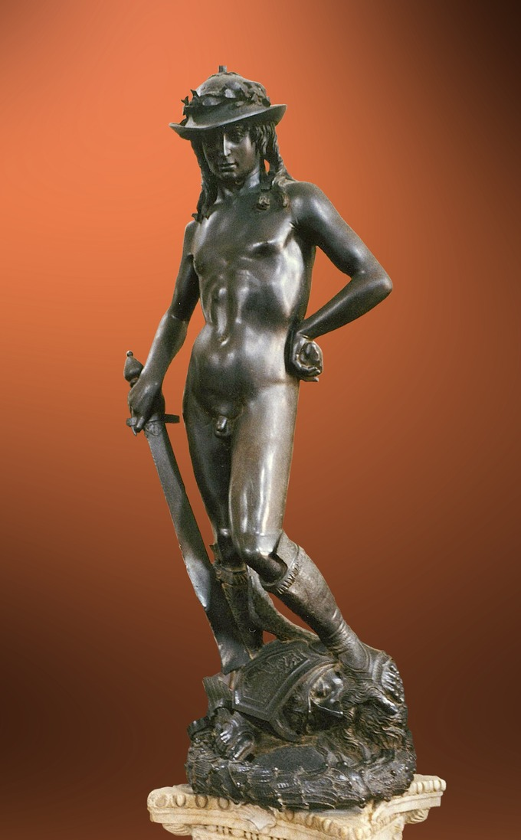

**Donatello’s David:** Donatello’s David is regarded as an iconic Humanist work of art.

Humanism affected the artistic community and how artists were perceived. While medieval society viewed artists as servants and craftspeople, Renaissance artists were trained intellectuals, and their art reflected this newfound point of view. Patronage of the arts became an important activity, and commissions included secular subject matter as well as religious. Important patrons, such as Cosimo de’ Medici, emerged and contributed largely to the expanding artistic production of the time.

In painting, the treatment of the elements of perspective and light became of particular concern. Paolo Uccello, for example, who is best known for “The Battle of San Romano,” was obsessed by his interest in perspective, and would stay up all night in his study trying to grasp the exact vanishing point. He used perspective in order to create a feeling of depth in his paintings. In addition, the use of oil paint had its beginnings in the early part of the 16th century, and its use continued to be explored extensively throughout the High Renaissance.

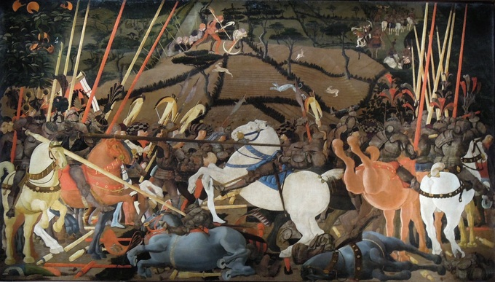

**“The Battle of San Romano” by Paolo Uccello:** Italian Humanist paintings were largely concerned with the depiction of perspective and light.

**Origins**

Some of the first Humanists were great collectors of antique manuscripts, including Petrarch, Giovanni Boccaccio, Coluccio Salutati, and Poggio Bracciolini. Of the three, Petrarch was dubbed the “Father of Humanism” because of his devotion to Greek and Roman scrolls. Many worked for the organized church and were in holy orders (like Petrarch), while others were lawyers and chancellors of Italian cities (such as Petrarch’s disciple Salutati, the Chancellor of Florence) and thus had access to book-copying workshops.

In Italy, the Humanist educational program won rapid acceptance and, by the mid-15th century, many of the upper classes had received Humanist educations, possibly in addition to traditional scholastic ones. Some of the highest officials of the church were Humanists with the resources to amass important libraries. Such was Cardinal Basilios Bessarion, a convert to the Latin church from Greek Orthodoxy, who was considered for the papacy and was one of the most learned scholars of his time.

Following the Crusader sacking of Constantinople and the end of the Byzantine Empire in 1453, the migration of Byzantine Greek scholars and émigrés, who had greater familiarity with ancient languages and works, furthered the revival of Greek and Roman literature and science.

**Education and Humanism**

Humanism played a major role in education during the Renaissance, with the goal of cultivating the moral and intellectual character of citizens.

Q: Define Humanism and its goals as a movement in education

**Ans: Key Points**

* The Humanists of the Renaissance created schools to teach their ideas and wrote books all about education.
* One of the most profound and important schools was established and created by Vittorino da Feltre in 1423 in Mantua to provide the children of the ruler of Mantua with a Humanist education.
* Humanists sought to create a citizenry able to speak and write with eloquence and clarity, thus capable of engaging in the civic life of their communities and persuading others to virtuous and prudent actions.
* Humanist schools combined Christianity and classical texts to produce a model of education for all of Europe.

**Key Terms**

* **Humanism**: A cultural and intellectual movement in 14th–16th century Europe characterized by attention to Classical culture and a promotion of vernacular texts, notably during the Renaissance.
* **Vittorino da Feltre**: An Italian humanist and teacher who started an important humanist school in Mantua.
* **Liberal arts**: Those areas of learning that require and cultivate general intellectual ability rather than technical skills; the humanities.
* **Cicero**: A Roman philosopher, politician, lawyer, orator, political theorist, consul, and constitutionalist who lived from 106–43 BCE.

**Overview**

During the Renaissance, Humanism played a major role in education. Humanists —proponents or practitioners of Humanism during the Renaissance—believed that human beings could be dramatically changed by education. The Humanists of the Renaissance created schools to teach their ideas and wrote books all about education. Humanists sought to create a citizenry able to speak and write with eloquence and clarity, thus capable of engaging in the civic life of their communities and persuading others to virtuous and prudent actions. This was to be accomplished through the study of the humanities: grammar, rhetoric, history, poetry, and moral philosophy.

The Humanists believed that it was important to transcend to the afterlife with a perfect mind and body, which could be attained with education. The purpose of Humanism was to create a universal man whose person combined intellectual and physical excellence and who was capable of functioning honorably in virtually any situation. This ideology was referred to as the *uomo universale*, an ancient Greco-Roman ideal. Education during the Renaissance was mainly composed of ancient literature and history, as it was thought that the classics provided moral instruction and an intensive understanding of human behavior.

The educational curriculum of Humanism spread throughout Europe during the 16th century and became the educational foundation for the schooling of European elites, the functionaries of political administration, the clergy of the various legally recognized churches, and the learned professionals of law and medicine.

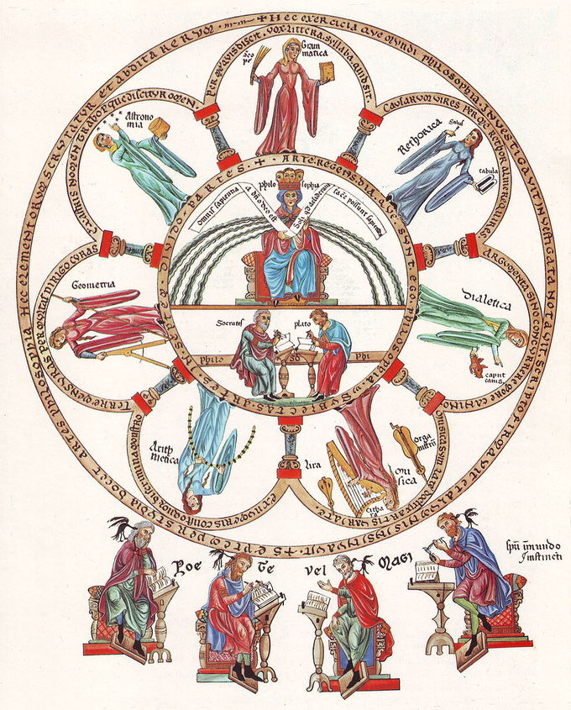

Philosophia et septem artes liberales

A painting symbolizing the liberal arts, depicting individuals representing the seven areas of liberal arts study, all circling around Plato and Socrates.

**Humanist Schools**

One of the most important Humanist schools was established by Vittorino da Feltre in 1423. The school was in Mantua, which is a small Italian state. The ruler of Mantua had always wanted to provide a Humanist education for his children, and the school was a way to help him.

Most of Feltre’s ideas were based on those of previous classical authors, such as Cicero and Quintilian. The main foundation of the school was liberal studies. Liberal arts were viewed as the key to freedom, which allowed humans to achieve their goals and reach their full potential. Liberal studies included philosophy, history, rhetoric, letters, mathematics, poetry, music, and astronomy. Based on the Greek idea of a “sound mind,” the school in Mantua offered physical education as well. This included archery, dance, hunting, and swimming.

The children that attended the schools were generally from upper-class families, though some seats were reserved for poor but talented students. Females were not usually allowed to attend, but were encouraged to know history, learn dance, and appreciate poetry. Some important females that were educated during the Renaissance were Isotta Nogarola, Cassandra Fedele of Venice, and Laura Cereta.

Overall, Humanist education was thought at the time to be an important factor in the preparation of life. Its main goal was to improve the lives of citizens and help their communities. Humanist schools combined Christianity and the classics to produce a model of education for all of Europe.

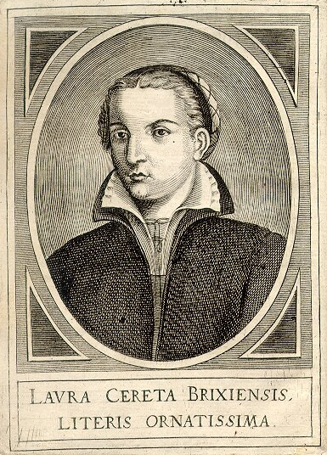

**Laura Cereta:** Laura Cereta (1469–1499) was a Renaissance Humanist and feminist. Most of her writing was in the form of letters to other intellectuals.