Transport Across a Cell Membrane
The cell membrane is one of the great multi-taskers of biology. It provides structure for the cell, protects cytosolic contents from the environment, and allows cells to act as specialized units. A membrane is the cell’s interface with the rest of the world - it’s gatekeeper. This phospholipid bilayer determines what molecules can move into or out of the cell, and so is in large part responsible for maintaining the delicate homeostasis(maintaining equilibrium) of each cell.
There are two kind of transport through cell membrane-
- Passive transport
- Active transport

- Passive transport: It do not require any energy supply for transportation. There are various types of Passive transport, which are given below-

1.A. Diffusion
Diffusion is a process of passive transport in which molecules move from an area of higher concentration to one of lower concentration.
Diffusion is a passive process of transport. A single substance tends to move from an area of high concentration to an area of low concentration until the concentration is equal across a space. You are familiar with diffusion of substances through the air. For example, think about someone opening a bottle of ammonia in a room filled with people. The ammonia gas is at its highest concentration in the bottle; its lowest concentration is at the edges of the room. The ammonia vapor will diffuse, or spread away, from the bottle; gradually, more and more people will smell the ammonia as it spreads. Materials move within the cell’s cytosol by diffusion, and certain materials move through the plasma membrane by diffusion. Diffusion expends no energy. On the contrary, concentration gradients are a form of potential energy, dissipated as the gradient is eliminated.
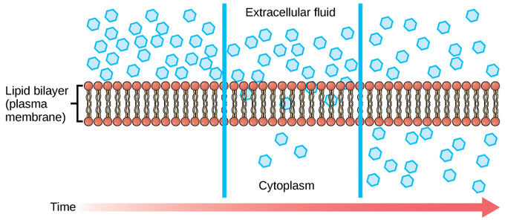
Fig.: Diffusion through a permeable membrane moves a substance from an area of high concentration (extracellular fluid, in this case) down its concentration gradient (into the cytoplasm).
Each separate substance in a medium, such as the extracellular fluid, has its own concentration gradient independent of the concentration gradients of other materials. In addition, each substance will diffuse according to that gradient. Within a system, there will be different rates of diffusion of the different substances in the medium.

Factors That Affect Diffusion
Molecules move constantly in a random manner at a rate that depends on their mass, their environment, and the amount of thermal energy they possess, which in turn is a function of temperature. This movement accounts for the diffusion of molecules through whatever medium in which they are localized. A substance will tend to move into any space available to it until it is evenly distributed throughout it. After a substance has diffused completely through a space removing its concentration gradient, molecules will still move around in the space, but there will be no net movement of the number of molecules from one area to another. This lack of a concentration gradient in which there is no net movement of a substance is known as dynamic equilibrium. While diffusion will go forward in the presence of a concentration gradient of a substance, several factors affect the rate of diffusion:
- Extent of the concentration gradient: The greater the difference in concentration, the more rapid the diffusion. The closer the distribution of the material gets to equilibrium, the slower the rate of diffusion becomes.
- Mass of the molecules diffusing: Heavier molecules move more slowly; therefore, they diffuse more slowly. The reverse is true for lighter molecules.
- Temperature: Higher temperatures increase the energy and therefore the movement of the molecules, increasing the rate of diffusion. Lower temperatures decrease the energy of the molecules, thus decreasing the rate of diffusion.
- Solvent density: As the density of a solvent increases, the rate of diffusion decreases. The molecules slow down because they have a more difficult time getting through the denser medium. If the medium is less dense, diffusion increases. Because cells primarily use diffusion to move materials within the cytoplasm, any increase in the cytoplasm’s density will inhibit the movement of the materials. An example of this is a person experiencing dehydration. As the body’s cells lose water, the rate of diffusion decreases in the cytoplasm, and the cells’ functions deteriorate. Neurons tend to be very sensitive to this effect. Dehydration frequently leads to unconsciousness and possibly coma because of the decrease in diffusion rate within the cells.
- Solubility: As discussed earlier, nonpolar or lipid-soluble materials pass through plasma membranes more easily than polar materials, allowing a faster rate of diffusion.
- Surface area and thickness of the plasma membrane: Increased surface area increases the rate of diffusion, whereas a thicker membrane reduces it.
- Distance travelled: The greater the distance that a substance must travel, the slower the rate of diffusion. This places an upper limitation on cell size. A large, spherical cell will die because nutrients or waste cannot reach or leave the center of the cell. Therefore, cells must either be small in size, as in the case of many prokaryotes, or be flattened, as with many single-celled eukaryotes.
A variation of diffusion is the process of filtration. In filtration, material moves according to its concentration gradient through a membrane; sometimes the rate of diffusion is enhanced by pressure, causing the substances to filter more rapidly. This occurs in the kidney where blood pressure forces large amounts of water and accompanying dissolved substances, or solutes, out of the blood and into the renal tubules. The rate of diffusion in this instance is almost totally dependent on pressure. One of the effects of high blood pressure is the appearance of protein in the urine, which is “squeezed through” by the abnormally high pressure.

1.B. Osmosis
Osmosis is the movement of water across a membrane from an area of low solute concentration to an area of high solute concentration.

Osmosis and Semipermeable Membranes
Osmosis is the movement of water through a semipermeable membrane according to the concentration gradient of water across the membrane, which is inversely proportional to the concentration of solutes. Semipermeable membranes, also termed selectively permeable membranes or partially permeable membranes, allow certain molecules or ions to pass through by diffusion.
While diffusion transports materials across membranes and within cells, osmosis transports only water across a membrane. The semipermeable membrane limits the diffusion of solutes in the water. Not surprisingly, the aquaporin proteins that facilitate water movement play a large role in osmosis, most prominently in red blood cells and the membranes of kidney tubules.

Mechanism of Osmosis
Osmosis is a special case of diffusion. Water, like other substances, moves from an area of high concentration to one of low concentration. An obvious question is what makes water move at all? Imagine a beaker with a semipermeable membrane separating the two sides or halves. On both sides of the membrane the water level is the same, but there are different concentrations of a dissolved substance, or solute, that cannot cross the membrane (otherwise the concentrations on each side would be balanced by the solute crossing the membrane). If the volume of the solution on both sides of the membrane is the same but the concentrations of solute are different, then there are different amounts of water, the solvent, on either side of the membrane. If there is more solute in one area, then there is less water; if there is less solute in one area, then there must be more water.
To illustrate this, imagine two full glasses of water. One has a single teaspoon of sugar in it, whereas the second one contains one-quarter cup of sugar. If the total volume of the solutions in both cups is the same, which cup contains more water? Because the large amount of sugar in the second cup takes up much more space than the teaspoon of sugar in the first cup, the first cup has more water in it.
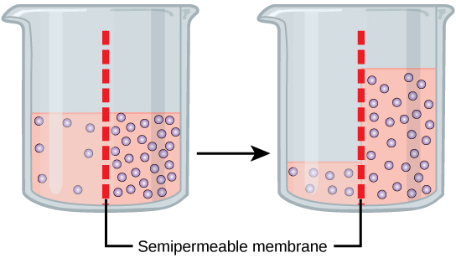
Fig. : In osmosis, water always moves from an area of higher water concentration to one of lower concentration. In the diagram shown, the solute cannot pass through the selectively permeable membrane, but the water can.
Returning to the beaker example, recall that it has a mixture of solutes on either side of the membrane. A principle of diffusion is that the molecules move around and will spread evenly throughout the medium if they can. However, only the material capable of passing through the membrane will diffuse through it. In this example, the solute cannot diffuse through the membrane, but the water can. Water has a concentration gradient in this system. Thus, water will diffuse down its concentration gradient, crossing the membrane to the side where it is less concentrated. This diffusion of water through the membrane—osmosis—will continue until the concentration gradient of water goes to zero or until the hydrostatic pressure of the water balances the osmotic pressure. In the beaker example, this means that the level of fluid in the side with a higher solute concentration will go up.

1.C. Tonicity
Tonicity, which is directly related to the osmolarity of a solution, affects osmosis by determining the direction of water flow.
Tonicity describes how an extracellular solution can change the volume of a cell by affecting osmosis. A solution’s tonicity often directly correlates with the osmolarity of the solution. Osmolarity describes the total solute concentration of the solution. A solution with low osmolarity has a greater number of water molecules relative to the number of solute particles; a solution with high osmolarity has fewer water molecules with respect to solute particles. In a situation in which solutions of two different osmolarities are separated by a membrane permeable to water, though not to the solute, water will move from the side of the membrane with lower osmolarity (and more water) to the side with higher osmolarity (and less water). This effect makes sense if you remember that the solute cannot move across the membrane, and thus the only component in the system that can move—the water—moves along its own concentration gradient. An important distinction that concerns living systems is that osmolarity measures the number of particles (which may be molecules) in a solution. Therefore, a solution that is cloudy with cells may have a lower osmolarity than a solution that is clear if the second solution contains more dissolved molecules than there are cells.

Hypotonic Solutions
Three terms—hypotonic, isotonic, and hypertonic—are used to relate the osmolarity of a cell to the osmolarity of the extracellular fluid that contains the cells. In a hypotonic situation, the extracellular fluid has lower osmolarity than the fluid inside the cell, and water enters the cell. (In living systems, the point of reference is always the cytoplasm, so the prefix hypo- means that the extracellular fluid has a lower concentration of solutes, or a lower osmolarity, than the cell cytoplasm. ) It also means that the extracellular fluid has a higher concentration of water in the solution than does the cell. In this situation, water will follow its concentration gradient and enter the cell, causing the cell to expand.
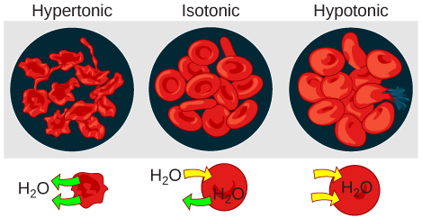
Changes in Cell Shape Due to Dissolved Solutes: Osmotic pressure changes the shape of red blood cells in hypertonic, isotonic, and hypotonic solutions.

Hypertonic Solutions
As for a hypertonic solution, the prefix hyper- refers to the extracellular fluid having a higher osmolarity than the cell’s cytoplasm; therefore, the fluid contains less water than the cell does. Because the cell has a relatively higher concentration of water, water will leave the cell, and the cell will shrink.

Isotonic Solutions
In an isotonic solution, the extracellular fluid has the same osmolarity as the cell. If the osmolarity of the cell matches that of the extracellular fluid, there will be no net movement of water into or out of the cell, although water will still move in and out.
Blood cells and plant cells in hypertonic, isotonic, and hypotonic solutions take on characteristic appearances. Cells in an isotonic solution retain their shape. Cells in a hypotonic solution swell as water enters the cell, and may burst if the concentration gradient is large enough between the inside and outside of the cell. Cells in a hypertonic solution shrink as water exits the cell, becoming shriveled.

1.D. Facilitated transport
Facilitated diffusion is a process by which molecules are transported across the plasma membrane with the help of membrane proteins.
Facilitated transport is a type of passive transport. Unlike simple diffusion where materials pass through a membrane without the help of proteins, in facilitated transport, also called facilitated diffusion, materials diffuse across the plasma membrane with the help of membrane proteins. A concentration gradient exists that would allow these materials to diffuse into the cell without expending cellular energy. However, these materials are ions or polar molecules that are repelled by the hydrophobic parts of the cell membrane. Facilitated transport proteins shield these materials from the repulsive force of the membrane, allowing them to diffuse into the cell.
The material being transported is first attached to protein or glycoprotein receptors on the exterior surface of the plasma membrane. This allows the material that is needed by the cell to be removed from the extracellular fluid. The substances are then passed to specific integral proteins that facilitate their passage. Some of these integral proteins are collections of beta-pleated sheets that form a channel through the phospholipid bilayer. Others are carrier proteins which bind with the substance and aid its diffusion through the membrane.

Channels
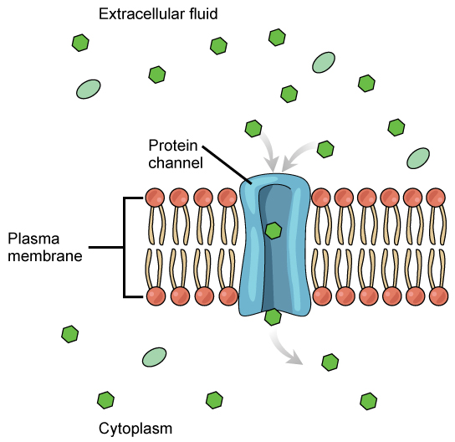
Channel Proteins in Facilitated Transport: Facilitated transport moves substances down their concentration gradients. They may cross the plasma membrane with the aid of channel proteins.
The integral proteins involved in facilitated transport are collectively referred to as transport proteins; they function as either channels for the material or carriers. In both cases, they are transmembrane proteins. Channels are specific for the substance that is being transported. Channel proteins have hydrophilic domains exposed to the intracellular and extracellular fluids; they additionally have a hydrophilic channel through their core that provides a hydrated opening through the membrane layers. Passage through the channel allows polar compounds to avoid the nonpolar central layer of the plasma membrane that would otherwise slow or prevent their entry into the cell. Aquaporins are channel proteins that allow water to pass through the membrane at a very high rate.
Channel proteins are either open at all times or they are “gated,” which controls the opening of the channel. The attachment of a particular ion to the channel protein may control the opening or other mechanisms or substances may be involved. In some tissues, sodium and chloride ions pass freely through open channels, whereas in other tissues, a gate must be opened to allow passage. An example of this occurs in the kidney, where both forms of channels are found in different parts of the renal tubules. Cells involved in the transmission of electrical impulses, such as nerve and muscle cells, have gated channels for sodium, potassium, and calcium in their membranes. Opening and closing of these channels changes the relative concentrations on opposing sides of the membrane of these ions, resulting in the facilitation of electrical transmission along membranes (in the case of nerve cells) or in muscle contraction (in the case of muscle cells).

Carrier Proteins
Another type of protein embedded in the plasma membrane is a carrier protein. This protein binds a substance and, in doing so, triggers a change of its own shape, moving the bound molecule from the outside of the cell to its interior; depending on the gradient, the material may move in the opposite direction. Carrier proteins are typically specific for a single substance. This adds to the overall selectivity of the plasma membrane. The exact mechanism for the change of shape is poorly understood. Proteins can change shape when their hydrogen bonds are affected, but this may not fully explain this mechanism. Each carrier protein is specific to one substance, and there are a finite number of these proteins in any membrane. This can cause problems in transporting enough of the material for the cell to function properly.
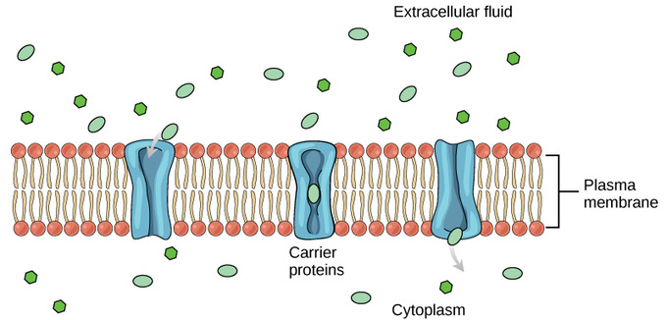
Carrier Proteins: Some substances are able to move down their concentration gradient across the plasma membrane with the aid of carrier proteins. Carrier proteins change shape as they move molecules across the membrane.
An example of this process occurs in the kidney. Glucose, water, salts, ions, and amino acids needed by the body are filtered in one part of the kidney. This filtrate, which includes glucose, is then reabsorbed in another part of the kidney. Because there are only a finite number of carrier proteins for glucose, if more glucose is present than the proteins can handle, the excess is not transported; it is excreted from the body in the urine. In a diabetic individual, this is described as “spilling glucose into the urine.” A different group of carrier proteins called glucose transport proteins, or GLUTs, are involved in transporting glucose and other hexose sugars through plasma membranes within the body.
Channel and carrier proteins transport material at different rates. Channel proteins transport much more quickly than do carrier proteins. Channel proteins facilitate diffusion at a rate of tens of millions of molecules per second, whereas carrier proteins work at a rate of a thousand to a million molecules per second.

The Role of Passive Transport
Passive transport, such as diffusion and osmosis, moves materials of small molecular weight across membranes.

Introduction: Passive Transport
Plasma membranes must allow or prevent certain substances from entering or leaving a cell. In other words, plasma membranes are selectively permeable; they allow some substances to pass through, but not others. If they were to lose this selectivity, the cell would no longer be able to sustain itself, and it would be destroyed. Some cells require larger amounts of specific substances than other cells; they must have a way of obtaining these materials from extracellular fluids. This may happen passively, as certain materials move back and forth, or the cell may have special mechanisms that facilitate transport. Some materials are so important to a cell that it spends some of its energy (hydrolyzing adenosine triphosphate (ATP)) to obtain these materials. Red blood cells use some of their energy to do this. All cells spend the majority of their energy to maintain an imbalance of sodium and potassium ions between the interior and exterior of the cell.
The most direct forms of membrane transport are passive. Passive transport is a naturally-occurring phenomenon and does not require the cell to exert any of its energy to accomplish the movement. In passive transport, substances move from an area of higher concentration to an area of lower concentration. A physical space in which there is a range of concentrations of a single substance is said to have a concentration gradient.
Passive Transport: Diffusion is a type of passive transport. Diffusion through a permeable membrane moves a substance from an area of high concentration (extracellular fluid, in this case) down its concentration gradient (into the cytoplasm).
The passive forms of transport, diffusion and osmosis, move materials of small molecular weight across membranes. Substances diffuse from areas of high concentration to areas of lower concentration; this process continues until the substance is evenly distributed in a system. In solutions containing more than one substance, each type of molecule diffuses according to its own concentration gradient, independent of the diffusion of other substances. Many factors can affect the rate of diffusion, including, but not limited to, concentration gradient, size of the particles that are diffusing, and temperature of the system.
In living systems, diffusion of substances in and out of cells is mediated by the plasma membrane. Some materials diffuse readily through the membrane, but others are hindered; their passage is made possible by specialized proteins, such as channels and transporters. The chemistry of living things occurs in aqueous solutions; balancing the concentrations of those solutions is an ongoing problem. In living systems, diffusion of some substances would be slow or difficult without membrane proteins that facilitate transport.

ACTIVE TRANSPORT: Active transport require some energy for transportation

2.A. Primary Active Transport
The sodium-potassium pump maintains the electrochemical gradient of living cells by moving sodium in and potassium out of the cell.

Primary Active Transport
The primary active transport that functions with the active transport of sodium and potassium allows secondary active transport to occur. The secondary transport method is still considered active because it depends on the use of energy as does primary transport.
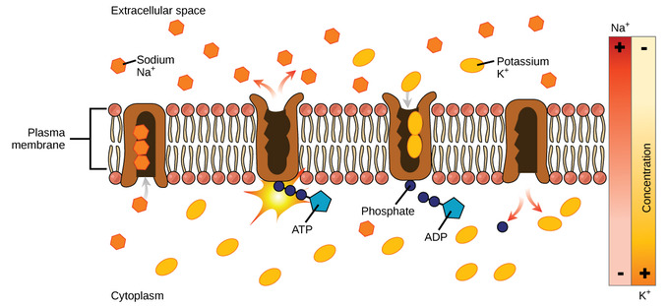
Active Transport of Sodium and Potassium: Primary active transport moves ions across a membrane, creating an electrochemical gradient (electrogenic transport).
One of the most important pumps in animals cells is the sodium-potassium pump ( Na⁺-K⁺ ATPase ), which maintains the electrochemical gradient (and the correct concentrations of Na⁺ and K⁺) in living cells. The sodium-potassium pump moves two K⁺ into the cell while moving three Na⁺ out of the cell. The Na+-K+ ATPase exists in two forms, depending on its orientation to the interior or exterior of the cell and its affinity for either sodium or potassium ions. The process consists of the following six steps:
- With the enzyme oriented towards the interior of the cell, the carrier has a high affinity for sodium ions. Three sodium ions bind to the protein.
- ATP is hydrolyzed by the protein carrier, and a low-energy phosphate group attaches to it.
- As a result, the carrier changes shape and re-orients itself towards the exterior of the membrane. The protein’s affinity for sodium decreases, and the three sodium ions leave the carrier.
- The shape change increases the carrier’s affinity for potassium ions, and two such ions attach to the protein. Subsequently, the low-energy phosphate group detaches from the carrier.
- With the phosphate group removed and potassium ions attached, the carrier protein repositions itself towards the interior of the cell.
- The carrier protein, in its new configuration, has a decreased affinity for potassium, and the two ions are released into the cytoplasm. The protein now has a higher affinity for sodium ions, and the process starts again.
Several things have happened as a result of this process. At this point, there are more sodium ions outside of the cell than inside and more potassium ions inside than out. For every three ions of sodium that move out, two ions of potassium move in. This results in the interior being slightly more negative relative to the exterior. This difference in charge is important in creating the conditions necessary for the secondary process. The sodium-potassium pump is, therefore, an electrogenic pump (a pump that creates a charge imbalance), creating an electrical imbalance across the membrane and contributing to the membrane potential.

2.B. Electrochemical Gradient
To move substances against the membrane’s electrochemical gradient, the cell utilizes active transport, which requires energy from ATP.

Electrochemical Gradients
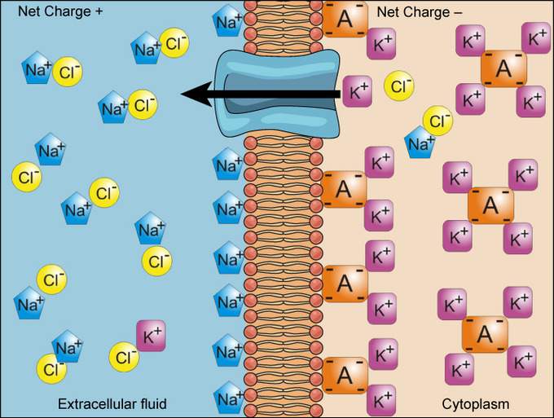
Electrochemical Gradient: Electrochemical gradients arise from the combined effects of concentration gradients and electrical gradients.
Simple concentration gradients are differential concentrations of a substance across a space or a membrane, but in living systems, gradients are more complex. Because ions move into and out of cells and because cells contain proteins that do not move across the membrane and are mostly negatively charged, there is also an electrical gradient, a difference of charge, across the plasma membrane. The interior of living cells is electrically negative with respect to the extracellular fluid in which they are bathed. At the same time, cells have higher concentrations of potassium (K⁺) and lower concentrations of sodium (Na⁺) than does the extracellular fluid. In a living cell, the concentration gradient of Na⁺ tends to drive it into the cell, and the electrical gradient of Na⁺ (a positive ion) also tends to drive it inward to the negatively-charged interior. The situation is more complex, however, for other elements such as potassium. The electrical gradient of K⁺, a positive ion, also tends to drive it into the cell, but the concentration gradient of K⁺ tends to drive K⁺ out of the cell. The combined gradient of concentration and electrical charge that affects an ion is called its electrochemical gradient.

Moving Against a Gradient
To move substances against a concentration or electrochemical gradient, the cell must use energy. This energy is harvested from adenosine triphosphate (ATP) generated through the cell’s metabolism. Active transport mechanisms, collectively called pumps, work against electrochemical gradients. Small substances constantly pass through plasma membranes. Active transport maintains concentrations of ions and other substances needed by living cells in the face of these passive movements. Much of a cell’s supply of metabolic energy may be spent maintaining these processes. For example, most of a red blood cell’s metabolic energy is used to maintain the imbalance between exterior and interior sodium and potassium levels required by the cell. Because active transport mechanisms depend on a cell’s metabolism for energy, they are sensitive to many metabolic poisons that interfere with the supply of ATP.
Two mechanisms exist for the transport of small-molecular weight material and small molecules. Primary active transport moves ions across a membrane and creates a difference in charge across that membrane, which is directly dependent on ATP. Secondary active transport describes the movement of material that is due to the electrochemical gradient established by primary active transport that does not directly require ATP.

Carrier Proteins for Active Transport
An important membrane adaption for active transport is the presence of specific carrier proteins or pumps to facilitate movement. There are three types of these proteins or transporters: uniporters, symporters, and antiporters. A uniporter carries one specific ion or molecule. A symporter carries two different ions or molecules, both in the same direction. An antiporter also carries two different ions or molecules, but in different directions. All of these transporters can also transport small, uncharged organic molecules like glucose. These three types of carrier proteins are also found in facilitated diffusion, but they do not require ATP to work in that process. Some examples of pumps for active transport are Na⁺-K⁺ ATPase, which carries sodium and potassium ions, and H⁺-K⁺ ATPase, which carries hydrogen and potassium ions. Both of these are antiporter carrier proteins. Two other carrier protein pumps are Ca²⁺ ATPase and H⁺ ATPase, which carry only calcium and only hydrogen ions, respectively.
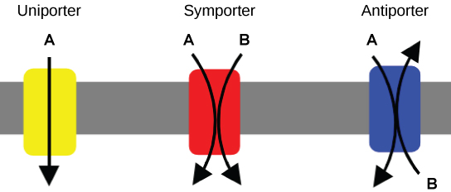
Uniporters, Symporters, and Antiporters: A uniporter carries one molecule or ion. A symporter carries two different molecules or ions, both in the same direction. An antiporter also carries two different molecules or ions, but in different directions.

2.C. Secondary Active Transport
In secondary active transport, a molecule is moved down its electrochemical gradient as another is moved up its concentration gradient.

Secondary Active Transport (Co-transport)
Unlike in primary active transport, in secondary active transport, ATP is not directly coupled to the molecule of interest. Instead, another molecule is moved up its concentration gradient, which generates an electrochemical gradient. The molecule of interest is then transported down the electrochemical gradient. While this process still consumes ATP to generate that gradient, the energy is not directly used to move the molecule across the membrane, hence it is known as secondary active transport. Both antiporters and symporters are used in secondary active transport. Co-transporters can be classified as symporters and antiporters depending on whether the substances move in the same or opposite directions across the cell membrane.
Secondary active transport brings sodium ions, and possibly other compounds, into the cell. As sodium ion concentrations build outside the plasma membrane because of the action of the primary active transport process, an electrochemical gradient is created. If a channel protein exists and is open, the sodium ions will be pulled through the membrane. This movement is used to transport other substances that can attach themselves to the transport protein through the membrane. Many amino acids, as well as glucose, enter a cell this way. This secondary process is also used to store high-energy hydrogen ions in the mitochondria of plant and animal cells for the production of ATP. The potential energy that accumulates in the stored hydrogen ions is translated into kinetic energy as the ions surge through the channel protein ATP synthase, and that energy is used to convert ADP into ATP.
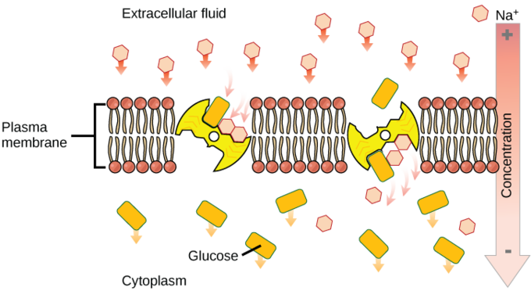
Secondary Active Transport: An electrochemical gradient, created by primary active transport, can move other substances against their concentration gradients, a process called co-transport or secondary active transport.

Endocytosis
Endocytosis takes up particles into the cell by invaginating the cell membrane, resulting in the release of the material inside of the cell

Endocytosis
Endocytosis is a type of active transport that moves particles, such as large molecules, parts of cells, and even whole cells, into a cell. There are different variations of endocytosis, but all share a common characteristic: the plasma membrane of the cell invaginates, forming a pocket around the target particle. The pocket pinches off, resulting in the particle being contained in a newly-created intracellular vesicle formed from the plasma membrane.

Phagocytosis
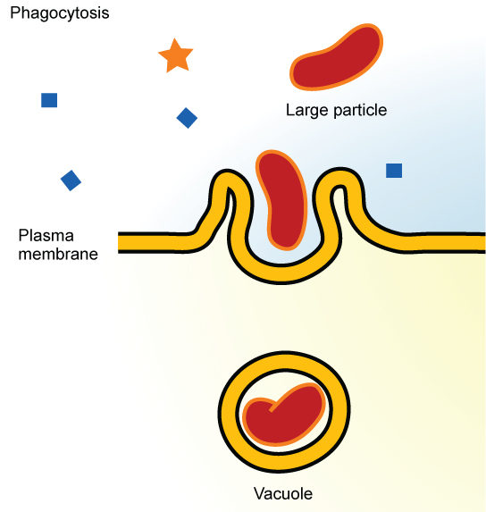
Phagocytosis: In phagocytosis, the cell membrane surrounds the particle and engulfs it.
Phagocytosis (the condition of “cell eating”) is the process by which large particles, such as cells or relatively large particles, are taken in by a cell. For example, when microorganisms invade the human body, a type of white blood cell called a neutrophil will remove the invaders through this process, surrounding and engulfing the microorganism, which is then destroyed by the neutrophil.
In preparation for phagocytosis, a portion of the inward-facing surface of the plasma membrane becomes coated with a protein called clathrin, which stabilizes this section of the membrane. The coated portion of the membrane then extends from the body of the cell and surrounds the particle, eventually enclosing it. Once the vesicle containing the particle is enclosed within the cell, the clathrin disengages from the membrane and the vesicle merges with a lysosome for the breakdown of the material in the newly-formed compartment ( endosome ). When accessible nutrients from the degradation of the vesicular contents have been extracted, the newly-formed endosome merges with the plasma membrane and releases its contents into the extracellular fluid. The endosomal membrane again becomes part of the plasma membrane.

Pinocytosis
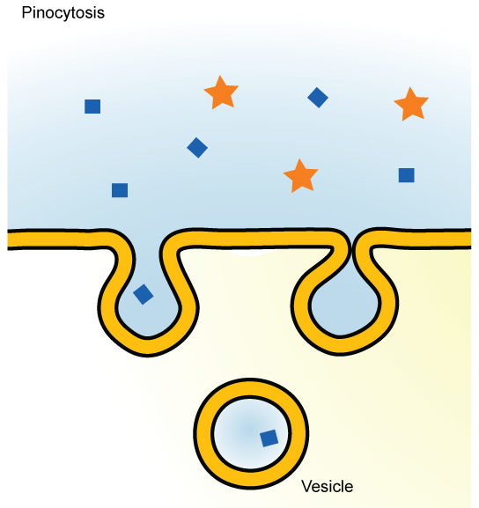
Pinocytosis: In pinocytosis, the cell membrane invaginates, surrounds a small volume of fluid, and pinches off.
A variation of endocytosis is called pinocytosis. This literally means “cell drinking” and was named at a time when the assumption was that the cell was purposefully taking in extracellular fluid. In reality, this is a process that takes in molecules, including water, which the cell needs from the extracellular fluid. Pinocytosis results in a much smaller vesicle than does phagocytosis, and the vesicle does not need to merge with a lysosome.
Potocytosis, a variant of pinocytosis, is a process that uses a coating protein, called caveolin, on the cytoplasmic side of the plasma membrane, which performs a similar function to clathrin. The cavities in the plasma membrane that form the vacuoles have membrane receptors and lipid rafts in addition to caveolin. The vacuoles or vesicles formed in caveolae (singular caveola) are smaller than those in pinocytosis. Potocytosis is used to bring small molecules into the cell and to transport these molecules through the cell for their release on the other side of the cell, a process called transcytosis.

Receptor-mediated Endocytosis
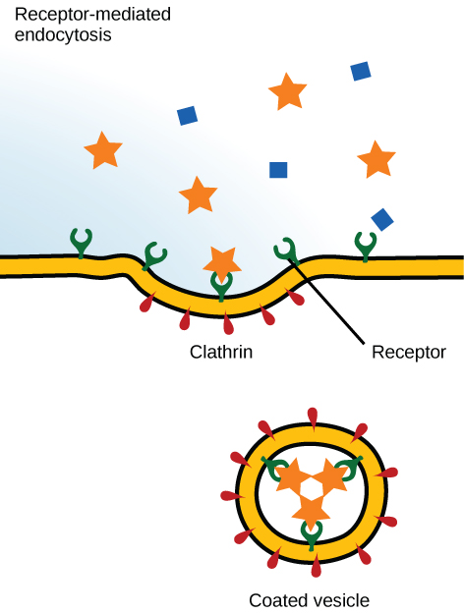
Receptor-Mediated Endocytosis: In receptor-mediated endocytosis, uptake of substances by the cell is targeted to a single type of substance that binds to the receptor on the external surface of the cell membrane.
A targeted variation of endocytosis, known as receptor-mediated endocytosis, employs receptor proteins in the plasma membrane that have a specific binding affinity for certain substances. In receptor-mediated endocytosis, as in phagocytosis, clathrin is attached to the cytoplasmic side of the plasma membrane. If uptake of a compound is dependent on receptor-mediated endocytosis and the process is ineffective, the material will not be removed from the tissue fluids or blood. Instead, it will stay in those fluids and increase in concentration. Some human diseases are caused by the failure of receptor-mediated endocytosis. For example, the form of cholesterol termed low-density lipoprotein or LDL (also referred to as “bad” cholesterol) is removed from the blood by receptor-mediated endocytosis. In the human genetic disease familial hypercholesterolemia, the LDL receptors are defective or missing entirely. People with this condition have life-threatening levels of cholesterol in their blood, because their cells cannot clear LDL particles from their blood.
Although receptor-mediated endocytosis is designed to bring specific substances that are normally found in the extracellular fluid into the cell, other substances may gain entry into the cell at the same site. Flu viruses, diphtheria, and cholera toxin all have sites that cross-react with normal receptor-binding sites and gain entry into cells.

