Technology, Culture, and Trade in Medieaval Europe: 7th to 14th Century

During the Middle Ages, between 900 and 1300, Europe experienced one of the longest periods of sustained growth in human history. What led to this tremendous expansion?
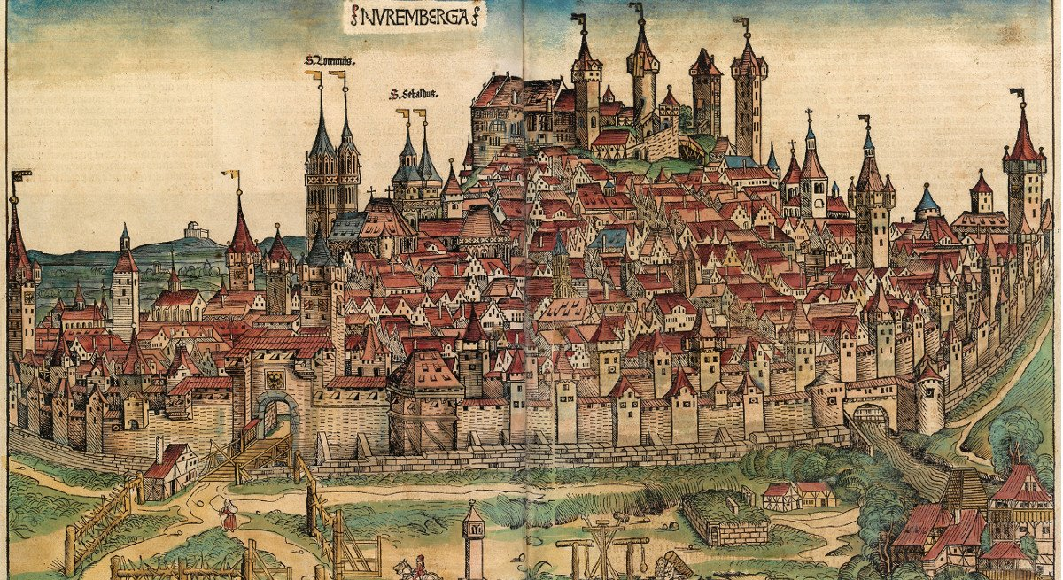The walled medieval German town of Nuremburg
Europe during the High Middle Ages was buoyant and optimistic everywhere. It strike out against its neighbors in the movements of the Crusades and there was an unprecedented period of economic growth, and the age saw the soaring of great architecture—first Romanesque and then Gothic—cathedrals and churches all over Europe. New states were created, in a great arc running from the Celtic world through Scandinavia, and on to the Slavic world.
It is a truly dynamic and remarkable period—one that would not have been possible if it was not for the remarkable population growth. Between about 900 to 1300, Europe experienced one of the longest periods of sustained growth in human history, seen in almost every aspect of life. This growth was the crucial background to the political and cultural achievements of this period. How do we capture a sense of the growth in this period, and how do we explain it?

Population Growth in the Middle Ages
The first fundamental fact was a long-term rise in the population. The evidence at our disposal indicates that probably by the middle of the 8th century, but surely by the middle of the 9th—during the Carolingian period—the population began rising. Between about 1050 and 1200, there was an intense increase in population all over Europe. It gradually began to slow, between about 1200 and 1275, and then it finally leveled off.
Evidence for this is qualitative, not quantitative. We don’t have census data or the kinds of sources that demographers, those who study population groups, would have to study from the 17th or 18th centuries to the present. In earlier times, historians look at other kinds of evidence and try to assess the general direction in which all of that evidence points.
Although census records do not exist for most of medieval Europe, much information about population size can be gleaned contextually by studying families and other records. (Image: By Limbourg brothers/Public domain)
Certain indicators lend clues to this expansion. Wherever we have evidence of family size, families appear to be larger. It does not appear that more babies are being born, but rather that more of them are surviving and people were living longer.
There was no plague or significant famine throughout this period. Generally speaking, this was a period of warm, dry climate through much of Europe, when enormous amounts of new land were brought under cultivation. People did not bring new land under cultivation for no reason. There were mouths to feed and diets improved.
More and more land was given over to crops that were rich in iron and protein so that people were simply eating better. They were healthier; they could do more work; they were more productive; they lived longer—the population curve marched upward due to these gains.

Technology in the Middle Ages Driving Growth
A second element of the growth and expansion of Europe in this period is technological innovation and dissemination. The Romans were not interested in technological gains; there wasn’t much in the way of important technological achievement during the Roman period.
The medieval period, on the other hand, was one that was fairly rich in technological innovation. Stereotypes contribute to the idea of the Middle Ages as the Dark Ages, as having descended from the heights of classical antiquity. If we were talking about technology, we’d have to flip the polarity of that old equation and say that the Middle Ages were rather cleverer.
The clearest indicator we have of medieval technology, of its application and its connection to this population increase, is in the realm of cereal production, where medieval farmers vastly expanded it. But how?
They laid down most of the fundamental ways: By getting maximum cereal production out of the soil, before the advent of modern chemical fertilizers. This has been the greatest change in modern times, not anything else—not even, for example, the use of motor-driven tractors. How did medieval people increase cereal production, thus making it possible to feed a larger population? It was through greater use of horses as draft animals. A horse is significantly more efficient than an ox. He does more work for the same amount of food, perhaps even a little bit less. He is stronger, thus larger fields can be plowed, or fields can be plowed more times, and the soil can be turned more carefully.
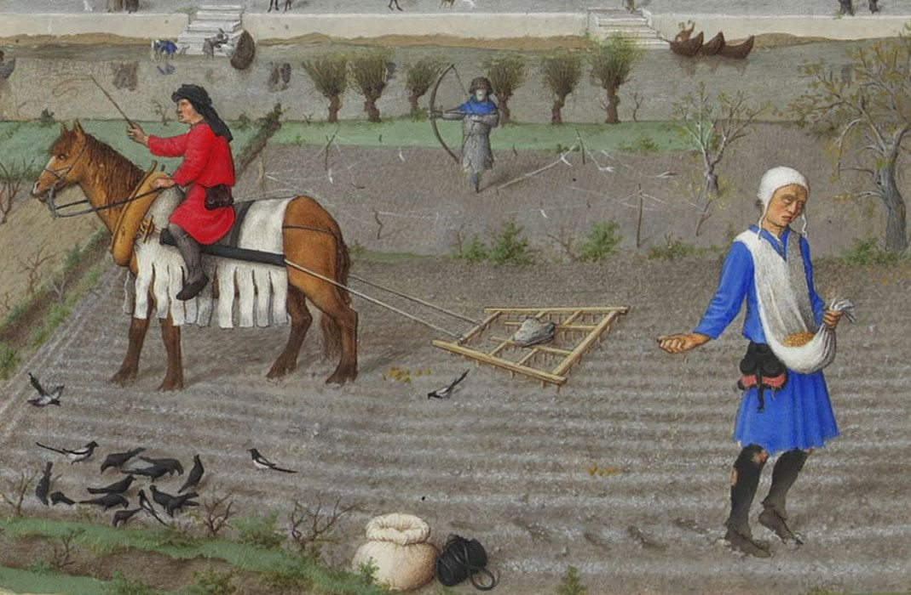The horse collar was a key invention that allowed medieval Europeans to make use of the horse as a draft animal, rather than the ox.
A horse requires very different harnessing than an ox, and so we see, from about the year 1000 or a little after, the proliferation of the horse collar. In a sense, when a horse pulls a plow or wagon, the horse is driving the horse collar forward, and it’s the horse collar that’s pulling the wagon or plow. If a horse were simply harnessed the way an ox was, with leather traces across its chest, it would immediately choke him; he’d stop and be unable to work.
New harnessing was required. The hooves of horses are particularly sensitive, and therefore they had to be shod. This virtually universalized the use of horseshoes in Europe. It protected the horse’s hooves and provided a bit of traction as well.
If you’re going to shoe all of those horses, you’re going to be involved in iron and smithing. Certain other things have to develop, as horse harnessing and the use of horses as draft animals increases.

More Farming Improvements in the Middle Ages
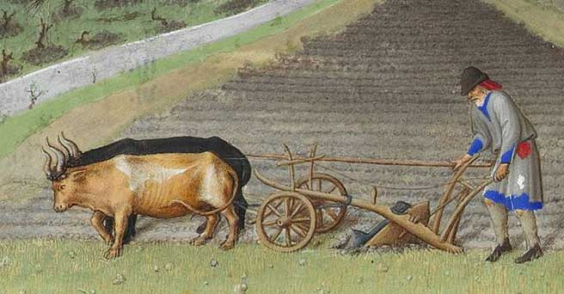The heavy, wheeled plow allows for deeper plowing and aerates the soil better, a key need in making rich, wet European soil as productive as possible.
The new heavy, wheeled plow, with an iron plowshare, fits into this picture as well. This type of plow appears to be an invention of the Slavic world and came into Western Europe in the Carolingian period. It was used on large estates: On the estates of the Carolingian family and the greatest churches and monasteries. But it wasn’t widely used, perhaps, until the 11th century when it finally began to proliferate throughout Europe.
The heavy, wheeled plow played a significant role in changing how farming was conducted. Once again, using horses to pull it allowed more work to be completed. A heavy iron plowshare can cut much more deeply into the soil than can the older forms of the aratrum, the Roman scratch plow, which didn’t do much more than just disturb the surface.
The soils of northern Europe are very good, but they’re damp and heavy. The heavy, wheeled plow was able to turn the soil, which aerates it. This new plow with its iron plowshare also called for a greater proliferation of iron in this society leading to more smithing. We can see connections between the use of the plow, the advantages that it brought, and then some of the requirements that flowed from its development.
Watermills were widely used in the 11th century. In some parts of northern Europe, for example, in the Low Countries windmills were used, but watermills were fairly common. Mills demanded engineering gains, in terms of gearing. If we had a flow of water, a water wheel could be laid parallel to that flow of water, which makes the gearing turn a mill wheel fairly easily. However, that’s an inefficient way to turn a water wheel. If I sent the water wheel perpendicular to the flow of water, it is a much more efficient way to turn the water wheel, but I now have to turn vertical motion into horizontal motion. I have to engineer some elaborate gearing.
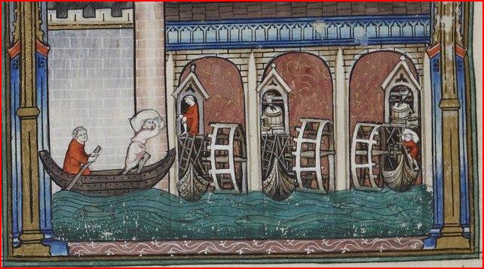Water mills required complicated gears that had to be built and maintained which, in turn, drove advances in engineering.
The mill wheel also has to run at a common speed, whether the water is running very fast or very slow. If the water itself is running very slow, or if the water supply is somewhat unpredictable, I’ve got to engage in a little hydraulic engineering and create millraces. Engineers had to make the water go past the water wheel, whether the water wanted to or not, to do the milling at the convenience of the miller, and not by the movements of the river naturally. A variety of technologies were spawned by the need to use more mills.
Mills were imperative because there was an increase in grain. As more and more land was brought under cultivation, the new technological inputs made the land that was being plowed and farmed more productive, producing yet more grain. A rising population needs more food. Bread is the staple of the diet and is baked from flour. To make flour, all the grain must be ground. One factor drives another factor that drives another factor. We begin to see the interconnectedness of the elements of this economy.

New Methods of Land Use in the Middle Ages
Farmers began to use the land more efficiently. In early European history—northern Europe at the time of the Romans and the Greeks—agricultural communities would often farm a particular area quite intensively for a brief period, and then move. They didn’t necessarily move very far, maybe just a few kilometers, but they would move, farm fairly intensively, and move, farm and move. Slowly but surely, as people began moving into the Middle Ages, communities began to anchor themselves.
For a long time, they tended to practice what we would call two-field agriculture. About half of your land was plowed, and about half of it was left fallow. On that fallow land, you would also run your animals, so that animal manure would provide some enrichment to the soil. Household wastes and so on might also be spread on that land to provide some enrichment. About half of the available land was under the plow at a given moment.
In the Carolingian era, there was the proliferation of the three-field system, but again mostly on the estates of the Carolingian family, and the estates of the Church. By the High Middle Ages, after the year 1000 to 1050, we begin to see the three-field system widely used across Europe.
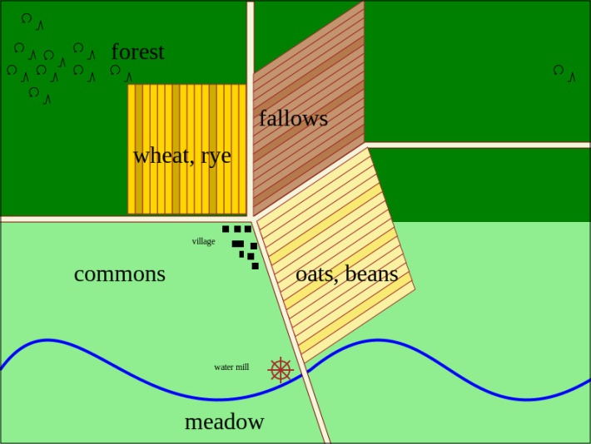In the three-field system, land is divided into three parts and used for crop-rotation.
What exactly is the three-field system? You divide the available land of an estate into three roughly equal parts. One of these is left fallow, one of these is planted in winter crops and one of these is planted in spring crops. You work your way through a rotation this way.
Right away, we see that from 50% we got to 66.67% of our land under the plow. Second, by balancing winter and spring crops, we guarantee against one season of terrible weather or blight. If you get two in a row, you’re in big trouble, but if you get one, you’re still going to get a crop during that year. It also means that one can vary the agricultural regime. You can plant different kinds of crops and have different plants coming in at different points in the year.
This is interesting in connection with the horses. Virtually everywhere in Europe, horses eat oats, but people don’t. They do in Brittany and Scotland, but in most parts of the European world, people don’t eat oats. As a farmer, if I’ve decided that I’m going to have a horse for my tractor, I have to grow that tractor’s fuel someplace. If I give over my estate, or a substantial part of my estate, to growing the fuel for my horse tractor, then what’s the fuel for me?
If I’m dividing up my agricultural regime in such a way that I can set aside a certain amount of land to grow oats to feed my horses, then I have other lands that I can use to grow crops that I will use to support myself and my family, I may be able to sell the excess. If I produce excess, I can sell in local markets. From the crops that I’m able to sell, I can make money with which to buy other kinds of goods.
With more land under the plow, a greater variety of crops, and greater insurance against individual seasons of bad weather, we also see a growing tendency towards agricultural specialization. People in particular regions understood how to grow certain crops very well. In areas of Europe where grapevines are tended, viticulture is a complex and sophisticated operation, but in other parts, cereal grains are particularly cultivated.
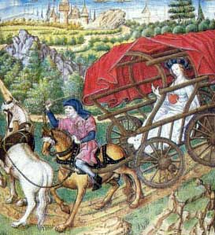The spread of four-wheeled wagons increased the carrying capacity for horse-drawn wagons, a feature that helped to boost trade between communities.
This produces a situation where if a given region concentrates on particular kinds of crops, then those regions rely on other places and trade to get the things that they do not themselves produce. In turn, they have to be able to move the goods that they do produce to other places. This requires improved roads and improved transport vehicles to move more goods, farther and faster. Again, the use of horses as draft animals pulling wagons: They can pull heavier loads and they can pull those loads farther. The use of large four-wheeled wagons becomes widespread, instead of two-wheeled carts, so that more can be moved in one trip.

Trade in the High Middle Ages
Improved roads and vehicles of transportation provide for increasingly far-flung urban markets. Cities are, in some ways, parasitical on the land around them. They don’t grow their own food, and as cities get larger and larger, they require more resources. That food is going to have to come from farther and farther away, so a great deal of this agricultural productivity out in the countryside also permits the growth of cities and urbanization.
We notice also that both the Church and secular governments worked to protect trade and traders. Agricultural specialization was one important impetus to trade, but there were others like growing prosperity, more money at people’s disposal, and a desire to have more products. Increasingly through movements like the crusades, people were becoming familiar with exotic products from other parts of the world that they wished to have, either because they brought pleasure or because they brought a certain kind of prestige; a certain cachet was attached to having spices on one’s table, for example.
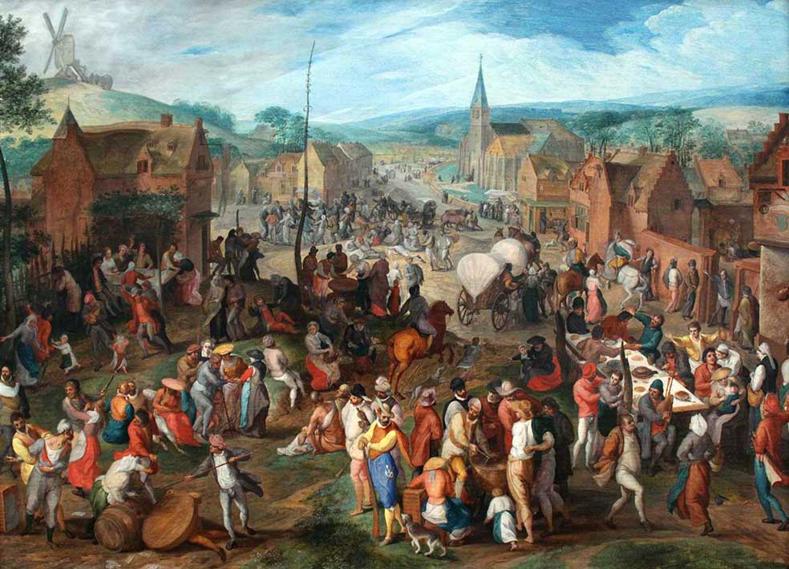
Image of A medieval fair.
Trade was facilitated by several things, in particular fairs, the fairs in the Champagne region of France being perhaps the most famous. These fairs were held over many months of the year, except the dead of winter, and they moved around from town to town in the Champagne region. Merchants from the south of Europe came north; merchants from the north of Europe came south.
These great fairs were important centers for the growth and promotion of trade, until gradually, by the end of the 13th or beginning of the 14th century, trade began to move from the Mediterranean world to northern Europe and in the opposite direction by ship.
Earlier trade tended to move over land or by preference, when possible, on rivers. It was always much easier to float your stuff down a river than to drag it down a road. There were also places, in the south of England or the Baltic Sea basin, for example—where various cities leagued together to protect their commercial interests and to avoid unwanted and unwarranted competition.
The increasing growth of trade began to lead to more sophisticated commercial contracts. This lead to partnerships and then eventually, to corporations. Quite simply, the idea was a large number of people could get together, pool their wealth, and be vastly stronger than any one of them by himself.
Moreover, it was also a way to distribute risk. If I buy a share in a ship and that ship sinks, I’ve lost something. If I own the ship and the ship sinks, I may have lost everything. Because there can be mishaps, insurance began to be sold. A whole series of subsidiary industries, businesses, and economic practices that were based on commerce began to grow, spread, and develop in High Medieval Europe.
Several vast, large-scale commercial networks emerged. For example, there was one that connected the North and the Baltic Seas, which linked together the British Isles, the Low Countries, as well as northern Germany and southern Scandinavia. There were important commercial networks that went up and down the Rhine, back and forth on the Danube, and up and down the Rhone, the great river of southeastern France. The great river networks were always significant.
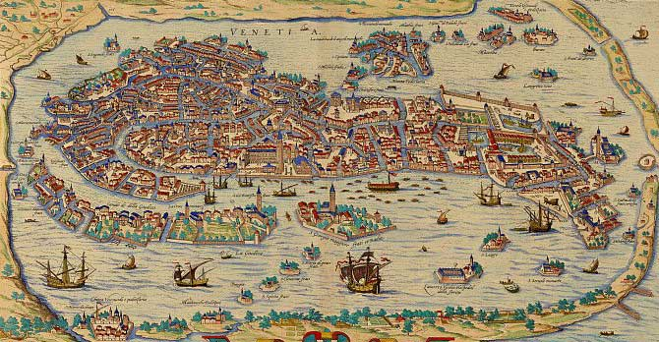Medieval Venice:center of a vast trading network.
Italian cities such as Venice, Bari, and Genoa had important commercial networks in the Mediterranean. Venice, in particular, had a far-flung and sophisticated commercial network in the eastern Mediterranean.
Outside of Europe, the eastern Mediterranean world was linked by land routes that went right through Central Asia to China—the Silk Road, for example—but it was also linked to a vast set of seaborne trade routes in the Persian Gulf and the Indian Ocean. Goods came by caravan or by ship from the Persian Gulf region and the Indian Ocean region, eventually linking together South Asia and the eastern coast of Africa with the eastern Mediterranean. Then through Italian merchants, the products of those parts of the world were brought back to Western Europe, via river or overland trade routes, to places like France and England.

Mining and Heavy Industry in the Middle Ages
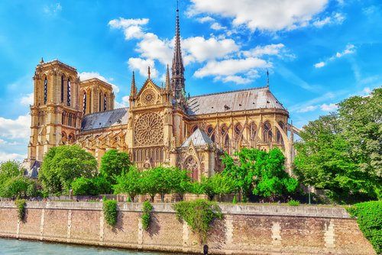
Notre-Dame de Paris: one of many European cathedrals built of stone during the 12th and 13th centuries.
By this time there were greater efficiencies in surface mining. In the Middle Ages, deep mining was impossible because you couldn’t get the water out of the shafts, or out of the mine galleries. Thus, most mining tended to be surface mining, focusing on stone, called quarrying, the most prominent kind. If you think of some famous churches that you’re aware of and look when they were built, there’s a very good chance they were built out of stone in the 12th and 13th centuries. These vast stone buildings required ever more efficient mining. As they were often built long distances from the sources of the stone, once again, better roads and more efficient vehicles of transportation played a significant role in the functioning of medieval society.
There was a certain amount of surface mining for iron, a necessary resource for all the new horseshoes and heavy iron plows, not to mention the traditional mix of weapons: Swords, armor, spear tips, arrow tips, and so on.

Urban Centers in the Middle Ages
All of these above factors together put a great deal more money into circulation, facilitated economic specialization, and promoted the growth of towns. Early medieval towns had tended to be either governmental seats and/or ecclesiastical sites. They would have either a count, an officer of government, even a royal court in the town, or they would have a great monastery or a bishop. In the Carolingian period, some of these centers began to have faux-burgs or as we’re more familiar with today, sub-urbs. A small community of merchants would gather outside on the edge of this community to do their business. Mostly, they were part-time. They were more sophisticated, perhaps than peddlers, but they were people who conducted business part-time.
After about 1100, those communities of merchants began to settle permanently and engage in trade regularly, even in the artisanal industry, with the exception being the cloth industry.
This is not the large-scale industrialization seen in 18th and 19th-century Europe—it was smaller in scale—but it was notable all the same. With the settlement of permanent communities like this, towns took on a new life. They remained ecclesiastical centers and even governing centers, and with their universities, they became intellectual centers. But they are, first and foremost, economic engines, driving a growing Europe.
Town people needed different things than the rural elite who dominated society and politics. They needed peace, security, order, predictable supplies of food, and predictable raw materials. They needed a kind of peace in the countryside that the rather rambunctious, chivalrous nobility were not necessarily keen on providing.
The Church and royal governments legislated to provide the kind of peace, order, and harmony that the townspeople needed, through the Peace and Truce of God movements. One of the key visible features of expansion is the growth of towns. Again and again, city walls expanded and towns grew.
Conclusion: Europe in the High Middle Ages was dynamic and prosperous. Such widespread prosperity had not been seen since the Pax Romana. In certain respects, it would not be seen again until the dawn of modern times. When we talk about the society, government, politics, culture, art, architecture, and literature of High Medieval Europe, we keep in mind a picture of this growing, expanding Europe.
It is largely thought that the dismantling of the great civilizations of Greece and the Rome led to feudalism and a deteriorated state, in which Europe remained in the Middle Ages until the Renaissance.

