Feudalism

Feudalism, also called feudal system or feudality, French féodalité, historiographic construct designating the social, economic, and political conditions in western Europe during the early Middle Ages, the long stretch of time between the 5th and 12th centuries. Feudalism and the related term feudal system are labels invented long after the period to which they were applied. They refer to what those who invented them perceived as the most significant and distinctive characteristics of the early and central Middle Ages. The expressions féodalité and feudal system were coined by the beginning of the 17th century, and the English words feudality and feudalism (as well as feudal pyramid) were in use by the end of the 18th century. They were derived from the Latin words feudum (“fief”) and feodalitas (services connected with the fief), both of which were used during the Middle Ages and later to refer to a form of property holding. Use of the terms associated with feudum to denote the essential characteristics of the early Middle Ages has invested the fief with exaggerated prominence and placed undue emphasis on the importance of a special mode of land tenure to the detriment of other, more significant aspects of social, economic, and political life.
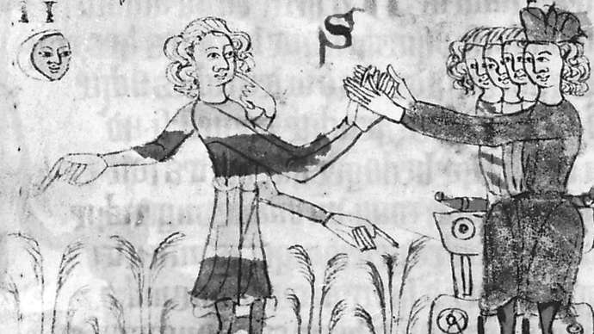
feudalism
Detail from the Heidelberger Sachsenspiegel showing the homage ceremony, in which the vassals put themselves under the protection of their lords by placing their hands between his hands, 14th century; in the Universitatsbibliothek, Heidelberg, Germany.
Universitatsbibliothek, Heidelberg, Germany

Origins of the idea
The terms feudalism and feudal system were generally applied to the early and central Middle Ages—the period from the 5th century, when central political authority in the Western empire disappeared, to the 12th century, when kingdoms began to emerge as effective centralized units of government. For a relatively brief period, from the mid-8th to the early 9th century, the Carolingian rulers, especially Pippin (reigned 751–768) and Charlemagne (reigned 768/771–814), had remarkable success in creating and maintaining a relatively unified empire. Before and afterward, however, political units were fragmented and political authority diffused. The mightier of the later Carolingians attempted to regulate local magnates and enlist them in their service, but the power of local elites was never effaced. In the absence of forceful kings and emperors, local lords expanded the territory subject to them and intensified their control over the people living there. In many areas the term feudum, as well as the terms beneficium and casamentum, came to be used to describe a form of property holding. The holdings these terms denoted have often been considered essentially dependent tenures, over which their holders’ rights were notably limited. As the words were used in documents of the period, however, the characteristics of the holdings to which they were applied are difficult to distinguish from those of tenures designated by such words as allodium, which has generally been translated as “freehold property.”
Fiefs still existed in the 17th century, when the feudal model—or, as contemporary historians term it, the feudal construct—was developed. At that time, the fief was a piece of property, usually land, that was held in return for service, which could include military duties. The fief holder swore fidelity to the person from whom the fief was held (the lord, dominus, or seigneur) and became his (or her) man. The ceremony in which the oath was taken was called homage (from the Latin, homo; “man”). These institutions survived in England until they were abolished by Parliament in 1645 and, after the Restoration, by Charles II in 1660. Until their eradication by the National Assembly between 1789 and 1793, they had considerable importance in France, where they were employed to create and reinforce familial and social bonds. Their pervasiveness made students of the past eager to understand how they had come into being. Similarities of terminology and practice found in documents surviving from the Middle Ages—especially the Libri feudorum (“Book of Fiefs”), an Italian compilation of customs relating to property holding, which was made in the 12th century and incorporated into Roman law—led historians and lawyers to search for the origins of contemporary feudal institutions in the Middle Ages.
Charles II
Charles II, oil on canvas by Philippe de Champaigne, 17th century.
The Cleveland Museum of Art; The Elisabeth Severance Prentiss Collection 1959.38; www.clevelandart.org

As defined by scholars in the 17th century, the medieval “feudal system” was characterized by the absence of public authority and the exercise by local lords of administrative and judicial functions formerly (and later) performed by centralized governments; general disorder and endemic conflict; and the prevalence of bonds between lords and free dependents (vassals), which were forged by the lords’ bestowal of property called “fiefs” and by their reception of homage from the vassals. These bonds entailed the rendering of services by vassals to their lords (military obligations, counsel, financial support) and the lords’ obligation to protect and respect their vassals. These characteristics were in part deduced from medieval documents and chronicles, but they were interpreted in light of 17th-century practices and semantics. Learned legal commentaries on the laws governing the property called “fiefs” also affected interpretation of the sources. These commentaries, produced since the 13th century, focused on legal theory and on rules derived from actual disputes and hypothetical cases. They did not include (nor were they intended to provide) dispassionate analysis of historical development. Legal commentators in the 16th century had prepared the way for the elaboration of the feudal construct by formulating the idea, loosely derived from the Libri feudorum, of a single feudal law, which they presented as being spread throughout Europe during the early Middle Ages.
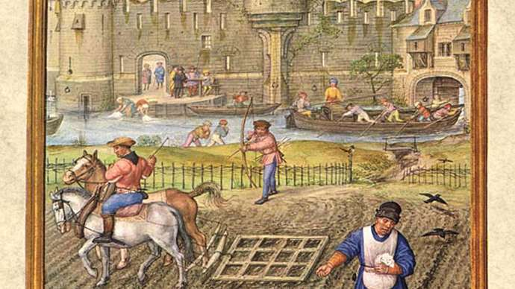
Feudalism
Peasants at work before the gates of a town. Miniature painting from the Breviarium Grimani, c. late 15th century.
The History Collection/Alamy

The terms feudalism and feudal system enabled historians to deal summarily with a long span of European history whose complexities were—and remain—confusing. The Roman Empire and the various emperors’ accomplishments provided a key to understanding Roman history, and the reemergence of states and strong rulers in the 12th century again furnished manageable focal points for historical narrative, particularly since medieval states and governmental practices can be presented as antecedents of modern nations and institutions. The feudal construct neatly filled the gap between the 5th and the 12th century. Although Charlemagne may seem an anomaly in this evolution, he was presented as “sowing the seeds” from which feudalism emerged. A variety of Roman, barbarian, and Carolingian institutions were considered antecedents of feudal practices: Roman lordship and clientage, barbarian war chiefdoms and bands, grants of lands to soldiers and to officeholders, and oaths of loyalty and fidelity. In the 17th century, as later, the high point of feudalism was located in the 11th century. Later rulers who adopted and adapted feudal institutions to increase their power were labeled “feudal” and their governments called “feudal monarchies.” Despite the survival of institutions and practices associated with the medieval feudal system in the 17th century, historians of that time presented medieval feudalism and the feudal system as declining in importance in the 14th and 15th centuries. This period was later dubbed an age of “bastard feudalism” because of the use of salaries and written contracts between lords and dependents.
Those who formulated the concept of feudalism were affected by the search for simplicity and order in the universe associated with the work of Nicolaus Copernicus (1473–1543) and especially Isaac Newton (1642–1727). Historians and philosophers were persuaded that if the universe operated systematically, so too must societies. In the 16th century some students of the law and customs of the fief declared that feudal institutions were universal and maintained that feudal systems had existed in Rome, Persia, and Judaea. The philosopher Giambattista Vico (1668–1744) considered the fief one of humankind’s eternal institutions. Adopting a similar position, Voltaire (1694–1778) contested the judgment of Montesquieu (1689–1755) that the appearance of feudal laws was a unique historical event. The philosophical historians of 18th-century Scotland searched for feudalism outside western Europe, and they expanded the construct’s field of significance to encompass peasants as well as lords. Adam Smith (1723–90) presented feudal government as a stage of social development characterized by the absence of commerce and by the use of semi-free labour to cultivate land. Smith’s student John Millar (1735–1801) found “the outlines of the feudal policy” in Asia and Africa. The association popularly made between the feudal construct and ignorance and barbarism fostered its extension to regions which Europeans scarcely knew and which they considered backward and primitive.
Giambattista Vico
Giambattista Vico, from an Italian postage stamp, 1968.
© irisphoto1/Shutterstock.com
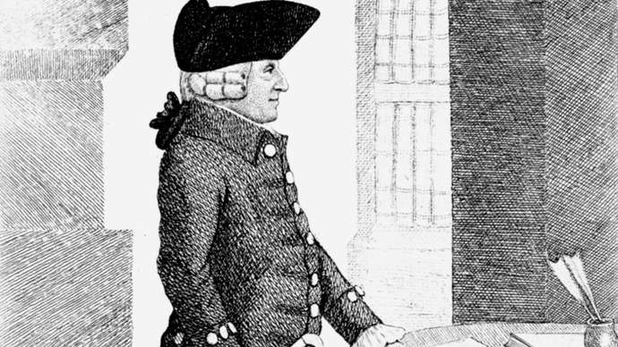
Adam Smith
Adam Smith, drawing by John Kay, 1790.
© Photos.com/Thinkstock
Following Millar’s precedent, some later historians continued to look for feudal institutions in times and places outside medieval Europe, most notably Japan. These efforts, predictably, resulted in misconceptions and misunderstanding. Historians using the feudal model for comparative purposes emphasized those characteristics which resemble or seem to resemble Western feudal practices and neglected other, dissimilar aspects, some of which were uniquely significant in shaping the evolution of the areas in question. For Westerners, the use of the feudal model necessarily created a deceptive sense of familiarity with societies that are different from their own.

Development in the 19th and 20th centuries
In the 19th century, influenced by Adam Smith and other Scottish thinkers, Karl Marx (1818–83) and Friedrich Engels (1820–95) made “the feudal mode of production” one stage in their visionary reading of Western historical development; the feudal model followed “the ancient mode of production” and preceded capitalism, socialism, and communism. Marx and Engels rejected the traditional understanding of feudalism as consisting of fiefs and relations among the elite and emphasized the lords’ exploitation of the peasants as the essence of the feudal mode of production. Marx and Engels did not try to establish that the feudal period had existed universally; they formulated for Asia the idea of a specific Asiatic mode of production. Still, by incorporating “the feudal mode of production” into their design, they endowed it with seminal significance. Their followers came to view the feudal stage as a necessary prerequisite for the emergence of socialism, and socialist scholars and activists sought traces of it throughout the world.
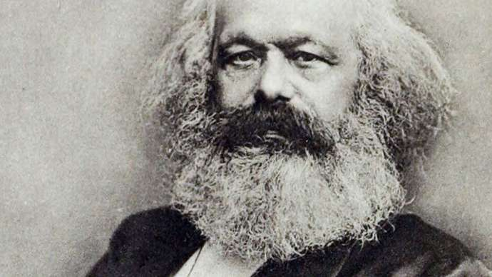
Karl Marx
Karl Marx, c. 1870.
From Karl Marx's Oekonomische Lehren, by Karl Kautsky, 1887

Marx and Engels’s model of Western historical development indicates how popular the feudal construct had become by the middle of the 19th century. Their modification of the construct to serve their own purposes demonstrates its pliancy. However, they were not unique in having shaped the feudal construct to suit their particular perspective. The Australian medieval historian John O. Ward isolated 10 different sets of phenomena that historians had associated with feudalism. Some employed narrow legalistic definitions like those elaborated by 16th-century lawyers. Others, following the English historian Thomas Madox (1666–1726/27) and the French historian Marc Bloch (1886–1944), equated feudalism with feudal society. They saw feudalism as encompassing many if not most aspects of medieval society: peasants, whether free, unfree, or semi-free; a ruling warrior class with subordinates compensated for military service by grants of land rather than money; fragmentation of power; and disorder—yet with the family and the state retaining their importance. The American historian Joseph R. Strayer (1904–87) laid special emphasis on the splintering of political and public power and authority, and he believed that systematized feudal institutions and customs were compatible with the formation of large political units, which he viewed as recognizable precursors of contemporary nation-states. Although Bloch and Strayer employed the feudal construct throughout their careers, both admitted the idiosyncrasy of the various definitions of the feudal labels that have been proposed, and both acknowledged that focusing on the construct inevitably obscures the human beings, both individuals and groups, whose actions historians are dedicated to comprehending.
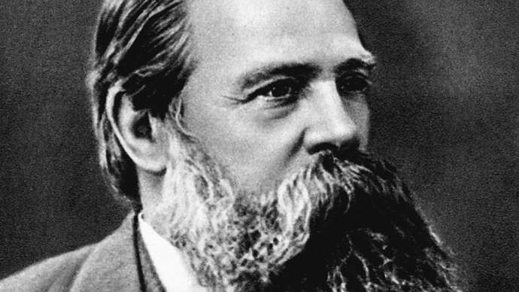
Friedrich Engels
Friedrich Engels, German socialist and supporter of Karl Marx, 1879.
Universal History Archive/Universal Images Group/REX/Shutterstock.com

Modern critiques
From the time of the French historian Louis Chantereau Le Febvre (1588–1658), questions were raised concerning the extent to which the feudal construct oversimplified and distorted the historical realities it was intended to capture. Chantereau Le Febvre denounced as futile the attempts of his contemporaries to deduce general rules from uncertain principles. He stressed the necessity of studying authentic acts and working “historically,” implying thereby that his contemporaries were not working in this fashion. He cautioned against reducing the great variety of fiefs to a single type, because each fief was different from the others. Despite Chantereau Le Febvre’s reservations, in the end he succumbed to current fashion and endorsed a simplified picture of feudal institutions. He did, however, edit and publish medieval documents demonstrating the difficulty of attaching precise meanings to such words as feudum and allodium.
Many modern historians have attempted to follow Chantereau Le Febvre’s admonitions and have studied these words and others, such as vassus (“vassal”), homo (“man”), and fidelis (“the faithful”), which figured centrally in the classic definitions of the feudal construct. By examining the contexts in which key words appear in a host of medieval acts and chronicles, they have demonstrated the wide range of meanings these words possessed and the difficulty of formulating simple and precise definitions of any of them. It is clear that in the Middle Ages those who fought (like those who farmed) were rewarded in different ways and were sometimes paid in money. Land was owned, controlled, and held in a variety of ways. Similarly, enterprising individuals used a range of tactics to augment their lands and wealth and increase their power. Standardization and regularization of tenurial and territorial bonds and of ceremonies such as homage accompanied the development of centralized government, as lords and kings utilized these devices (and many others) to buttress and extend their authority.
The extent to which surrender of property to a lord as a fief limited control and rights over the property has been investigated, as has the importance of such acts in creating ties between family groups that could be repeatedly renewed. The difficulty and danger of drawing sharp distinctions between the ceremonial practices of the nobility and the peasantry have been recognized, so too the importance of urban and parochial communities and the significance of spiritual and economic links between religious establishments and the laity. In studying the settlement of disputes, historians have emphasized the continuing importance of mediation and of judgments given by free men, especially members of the secular and ecclesiastical elite. Lordship has emerged as a more centrally important topic than the feudum. The quality of lords’ relationships with their dependents, free and unfree, has been debated, with some historians stressing the predatory, exploitative aspects of lordship and others emphasizing its protective, beneficial features.
Increased knowledge of the Middle Ages and greater sophistication regarding the constructs (and periods) that scholars have created in attempting to comprehend the past have sparked the search for appropriate terms to describe human institutions and societies. Although the feudal labels have lost their validity as terms to designate the realities of medieval society, they provide insight into the thought processes and assumptions of the lawyers and historians who formulated and utilized them between the 16th and the 20th century.
Pronoia system

Pronoia system, Byzantine form of feudalism based on government assignment of revenue-yielding property to prominent individuals in return for services, usually military; instituted during the reign of the Byzantine emperor Constantine IX Monomachus (1042–55).
In the beginning, a pronoia (grant of land) was bestowed for the life of the holder and could not be transferred by alienation or inheritance. The grants varied from large areas including several villages to small estates sufficient to fill a single family’s needs. The holder was absolute master over the peasants living on his land, collecting taxes from them and meting out justice to them.
In the 11th century the pronoia became the basis of the military system, obliging its holder to provide military service and troops in proportion to the value of his grant. Under the Comnenus dynasty (1081–1185), monastic lands were seized in order to be redistributed as pronoias, thereby increasing the number of landholders supplying troops for the army.
By the late 13th century, the pronoia could be passed on to heirs, and the obligation for military service was transferred as well. Under the Palaeologian dynasty (1261–1453), the feudal nobility refused to fulfill their military obligations but retained their grants of land.

Feudal land tenure

Feudal land tenure, system by which land was held by tenants from lords. As developed in medieval England and France, the king was lord paramount with numerous levels of lesser lords down to the occupying tenant.

Tenures were divided into free and unfree. Of the free tenures, the first was tenure in chivalry, principally grand sergeanty and knight service. The former obliged the tenant to perform some honourable and often personal service; knight service entailed performing military duties for the king or other lord, though by the middle of the 12th century such service was usually commuted for a payment called scutage. Another type of free tenure was socage, primarily customary socage, the principal service of which was usually agricultural in nature, such as performing so many days’ plowing each year for the lord. In addition to the principal service, all these tenures were subject to a number of conditions, such as relief, the payment made on transfer of a fief to an heir, and escheat, the return of the fief to the lord when the vassal died without an heir. Chivalric tenures were also subject to wardship, the guardianship of a fief of a minor, and marriage, payment made in lieu of marriage of the vassal’s daughter to the lord.
Another form of free tenure was the spiritual tenure of bishops or monasteries, their sole obligation being to pray for the souls of the grantor and his heirs. Some ecclesiastics also held temporal lands for which they performed the required services.
The main type of unfree tenancy was villenage, initially a modified form of servitude. Whereas the mark of free tenants was that their services were always predetermined, in unfree tenure they were not; the unfree tenant never knew what he might be called to do for his lord. Although at first the villein tenant held his land entirely at the will of the lord and might be ejected at any time, the royal courts later protected him to the extent that he held tenancy at the will of the lord and according to the custom of the manor, so that he could not be ejected in breach of existing customs. Moreover, an unfree tenant could not leave without his lord’s approval. Tenure in villenage in England then became known as copyhold tenure (abolished after 1925), in which the holder was personally free and paid rent in lieu of services.

Sceutage system: feudal law

Scutage, also called shield money, French écuage, (scutage from Latin scutum, “shield”), in feudal law, payment made by a knight to commute the military service that he owed his lord. A lord might accept from his vassal a sum of money (or something else of value, often a horse) in lieu of service on some expedition. The system was advantageous to both sides and grew rapidly with the expansion of money economy in Europe in the 12th and 13th centuries.
Scutage existed in various countries, including France and Germany, but was most highly developed in England, where it was first mentioned in 1100. It seems to have been levied, at first, on ecclesiastical tenants in chief, who had difficulty in finding their full quota of knights for the king’s army. It soon became a general tax on knights’ estates, and by the 13th century the rates were standardized.
Though the crown could demand scutage, tenants could not refuse to perform military service if required to do so. From the time of Richard I (1189–99), however, special fines (payments larger than the routine scutage) were accepted from tenants in chief in lieu of service on a particular campaign. As a result of the frequent and heavy scutages exacted by King John, Magna Carta (1215) forbade the levy of scutage without the consent of a great council. During the 13th century, scutages and fines continued, the latter becoming more general. Scutage, collected from mesne (intermediate) tenants who had not attended a campaign, was divided between the king and those tenants in chief who had served in person. By the 14th century, however, scutage had become obsolete.

