Secondary active transport
The electrochemical gradients set up by primary active transport store energy, which can be released as the ions move back down their gradients. Secondary active transport uses the energy stored in these gradients to move other substances against their own gradients.
As an example, let's suppose we have a high concentration of sodium ions in the extracellular space (thanks to the hard work of the sodium-potassium pump). If a route such as a channel or carrier protein is open, sodium ions will move down their concentration gradient and return to the interior of the cell.
In secondary active transport, the movement of the sodium ions down their gradient is coupled to the uphill transport of other substances by a shared carrier protein (a cotransporter). For instance, in the figure below, a carrier protein lets sodium ions move down their gradient, but simultaneously brings a glucose molecule up its gradient and into the cell. The carrier protein uses the energy of the sodium gradient to drive the transport of glucose molecules.

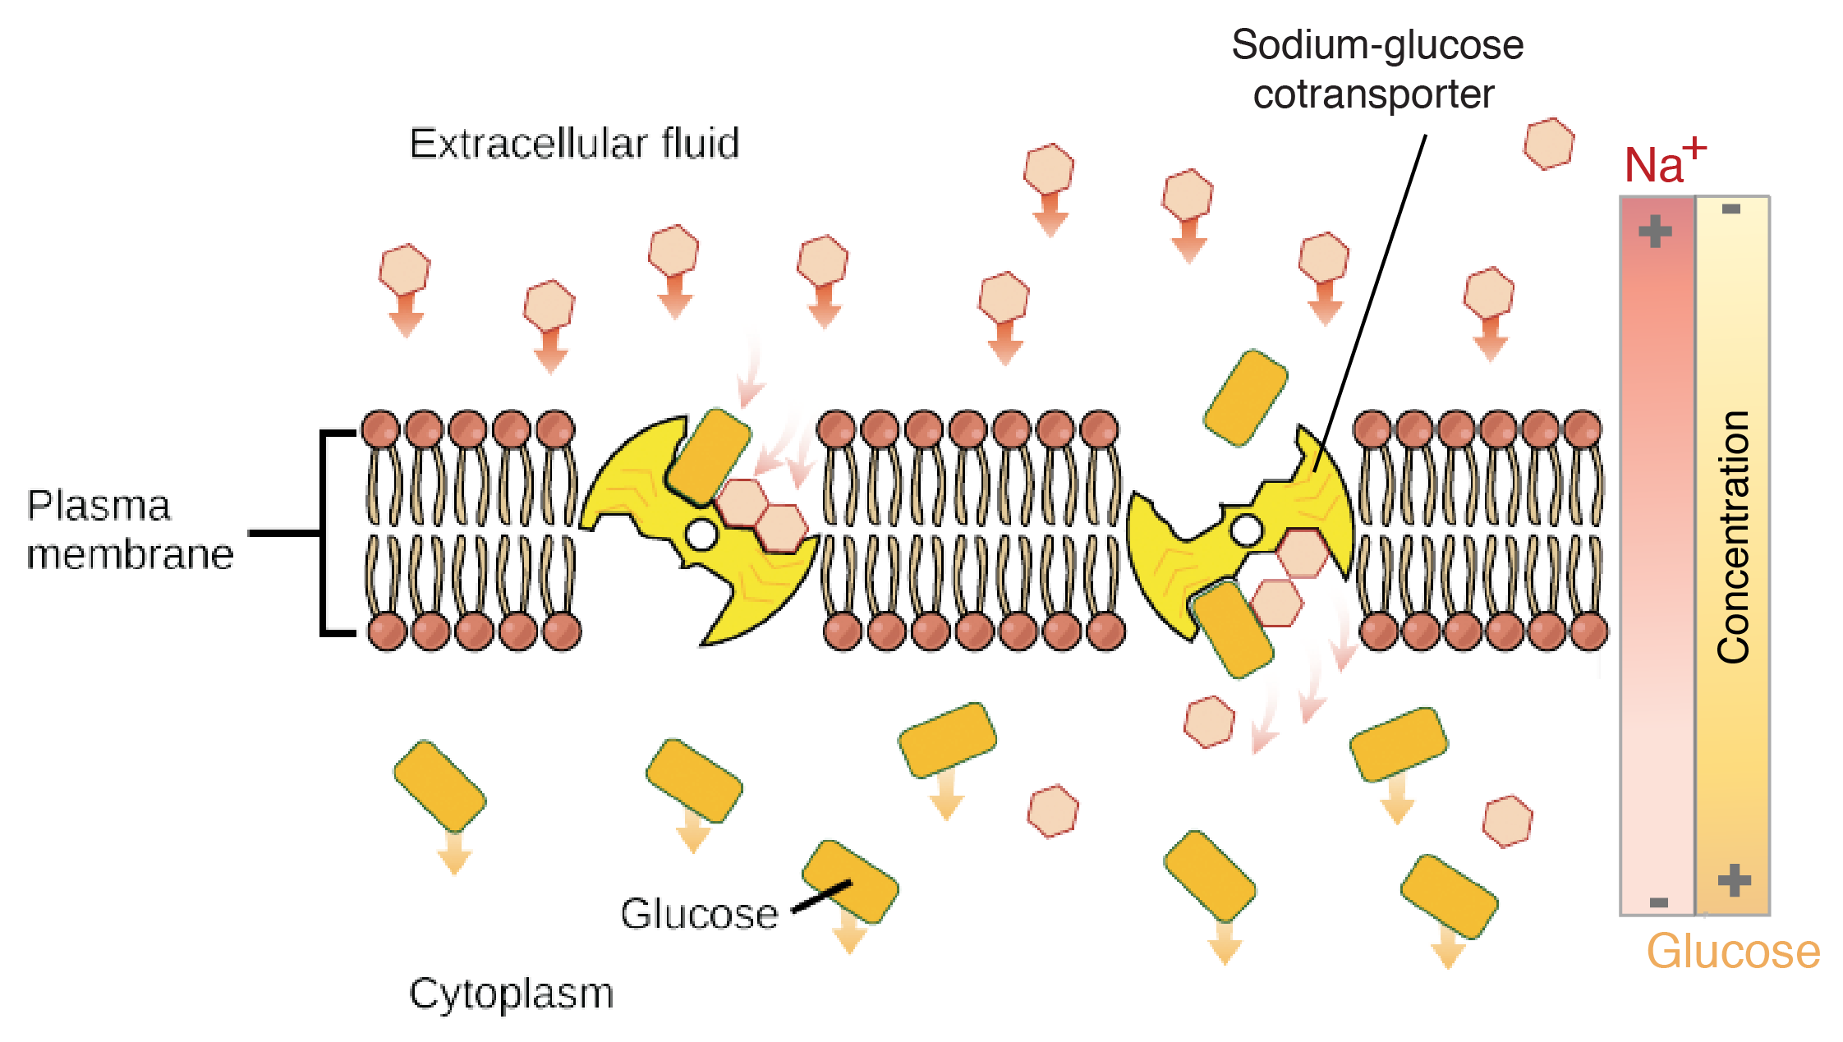

In secondary active transport, the two molecules being transported may move either in the same direction (i.e., both into the cell), or in opposite directions (i.e., one into and one out of the cell). When they move in the same direction, the protein that transports them is called a symporter, while if they move in opposite directions, the protein is called an antiporter.

