Fungal Nutrition –
The supply of nutrients is essential for every living organism because the nutrients serve as structural units and also as source of energy for the building up protoplasm which is thebasis of life. Nutrition is the process of procuring nourishment or nutrient and is the principle function of mycelium.
- Nutritional requirements – Due to lake of chlorophyll the fungi are unable to photosynthesize or use carbon-di-oxide to built up organic food materials. The fungi utilize both organic compounds and inorganic materials as the source of their nutrient supply. They are heterotrophic in nutrition and obtain food materials by living as saprophytes or parasites from dead or living plants, animals or microorganisms or their wastes.
The basic nutritional need of fungi are-
- A sweetable organic compound as a source of carbon and energy – The organic substances usually utilize by fungi are vary varied in nature. For eg. Yeast can use acetats as a souece of carbon. The carbohydrates are needed for building up the body and also as a source of energy. Among the carbohydrates most fungi use simple sugar as the source of carbon. In this way glucose is sweetable for almost all fungi. Next to glucose fructose is also sweetable for some fungi. Except this some fungi utilize pentose sugar like xylose. It has been reported to be superior to glucose for some fungi. Some fungi use mannitol as a source of carbon which is equivalent to glucose. Some fungi utilized maltose as the source of carbon which is a by product of starch. Sucrose is also a good source of food for some fungi. Few fungi utilized polysaccharide like starch am\nd cellulose as the source of carbon. Some fungi is able tomake good growth on fats which is the source of carbon. Besides this, proteins, lipids, some organic acid and some higher alcohol utilized by some fungi as asource of energy. Therefore growth offungi is always greater on a substrate containing a sweetable carbohydrate.
- A sweetable source of nitrogen – besides carbon fungi require nitrogen they obtain nitrogen from organic and inorganic materials i.e. the source of nitrogen are organic and inorganic are protein, peptide or amino acid. In mature fungi decompose protein and other materials to obtain their supply of nitrogen. In pure culture amino acids, peptides of pepton, jelatin, casein and egg albumin can serve as sources of organic nitrogen for building up protoplasm.som fungi utilize urea as the source of nitrogen.
However many sources also a number of fungi use both nitrate and ammonia salts as the source of nitrogen.
- Inorganic ions of sulphur, phosphorus, potassium and magnassium in significant amount- macro nutrients, inorganic ions of iron, zinc, copper, molebdenum- minute traces micro nutrients - The chief inorganic nutrients which the fungi required in large amount for their mineral nutrition S,P,K,Mg. these are the macro nutrients, the fungi obtain from simple inorganic forms or sources such as sulphates for sulphur, phosphate for phosphorus. Some fungi require only minute traces of Fe, Zn, Cu, Mn, Co and Mb. These are the micronutrients which are considered essential for growth of fungi.
- Certain vitamins or organic growth factor in trace amount – The fungi require minute amounts of specific relatively complex organic compounds for their growth these are the vitamins or growth factors. Many fungi synthesized their own supply of appropriate growth factor. Such are called as auxo-autotrophic. The fungi which are heterotrophic for their needs of growth factor aexotrophic. The important fungal vitamins which may function in enzyme system includes thiamine (B₁), Biotin, Pyredoxin (B₆) and riboflavin (B₂). A few fungi also need nicotinic acid and pantothenic acid.
Water and oxygen are also the nutrients which are supplied in the form of water. Water is the major constituent of fungus mycelium forming about 82-90% of the entire weight.
Besides the nutritional requirement mentioned above the growth of fungi is influence by habitate factor, temperature supply, moisture, P^{H} value and by products of metabolism.

Mechanisms of Nutrition
In fungi the whole mycelium may have the power to absorb their nutrients or some special portion of the mycelium may be assign to absorb their nutrients. In saprophytic fungi the hyphae (Mucor, mucedo) or rhizoidal hyphae (Rhizopus stolonifer) come in intimate contact with the substratum.
They secrete some enzymes which convert insoluble complex food material in the substratum to soluble one which they absorb by direct diffusion either through the hyphal walls of the hyphae that penetrate that the substratum or by the rhizoidal hyphae.
The mycelium of the parasites is rarely ectophytic and frequently grows inside the host. The hyphae either ramify in the intercellular space between the host cell or penetrate into the host cells.
The former are called intracellular hyphae and the latter intercellular hyphae. The intracellular hyphae obtain nutrition through the cell walls or membranes of the host cell by secrearting on enzyme upon the plasma membrane of the host cells. The enzymes makes the membrane more diffuse out and are absorb by the hyphal walls. The hyphal walls of the intercellular hyphae come in direct contact with the host protoplasm and obtained food by direct diffusion.
The intercellular hyphae of some highly specialized fungi give out slender lateral outgrowths. The lateral branch penetrats the wall of the host cells by a minute pore. Within the host cell it enlarges to form globuse , lobed or branched absorptive organs called haustaria. The haustarium is a specialized absorbing hyphae pushed in to the living cell of a host and absorb food from the host cells without killing it. Haustaria are characteristic of obligate parasites. It varied in shape and size in different fungi eg. In Albugo the haustarium is a button like spherical structure. Peronospora Parasitica has sac-like haustaria, in the Galium has filamentous haustaria, Erysiphe graminis forms an elongated branched haustarium inside the host cell.
Each haustarium usually consists of two parts, a constricted region which is in the form of a narrow penetration tube and the expanded or branched region in the host cell. The haustarium secrets some enzyme upon the plasma membrane which make it permeable to solutes contained in tha sap cavity. They diffused out and then absorbed by the haustaria. In artificial culture the parasitic fungi donot produce by fungi which live as parasite in animals.

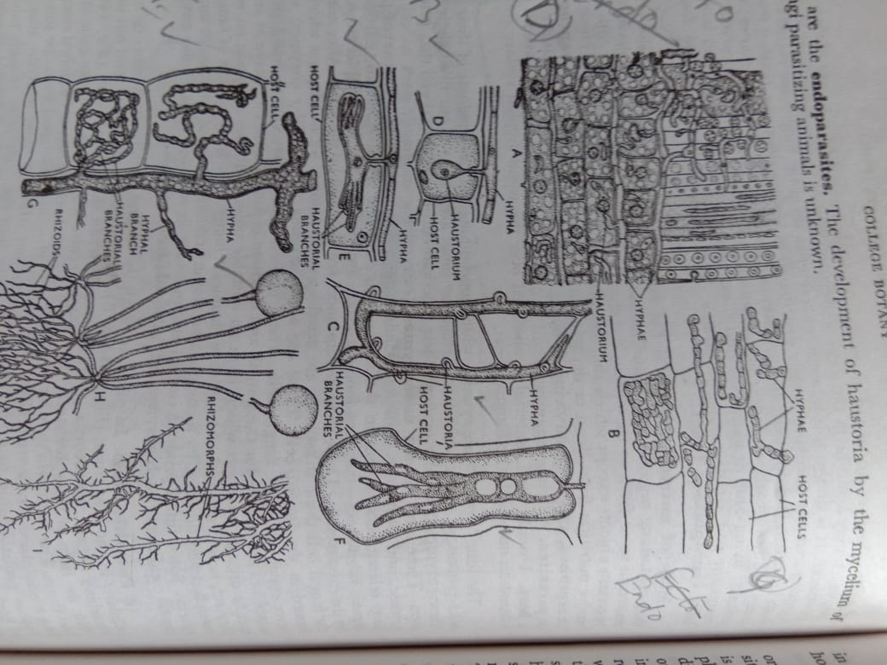

A . Intercellular hyphae,
B- Intra cellular hyphae,
C-G- Various types of hyphae,
H- Rhizoids penetrating substratum
I- Rhizomorphs

