Mode of Nutrition
The fungi are chlorophyll less plants and cannot synthesized their own food unlike green plants from carbohydrate and water in the presence of sunlight. They cannot obtained inorganic food directly from the soil and always depended for their food on some other dead organic materials or living organisms. They are heterotrophic and never autotrophic according to their method of obtaining food. According to the nutrition they can be divide only mainly two groups
- Saprophytes or saprobes
- Parasites

- Saprophytes or saprobes
The saprophytic fungi live on dead organic materials produced by decay organic matter such as rotten foods, rotten vegetable, moist food, moist lathers, jams, jellies etc. eg. Mucor, Saprolagnia, Penicillium etc.
The saprophytic fungi absorbs their foods from the substratum by ordinary vegetative hyphae which penetrate the substratum. In other cases of the saprophyte fungi such as rhizopus, some rhizoids developed which absorbs the food material from the substratum.
- Parasites
The parasitic fungi absorb their food material from the living tissues of the host on which they parasitze. Such parasitic fungi cause many serious diseases and are harmful.
The psarasitic fungi absorb their food from the host in different ways. The fungus having the mycelium embaded in the host tissue is called endoparasites.
Some fungi live in close association of some higher plant whwere they are mutually beneficial to each other. Such relationship is called the symbiosis and the participants are called the symbionts eg. Lichens- are the symbiotic association of algae and fungi.
Mycorrhiza- These type of fungi developed in the roots of the higher plants.

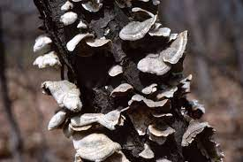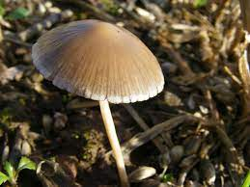

- Fig: Saprophytes or saprobes

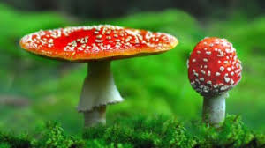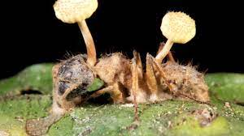

B)Fig: Parasites

