CCIII: MYCOLOGY AND PHYTOPATHOLOGY
UNIT 3: Oomycota (common name: watermolds)
Oomycetes (a term used to refer to organisms in the phylum Oomycota) are a group of fungus-like organisms that rely on water for completion of their life cycle. The members are either free-living or parasitic. As they live in water they are called as “water molds”.
General characteristics
- The Oomycota have long been considered fungi because they obtain their nutrients via absorption and many of them produce the filamentous threads known as mycelium characteristic of many fungi. The Oomycota now are classified as a distinct group based on a number of unique characteristics.
- All members of the Oomycota undergo oogamous reproduction, meaning that diploid oospores are produced as zygotes following fertilization of haploid oospheres by haploid gametes. These oospores may be large and solitary or smaller and numerous inside the oogonium.
- When oomycetes produce swimming stages, they usually have two flagella of different types — a whiplash flagellum and a tinsel flagellum, the latter of which is decorated with small hairs. These hairs give the tinsel flagellum greater and reverse thrust, dragging spores through the water.
- They produce bi-flagellate zoospores and are of two kinds- Pear shaped or pyriform and Reniform or kidney shaped

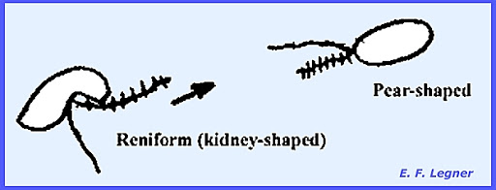

- The vegetative stages of oomycetes are generally either diploid or polyploid, including the egg-like resting spores, oospores, from which the name oomycetes is derived.
- An advanced type of oogamous reproduction takes place by the passage of gametic nuclei.
- Meiosis is gametangial rather than zygotic and the vegetative thallus is diploid.
- In addition, oomycetes differ in various physiological and chemical characteristics from fungi; for example, by having a cell wall containing glucan and cellulose, producing a different storage polysaccharide, and by utilizing different pathways to synthesise lysine and sterols.
- Members cause diseases on different economically important plant like- Phytophthora, saprolegnia, Phaerenospora, Aphanomyces etc.
MAJOR DIFFERNECE OF OOMYCOTA AND TRUE FUNGI
Table 1. Major distinctions between the Oomycota and the true Fungi

Character | Oomycota | True Fungi
Sexual reproduction | Heterogametangia. Fertilization of oospheres by nuclei of oospores. | Oospores not produced; sexual reproduction results in zygospores, ascospores or basidiospores
Nuclear state of vegetative mycelium | Diploid | Haploid o
Type of flagella on zoospores, if produced | Heterokont, of two types, one whiplash, directed posteriorly, the other fibrous, ciliated, directed anteriorly | If flagellum produced, usually of only one type: posterior, whiplash
Mitochondria | With tubular cristae | With flattened cristae
Cell wall | composed of beta glucans and cellulose | composed of chitin.

