Lytic and Lysogenic cycle of viral infection: By Manash Pratim Dutta
In order to have a clear picture we need to know about Bacteriophage.
Bacteriophage (phage) are obligate intracellular viruses that specifically infect bacteria. They were discovered independently by two researchers, Frederick William Twort at the University of London in 1915, and Félix d’ Herelle, who confirmed the finding and coined the term bacteriophage in 1917 and have been much studied since.
Phage have a very simple structure. Their genetic material is contained in a prism shaped head, surrounded by a protein capsid. This is connected to the elongated sheath (sometimes called the tail) by a neck or collar region.
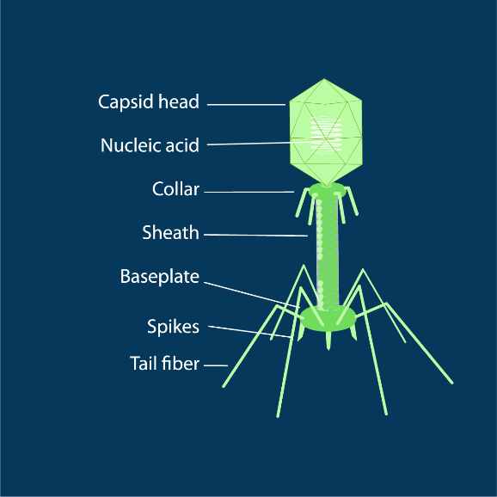
The sheath forms a hollow tube through which the viral DNA/RNA is injected into the host cell and is surrounded by protective sheath proteins. At the bottom of the sheath is the base plate to which the tail fibers (normally six) that facilitate attachment to the host cell are attached.

Fig:1

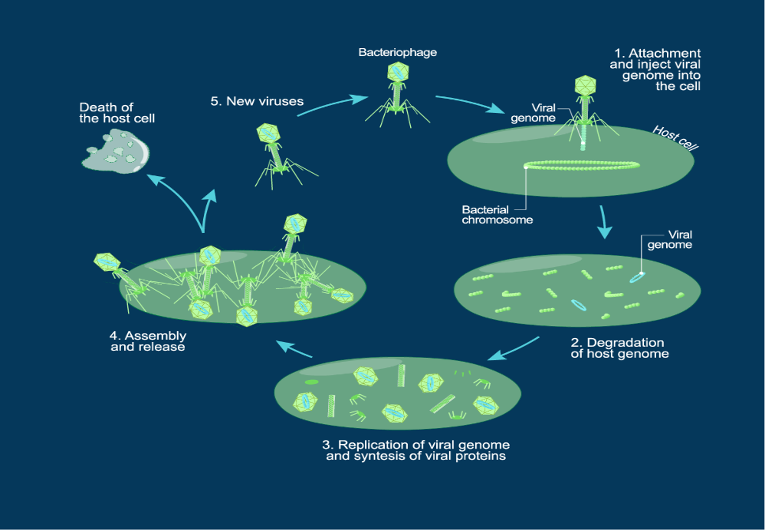
Lytic cycle: In the lytic cycle (Figure 2), sometimes referred to as virulent infection, the infecting phage ultimately kill the host cell to produce many of their own progeny. Immediately following injection into the host cell, the phage genome synthesizes early proteins that break down the host DNA, allowing the phage to take control of the cellular machinery. The phage then uses the host cell to synthesize the remaining proteins required to build new phage particles. The heads and sheaths are assembled separately, the new genetic material packed into the head and new daughter phage particles constructed. During this process, the host cells gradually become weakened by phage enzymes and eventually burst, releasing on average 100-200 new phage progeny into the surrounding environment.

Lysogenic cycle
The lysogenic cycle (Figure 3), sometimes referred to as temperate or non-virulent infection, does not kill the host cell, instead using it as a refuge where it exists in a dormant state. Following the injection of the phage DNA into the host cell, it integrates itself into the host genome, with the help of phage-encoded integrases, where it is then termed a prophage. The prophage genome is then replicated passively along with the host genome as the host cell divides for as long as it remains there and does not form the proteins required to produce progeny. As the phage genome is generally comparatively small, the bacterial hosts are normally relatively unharmed by this process.
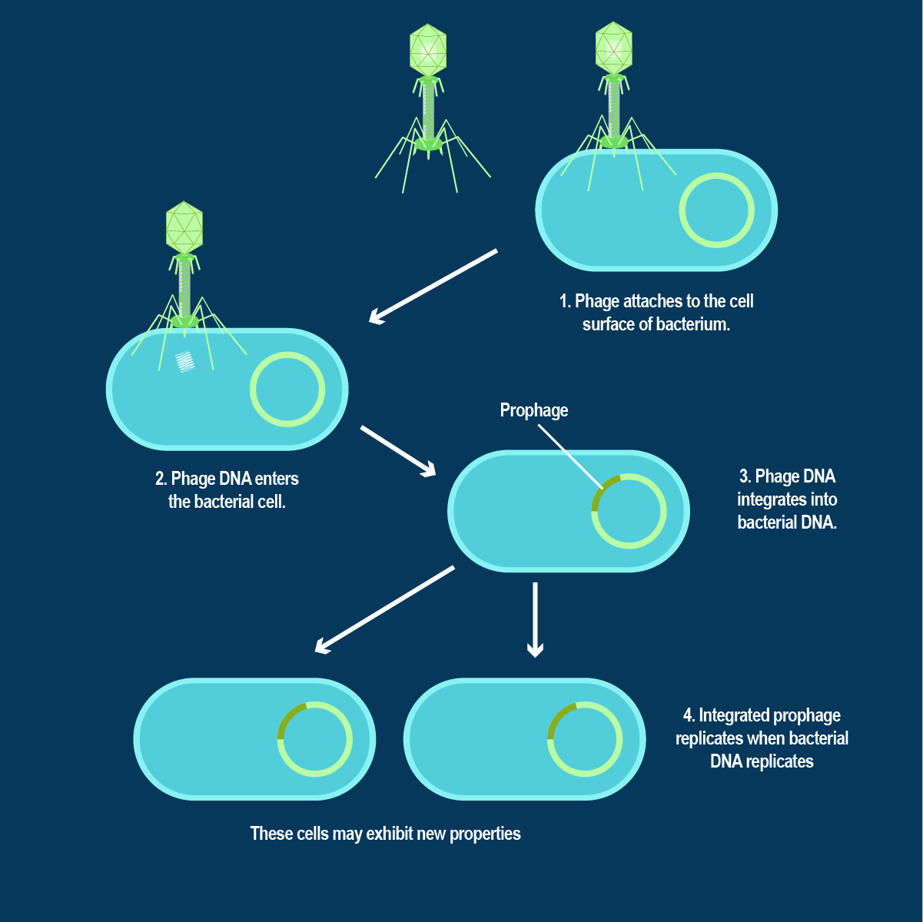

Transition from lysogenic to lytic
If a bacterium containing prophage is exposed to stressors, such as UV light, low nutrient conditions, or chemicals like mitomycin C, prophage may spontaneously extract themselves from the host genome and enter the lytic cycle in a process called induction.
This process, however, is not perfect and prophage may sometimes leave portions of their DNA behind or take portions of host DNA with them when they re-circularize. If they then infect a new host cell, they may transport bacterial genes from one strain to another in a process called transduction. This is one method by which antibiotic resistance genes, toxin and superantigen-encoding genes and other virulence traits may spread through a bacterial population.
Recent work has shown that transition between lytic and lysogenic infection is also dependent on the abundance of phage in an area as they are able to produce and sense small peptides in a process akin to quorum sensing.

