Rice: Oryza sativa L.
Family: Poaceae
Origin: China
Rice, (Oryza sativa), edible starchy cereal grain and the grass plant (family Poaceae) by which it is produced. Roughly one-half of the world population, including virtually all of East and Southeast Asia, is wholly dependent upon rice as a staple food; 95 percent of the world’s rice crop is eaten by humans. Rice is cooked by boiling, or it can be ground into a flour. It is eaten alone and in a great variety of soups, side dishes, and main dishes in Asian, Middle Eastern, and many other cuisines. Other products in which riceis used are breakfast cereals, noodles, and such alcoholic beverages as Japanese sake

Physical description
The cultivated rice plant is an annual grass and grows to about 1.2 metres (4 feet) in height. The leaves are long and flattened and are borne on hollow stems. The fibrous root system is often broad and spreading. The panicle, or inflorescence (flower cluster), is made up of spikelets bearing flowers that produce the fruit, or grain. Varieties differ greatly in the length, shape, and weight of the panicle and the overall productivity of a given plant.

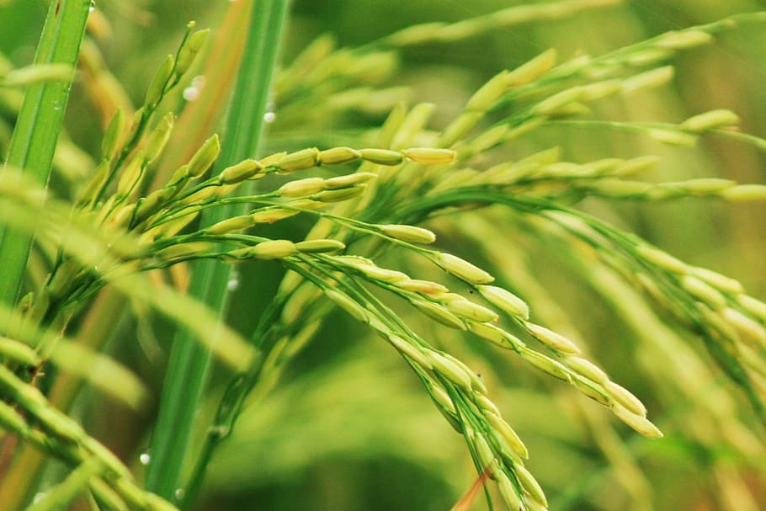
In the 1960s the so-called Green Revolution, an international scientific effort to diminish the threat of world hunger, produced improved strains of numerous food crops, including that known as miracle rice. Bred for disease resistance and increased productivity, this variety is characterized by a short sturdy stalk that minimizes loss from drooping. Poor soil conditions and other factors, however, inhibited its anticipated widespread success.

Domestication and cultivation
Many cultures have evidence of early rice cultivation, including China, India, and the civilizations of Southeast Asia. However, the earliest archaeological evidence comes from central and eastern China and dates to 7000–5000 BCE. More than 90 percent of the world’s rice is grown in Asia, principally in China, India, Indonesia, and Bangladesh, with smaller amounts grown in Japan, Pakistan, and various Southeast Asian nations. Rice is also cultivated in parts of Europe, in North and South America, and in Australia
With the exception of the type called upland rice, the plant is grown on submerged land in the coastal plains, tidal deltas, and river basins of tropical, semitropical, and temperate regions. The seeds are sown in prepared beds, and when the seedlings are 25 to 50 days old, they are transplanted to a field, or paddy, that has been enclosed by levees and submerged under 5 to 10 cm (2 to 4 inches) of water, remaining submerged during the growing season. In hilly areas rice farms are commonly terraced to keep the paddies flooded at various elevations. Successful rice production depends on adequate irrigation, including construction of dams and waterwheels, and on the quality of the soil. Long periods of sunshine are essential. Rice yields vary considerably, ranging from 700 to 4,000 kilograms per hectare (600 to 3,500 pounds per acre). Adequate irrigation, which means inundation of the fields to a depth of several inches during the greater part of the growing season, is a basic requirement for productive land use.
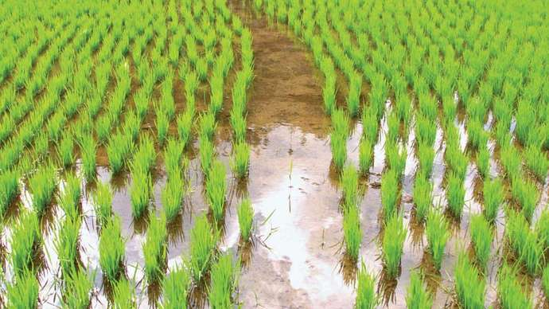

In Asia the paddy is cultivated in three main types of soil, including clays with a firm bottom within a few inches of the surface; silts and soft clays with soft bottoms becoming hard on drying; and peats and “mucks” containing peat, provided the depth of the peat is not excessive. Fields must be drained and dried before harvesting. When combine harvesters or binder threshers are employed, the grain must be dried to about 14 percent moisture so that no deterioration takes place in storage. When reaper binders are used, the crop is “shocked” in certain ways so that the grain is protected from rain.

Rice processing and uses
The harvested rice kernel, known as paddy, or rough, rice, is enclosed by the hull, or husk. Milling usually removes both the hull and bran layers of the kernel, and a coating of glucose and talc is sometimes applied to give the kernel a glossy finish. Rice that is processed to remove only the husks, called brown rice, contains about 8 percent protein and small amounts of fats and is a source of thiamine, niacin, riboflavin, iron, and calcium. Rice that is milled to remove the bran as well is called white rice and is greatly diminished in nutrients. When white rice forms a major portion of the diet, there is a risk of beriberi, a disease resulting from a deficiency of thiamine and minerals. Parboiled white rice is specially processed before milling to retain most of the nutrients, and enriched rice has iron and B vitamins added to it.
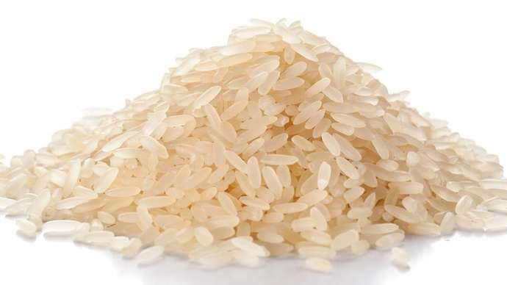

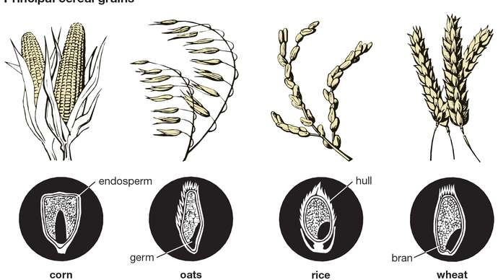
cereal grains
The kernels of the various cereal grains differ in size and shape, but their structure is similar. The hull is the sheath that encloses the kernel. The bran is the kernel's outer covering. The endosperm (80 to 85 percent of the kernel) is the embryo's food supply if the kernel germinates. The germ contains elements needed for development. When grains are milled, the hull and sometimes the bran is removed.

The milling methods used in most of Asia remain fairly primitive, but large mills operate in Japan and some other areas. Hulling of the paddy is usually accomplished by pestle and mortar worked by hand, foot, or water power. Improvements are slowly taking place. The yield of milled rice is dependent on the size and shape of the grain, the degree of ripeness, and the extent of exposure to the sun. Some large mills, handling 500 to 1,000 tons of paddy daily, have specialized hulling plants with consequent smaller losses from broken grain. They generally employ modern milling techniques and rely on controlled drying plants instead of on sun drying.
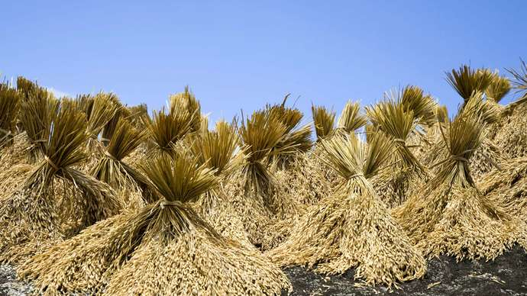

The by-products of milling, including bran and rice polish (finely powdered bran and starch resulting from polishing), are sometimes used as livestock feed. Oil is processed from the bran for both food and industrial uses. Broken rice is used in brewing, distilling, and in the manufacture of starch and rice flour. Hulls are used for fuel, packing material, industrial grinding, fertilizer manufacture, and in the manufacture of an industrial chemical called furfural. The straw is used for feed, livestock bedding, roof thatching, mats, garments, packing material, and broomstraws.

