B.Sc Second Semester
Science
Ability Enhancement CompulsoryCourse (AECC)
Environmental Science
Silapathar College, Silapathar

Dr. Lipika Lahkar
Assistant Professor
Department of Botany
Silapathar College
Silapathar
Dhemaji-787059
Assam

Definition, causes, effect and control measures of
Noise pollution, Thermal pollution
Disaster management: Floods, earthquake, cyclone and landslides

Noise pollution
Sound is a normal feature and one of the most common alarm system of human beings. Only when a sound is not liked or is unwanted, it is called as noise and when the loudness of sound is irritating or unbearable are regard it as noise pollution (ambast, 1988). Like other pollution as it has adverse effects on human as well other living organisms. The intensity or loudness of the sound is measured in terms of relative units of energy of power on a logarithmic decibel (dB) scale. The instruments measure sound level of noise pollution. Zero dB is the threshold of hearing and base line noise levels in the community around 40 dB, while international standards prescribes a maximum of 50 dB for day and 40 dB for night time in a residential area.
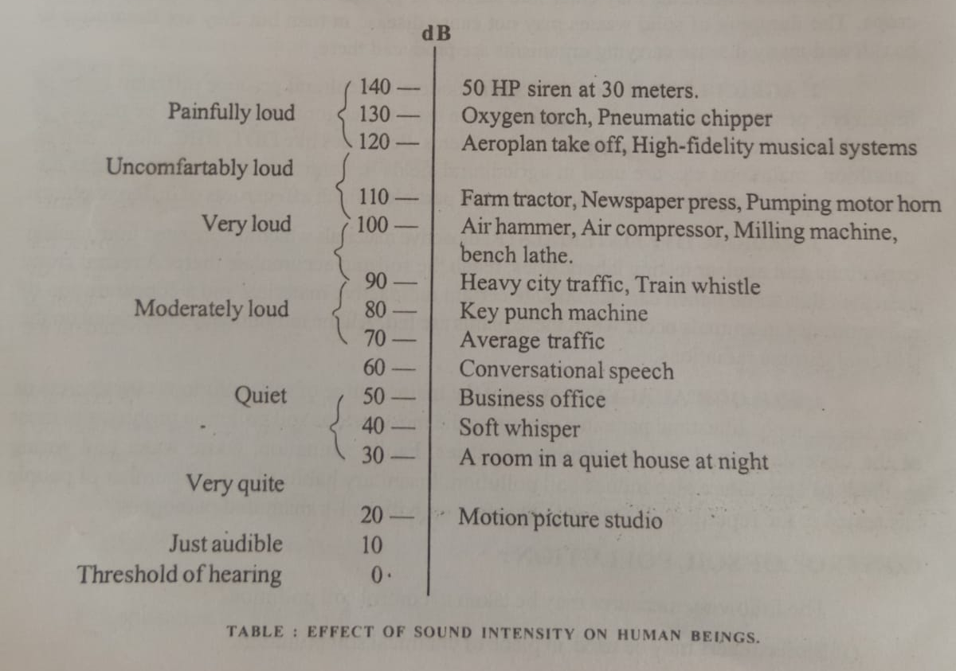

Causes of Noise pollution
Industry and transport are the main source of noise pollution. The number of road vehicles particularly diesel engine vehicles have increased enormously day by day. The noise of jet aircraft are painfully loud and the important aspects of the noise of an aeroplane is the sonic boom. It creates mental anguish and fright to animals. The noise from heavy diesel vehicles and motor cycles is the most annoying form of noise. The sound level of some music transmitted through amplifiers is also causes noise pollution. Modern civilization creates more and more noise, particularly in factories, in hospitals, at building sites, fireworks during festivals, comb blast, political rally, religious discourse on loud speakers, occasion in wedding, procession of agitating strikers etc. The power of industrial machinery has increased enormously. It is reported that noise factories can become a health hazard causing deafness.
Source of sound | Sound level (dB) | Effects
Rocket engine | 180 | Damage to hearings
Jet plane take of | 150 | Tranmatic injury
Maximum recorded rock music | 130 | Injurious range irreversible music
Newspaper press/ construction work | 110 | Progressive loss of hearing
Motor cycle | 90 | Damage begins after long exposure
Air conditioner | 60 | Irritation
Average living room | 50 | No effects
Broadcasting studio | 20 | No effects

Effects of Noise pollution
- The most immediate and acute effect of noise pollution is that impairment of hearing which is caused by the damage to some part of auditory system. Impulsive noises are generally thought to be even worse than continuous noise and capable of causing sudden damage to hearing.
- Constant noise affects human beings physically as well as mentally. It induces vasoconstriction reflex (where small blood vessels constrict and reduce the flow of the blood), dilation of the pupils, tensing of voluntary muscles, increase in blood pressur, skin to become pale and nervousness.
- It can adversely affect the development of unborn babies.
- A recent report indicated that blood is also thickened by excessive noise. Changes in breathing amplitude, eosinophilia, hyperglycamia, hypokalaemia and hypoglycaemia are also caused by change in blood and other body fluids due to noise.
- In the areas of constant barrage of sound from the aeroplanes, there is a much higher incidence of psychiatric illness.
- Noise also causes headache, irritability, affects sleep and work performance.

Control of noise pollution
- The noisy industries, aerodromes, railway stations, bus terminus should be permitted quite away from dwelling units.
- Sound absorbing materials should be used to reduce industrial noise.
- Measures should be taken to deflect the noise of the aeroplanes instead of downwards.
- Industrial workers should provided with ear-muffs and ear plugs.
- During marriages, social and religious ceremonies and other functions, loudspeakers and other sound producing gadgets should be banned, particularly during night.
- High intensity sound producing fire crackers should be banned with intermediate effect.
- Noise producing vehicles should not be allowed to play on roads.
- Plantation of trees surrounding industrial areas, on both the sides of the roads and high ways should be done. Trees can minimize noise level by 5-10 dB.
- Using cotton plugs in the ear, to move away from the source of noise and to protect ears by covering with hands under noisy atmosphere are the some of the personal protection can be taken against noise.

Thermal pollution
Thermal pollution, sometimes called "thermal enrichment," is the degradation of water quality by any process that changes ambient water temperature. Thermal pollution is the rise or fall in the temperature of a natural body of water caused by human influence. Thermal pollution, unlike chemical pollution, results in a change in the physical properties of water.
Thermal pollution is defined as a sudden increase or decrease in temperature of a natural body of water, which may be ocean, lake, river or pond by human influence. This normally occurs when a plant or facility takes in water from a natural resource and puts it back with an altered temperature. Usually, these facilities use it as a cooling method for their machinery or to help better produce their products.
Plants that produce different products or waste water facilities are often the culprits of this massive exodus of thermal pollution. In order to properly control and maintain thermal pollution, humans and governments have been taking many steps to effectively manage how plants are able to use the water. However, the effects are still lasting today.

Causes of Thermal Pollution

1. Water as a Cooling Agent in Power, Manufacturing and Industrial Plants
Production and Manufacturing plants are the biggest sources of thermal pollution. These plants draw water from a nearby source to keep machines cool and then release back to the source with higher temperatures. When heated water returns to the river or ocean, the water temperature rises sharply.
When oxygen levels are altered in the water, this can also degrade the quality and longevity of life in wildlife that lives underwater. This process can also wipe away streamside vegetation, which constantly depends on constant levels of oxygen and temperature.
By altering these natural environments, industries are essentially helping decrease the quality of life for these marine-based life forms, which can ultimately destroy habitats if they are not controlled and careful about their practices.

2. Soil Erosion
Soil erosion is another major factor that causes thermal pollution. Consistent soil erosion causes water bodies to rise, making them more exposed to sunlight. The high temperature could prove fatal for aquatic biomes as it may give rise to anaerobic conditions.

3. Deforestation
Trees and plants prevent sunlight from falling directly on lakes, ponds or rivers. When deforestation takes place, these water bodies are directly exposed to sunlight, thus absorbing more heat and raising its temperature. Deforestation is also the main cause of the higher concentrations of greenhouse gases, i.e. global warming in the atmosphere.

4. Runoff from Paved Surfaces
Urban runoff discharged to surface waters from paved surfaces like roads and parking lots can make the water warmer. During summer seasons, the pavement gets quite hot, which creates warm runoffs that get into the sewer systems and water bodies.

5. Natural Causes
Natural causes like volcanoes, geothermal vents and hot springs under the oceans and seas can trigger warm lava to raise the temperature of water bodies. Lightening can also introduce a massive amount of heat into the oceans. This means that the overall temperature of the water source will rise, having significant impacts on the environment.

6. Retention Ponds
Retention ponds can be another source of thermal shock because the water bodies that are relatively small and shallow can absorb quite a bit of heat energy from the sun.
significant temperature increase. It is similar to pouring a hot pitcher of water into a bathtub full of water that causes the water to jump a few degrees Fahrenheit.

7. Domestic Sewage
Domestic sewage is often discharged into rivers, lakes, canals or streams without treating the waste. The temperature of municipal water sewage is normally high than receiving water.
With the increase in temperature of the receiving water, the dissolved oxygen (DO) decreases, and the demand for oxygen increases, causing anaerobic conditions.

Effects of Thermal Pollution
Among scientists and scholars, there are generally two schools of thought when it comes to the effects of thermal pollution. Some lean on the side of the negatives of this pollution on marine ecosystems and how it is detrimental to positive environmental practices.
However, some lean towards the side that without these industries operating the way they do, some of the most fundamental parts of human life would be completely obsolete.
Wastewater would not be able to be properly maintained; we would have no industries that could produce the goods we need, and so on. The effects of thermal pollution on ecosystems, however, greatly outweigh the benefits that industries have by participating in the act.

1. Decrease in DO (Dissolved Oxygen) Levels
The warm temperature reduces the levels of DO (Dissolved Oxygen) in water. The warm water holds relatively less oxygen than cold water. The decrease in DO can create suffocation for plants and animals such as fish, amphibians and copepods, which may give rise to anaerobic conditions.
Warmer water allows algae to flourish on the surface of the water, and over the long term, growing algae can decrease oxygen levels in the water.

2. Increase in Toxins
With the constant flow of high-temperature discharge from industries, there is a huge increase in toxins that are being regurgitated into the natural body of water. These toxins may contain chemicals or radiation that may have a harsh impact on the local ecology and make them susceptible to various diseases.

3. Loss of Biodiversity
A dent in the biological activity in the water may cause a significant loss of biodiversity. Changes in the environment may cause certain species of organisms to shift their base to some other place while there could be a significant number of species that may shift in because of warmer waters.
Organisms that can adapt easily may have an advantage over organisms that are not used to the warmer temperatures.

4. Ecological Impact
A sudden thermal shock can result in mass killings of fish, insects, plants or amphibians. Hotter water may prove favorable for some species, while it could be lethal for other species. Small water temperature increases the level of activity, while higher temperature decreases the level of activity.
Many aquatic species are sensitive to small temperature changes such as one degree Celsius that can cause significant changes in organism metabolism and other adverse cellular biology effects.

5. Affects Reproductive Systems
A significant halt in the reproduction of marine wildlife (although this may be true, reproduction can still occur between fish – but the likelihood of defects in newborns is significantly higher) can happen due to increasing temperatures as reproduction can happen within a certain range of temperature. Excessive temperature can cause the release of immature eggs or can prevent the normal development of certain eggs.

6. Increases Metabolic Rate
Thermal pollution increases the metabolic rate of organisms as increasing enzyme activity occurs that causes organisms to consume more food than what is normally required if their environment were not changed. It disrupts the stability of the food chain and alters the balance of species composition.

7. Migration
The warm water can also cause particular species of organisms to migrate to a suitable environment that would cater to its requirements for survival. This can result in a loss for those species that depend on them for their daily food as their food chain is interrupted.

Controls of thermal pollution
Solutions of thermal pollution is required for its detrimental effects on the aquatic ecosystem in the future. A number of methods have been suggested and developed to convert the thermal effluents from power plants into useful heat resources for maximizing the benefits. The solutions to thermal discharge into water bodies are as follows:

1. Cooling Ponds
Cooling ponds or reservoirs are the simplest methods of controlling thermal discharges. In cooling ponds, heated effluents on the surface of water maximize the dissipation of heat to the atmosphere and minimize the area and volume of water.
This is the simplest and cheapest method that cools the water to a considerably low temperature. However, the method alone is less desirable as well as inefficient in terms of air-water contact.

2. Cooling Towers
After using water from water sources for cooling purposes, it is subsequently returned to the water body after passing through the condenser, which is termed as the cooling process.
Therefore cooling towers are designed to control the temperature of water to make the cooling process more effective. Cooling towers are mainly used to dissipate the recovered waste heat to eliminate the problems of thermal pollution.

3. Artificial Lake
Artificial lakes are man-made water bodies that offer a possible alternative. The heated effluents may be discharged into the lake at one end, and the water may be withdrawn from the other end for cooling purposes. The heat is eventually dissipated through evaporation. However, these lakes have to be rejuvenated continuously.

4. Water Recycling
Industrially treated water can be recycled for domestic use or industrial heating that the problem of thermal pollution can be mitigated.

5. Other Applications
The thermal discharge (rejected heat) of power plants can be used in other purposes like:
- Industrial and space heating.
- Biological applications such as soil warming.
- Fish culture, livestock shelters and heating greenhouses.
Most of these potential physical applications are applicable in colder regions or locations.
Above all else, the most important thing to consider is that the effects of thermal pollution greatly outweigh the human need for it to be done. Plants and industries have been able to find successful ways around thermal pollution, but many of them are not practicing it because it’s simply easier to work from the traditional model. If we want to promote the thriving environment that surrounds marine biology, then the attitude around thermal pollution needs to take a drastic turn.
By being aware of the causes and effects, you can have a significant impact on how these plants choose to operate, and you can opt to make the change.

