STELAR EVOLUTION
Stele is the central cylinder or core of vascular tissue in higher plants and Pteridophytes. It consists of xylem, phloem, pericycle and medullary rays and pith if present.
The term stele has been derived from a Greek word meaning rod or column. Van Tieghem and Douliot (1886) introduced this term and put forward the stelar theory. The theory suggests that the cortex and the stele are the two fundamental parts of a shoot system. Both these components (stele and cortex) separated by endodermis.
There are several types of stele found in pteridophytes which are:
- Protostele
- Siphonostele
- Solenostele
- Dictyostele
- Polycyclic stele
- Eustele
- Polystele

- Protostele

Jeffrey (1898), for the first time pointed out the stelar theory from the point of view of the phylogeny. According to him, the primitive type of stele is protostele.
In protostele, the vascular tissue is a solid mass and the central core of the xylem is completely surrounded by the strand of phloem. This is the most primitive and simplest type of stele.
- Pith is absent in protostele i.e. it is non-medullated.
- Majority of the pteridophytes show protostelic conditions in their rhizome, stem or roots.

There are five forms of protostele

- Haplostele
- Actinostele
- Plectostele
- Mixed Protostele
- Mixed Protostele with pith

- Haplostele

This is the most primitive type of protostele. Here the central solid smooth core of xylem remains surrounded by uniform layers of phloem (e.g., in Selaginella spp., Gleichenia, Lycopodium).
- Named by Brebner in 1902.
- Usually present in fossil genera like Rhynia and Horneophyton.

- Actinostele

This is the modification of the haplostele and somewhat more advanced in having the central xylem core with radiating ribs or arms (e.g., in Psilotum spp., Asteroxylon, Lycopodium serratum).
- Xylem is star shaped or stellate, hence the name.
- The phloem is not present in continuous manner.
- Phloem occurs as separate patches between arms of the xylem.
- Named by Brebner in 1902.
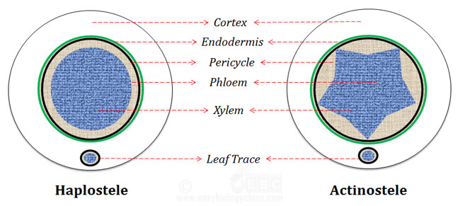

- Plectostele

This is the most advanced type of protostele. Here the central core of xylem is divided into number of plates arranged parallel to each other. The phloem alternates the xylem (e.g., in Lycopodium clavatum).
- Named by Zimmerman in 1930.
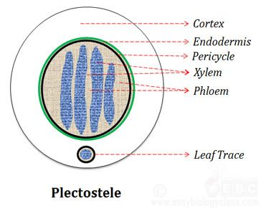

- Mixed protostele

Xylem is divided into several units or groups. Each xylem units are scatteredly arranged inside the ground mass of phloem. Example: Lycopodium cernuum.
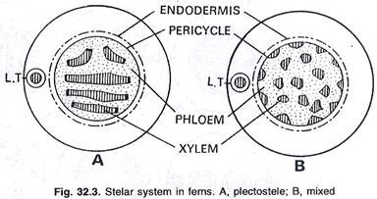

- Mixed protostele with pith

Here the xylem elements (i.e., tracheids) are mixed with the small patches of parenchymatous cells of the pith. This type is found in primitive fossils and living ferns. They are treated to be the transitional types in between true protosteles on the one hand and siphonosteles on the other (e.g., in Hymenophyllum demissum, Lepidodendron selaginoides etc.).
- Siphonostele

This is the modification of protostele. A stele in which the protostele is medullated or with pith at the centre is known as siphonostele. Such stele contains a tubular vascular region and a parenchymatous central region i.e the central core of pith is surrounded by the xylem.

Origin of siphonostele

There are different views among the scientists regarding the origin of siphonostele. But they all agreed that, the siphonostele is originated from protostele by formation of pith in the center. Here, the centrally placed xylem core is replaced with parenchymatous pith.
Different stages of changing protostele to siphonostele can be observed in the T.S. at different levels in Gleichenia, Osmunda and Anemia.
There are two views regarding the origin of pith in the siphonostele.
Jeffrey’s theory

According to this theory, the pith is formed as a result of the invasion of cortical parenchymatous cells into the stele. The invasion of pith occurs through the leaf gap or branch gap.
Thus pith and cortex are homogeneous structures according to this theory.
This theory is not accepted by most of the authors since in many pteridophytes there is stele without leaf gaps but having siphonostele.
Boodle’s theory

According to the theory proposed by Boodle (1901), and Gwynne Vaughan, the siphonostele has been evolved from the protostele by a transformation of the inner vascular tissue into parenchyma.

A siphonostele may be of the following types
(a) Ectophloic
In this type of siphonostele, the pith is surrounded by concentric xylem cylinder and next to xylem the concentric phloem cylinder.
(b) Amphiphloic
In this type of siphonostele the pith is surrounded by the vascular tissue. The concentric inner phloem cylinder surrounds the central pith. Next to the inner phloem is the concentric xylem cylinder which is immediately surrounded by outer phloem cylinder (e.g., in Marsilea rhizome).
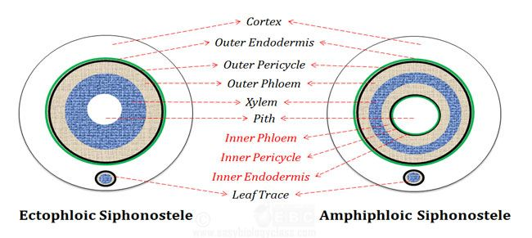

3. Solenostele
In solenostele, pith is found with one leaf gap. It may be ectophloic or amphiphloic solenostele.
(a) Ectophloic: Xylem is surrounded by only on the outer side by phloem. E.g. in Osmunda.
(b) Amphiphloic: In center, pith is found. Xylem is surrounded on both sides by phloem. E.g. Marsilea rhizome.
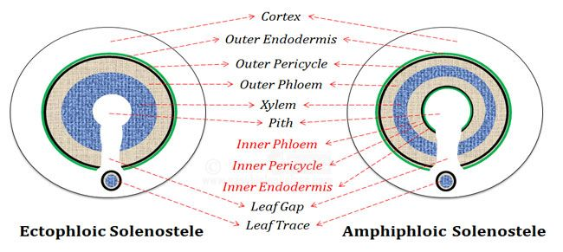

4. Dictyostele

Solenostele that is broken into a network of separate vascular strands are called dictyostele. This breaking up of stelar core is due to the presence of large number of leaf gaps.
Each such separate vascular strands is called meristele. Each meristele is of protostelic type. The dictyostele with many meristeles looks like a cylindrical meshwork.
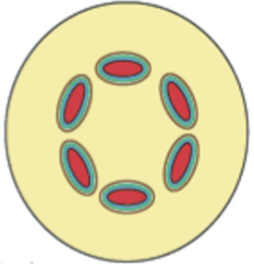Source here
Examples: Pteris, Adiantum capillus-veneris.
- Polycylic Stele

This type of stelar organization is the most complex one amongst all vascular cryptogams (pteridophytes). Such type of steles are always siphonostelic in structure.
A typical polycyclic stele possesses two or more concentric rings of vascular tissue. This may be a solenostele or a dictyostele. Two concentric rings of vascular tissue are found in Pteridium aquilinum and three in Matonia pectinata.
(a) Polycyclic solenostele
(b) Polycyclic dictyostele
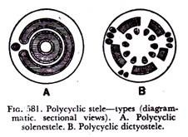

6. Eustele
According to Brebner (1902), there is one more modification of the siphonostele known as eustele. Here the vascular system consists of a ring of collateral or bicollateral vascular bundles situated on the periphery of the pith. The example of this type is internode of Equisetum.
- It is the modification of ectophloic siphonostele.
- Splitting takes place because of the overlapping leaf gaps.
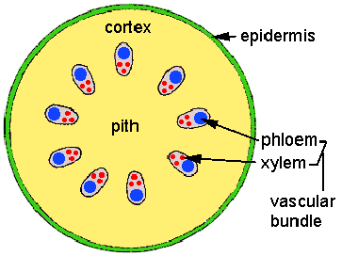

7. Polystele
More than one stele in the axis of pteridophytes is present known as polystele. It is a type that must have derived from protostele because each such stele shows protostelic condition. In Selaginella kraussiana generally two stele present. But in Selaginella laevigata as many as 16 steles are present.
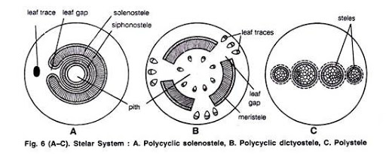

Other modifications of siphonostele
- Cladosiphonostele: No leaf gaps present. It is the simplest type of siphonostele. And found in several species of Selaginella.
- Phyllosiphonic siphonostele: Siphonostele that remain perforated by smaller or larger leaf gaps caused by leaf traces. Members of Filicophyta.

