ECOLOGICAL SUCCESSION

Ecological Succession Definition
According to E.P. Odum (1971), “the ecological succession is an orderly process of community change in a unit area”. It is the process of changes in species composition in an ecosystem over time.
“Ecological succession is a series of changes that occur in an ecological community over time.”
Ecological succession is the steady and gradual change in a species of a given area with respect to the changing environment. It is a predictable change and is an inevitable process of nature as all the biotic components have to keep up with the changes in our environment.
The ultimate aim of this process is to reach equilibrium in the ecosystem. The community that achieves this aim is called a climax community. In an attempt to reach this equilibrium, some species increase in number while some other decrease.

Ecological succession, the process by which the structure of a biological community evolves over time. Two different types of succession—primary and secondary—have been distinguished. Primary succession occurs in essentially lifeless areas—regions in which the soil is incapable of sustaining life as a result of such factors as lava flows, newly formed sand dunes, or rocks left from a retreating glacier. Secondary succession occurs in areas where a community that previously existed has been removed; it is typified by smaller-scale disturbances that do not eliminate all life and nutrients from the environment.
Primary and secondary succession both create a continually changing mix of species within communities as disturbances of different intensities, sizes, and frequencies alter the landscape. The sequential progression of species during succession is not random. At every stage certain species have evolved life histories to exploit the particular conditions of the community. This situation imposes a partially predictable sequence of change in the species composition of communities during succession. Initially only a small number of species from surrounding habitats are capable of thriving in a disturbed habitat. As new plant species take hold, they modify the habitat by altering such things as the amount of shade on the ground or the mineral composition of the soil. These changes allow other species that are better suited to this modified habitat to succeed the old species. These newer species are superseded, in turn, by still newer species. A similar succession of animal species occurs, and interactions between plants, animals, and environment influence the pattern and rate of successional change.

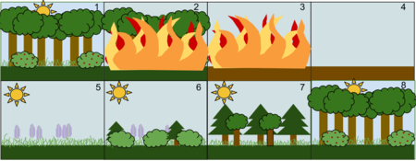

Causes of plant succession

Causes of Succession
Since succession is a series of complex processes, it is natural that there may not be a single cause for this. There are three types of cause:
- Initial or initiating cause can be climatic as well as biotic. The initial cause includes factors such as erosion and deposits, wind, fire, etc., caused by lightning or volcanic activity, and the latter includes the various activities of organisms.

- Continuing causes involve processes such as migration, ecesis, aggregation, competition, reaction, etc., which result in changes, chiefly in edaphic features of the area.

iii) Stabilising causes result in the stabilisation of the community. Clements describes it as “the climate of the area is the chief of stabilisation, other factors are of secondary value”. It can be said that the final terminal community becomes more or less stabilised for a longer period of time, which can also be called the climax community.
Autogenic succession can be brought by changes in the soil caused by the organisms there. These changes include accumulation of organic matter in litter or humic layer, alteration of soil nutrients, or change in the pH of soil due to the plants growing there. The structure of the plants themselves can also alter the community. For example, when larger species like trees mature, they produce shade on to the developing forest floor that tends to exclude light-requiring species. Shade-tolerant species will invade the area.
Allogenic succession is caused by external environmental influences and not by the vegetation. For example, soil changes due to erosion, leaching or the deposition of silt and clays can alter the nutrient content and water relationships in the ecosystems. Animals also play an important role in allogenic changes as they are pollinators, seed dispersers and herbivores. They can also increase nutrient content of the soil in certain areas, or shift soil about (as termites, ants, and moles do) creating patches in the habitat. This may create regeneration sites that favor certain species.

Mechanisms of succesion
- Nudation: Succession begins with the development of a bare site, called Nudation (disturbance).
- Migration: refers to arrival of propagules.
- Ecesis: involves establishment and initial growth of vegetation.
- Competition: as vegetation becomes well established, grows, and spreads, various species begin to compete for space, light and nutrients.
- Reaction: during this phase autogenic changes such as the buildup of humus affect the habitat, and one plant community replaces another.
- Stabilization: a supposedly stable climax community forms

COMMUNITY INVOLVED IN SUCCESSION
PIONEER COMMUNITY
First, weathering and other natural forces break down the substrate, rock, enough for the establishment of certain plants and lichens with few soil requirements, known as pioneer species, These species help to further break down the mineral-rich lava into soil where other, less hardy species can grow and eventually replace the pioneer species. In addition, as these early species grow and die, they add to an ever-growing layer of decomposing organic material and contribute to soil formation.

SERAL COMMUNITY
A seral community is an intermediate stage found in ecological succession in an ecosystem advancing towards its climax community. In many cases more than one seral stage evolves until climax conditions are attained. A prisere is a collection of seres making up the development of an area from non-vegetated surfaces to a climax community.
A seral community is the name given to each group of plants within the succession. A primary succession describes those plant communities that occupy a site that has not previously been vegetated. These can also be described as the pioneer community. Computer modeling is sometimes used to evaluate likely succession stages in a seral community
Depending on the substratum and climate, a seral community can be one of the following:
Hydrosere: Community in water
Lithosere: Community on rock
Psammosere: Community on sand
Xerosere: Community in dry area
Halosere: Community in saline body (e.g. a marsh)
Seral communities in secondary succession can be seen in a recently logged coniferous forest. During the first two years, grasses, heaths and herbaceous plants such as fireweed will be abundant. After a few more years shrubs will start to appear; and about six to eight years after clearing, the area is likely to be crowded with young birches. Each of these stages can be referred to as a seral community.
In the far western part of North America, chaparral plant communities are typically controlled by periodic natural wildfires. In the southern portion of the Coast Ranges and in Southern California chaparral, toyon is often a locally dominant taxon in seral communities transitional between coastal sage scrub

Climax concept
According to classical ecological theory, succession stops when the sere has arrived at an equilibrium or steady state with the physical and biotic environment. Barring major disturbances, it will persist indefinitely. This end point of succession is called climax.

Climax community
The final or stable community in a sere is the climax community or climatic vegetation. It is self-perpetuating and in equilibrium with the physical habitat. There is no net annual accumulation of organic matter in a climax community. The annual production and use of energy is balanced in such a community.

Characteristics
- The vegetation is tolerant of environmental conditions.
- It has a wide diversity of species, a well-drained spatial structure, and complex food chains.
- The climax ecosystem is balanced. There is equilibrium between gross primary production and total respiration, between energy used from sunlight and energy released by decomposition, between uptake of nutrients from the soil and the return of nutrient by litter fall to the soil.
- Individuals in the climax stage are replaced by others of the same kind. Thus the species composition maintains equilibrium.
- It is an index of the climate of the area. The life or growth forms indicate the climatic type.

Types of climax
Climatic Climax
If there is only a single climax and the development of climax community is controlled by the climate of the region, it is termed as climatic climax. For example, development of Maple-beech climax community over moist soil. Climatic climax is theoretical and develops where physical conditions of the substrate are not so extreme as to modify the effects of the prevailing regional climate.
Edaphic Climax
When there are more than one climax communities in the region, modified by local conditions of the substrate such as soil moisture, soil nutrients, topography, slope exposure, fire, and animal activity, it is called edaphic climax. Succession ends in an edaphic climax where topography, soil, water, fire, or other disturbances are such that a climatic climax cannot develop.
Catastrophic Climax
Climax vegetation vulnerable to a catastrophic event such as a wildfire. For example, in California, chaparral vegetation is the final vegetation. The wildfire removes the mature vegetation and decomposers. A rapid development of herbaceous vegetation follows until the shrub dominance is re-established. This is known as catastrophic climax.
Disclimax
When a stable community, which is not the climatic or edaphic climax for the given site, is maintained by man or his domestic animals, it is designated as Disclimax (disturbance climax) or anthropogenic subclimax (man-generated). For example, overgrazing by stock may produce a desert community of bushes and cacti where the local climate actually would allow grassland to maintain itself.
Subclimax
The prolonged stage in succession just preceding the climatic climax is subclimax.
Preclimax and Postclimax
In certain areas different climax communities develop under similar climatic conditions. If the community has life forms lower than those in the expected climatic climax, it is called preclimax; a community that has life forms higher than those in the expected climatic climax is postclimax. Preclimax strips develop in less moist and hotter areas, whereas Postclimax strands develop in more moist and cooler areas than that of surrounding climate.

THOERIES
There are three schools of interpretations explaining the climax concept:
- Monoclimax or Climatic Climax Theory was advanced by Clements (1916) and recognizes only one climax whose characteristics are determined solely by climate (climatic climax). The processes of succession and modification of environment overcome the effects of differences in topography, parent material of the soil, and other factors. The whole area would be covered with uniform plant community. Communities other than the climax are related to it, and are recognized as subclimax, postclimax and disclimax.
- Polyclimax Theory was advanced by Tansley (1935). It proposes that the climax vegetation of a region consists of more than one vegetation climaxes controlled by soil moisture, soil nutrients, topography, slope exposure, fire, and animal activity.
- Climax Pattern Theory was proposed by Whittaker (1953). The climax pattern theory recognizes a variety of climaxes governed by responses of species populations to biotic and abiotic conditions. According to this theory the total environment of the ecosystem determines the composition, species structure, and balance of a climax community. The environment includes the species' responses to moisture, temperature, and nutrients, their biotic relationships, availability of flora and fauna to colonize the area, chance dispersal of seeds and animals, soils, climate, and disturbance such as fire and wind. The nature of climax vegetation will change as the environment changes. The climax community represents a pattern of populations that corresponds to and changes with the pattern of environment. The central and most widespread community is the climatic climax.
The theory of alternative stable states suggests there is not one end point but many which transition between each other over ecological time.

Changes in animal life
Succession theory was developed primarily by botanists. The study of succession applied to whole ecosystems initiated in the writings of Ramon Margalef, while Eugene Odum's publication of The Strategy of Ecosystem Development is considered its formal starting point.
Animal life also exhibits changes with changing communities. In the lichen stage fauna is sparse. It comprises a few mites, ants and spiders living in cracks and crevices. The fauna undergoes a qualitative increase during the herb grass stage. The animals found during this stage include nematodes, insects larvae, ants, spiders, mites, etc. The animal population increases and diversifies with the development of the forest climax community. The fauna consists of invertebrates like slugs, snails, worms, millipedes, centipedes, ants, bugs; and vertebrates such as squirrels, foxes, mice, moles, snakes, various birds, salamanders and frogs.

Microsuccession
Succession of micro-organisms including fungi and bacteria occurring within a microhabitat is known as microsuccession or serule. Like in plants, microbial succession can occur in newly available habitats (primary succession) such as surfaces of plant leaves, recently exposed rock surfaces (i.e., glacial till) or animal infant guts,^{[15]} and also on disturbed communities (secondary succession) like those growing in recently dead trees, decaying fruits, or animal droppings. Microbial communities may also change due to products secreted by the bacteria present. Changes of pH in a habitat could provide ideal conditions for a new species to inhabit the area. In some cases the new species may outcompete the present ones for nutrients leading to the primary species demise. Changes can also occur by microbial succession with variations in water availability and temperature. Theories of macroecology have only recently been applied to microbiology and so much remains to be understood about this growing field. A recent study of microbial succession evaluated the balances between stochastic and deterministic processes in the bacterial colonization of a salt marsh chronosequence. The results of this study show that, much like in macro succession, early colonization (primary succession) is mostly influenced by stochasticity while secondary succession of these bacterial communities was more strongly influenced by deterministic factors.[

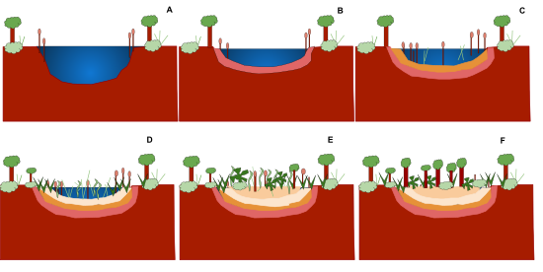
Fig. Succession stages

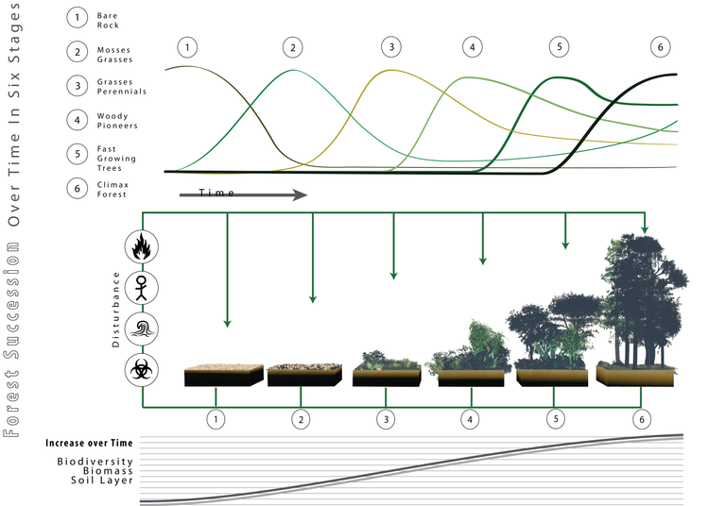

What are the main causes of ecological succession?
The main causes of ecological succession include the biotic and climatic factors that can destroy the populations of an area. Wind, fire, soil erosion and natural disasters include the climatic factors.

What is the importance of ecological succession?
Ecological succession is important for the growth and development of an ecosystem. It initiates colonization of new areas and recolonization of the areas that had been destroyed due to certain biotic and climatic factors. Thus, the organisms can adapt to the changes and learn to survive in a changing environment.

Difference Between Primary And Secondary Succession
Primary Succession | Secondary Succession
Occurs
In areas which are lifeless or barren | In areas which were previously inhabited or recently denuded
Time to complete
Around 1000 years or more | Around 50 – 200 years
Humus
Humus is absent in the starting as there is no soil | Presence of Humus due to the previous occupants and their decomposition
Solubility
Dissolves in warm water | Does not dissolve in water
Soil
The absence of soil in the initial process | Presence of soil along with organisms
Seral community
There are many intermediary seral communities | Few intermediary seral communities when compared to the primary succession
Environment
An unfavorable environment in the starting | Since beginning the environment is favorable
Examples
Bare rock, ponds, desert, etc. | The area affected by natural calamities, covered under deforestation, etc.

