UNIT: 1
Economics and the Environment
- Economic theory explains what we observe in reality, including environmental problems
- Recognize the link between economic activity and the environment using models
  - Circular Flow Model
  - Materials Balance Model

- Circular Flow Model

- Shows the real and monetary flows of economic activity through the output and factor markets.
- Forms the basis for modeling the relationship between economic activity and the environment
- But does not explicitly show the linkage between economic activity and the environment

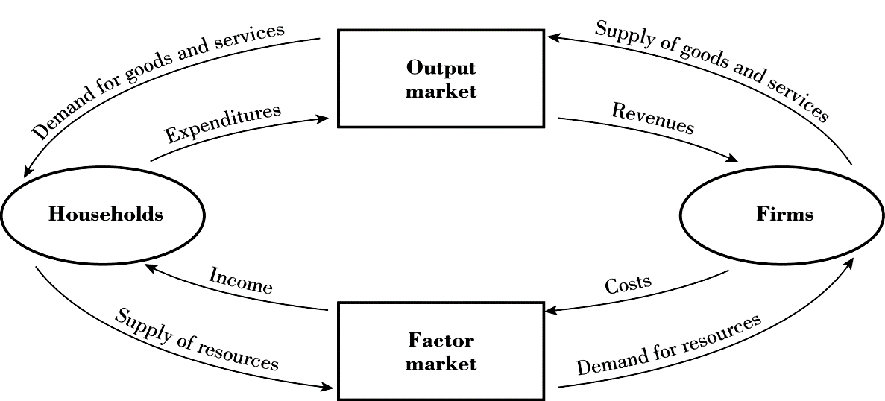

- Materials Balance Model

- Places the circular flow within a larger schematic to show links between economic activity and the natural environment via two sets of flows:
  - Flow of resources from the environment to the economy
    - The focus of Natural Resource Economics
  - Flow of residuals from the economy to the environment
    - The focus of Environmental Economics
- Residuals are pollution remaining in the environment after some process has occurred
- Residuals can be delayed, but not prevented, through recovery, recycling, and reuse. Shown as inner flows in the model

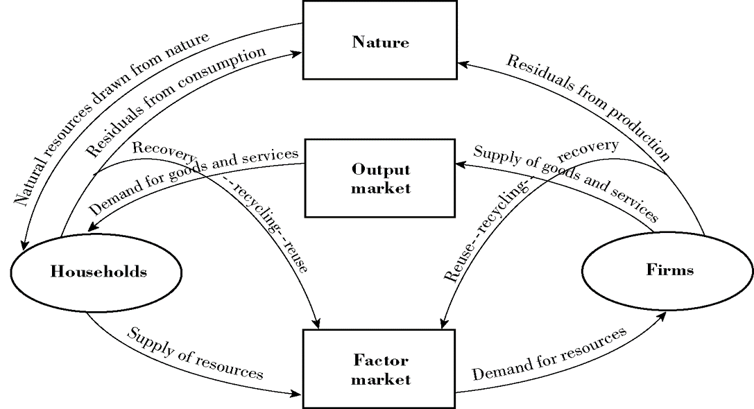

Science and the Materials Balance Model

- The flow of resources and residuals are balanced according to laws of science.
- First Law of Thermodynamics
  - Matter and energy can neither be created nor destroyed
- Second Law of Thermodynamics
  - Nature’s capacity to convert matter and energy is not without bound

**********************************************************

