**Unit 1:Microbes**

**Viruses**

Virus can be defined as “**noncellular , submicroscopic, obligatory intracellular parasites composed of a proteinaceous covering around central nucleic acid (either DNA or RNA) and capable of self –replication within the living host cells**.” The word virus is a Latin word **Viron** which means ‘**poison**’ or ‘**slime**’ and it was considered to be the word always associated with some diseases or harmful influence. The study of virus is called **virology** and the specialists in the field are called **virologists**.viruses are found within living cells of plants and animals iincluding man. They are also found in bacterial cells which are called bacteriophage.

**Discovery of virus**

The tobacco crop in Holland was struck by a severe disease around 1870. Although, viral diseases like small-pox and yellow fever are known since early days of human history, the nature of their causes was, however, known quite late. Adolf Meyer, Dutch agricultural chemist in1886 observed a mottling disease in leaves of tobacco plants and named it **Mosaikkrankhet** i.e. **mosaic**. He could show the infectious nature of sap of diseased leaves. He was able to demonstrate that the clear filtrate obtained by passing the juice (obtained by grinding the diseased leaves in water) through double filter paper was infectious (i.e. caused disease when applied to healthy leaves). Since the capacity of causing disease was lost by heating 80°C, he concluded that bacteria were the cause of the disease.

D. Iwanowaski, a Russian in1892 was the first to discover a viral disease in plants because he demonstrate for the first time about the tobacco mosaic virus transmission to healthy plants through the sap from diseased plants even though the sap had been passed through the filters fine enough to remove all bacteria. However, no living thing capable of profucing tobacco mosaic grew from the filtered sap of diseased plants on any culture medium. Beijerinck in 1898 in Holland found that the filterable, invisible and noncultivable infectious principle would diffuse through an agar gel, like a fluid. He thought the fluid itself alive, and called it **contagium vivum fluidum** i.e. a living infectious fluid.

Viral diseases of vertebrates were well known by 1892, since Louis Pasteur had been studying canine rabies for some time. He indicated the cause of this disease as a virus was then commonly used for a variety of infectious agents, including bacteria.

Loeffler and Frosch in 1898, showed that the agent of foot-and- mouth disease of cattle, like TMV, passed through bacteria retaining filters, and was neither visible with microscope nor cultivable on inanimate media. In **1900 Walter Reed** and his associates discovered the virus of **yellow fever**, the first viral disease of man. Today many viral diseases of vertebrates are known.

Viruses that attack bacteria were first described in 1915 by the British scientist, Twort and were independently observed and more fully studied around 1917 by a French, d’Herelle who named them as **bacteriophage**. The term **phage** is commonly used. Subsequent studies of many animals, bacteria and higher plants revealed the existence of hundreds of other viruses.

The major breakthrough in viral history was made in 1930’s providing details on physical and chemical nature of viruses. The first virus was purified in 1933 by Schlessinger using differential centrifugation. A few years later in 1935 Stanley (Nobel Prize winner) isolated tobacco mosaic virus (TMV) in paracrystalline form- major advance in nature of life that could be crystallised. In 1937 Bawden and Pirie extensively purified TMV and showed it to be nucleoprotein containing RNA.

**physiochemical** **Characteristics of virus**

The three properties of virus were thought to be unique and absolutely distinctive of virus. These are ultramicroscopic nature (i.e. invisible with optical microscope), filterable (as they could pass through unglazed porcelain and other bacteria retaining filters) and noncultivable on inanimate media. However, if these features are view in the light of present day development in microscopy, ultracentrifugation, cultural techniques etc it will be seen that none of these three characteristics is valid. Structural details of virus are well known by means of high power electron microscope. They can now be easily retained on specially prepared molecular filters made of very fine pore collodion or plastic material and are thus nonfilterable. They can now be easily propagated in living culture media at least.

In light of these developments, viruses can be characterized as follows:

1. They are not free living in nature, and occur only as obligate intracellular parasites
2. They have only a single kind of nucleic acid either DNA or RNA, but never both
3. Nucleic acid is a single molecule i.e. one replicon, which may be single or double stranded.
4. The outer shell capsid is mostly of protein, except a few animal viruses where additional polysaccharides are also present.
5. They can be propagated in living culture media only.
6. They contain no metabolic enzymes or protein synthetic machinery of their own. They use host machinery of their own. They use host machinery for synthesis of their proteins.
7. They replicate, they do not grow, but their nucleic acid directs the host cell to make various part of virus and then to assemble these parts into complete, infectious particles. **Virions.**

**Biological characteristics/Nature of virus/Why virus is called puzzle of biological world?/Virus are in between living and non-living organisms-Discuss**

Viruses are obligate parasite and have two phases in their life cycle, one within the cell of other organism and the other organism and the other outside the body of another organism.

1. They are very small without any cellular structure and cytoplasmic material.
2. They can pass through the bacteriological filter.
3. They synthesize their structural material with the help of the enzymes of the host when they are within the cell of the host organism.
4. Reproduction by means of replication of genes.
5. They become active and multiply only as parasite.

There are some controversies regarding the nature of virus. They exhibit both living and non-living characteristics which are described below.

1. They have their own genetic material (DNA or RNA).
2. They reproduce using the metabolic machinery of the host cell which they infect.
3. They can undergo mutations.
4. They are disease producing particles and live as obligate parasite.
5. They get destroyed by treatment of pepsin and ultraviolet.

Viruses may be considered as non-living because

1. They have no cellular structure.
2. They can be crystallized and stored in bottles like crystals.
3. They lack enzyme system and donot have metabolic activity of their own.
4. They cannot be grown in artificial culture media.
5. Viruses donot have any independent existence
6. They donot respire.
7. No fat is present in the body of viruses.

According to another view viruses are neither living nor non-living, they are between living and non-living. The reasons are:

1. Viruses are protein molecules
2. Viruses behave as living organisms when they are within living bodies and behave as non-living inanimate chemical particles when they are come into contact with any non –living organisms.
3. Enzymes present, but incapable of synthesizing new viral parts.

From the above discussion we have seen that they are neither living nor noon-living objects, but between living and non-living objects with biological puzzle.

**General structure**

Viruses are not cellular and, therefore, do not have a nucleus, cytoplasm or cell membrane. Unlike all cellular forms of life their particle contains only one kind of nucleic acid, DNA or RNA. In each particle as seen in an electron micrograph, there is a central **core** of nucleic acid surrounded by a protein coat called, a **capsid**. The capsid is made up of many identical structural units, the **capsomeres**. The composition, number and form of capsomeres vary with the kinds of viruses. The core with its capsid is called the **nucleocapsid** of the virus. Many viruses have outside the capsid also an envelope or limiting membrane, usually of lipids or lipoproteins. Such viruses are also called **lipoviruses**. The amount of nucleic acid in virus particle varies from 1-50%.

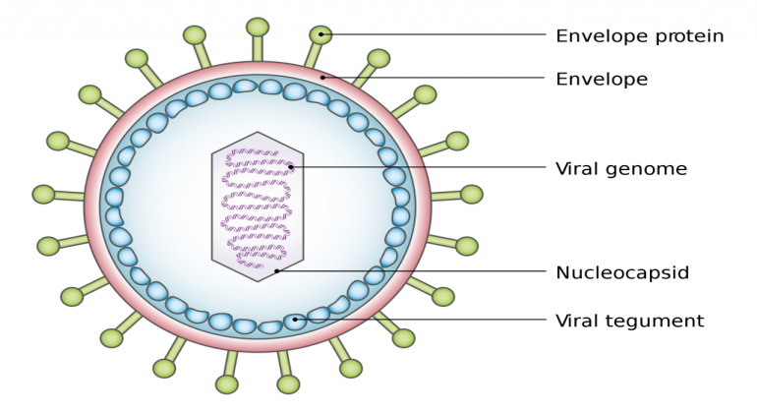

Fig: a diagrammatic representation of different components of a virus

**Shape and size**

Viruses exhibit considerable variation in shape and size. Under electron microscope, it has been observed that the diameter of viruses range from 8 µ to 300µ. Foot and mouth disease creating viruses of domestic cattles are the smallest (8-12 µ) while Vaccinia (smallpox) and Variola type of virus particles are the largest (280-300 µ).

The shape of plant viruses can be divide into two general categories-

1. Anisometric- The viruses are rigid rod shaped wit long flexuous. Eg. TMV
2. Isometric- These type of viruses are spherical or polyhedral having 20 sides. E.g. polio virus.

The negative staining method revealed that viruses fall into three main symmetry groups. These are-

1. Cubic symmetry- it has cubic symmetry. Each particle is an icosahedrons. The electron micrograph shows that the surface of the particle is composed of regularly arranged structural units resembling tiny balls. E.g. adenovirus (associated with respiratory disease in man), herpes virus (cold sores in man).

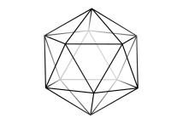

Fig: Cubical virus

1. Helical symmetry- the capsomeres are elongated structures arranged in a helical manner. Eg tobacco mosaic virus (TMV).

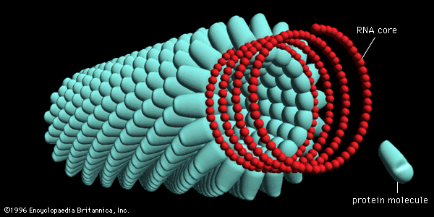

Fig: Helical virus

1. Complex symmetry- this virus has a head of shape of a bipyramidal hexagonal prism. Attached to one end of the prism is a tail structure consisting of a helical contractile sheath surrounding a central hollow core. Eg. T2 and other T even virus, pox virus.

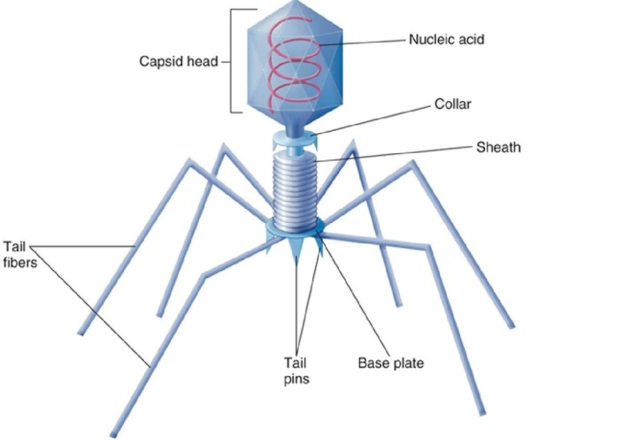

Fig Complex virus

**Viroids**

Viroids are distinct low molecular weight nucleic acids that could be isolated from certain plants affected with specific diseases. Unlike viral nucleic acids their capsid is lacking. Viroids are smallest known agents of infectious disease. So far viroids are definitely known to exist only in higher plants, and to consist of RNA only.

At first viroids was discovered in attempts to purify and characterize the causative agent of potato spindle tuber. Diener (19717) introduced the term viroid to denote it and agents with similar properties. A dozen diseases of higher plants are now known to be caused by viroids. Some of these are

1. Potato spindle tuber
2. Citrus exocortis
3. Chrysanthemum stunt
4. Chrysanthemum chlorotic mottle

**Structure of viroids**

Viroids are single stranded, covalently circular as well as linear RNA molecules that occur because of extensive regions of intramolecular complementarity. Viroid RNA molecule are so small that the largest one (CEV- Citrus exocortis viroids) is only 371 nucleotides long about one tenth of the size of the smallest RNA virus. The complete primary sequence of potato spindle tuber viroid (PSTV) has been determined and a model for the secondary structure has been proposed by Gross et. al. (1978). According to this model viroids exist in their native configuration as extended rod-like structures characterize by a series of double helical sections and internal loops. Thus the rigid rod like structure of the native viroid is based on a defective rather than homogeneous RNA helix. From a plant physiological view point, viroids may be regarded as abnormal products of plant metabolism.

**Prions (Slow Virus)**

Prions are proteinaceous particles to cause a number of diseases including the slow virus diseases. Prions were named by Stanley B.Prusiner (1982). It can survive heat, radiation and chemical treatments that normally inactitivate viruses. They composed with protein only. The viruses cause in there hosts a range of infections viz. acute, chronic, persistent slow progressive and tumorgenic infections. This slow viruses are involved in slow progressive diseases.

The term prions refers to abnormal pathogenic agents that are transmissible and are able to induced abnormal folding of specific normal cellular proteins called prion proteins that arefound most abundantly iin the brain nervous system.

The concept of prionn was first understood from the work of Gajdusek in1966, while examining the transmission of ‘kuru’ a neurological disease in chimpanzee. The prions are actually the misfolded proteins with the ability to transmit their misfolded shape onto normal variant of the same protein. They characterize several fatal and transmissible neurodegenarative diseases in human and in many other animals. It is not known what causes the normal proteins to misfold. The word ‘prion’ is derived from “protein aquous infectious particle” Some important human prion diseases are Creutz-Jacob Feldt-Jacob disease (CJD), Fatal Familial insomnia etc.

**DNA virus/Bacterial Viruses/Bacteriophages (T-phage)**

Viruses that infect bacteria are called bacteriophages. The other word bacteriophage means eater of bacteria. The most insentive group of phages belong to the T-series, numbered from 1-7 which attack the non-motile strain of *E.coli*. The bacteriophage capable of destroying *E.coli* is called coliphage. The types of coliphage have been designated as T1, T2….T7. The best known and thoroughly studies phages are T2,T4 and T6 are collectively called T even bacteriophages.

The T-even phages have a todpole shape wit a hexagonal head and a long cylindrical tail. The head consists of tightly packed core of nucleic acid surrounded by protein sheath. The tail is made up of a hollow core enveloped by a contractile sheath. The terminal end of the tail connects the head at the head end with a thin disc called ‘collar’. The nucleic acid, in the head of T-even phages is double stranded DNA. The DNA molecule is about 50000nm long and 2.4 nm in diameter. The tail is hollow tube, enveloped by proteinaceous sheath. The end plate is hexagonal.

**RNA virus (TMV)**

TMV is a rod shaped virus. Each particle is elongated is elongated, cigarette-like in form,. Each rod is about 3000A° (300 nm) long and of 150A° (15nm) diameter. In each rod, there are about 2130 protein subunits – the **capsomeres**, The capsomeres are closely packed and arranged in a helical manner around the RNA helix, forming a hollow cylinder. Thus, there is a hollow core (axial hole) of about 4nm (40A°) diameter which runs the entire length of the rod and it contains the RNA. The RNA does not occupy the hole but is deeply embedded in the protein subunits, thus having its own helix. RNA is single stranded molecule in the form of a long helix extending the entire of the particle. The protein amounts about 95% of the total substances of the rod and the remaining 5% is RNA. The proteins are of high molecular weight, of about 40 million, RNA provides a code which directs the synthesis of specific viral proteins in the host cell.

There are about 16.33 protein subunits in each helical turn, and three turns of the helix contain about 49 capsomeres. Each capsomere has a molecular weight of about17,300 and arranged in the virus with a pitch of 23A°. The capsid has all amino acids found in other plant proteins. Each capsomere contains about 168 amino acid molecules.

The particles were crystallized by Stanley (1935) who found that crystals were highly infectious. It was known later that RNA alone in infectious. The viron may remain infective for about 50 years and can withstand boiling for about minutes.

The particles infect tobacco leaves. It is transmitted and introduced into the host cells by vectors like *Myzus pseudosolani*.

**Replication (general account)**

The process of reproduction is commonly known as replication. It is quite different from the reproduction found in cellular organisms. It is not definitely known that how reproduction in viruses takes place. Only in bacteriophages the reproduction process is well known which is, therefore, accepted as the stranded process of reproduction in virus. The process of reproduction of bacteriophage can be divided into four steps. They are – a) Infection, b) Synthesis of phage components in the host cells, c) Assembly of new phage particle and d) Liberation of phage particles from the host cells.

First of all the phase (virus) attaches itself to the wall surface of the bacterium with the help of tail fibres and then nucleic acids are transmitted into the host cell through a specific site known as receptor sites. Immediately after landing on the host surface the tail fibres bend and bring the end plate of the phage in contact with the bacterial cell wall. The nucleic acid of the phage flows into the host cell through the hollow centre of the tubular needle. After transfer of the nucleic acid, the protein shell of the phage remains attached to the host cell which is called ghosts. The released nucleic acid then controls all the metabolic activities of the host cell and allows only to manufacture that type of protein which are the constituent of new phage materials. At the time of protein synthesis nucleic acid and replication takes place. As a result numerous molecules of viral nucleic acid and sub-units of viral capsid are accumulated in the host cell. The protein coats (capsids) are assembled around phase DNA till large numbers of virus particles are formed. Finally the natural virus particles are liberated from the bacterial cell by rupturing the cell wall through the action of viral enzyme. This method of liberation is termed as lysis.

The entire cycle of phage development is completed within 30-90 minutes. In an infected bacterium 7-8 phage particles are formed per minute and a total of about 200 phages are formed is a bacterium.

**Growth cycle of Bacteriophages (Lytic and Lysogenic cycle)**

Two different types of growth cycles are seen in bacteriophages e.g. **lytic and lysogenic cycle**. Lytic cycle is seen in **virulent phages** which are typified by T-series, in this cycle the sensitive bacterium **lyses** and large number of newly formed virus particles are released. In the lysogenic cycle the virus (temperate phage) does not liberated fromm the host cell and host cell **donot die**.

1. **Lytic cycle** – This type of cycle is seen in T-series of phages which attack E.coli. the stages are-
2. **Attachment to the host**- The phage particle is came in contact with the bacterial cell. The tail plate of the phage is attached to the surface of a susceptible host bacterium along with tail fibres.
3. **Adsorption**- this phenomenon of the virus particle is a specific process. The phage particles are adsorbed because of the presence of some complementary chemical group onn the terminal base plate of the phage on the receptor sites on bacterial wall.
4. **Penetration into host**- Adsorption is followed by penetration of the phage nucleic acid (DNA) into the bacterial cell.
5. **Replication of viral nucleic acid**- After the penetration of DNA, the production of its DNA many replication takes place. Enzymes are also involved in the replication of nucleic acid. This replication in the double stranded DNA viruses occur in the nuclear material of the host cells. This replication process changes in the metabolism of the host cell.
6. **Protein synthesis**- the phage DNA controls the protein synthesis mechanism of the cell and forms viral messenger RNA and through them the proteins. Some proteins are utilised as enzymes for the synthesis of viral DNA. Proteins of capsid (protein coat) are also synthesized.
7. **Assembly of new virions**- in the bacterial cell the DNA of the phage and protein of its head and tail are synthesized separately. Firstly, the phage DNA forms a compact polyhedron and then packed into the head then tail structure is added by. In this way new virion is assembled.
8. **Release of virus from the cell**- During this process of the replication of phage, thr bacterial cell wall becomes weakend. Next the phage enzyme act on the weakend bacterial cell wall releases the mature daughter phages. So in bacteria such liberation takes place by lysis (i.e. by sudden rupture) of the host cell wall through the action of viral enzyme (lysozyme).
9. **Lysogenic cycle**- This type of cycle was discovered by A. Lwoff (1953) which occur in Lambda ( λ) phages attacking *E.coli*. the phages that exhibit lysogenic cycle are called temperate phage and the bacteria in which it occurs are termed as lysogenic strain – the entire process is called lysogeny. Here the host cell do not lyse and virus particles are not formed also, moreover a type of symbiotic association develops which is called lysogenic state. The phage at first is adsorbed on the host cell wall and the phage DNA after injection enters the cell. Here the viral genome does not take over the host cells protein synthesis machinery, instead the viral genome which becomes integrated with the bacterial genome- in this integrated state the viral genome is called a prephage. The new genome compossed of viral and bacterial genome (DNA), replicates as one unit and daughter genome (DNA) are passed on to the offsprings. In this way virus genome continue multiplying in the daughter lysogenic bacteria indefinitely.

However, very rarely such association of viral and bacterial genomes breaks down and the viral genome is released into the cytoplasm- this dissociation is called induction. After release, the viral genome enters the lytic cycle and forms mature temperate phages. Temperate phages are released by lysis of the host cell wall.

**Classification**

classification of viruses is very difficult due to their ultra microscopic size, absence of fosil records and they exhibit both living and non-living characteristics. Initially viruses were classified on yhe basis of their host, physiological characters. In 1962 Lwoff, Horne and Tournier proposed a system of classification of virus known as LHT system and this system was accepted by the International Committee for Virus Nomenclature in 1966. The main criterias of their system of classification were- type of nucleic acid, molecular weight of the virus , shape and size of virus, symmetry of capsid, presence or absence of envelope around the capsid , diameter of the coil of nucleic acid, intercellular multiplication and symptom of virus on host. The following is an outline of this system of classification.



**Baltimore Classification**

Baltimore’s classification was developed by David Baltimore, is a virus classification system that groups viruses into families depending on their type of genome [DNA, RNA, Single stranded (ss), Double stranded (ds)] and their method of replication.

Baltimore divided viruses into 7 classes

1. Ds DNA viruses- eg. Adenoviruses, poxviruses.
2. Ss DNA viruses- + strand or sense DNA. Eg. Parvoviruses.
3. Ds RNA viruses- eg. Reoviruses.
4. Ss RNA viruses- + strand or sense RNA eg. Picornaviruses, Novel corona viruses (COVID-19).
5. (-) ssRNA viruses- - strand or antisense RNA. Eg. Orthomyxoviruses.
6. Ss RNA-RT viruses- + strand or sense RNA with DNA intermediate in life cycle
7. dsRNA-RT viruses- DNA with RNA intermediate in life cycle. Eg. Hepadnaviruses.

**Importance of Virus**

Viruses are the disease causing agents and they are also used as tools in genetic analysis. Now a day virology (study of Viruses) is emerging as an independent branch of science. It has occupied an important place in molecular biology and genetic engineering. Viruses also responsible for various plant and animal diseases which cause great economic losses by reduction in yield and quality of plant products. In industry viruses are used for the production of vaccine which are used against viral infections to develop immunity. From the study of viruses we may determine about the origin of life form on earth as viruses hold a key position in the living world. Scientists are now trying to use viruses to control pathogens biologically.

**Unit4: Introduction to Archegoniates (2 lectures)**

Unifying features of archegoniates; Transition to land habit; Alternation of generations.

**Unifying features of archegoniates**

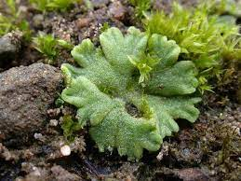

Archegoniate

1. The archegoniates are a small group of primitive land dwellers. They have leafy or thalloid, green plant body which is small in structure.
2. The vegetative body is completely adapted to the land habit. However they still rely on water for sexual reproduction.
3. The plant body lacks true roots, stem or leaves. It is relatively simple thallus like. It grows prostrate on the ground and is attached to the substratum by delicate, unbranched, unicellular hair-like organs called rhizoids.
4. The most conspicuous phase in the life cycle is the gametophyte. It is independent and concerned with sexual reproduction.
5. Archegoniates lack vascular tissue.
6. Sexual reproduction is of oogamous type. The sex organs are jacketed and multicellular.
7. Female sex organ are in the form of an archegonium.
8. The sperms are biflagellate. Both the flagella are of whiplash type.
9. Fertilization takes place in the presence of water.
10. The fertilized egg is retained within the venter of the archegonium
11. Zygote undergoes repeated division to form an undifferentiated, multicellular structure called embryo.
12. The venter wall enlarges with the developing embryo to form a protective, multicellular envelope, the calyptras.
13. The embryo by further division and differentiation produces a relatively small spore producing structure called sporogonium.
14. The sporophyte is without differentiation into stem and leaves. It is rootless and consists of a foot, a seta and a capsule.
15. The sporophyte is simpler than gametophyte and is attached to the parent gametophyte throughout its life.
16. The sporogonium is concerned with the production of wind-disseminated , non-motile, cutinized spores which belong to the category of gonospore or meiospores.
17. Morphologically the meiospores in a given species are of one kind. Thus archgoniates are known as homosporous.
18. Each spore on falling on a suitable soil germinates to give rise to the gametophyte plant either directly or indirectly as a lateral bud from the protonrema.
19. The occurance of heterologous type life is a constant feature.

**Transition to land habit**

Archegoniates grow in water and land, two well defined habits. The plants are growing in water called aquatics and the others are terrestrial. The aquatic plants are algae and the land dwellers are seed plants. Between these two extremes of habitats there is a **transitional zone**. It is represented by the **swamps** and the areas where water and land meet. It may be called **amphibious zone**. Inhabiting the ambhibious zone is archegoniates are **nonvascular** plants. These are simple thallus like algae through which terrestrial plants evolved. Most of the archegoniates are land dwellers inhabit damp, shaded and humid localities. However a few are living in or float on water. The **aquatic habit** acquired by these plants **secondarily**. When the water dries up they grow equally well on the drying mud. Some, of course, can withstand long periods of **drought**. During the dry period they become almost brittle texture. With the onset of rainy season the apparently dried, brittle thalli turn green and become active to carry out the normal life functions. Even these **apparently xerophytic** species grow actively only during the wet weather.

Archegoniates, simple cryptogams in which zygote divides by mitosis and forms embryo. Embryo – the sporophytic phase depends upon gametophyte for nutrition and support. These are amphibions of the plant kingdom.

Evidences supports the view that these early land plants descended from alga-like ancestors which were probably green. Adaptation to land environment or sub-aerial life involved the development of certain features that were not possessed by their aquatic ancestors. These are-

1. **Development of organs for attachment and absorption of water-** archegoniates develop special hair like structures called rhizoids that function as absorbing and attaching organs.
2. **Protection against desiccation-** The thick, compact multicellular, thallus-like plant body covered with an epidermis is protected to a certain extent against the drying effects of air. Further even the free surface of the epidermal cells, in some species is coated with waxy substance like cutin which is water proof and thus reduces the rate of water loss. Moreover, total surface area of a compact body is reduced in proportion to its volume.
3. **Absorption of carbon dioxide from the atmosphere for photosynthesis-** In many species there are numerous pore on the upper surface of the thallus. These are called the air pores. They facilitate gaseous exchange between the atmosphere air and the interior of the thallus.
4. **Protection of reproductive cells from drying and mechanical injury** – The sex organs in the archegoniates are multicellular and jacketed. The jacket of sterile cells around the sperms and eggs is an adaptation to a life on land. It protects the sex cells against the drying effects if air.
5. The fertilized egg retained within archegonium. Here it obtaines food and water from the parent plant and is protected from drying as it develops into an embryo. This adaptation is essential for the survival of the land plants. It ensures nursing of the young embryo and its protection against mechanical injury.
6. The thick walled, wind disseminated spores and the primitive vascular system in the form of a conducting strand are the other adaptation to land habit.

**Alternation of generations**

The life cycle of archegoniates is very interesting. It is split up into two phases, each represented by a separate adult. Thus in life cycle there occur two distinct multicellular, vegetative individuals. One of these is the green thalloid (liverworts) or leafy (mosses) plant. The other is the sporogonium. The green individual is an independent plant.

It is haploid and bears the sex organs (antheridia and archegonia) which produce the gametes (sperm and eggs). As it bears the gametes the green, independent individual is called the gametophyte. It is concerned with sexual reproduction. The gametophyte plant along with the structures produced by it constitutes the gametophytic generation. In the life cycle it starts with the information of meiospores and consists of the green individual and the sex organs. The last structures formed during this phase are the gametes. The gametes fuse to form the zygote.

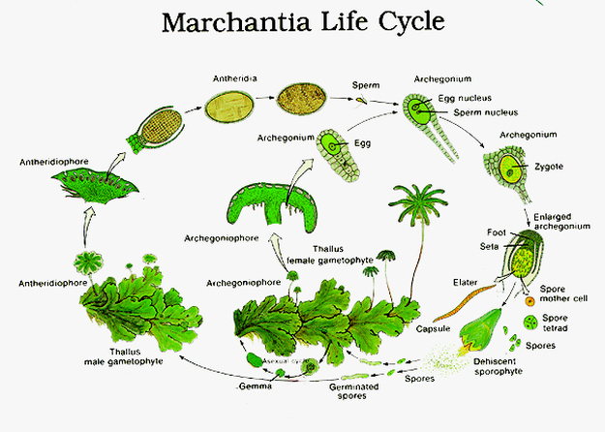

Fig: Alternation of generation of Archegoniates

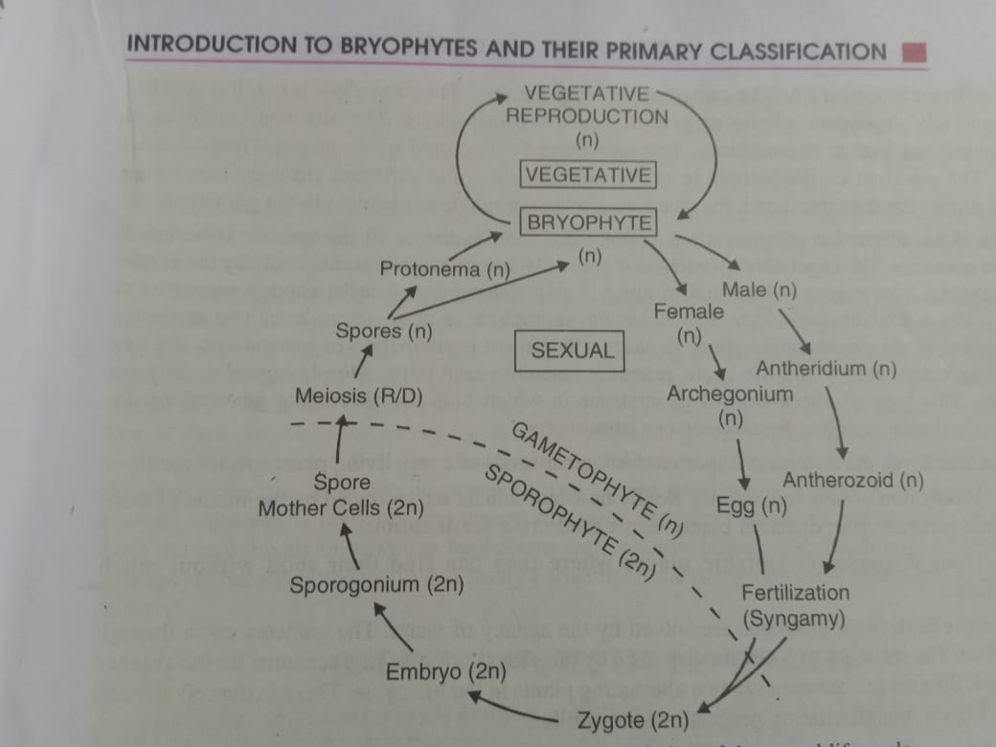

Fig: Diagramatic representation of alternation of generation of Archegoniates

The zygote, on germination, doesnot produces the gametophyte plant. It undergoes segmentation to form an embryo. The embryo by further segmentation and differentiation gives rise to the second adult called the sporogonium. It remains diploid and is usually differentiation into foot, seta and capsule. In due course of time, the diploid spore mother cells produced in the capsule give rise to haploid spores (meiospores) by meiosis. As the sporogonium is concerned with the production of spores it is called the sporophyte. The zygote, the embryo and the sporogonium together constitute the sporophyte generation. Moreover, it is dependent for its nutrition wholly or partially on the gametophyte plant to which it is attached organically throughout its life. On germination each spore produces a gametophyte and not a sporophyte plant.

From the account given above it is evident that on germination the reproductive cells of one generation give rise to the alternate generation in the life cycle. The two generations thus regularly alternate with each other in a single life cycle. This biological phenomenon is called alternation of generations. It is defined as the alternation in the life cycle of two distinct vegetative individuals with different functions. Cycles of this type characterized by alternation of generation and sporogenic meiosis are termed diplohaplontic life cycles.

In archegoniates alternation of generations becomes as integral part of the life cycle. Moreover, the alternating individuals in the life cycle of archegoniates are morphologically dissimilar. They differ not only in their structure but also in their physiology (nutrition). This kind of alternation of generations in which the alternating individuals are dissimilar is called heterologous or heteromorphic. The gametophyte is independent. The sporophyte is not. It is attached and generally dependent wholly or partially on the gametophyte.

**Unit 7: Gymnosperms** **(18 lectures)**

General characteristics, classification (up to family), morphology, anatomy and reproduction of *Cycas*, *Pinus* Developmental details not to be included); Ecological andeconomic importance.

**Gymnosperms**

Gymnosperms (gymnos= naked, sperma=seed), with over 63 genera and about 722 living species. Gymnosperm includes all autophytic green plants having their exposed seeds on megasporophylls i.e. carpels. The systematic position lies in between pteridophyta and angiospermae.

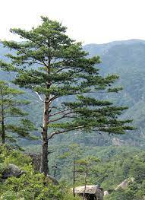 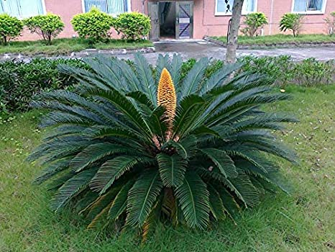

**General characteristics features of Gymnosperms**

1. Plants are sporophytes, majority are tall woody, perennial and evergreen trees, rarely shrubs. Sporophytes are larger in size and independent, true roots, stems and leaves present. Plants are heterosporous producing male and female gametophyte.
2. Two types of leaves are present- one brown small scale leaves called microsporophylls and other green foliage leaves called megasporophylls.
3. At the time of pollination, pollen grains (microspores) are directly carried by wind to the micropyle of the ovule.
4. Gametophytes are much smaller but more conspicuous than those of angiosperms. The male gametophyte i.e. microgametophyte mostly consists of one or two prothalial cells, a tube nucleus, a stalk cell (except *Gnetum*) and two male gamete. The male gametophyte is a multicellular structure bearing one or more archegonia (except *Gnetum*).
5. Male gametes are either ciliated and motile as in *Cycas, Ginkgo* etc. or nonciliated and nonmotile as in *Pinus, Gnetum* etc.
6. Number of cotyledons varies from one to many.
7. True seeds are always present. Seeds are borne uncovered or naked.
8. Endosperm formation takes place within female gametophyte before fertilization.
9. Flowers are unisexual, simple, reduced and naked i.e. without perianth. Male and female flowers are represented by mico and mega sporophyll respectively. Mico and mega sporophylls are aggregated forming male and female cone or strobili respectively. Megasporophylls are simply leaf like structure.

**Comparative account of gymnosperms and pteridophytes**

|  |  |  |
| --- | --- | --- |
| Sl. no | Gymnosperms | Pteridophyte |
| 1 | True Roots | Advetitious root |
| 2 | Stems aerial | Stems are underground rhizome |
| 3 | Heterosporous producing micro and megaspores | Usually homosporous but in some cases heterosporous |
| 4 | Seeds are naked | No seeds |
| 5 | Secondary growth takes place | Secondary growth does not takes place |
| 6 | Pollen tube produced due to germination of pollen grains. | No formation of pollen tube due to germination of spores. |
| 7 | Megasporangium is protected by integument | Megasporangium is not protected by integument |
| 8 | Nack canal and neck canal cells are absent in archegonia except *Gnetum*. | Nack canal and neck canal cells are present in archegonia |

**Characters resembling gymnosperm and pteridophytes**

1. Plant body is differentiated into root stem and leaves, they exhibit heterosporous life cycle.
2. In vascular elements i.e. xylem and phloem- xylem is without trachae (except *Gnetum*, some species of *Selaginella* *Pteridium*) phloem is without companion cell.
3. Gametophytes are very reduced and developed within the spore wall, female gametophyte contain archegonia (except *Gnetum*)
4. Embryo development starts with free nuclear division of zygote-nucleus (except *Gnetum*)
5. In the life history, sporophytic and gametophytic generations alternate regularly with each other.
6. In some heterosporous pteridophytes one megaspore is present within the megasporangium, like gymnosperms
7. Have ciliated sperms (*Cycas* and *Ginkgo*).

**Comparative account of gymnosperms and Angiosperms**

|  |  |  |
| --- | --- | --- |
| Sl. No. | Gymnosperms | Angiosperms |
| 1 | Plants are woody perennial trees or shrubs | Plants are annual, bi-annual or perennial hurbs, shrubs or trees- either woody or herbaceous |
| 2 | Xylem generally consists of tracheids and xylem parenchyma and phloem of sieve tubes and phloem parenchyma | Xylem generally consists of tracheids, tracheae and xylem parenchyma and phloem consists of sieve tubes, companion cells and phloem parenchyma |
| 3 | Leaves are two types i.e. green foliage and brown scale leaves | Only green foliage leaves present |
| 4 | Flowers are unisexual, simple and without perianth (except Gnetum) | Flowers are unisexual or bisexual with or without perianth |
| 5 | Carpels (megasporophylls) are not differentiated into stigma, style and ovary | Carpels are modified to form stigma, style and ovary |
| 6 | Ovules are freely exposed on carpels, hence seeds are remain naked | carpels form an ovarian chamber in which ovules are enclosed, consequently seeds remain closed within fruit |
| 7 | At the time of pollination pollen grains are directly carried by wind to the micropyle of the ovule | Pollen grains are carried by various agents and are deposited on the stigma- not directly to micropyle, as ovules are enclosed within the ovary |
| 8 | Embryo consists of one or more cotyledons. Here several embryos develop in each ovule, although one embryo survive, thus they are polyembryonic | Embryo consists of 1 or 2 cotyledons. Here 1 embryo develop in each ovule, although one embryo survive, thus they are not polyembryonic |

**Phylogenetic relationship of the gymnosperms**

The gymonsperms are generally divided into two main groups, *viz*. *Cycadophyta* and *Coniferophyta*. Most of the authors suggest that both groups originated from the filicinae of the pteridophyta, but it is still an unsettled question as to whether the two groups had a common origin or whether the two groups arose independently from different groups of Filicinae. Of course the pteridospermae (Cycadofilicales) i.e. seed ferns possess numerous fern-like characters. It is also reasonable to suppose that the orders Bennettitales and the Cycadales were derived from the Pteridospermae. The Cordaitales either evolved independently or they had a common origin with the Pteridospermae, anyway the Cordaitales probably gave rise to the Coniferales and the ginkgoales. The order Gentales may represent an offshoot from the Coniferophyta.

**Affinities of Gymnosperms**

The gymnosperms have close affinities with pteridophytes on the one hand and the angiosperms on the other.

The sporophyte and gametophytic generations in both pteridohytes and gymnosperms alternate with each other, but gymnosperms have more reduced gametophytic generations, here the gametophyte is unlike that of ferns as it is totally dependent upon the sporophyte. The cycads shows affinity with ferns in the compound nature of their leaves and in circinate vernation- both are also alike in the absence of companion cells in phloem and tracheids in xylem (except *Gnetum*). In heterospory, gymnosperms resembles *Selaginella, Isoetes, marsilea* etc. members of Cycadales show affinity with pteridophytes in presence of multiflagellate motile sperms.

Gymnosperms resemble angiosperms in habit (shrubs or tree-like), in unisexual apetalous (**flower** having no petals) flowers represented by microsporophylls (stamens) and megasporophylls (carpels), in presence of pollen tube for carrying male gametes to the egg, retention of megaspore inside the megasporangium and its development into female gametophyte.

**Classification**

Sahni (1920) has divided the gymnosperms into two groups, viz.

1. Phyllospermae (plants with leaf-borne seeds)-It includes 3 orders e.g. pteridospermae (Cycadofilicales), Cycadales and Bennettitales (Cycadeoidales),
2. Stachyospermae (plants with stem borne seeds) – it includes 4 orders e.g. Cordaitales, Ginkgoales, Coniferales and Gnetales.

Pilger and Melchior in the 1954 edition of Engler’s *Syllabus der Pflanzen familien* have classified Gymnosperms as follows



K. R. Sporne (1965) has also followed the classification of Pilger and Melchior

Cronquist, Takhtajan and Zimmermann (1966) have proposed a classification system in this system the subkingdom Embryophyta (embryo bearing plant) has been divided into eight divisions. All gymnospermous plants are grouped in the division *Pinophyta*.

Sub-kingdom Embryophyta

Division- Pinophyta (=Gymnospermae)

Subdivision A. Cycadicae (=Cycadophyta)

Class1. Lyginopteridatae (=Cycadofilicales)

,, 2. Cycadatae (=Cycadales)

,, 2. Bennettittae (=Bennittitales)

Subdivision B. Pinicae (=Coniferophyta)

Class1. Ginkgoatae (=Ginkgoales)

,, 2. Pinatae

Sub ,, i) Cordaitidae

Sub ,, ii) Pinidae (Coniferales)

Subdivision C. Gneticae (=Gnetales)

Sub Class1. Ephedridae

,, 2. Welwitsciidae

,, 2. Gnetidae

C.J. chamberlain (1935), based on morphological and anatomical characters, classified gymnosperms into two main groups, such as-

I. Cycadophyta, II. Coniferophyta

I. Cycadophyta- Plants are comparatively smaller in size. Stem is unbranched , leaves are large and pinnate compound . stem in transverse section shows i) a large pith, ii) scanty and soft wood and iii) a thick cortex. Sporophylls are in simple cones.

Cycadophyta are again divided into three orders, viz.-

1. Cycadofilicales- All are extinct
2. Bennettitales- includes extinct members
3. Cycadales- Includes both extinct and living members, e.g. *Cycas*, *Zamia* etc.

II Coniferophyta- Plants are comparatively larger in size, stem is branched, leaves are simple. Stem in transverse section shows i) a small pith, ii) dense and massive wood and iii) a thin cortex. Microsporophylls are in simple cones while megasporophylls are in compound cones.

Coniferophyta includes 4 orders-

1. Cordaitales- All are extinct
2. Ginkgoales- Except one species all are extinct, the living one is *Ginkgo biloba*
3. Coniferales- This great order contains many extinct and living members e.g. *pinus, Thuja, Taxus* etc.
4. Gnetales- It includes mainly living genera such as *Gnetum* etc.

**Economical importance of gymnosperm**

The tuber and seeds of *Cycas circinalis* produced arrowroot (a starch obtained from the rhizomes), a type of sago. Sometimes the seeds and young shoots are also taken as food. The stem produces gum. The juice of the tender leaves is supposed to be helpful for reducing vomiting. *Cycas revolute* also recognised as an important plant in the decoration of the garden. It is also said to be a tonic, helps expectoration. The resin of *Cycas ramphii* is used for the treatment of ulcers.

The woods of Pinaceae are of great commercial importance. *Pinus* produces a good quality of timber, which is used as building material, fuel, in making furniture, poles, shingles, packing cases, match boxes, pencils etc. Several species of *Pinus*, of which, *Pinus roxburghii*, commonly called ‘chir’, is the principal source of methyl alcohol, turpentine and resin. The resin is also internally used in connection with stomach troubles and as a remedy for gonorrhoea. It is extremely applied as aplaster to inflamed swelling of the glands and for the collection of pus in the cavity. It is also used as timber. The seeds of *Pinus gerardiana*, commonly called chilgoza, are eaten after roasting. It is very nourishing. Oil is also obtained from the seeds, which is applied for dressing wounds and ulcers. Some *Pinus* species produces pulp for the paper industry. The woods of *Pinus wallichiana* is superior in quality to that of *Pinus roxburghii* and yields resin. An essential oil produced by the leaves and wood of *Pinus insularis* is used as fuel. The seeds of *Pinus edulis* are consumed by human beings. The fossilised resin of *Pinus succinifera* (now extinct) is known as amber (hard translucent fossilized resin), which is of great commercial value and even used in jewellery.

Ephedra produces a medicine called ephedrine, which is used against asthma and bronchial trobles.

The seeds of *Gnetum gnem*on and *G latifolia* are edible. The seeds are taken as food after roasting or boiling and rejecting the yellowish red outer coat of fruit. The seed-kernel is crushed, moulded to form cakes or biscuits. After drying in the sun it is fried in the boiling oil. The young leaves and inflorescences are eaten as vegetable. The bark of the plant produces a fibre, which is strong, durable in sea water and has a good tensile strength both in dry and wet condition. It is used for fishing nets and lines. Ropes prepared from it are strong, flexible and light. The wood is used for anchoring posts for rafts and junks (a Chinese vessel). Split branches can be used for basket. The seeds of *Gnetum ula* are also edible and produce a cooking oil, used for edible purposes. *Gnetum montanum* is able to kill fish i.e they poses pesticidal properties.

**Ecological importance of gymnosperm**

The gymnosperms are a group of plants that includes the conifers, cycads, gnetophytes, and ginkgo. Each one of them contributed to the economical and ecological values. Of the four gymnosperm groups, the conifers are by far the predominant group, dominating forest ecosystems over most of the temperate and boreal zones of the Earth as well as widespread within tropical mountains. Conifers differ from angiosperms in a variety of ways that have implications for their ecological roles; for instance, conifers rely on aromatic hydrocarbons to deter herbivory and disease, are wind pollinated, grow relatively slowly, and live to relatively great ages. Conifer wood is light and easily worked, so humans have exploited the group from the earliest times, and it remains economically important across a spectrum of economic systems and cultures; thus applied conifer ecology is broad field of study. Nonetheless, the conifers are also an emotionally significant group of plants, and people of many cultures seek to protect and restore these plants and their habitats.

The **Conifers**are the most familiar gymnosperms which include pines, spruces, firs, cedars, hemlocks, yews laches, cypresses, and others. The pine have tough and needle like leaves. The leaves which have a thick cuticle and recessed stomata, represent a evolutionary adaptation for retarding water loss. They are important because many of trees grow in areas where the topsoil is frozen part of the year, making it hard for the roots to obtain water. And since conifers are almost trees, they create forests that provide habitat for wildlife. They are important economically because they provide wood and used it in making buildings, furniture and paper. And for ecological values the leaves of the conifers give them an advantage over broad-leafed tree in cold environment. Since the leaves of most conifers are evergreen, they can carry on photosynthesis on sunny winter days when most broad-leafed trees are leafless. They also have the advantage of not having to use the extra energy every year to produce a new crop of leaves in Spring.

The **Cycads**are slow-growing gymnosperms of tropical and subtropical regions. But even though they lived in that particular region they can cope up with dryness since their thick leaves lose little water. And when the leaves die, their stiff leaf bases remains. The **Gnetophytes**are the only gymnosperms with vessels in their xylem. They are use as folk medicines.

These plants are very useful in making furniture’s and for other construction purposes. They are the sources of food to animals and human. The strong roots of gymnosperm prevent from soil erosion. Gymnosperm plants are also scientifically important because they provide lots of evidence about the past. Beside these points, gymnosperm is also used as lumber.  
They are also used to make perfume, oil, nail polish and many more. Foliage leaves rich in organic acids. Decomposition makes soil acidic and relativley low in nutrients. Strongly affects plant species that can grow. Acidity hinders bacteria but favour fungi. Foliage and wood high in secondary compounds that inhibit grazing animals

***Cycas***

**Classification (up to family)**

Division- Cycadophyta

Order- Cycadales

Family- Cycadaceae

**Distribution-** The genus *Cycas* with at least 15 or 20 species is widely distributed. Its species are distributed abundantly in Australia, India, South China and South Japan.

In India 4 species of *Cycas* are found to occur- these species are, *Cycas circinalis, Cycas pectinata, Cycas rumphii, Cycas beddomei*. Besides these *Cycas revoluta*, in India is grown as an ornamental garden plant.

**Morphology-** *Cycas* is a small arborel (like) tree, looking like palm trees or a tree-fern. Therefore, *Cycas* is also called ‘palm fern’.

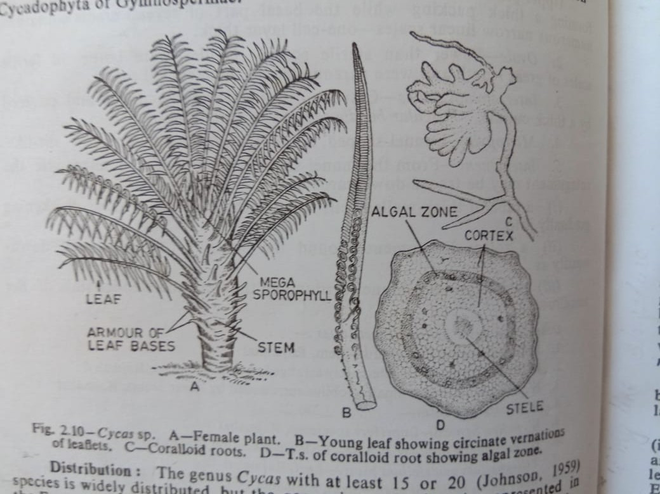

1. **Root**- *Cycas* plants posses a normal tap root system in the beginning. This tap root system is short-lived and later on is replaced by a number of adventitious roots. The adventitious roots develop a few negatively geotropic lateral roots which come out of the soil surface. These roots get infected by bacteria members of blue- green algae, possibly *Anabaena cycadacearum*, within the root cortex- as a result, the infected roots become distorted (twisted out of shape) producing a mass of exposed tubercles (prtruberance) which look like a coral or knob (rounded lump or ball). Hence such type of root is known as **coralloid root** or **corallorhiza.**
2. **Stem-** The stem is stout (strong), columnar (column like), erect (straight), unbranched and covered by armour (covering) of persistant leaf bases. They bear at the apex, a crown of large foliage leaves. The stem bears large adventitious buds carried with scales at the base often called bulbils, which helps in vegetative propagation.
3. **Leaves-** Leaves are dimorphic i.e. i) brown scale leaves and ii) large green pinnately compound foliage leaves are arranged spirally at the top of the stem forming crown. The foliage leaves are very large. Each pinnate leaf bears on its rachis several closely set leaflets. Leaflets are tough and leathery, they are sessile with a narrow base each leaflet shows only a single midvein without lateral veins and veinlets.

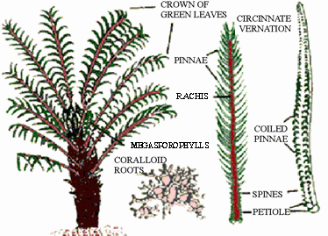

**Anatomy**

**Stem-** In transverse section the stem of *Cycas* assumes an irregular outline because of the presence of numerous armoured leaf bases. It shows in transverse section a relatively massive pith, extensive cortex and a scanty zone of wood between pith and cortex. The vascular cylinder i.e. is an endarch (xylem outside) siphonostele (eustelic type) like that of a dicotyledonous type.

The vascular bundles are conjoint (xylem and phloem are arranged together), collateral (Xylem is towards inner side and phloem towards outside) and open, primary xylem is endarch, in seedling stage xylem is mesarch. The vascular bundle is arranged in a ring around a massive central pith, pith is composed of parenchyma cells which contain starch and secretory ducts. Cortex is composed of thin walled parenchyma cells. Presence of leaf trace griddles in the cortex is another important feature of *Cycas*. A leaf trace often arising from the stellar cylinder generally does not enter into the nearest leaf directly, but the leaf trace form as a griddle or semicircle round the stem before entering the next leaf situated a little above. As those traces goes round the stem, so they are called girdling traces or indirect traces. Usually a number of leaf traces enter each rachis of a leaf. Both the cortex and pith contain numerous mucilage canals which are interconnected through leaf gaps. Medullary rays occur in between the vascular bundles.

Secondary increase in thickness in stem takes place but generally little amount of secondary wood is formed. The mode of secondary growth is anamolous.

In the comparatively older stem, there may be the formation of such 10-12 alternate rings of wood and bast (fibrous material from a plant). In addition to the rings of bundles, there may be developed accessory bundles both in pith and cortex resulting in the complicated arramngement of tissues in older stem. Periderm formation in cortex takes place.

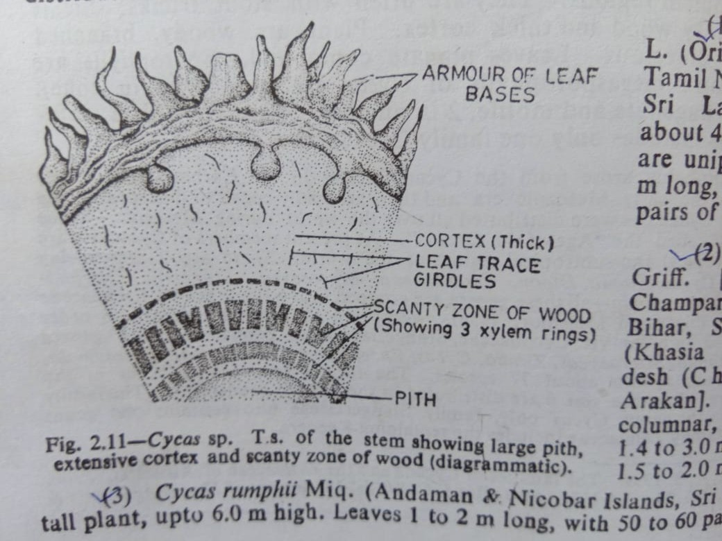 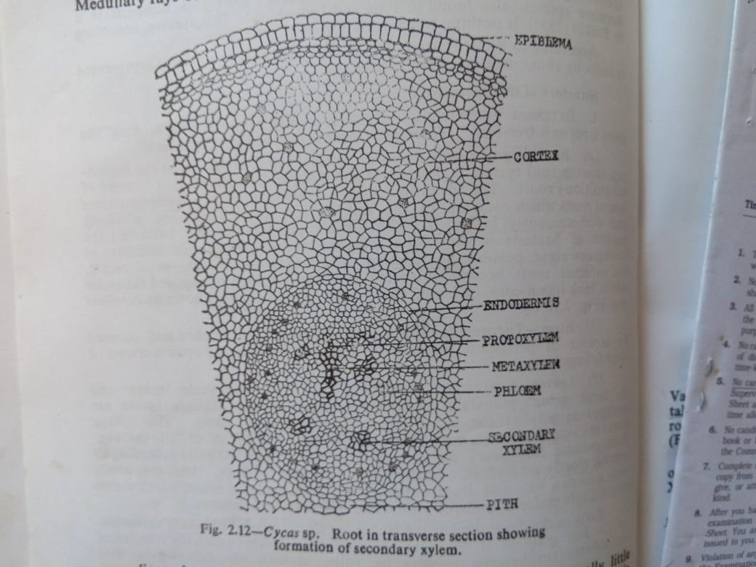

**Root-** In young stage, the root in transverse section shows an outermost thin layer called epiblema, a multilayered parenchymatous cortex containing mucilage canals and a central vascular cylinder i.e. stele. Cortex is internally limited by a single layered endodermis with companion strips. Pericycle is multilayered. Stele is tetrarch generally. Vascular bundles are radial, xylem is exarch. Secondary growth takes place early, but secondary wood formation is irregular. Coralloid roots have one or rarely more than one layered thick algal zone in the cortex.

**Petiole**- The petiole of the leaf in transverse section shows a large number of collateral bundles, often showing an inverted omega shaped arrangement. Xylem is situated on the upper side and the phloem below

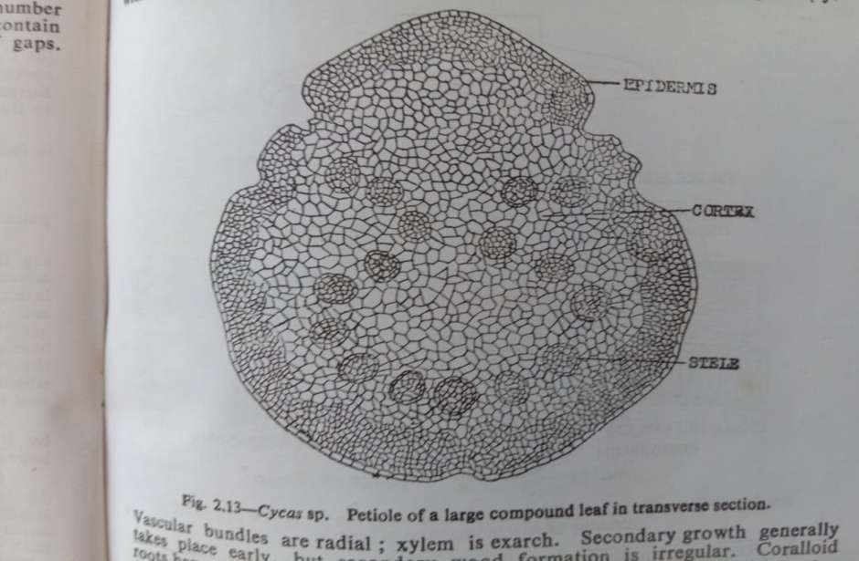 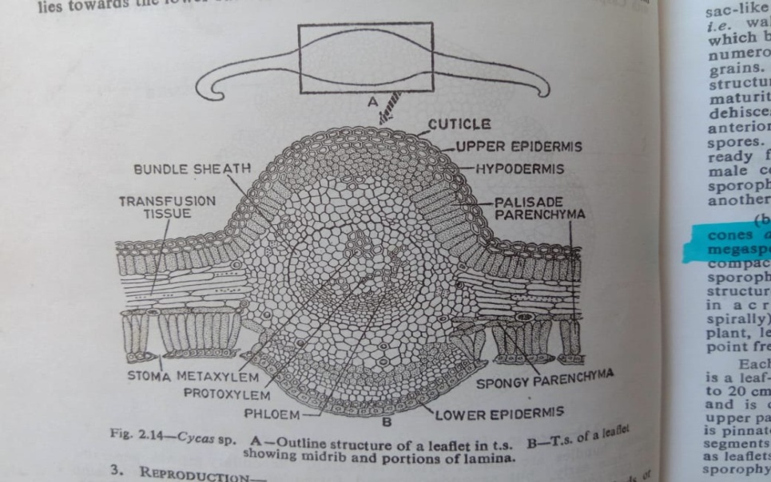

**Leaflet-**

The anatomy of the leaflet is interesting as it reveals xerophytic structure. The transverse section of a leaflet shows two cuticularised epidermal layers, one is upper and the other lower. The upper epidermis forms a continuous layer composed of oval or tubular cells. Beneath the upper epidermis, one or two layer of sclerenchymatous cells forming hypodermis is present. Beneath the hypodermis a row of palisade tissue consisting of elongated columner cells full of chloropalsts is present. Below the palisade tissue, scanty spongy parenchyma cells containing chloroplasts may or may not occur. Above the lower epidermis there lies spongy parenchyma tissue consisting of loosely arranged oval cells full of chloroplasts. Sunken stomata are present only in the lower epidermis. Lower epidermis may have palisade cells. Most important features of a *Cycas* leaflet is the presence of **transfusion tissue** (transport the material between vascular bundles and the mesophyll) in between upper pallisade and lower spongy layers. Transfusion tissue is arranged parallel to the epidermal layers. Transfusion tissue is composed of several layers of transversely elongated, thin-walled, colourless, short and wide cells, this tissue probably serves for lateral conduction.

There is only vascular bundle corresponding to the median vein (midrib) of the leaflet. The vascular bundle is encircled by sclerenchymatous sheath. Xylem is mesarch, it is directed towards the upper surface, phloem lies towards lower surface.

**Reproduction of *Cycas***

Vegetative reproduction takes place by the help of adventitious buds or bulbils, which commoly arise on trunk.

Cycas plants are dioecious as the male and female flowers (reproductive structure) occur on different plants. Flowers are unisexual and simple, male flowers are represented by microsporophylls (stamens) and female by megasporophylls (carpels), only microsporophylls are arranged in clusters forming compact cones i.e. strobili. The megasporophylls are loosely arranged and therefore no compact cone formation occurs.



**Male cone**

Male cone is compact structure, cylindrical or ovoid in form and woody in texture. Each cone is very large and upto 50 cm in length. The cone develops singly or a few at the growing apex of the stem but it becomes lateral in position by the growth of lateral bud.

Each cone consists of a central axis upon which several microsporophylls are compactly and spirally arranged in acropetal succession. Each microsporophylls measuring about 3-5 cm long and 12-23 mm wide, is a flattened and wedge-shaped woody structure. The basal narrow part is sterile while the flat distal portion is fertile. Beyond the fertile part of the microsporophylls, there is an expanded sterile part, often called ***apophysis***. On the under surface (i.e. abaxial surface) of the fertile portion numerous microsporangia (pollen sacs or one-lobed anthers) are borne in groups, i.e. in sori. Each sorus contains 3-6 microsporangia. The development of microsporangia is of eusporangiate type. Microsporangia are intermingled with hairs. Each microsporangium is almost sessile, unilocular, oval, sac-like structure. Microsporangium is provided with a multilayered jacket i.e. wall and a tapetum enclosing numerous microspores mother cells which by reduction division form numerous microspores i.e. pollen grains. Microspores are simple in structure and without wings. On maturity each microsporangium dehisces by a longitudinal slit at its anterior end to release the microspores. When microspores are ready for shedding, the axis of the male cone elongates and microsporophylls get separated from one another.

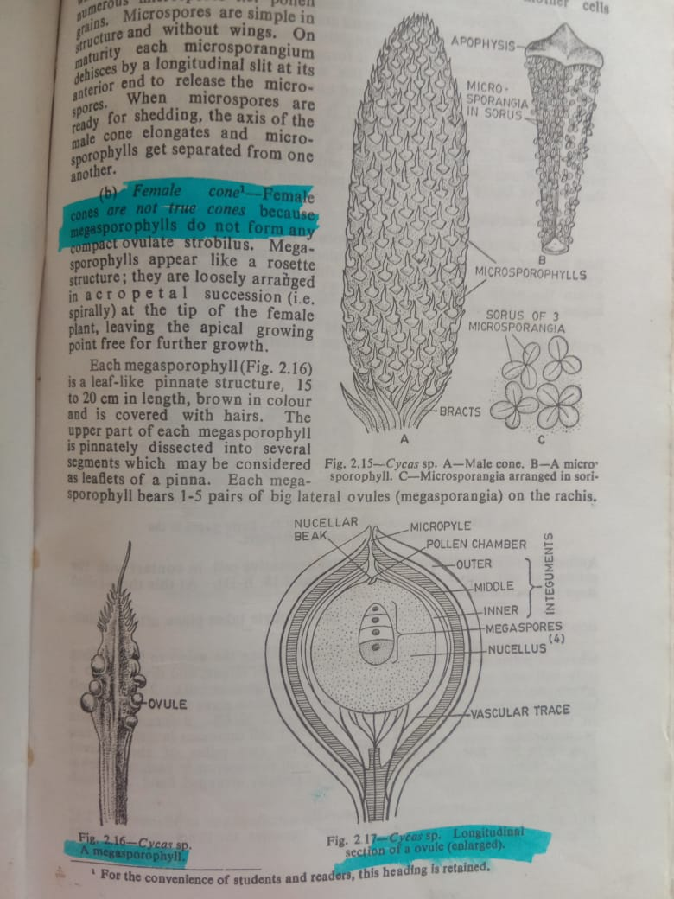 

**Female cone**

Female cone are not true cones because megasporophylls do not form any compact ovulate strobilus. Megasporophylls appear like a rosette structure, they are loosly arranged in acropetal succession (i.e. spirally) at the tip of the female plant, leaving the apical growing point free for the further growth.

Each megasporophylls is a leaf-like pinnate structure, 15 -20 cm in length, brown in colour and is covered with hairs. The upper part of each megasporophylls is pinnately dissected into several segments which may be considered as leaflets of pinna. Each megasporophyll bears 1-5 pairs of big lateral ovules (megasporangia) on the rachis.

Each megasporangium i.e. ovule is orthosporous and becomes very large, measuring about 6 cm in length. A mature ovule consists of a massive nucellus surrounded by a thich integument. The integument is three layered e.g. a) outer flesy layer, b) middle stony layer and c) inner flesy layer, often called *sarcotesta*, *sclerotesta* and *endotesta* respectively. The well developed nucellus of the megasporangium remains fused with the integument except at the micropylar end where it forms a beak like structure called nucellar beak. The pollen chamber lies in the nucellar-beak. Vascular supply is noted both in integuments and nucellus.

A single megaspore mother cell is differentiated within the nucellus tissue, which by meiosis gives rise to a linear –tetrad of four megaspores. Out of the four megaspores, only the lowermost one (i.e. the megaspore facing towards the chalazal end) is the functional megaspore while the rest three facing towards micropylar degenerate.

**Pollination**

Pollen grains i.e. microspores are liberated from the microsporangia at the 3-celled stage. In *Cycas* the pollination is anemophilous (wind pollinated). Pollen grains are carried to the pollen chamber of the ovule by wind. At the time of pollination, a drop of mucilage called pollination drop oozes out at the micropylar end of the ovule. The pollen grains which are floating in the air are caught in this drop. As the drops dries up the pollen grains are drawn into the pollen chamber, then due to the further drying up of the pollination drop the pollen chamber is closed.

At the time of pollination pollen grains are directly deposited on the nucellus of the female gametophyte.

**Fertilization**

Pollen tube grows towards the archegonium of the female gametophyte. There the end of the pollen tube bursts and discharges its contents into the archegonial chamber. Then motile male cells i.e. sperms swims towards the neck of the archgonium and make their way down to the egg cell. One of the sperms fuses with the egg nucleus i.e. oosphere as a result diplod oospore i.e. **zygote** (***2n***) develops.

**Embryo and seed**

After fertilization the zygote enlarges and its nucleus divides by free nuclear division. In *Cycas*, the embryo is formed from a cellular part of the chalazal end, thus this structure is called proembryo but not an embryo. The mature embryo is straight.

The mature seed of *Cycas* is fleshy, red or orange-brown in colour. The seed is enclosed by a thick seed coat formed from the integument. The straight embryo and the endosperm remain within the testa. The sweet testa and pleasant odour attract birds which helps in dispersal of seeds. The seeds fall to the ground and eventually germinates into a seedlings (young *Cycas* plant).

**Life cycle**- *Cycas* shows a distinctalteration of diploid i.e. sporophytic and haploid gametophytic generations. Plant body represents sporophytic generation while gametophytes (male and female) are very much reduced. Male gametophyte is represented by the pollen tube with persistent prothallial cell and sperms. The female gametophyte is represented by the endosperm tissue within the megaspore having archegonia, the female sex organ. After fertilization of the egg by a sperm, the oospore (zygote) results, which is the first step in the diploid phase i.e. sporophyte.

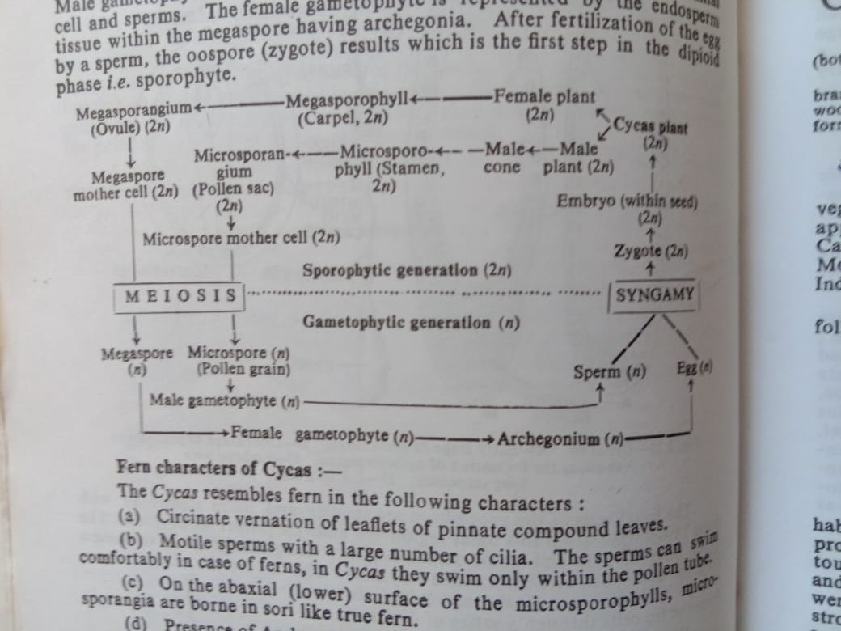

**Xerophytic characters of *Cycas* leaf**

The xerophytic adaptive feature of cycas leaves are

1. Tough, leathery texture of leaf
2. Strongly cutinized thick walled epidermal layer
3. Greatly thickened hypodermis on both upper and lower epidermis
4. Presence of sunken stomata on the lower epidermis
5. Presence of primary and secondary transfusion tissues.

**Fern characters of *Cycas***

The *Cycas* resembles fern in the following characters

1. Circinate vernation of leaflets of pinnate compound leaves.
2. Motile sperms with larger number of cilia. The sperm can swim comfortably in case of ferns, in *Cycas* they swim only within the pollen tube
3. On abaxial (lower) surface of the microsporophylls, microsporangia are borne in sori like true fern.
4. Presence of archegonia in the female gametophyte.

**Economic Importance**

Leaves of *Cycas* used in making mats. The young succulent shoot and seeds are cooked as vegetables by the people of Assam, Malaya, Indonesia etc. In Japan a type of starch is prepared from the trunk of the *Cycas* plant, this trunk is sold in market as ‘Sago’. Sago can also be obtained from the seeds which contain about 31% starch. In Malabar the flour of seeds known as ‘Indum podi’ is used in the preparation of cakes and porridges. Besides, various species of *Cycas* are planted in gardens for their ornamental value.

***Pinus***

**Classification (up to family)**

*Pinus* belongs to the family Pinaceae, order Coniferales and division Coniferophyta of Gymnospermae.

**Distribution**

*Pinus,* the most dominant genus of the order Coniferales, is represented by about 90 species. The genus *Pinus* is widely distributed throughout the temperate and sub-alpine regions of the Northern hemisphere and forms an evergreen forest belt. It is widely distributed in the hills and is an important source of resin and timber. In India 6 species of *Pinus* are found to occur in the North-west and North-East Himalayas. These are, *Pinus gerardiana, P. insularis, P. roxburghii, P. wallichiana, P. armandi, P. merkusii.*  Among these *P. insularis (*syn *P. khasya)*, the khasi pine, a tree (upto 45 m), found in Eastern Himalayas, especially in the khasia and Jaintia hills at an altitude of 1000-2500m.

**Morphology**

A tall, evergreen and lofty tree with strong tap root system. The tree takes a pyramidal form due to development of racemose branching.

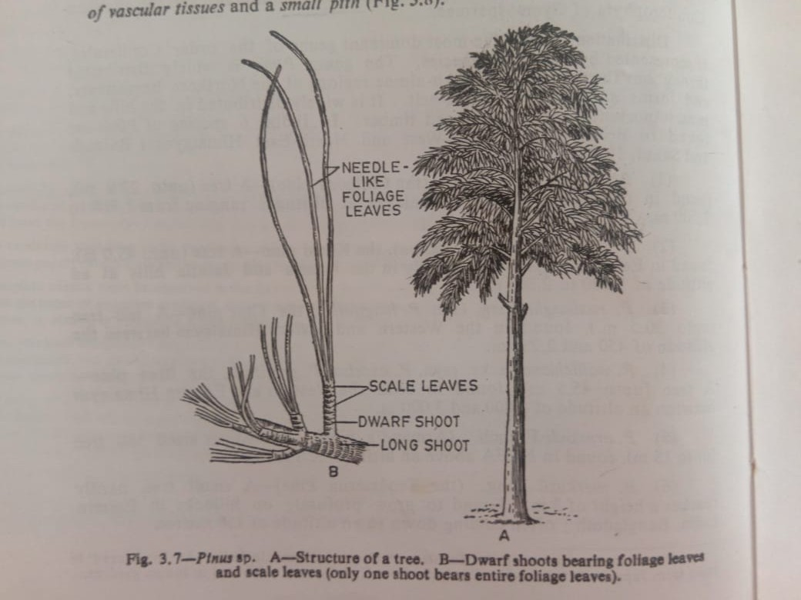

**Stem**

The stem is erect, stout, cylindrical and branched. The stem is covered with bark which is characteristic of different species. Branching is monopodial. Branches are two kinds viz. a) short branches of limited growth (dwarf or spur shoots) and b) long lateral branches of unlimited growth (long shoots). The dwarf shoots develop in the axils of scale leaves and are devoid of apical buds. These dwarf shoots possess scale leaves below and needle –like foliage leaves at their apices.

**Root**

*Pinus* has a strong tap root system, which may persist or may be associated with stronger adventitious roots. Root hairs are scanty and ectotrophic mycorrhiza occurs.

**Leaves**

Leaves are dimorphic i.e. i) brown, small, thin scale leaves and ii) needle-like green, simple, foliage leaves developing in cluster at the apex of dwarf shoot. The number of mature needle –like foliage leaves varies from 1-5 in different species. Scale leaves occur on long and as well as on dwarf shoots, and fall off as the branches attain maturity. But needle-like foliage leaves are borne only on dwarf shoots. The main photosynthetic function is performed by the needle-like leaves.

**Anatomy**

**Stem**

In transverse section the stem shows a thin cortex, a large zone of vascular tissue and a small pith. The stem is differentiated into outer cortex and stele i.e. central cylinder. Epidermis and pericycle are not very distinct. The pith is parenchymatous.

The pericycle is one cell layer thick and consists of tubular, close compact cells- the outer cortex is composed of parenchyma cells. **Resin ducts** are present in cortex. The vascular bundles are conjoint, collateral, open and endarch (i.e., protoxylem is directed towards pith). The primary permanent tissue and secondary tissue are developed in the same way as in dicotyledonous angiosperms.

The vascular bundles are composed of phloem, fascicular cambium and xylem. The xylem exclusivly consists of tracheids with bordrred pits and xylem rays. No vessels and wood fibres occur. Phloem consists of sieve tubes and phloem parenchyma; companion cells are absent. Stele is ectophloic dissected siphonostele. Cambium present in between xylem and phloem. The secondary wood contains special tracheidal rays i.e. the medullary rays. Secondary wood also contains tracheids; the medullary rays in the secondary bast or phloem consists of starch containing cells and albuminous matter containing cells. Resin ducts are also present in the secondary wood. Cork cambium appears successively in the cortex and in the outer part of the phloem.

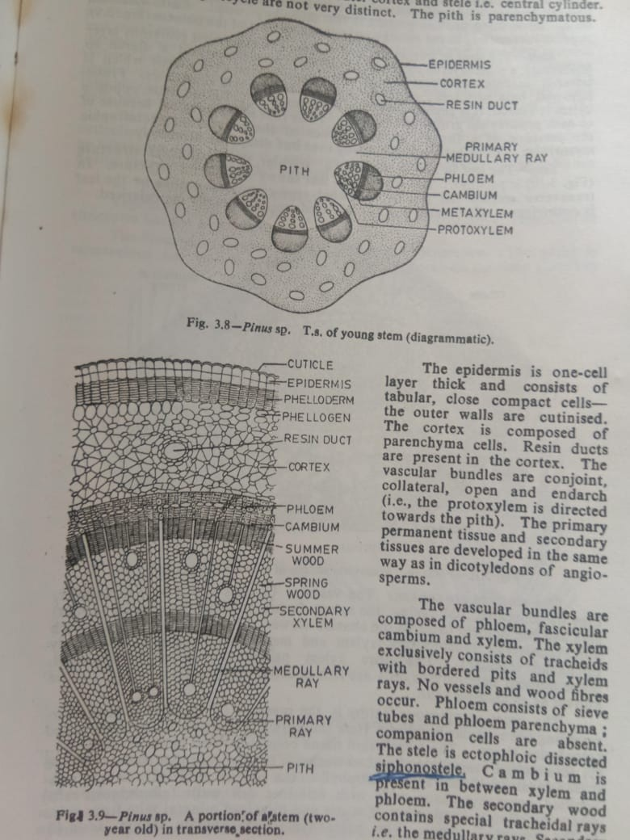



**Root**

The root in transverse section shows an outermost piliferous layer (epiblema), a multilayered cortex composed of parenchyma and diarch to tetrarch vascular cylinder. There is a single layered endodermis which is followed by a pericycle; pericycle is several layers thick sometimes. Protoxylem is exarch, it is slightly forked in the form of Y. Resin canals, opposite to each protoxylem group often occur. *Pinus* root is mycorrhizal because of the presence of a fungus on the surface of the root forming ectotrophic mycorrhiza. Root hairs arise in young root but disappear ultimately.

**Leaf**

The leaf is needle shaped, the anatomical structure is peculiar. The anatomy of leaf shows xerophytic structure. In transverse section the leaf is somewhat semi-circular in outline i.e. the leaf in centric type. The outer walls of leaf-epidermis are heavily cuticularised.

The stomta are sunken. The vascular bundles are 2-3 in number, they are somewhat obliquely, the xylem facing towards the adaxial (upper) side and phloem towards the abaxial (lower) side. The xylem is endarch and consists of crushed protoxylem and metaxylem composed of variously thickened tracheids. The entire xylem parenchyma is more abundant. Some phloem parenchyma cells are rich in dense cytoplasm and such cells are known as albuminous cells.

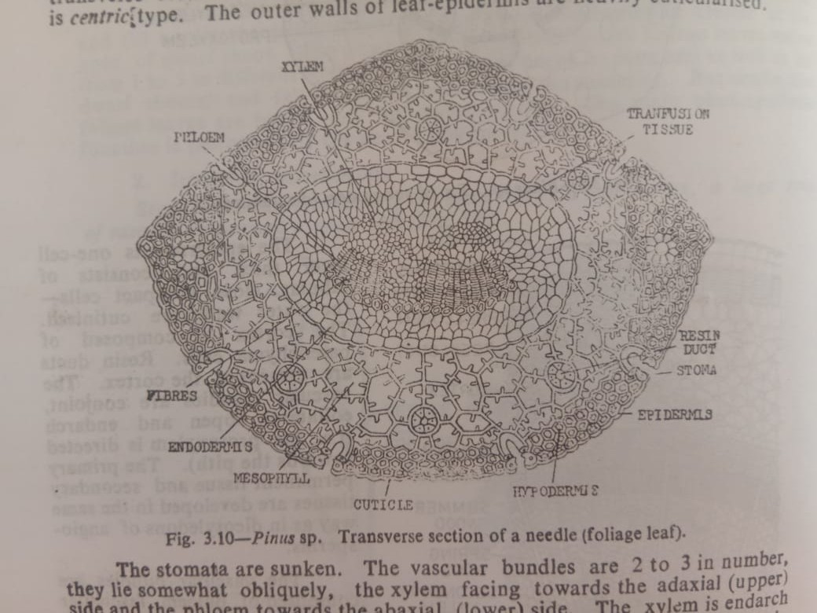

The most conspicuous feature is the presence of transfusion tissue surrounding the vascular bundles. Here the pericycle-cells are collectively called transfusion tissue. The transfusion tissue consists of two kinds of cells e.g. 1) thin-walled, non-lving lignified tracheids (tracheidal cells) whose function is translocation of food from mesophyll to the phloem and 2) living, non-lignified parenchymatous cells with cellulose cell walls (albuminous cells) whose function is conduction of water and dissolved mineral salts from xylem to mesophyll tissue. The parenchyma cells contain tannin, resin-like substances and starch. Towards the xylem the transfusion tracheids are elongated further away from the vascular bundle. They are short and parenchyma-like. The transfusion cells lying very close to phloem are similar to albuminous cells. The transfusion cells are auxillary conducting system helping the vascular bundle in coming close to mesophyll for physiological purpose. The mesophyll tissue is not usually differentiated into palisade and spongy cells. The cells of mesophyll have ridges on the walls projecting inside the cell-cavities known as arm palisade.

The leaf shows xerophytic structure as the epidermis is heavily cuticularised with stomata having sunken guard cells which are overtopped by subsidiary cells. Below the epidermis lies the sclerenchymatous hypodermis having fibre-like thick-walled lignified cells.

**Rreproduction of *Pinus***

Vegetative reproduction has not been reported. The *Pinus* plant represents the sporophytic generation. The plant is monoecius i.e. male and female sporophylls are borne on the same plant but in separate cones i.e. strobili. Flowers are unisexual, they are represented by sporophylls i.e. male flowers by microsporophylls (stamens) and female flowers by megasporophylls (carpels).

**Male cone i.e. Staminate strobilus**

Male cones are simple, they form compact and oval structures, measuring about 2-3 cm in length. They occur singly in the axils of scale leaves of long shoots replacing thereby dwarf shoots. Male cone thus appear to be morphologically equivalent to dwarf shoots.

Each cone is provide with a short and elongated central axis upon which numerous microsporophylls are arranged spirally. The microsporophylls are borne directly on the central axis, therefore the male cone is homologous to male flower of an angiosperm and not an inflorescence. Microsporophylls are scaly and they vary from 60 -135 in number in each cone. Each microsporophyll consists of a short stalk (i.e. filament) and leaf-like expanded structure, the apex of which is slightly bent upwards. Two microsporangia are borne on the lower i.e. abaxial surface of such leaf-like expanded portion of each microsporophyll.

A microsporangium is sessile and oblong in shape, it consists of a wall of several layers of cells. The development of the microsporangium is of eusporangiate type. A nearly mature microsporangium contains inside microspore mother cells surrounded externally by a sporangium wall and tapetum. Each microspore mother cell by reduction division forms four haploid, uninucleate microspore i.e. pollen grains. Each mature microsporangium, therefore, contains numerous microspores. The pollen grains are winged and yellow in colour. When mature each microsporangium dehisces by a longitudinal slit along the long axis. As a result large number of pollen grains get released forming a cloud which is often called shower of sulphur.

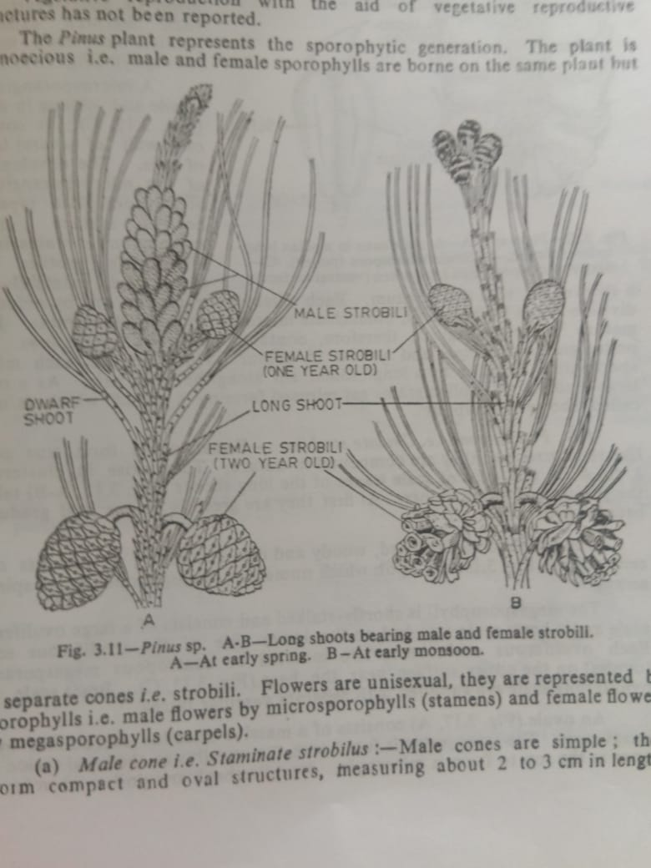

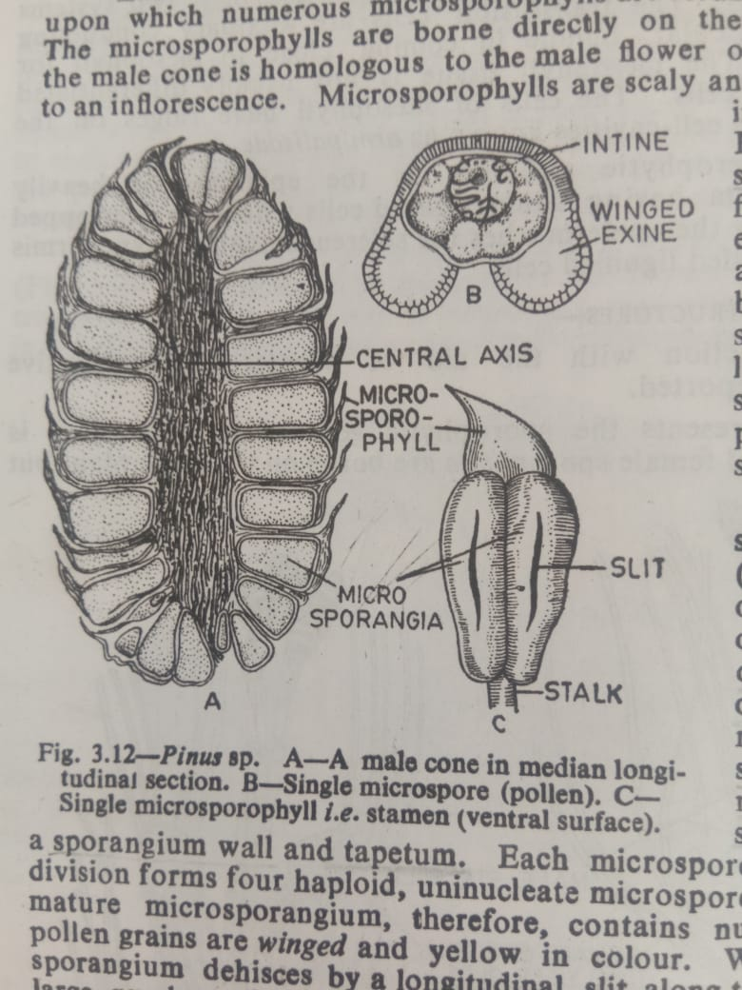

**Female cone i.e. ovulate strobilus**

Female cones form true cone-like structures and they are compound in nature. They arise in cluster of 1-4 in the axils ao scale leaves of the long shoots taking the position of dwarf shoots. At first they are green in colour and gradually become brown-red.

The female cone is hard, woody and dry structure, it consists of central axis upon which numerous megasporophylls are spirally arranged.

The megasporophyll is shortly stalked and consists of large ovuliferous scale and bract scale attached on the lower side of the ovuliferous scale. Each ovuliferous scale bears two inverted or anatropous meagsporangia (ovules) on the upper surface near the base. Bract scale and ovuliferous scale are supplied with separate vascular traces.

An ovule consists of a massive nucellus surrounded by an integument. The integument is fused with the nucellus at the basal region and open at the top to form an micropyl. Nucellar beak and pollen chamber are not formed here. The integument consists of three fused layers e.g. an outer flesy, a middle stony and an inner fleshy.

Only megaspore mother cell is differentiated within the nucellar tissue, which by meiosis gives rise to a linear-tetrad of four megaspores. Of these four megaspore, only the lowermost one is the functional megaspore while others degenerate.

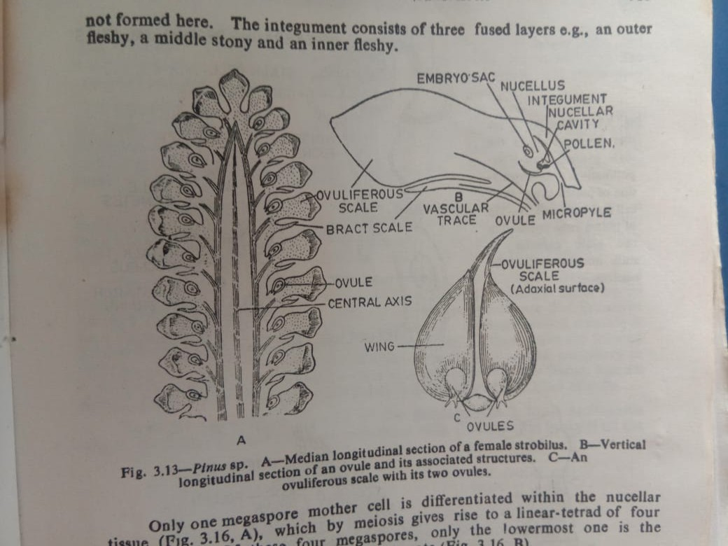

**Pollination**

Pollen grains, after liberation from microsporangia, are carried by means of wind at 4-celled stage. The yellow colours pollen grains are carried in a mass and they resemble dust of sulphur.

At the time of pollination, the scales of the female cone remain open for the reception of pollen grains, and pollen are caught in the mucilage drop oozing out of the micropyle. As the mucilage drop dries up, pollen grains are gradually drawn down the micropyle and finally taken at the nucellus tip.

**Fertilization**

Fertilization takes place after an year of pollination. Pollen tube makes its way down until it reaches the neck of the archegonium, the neck is penetrated and the tip of the pollen tube bursts. The contents of pollen tube are then discharged and of the two male cells, only one unites with the egg i.e. oosphere, as a result a diploid zygote i.e. oospore is formed.

Endosperm is cellular and is formed before fertilization from the megaspore nucleus due to repeated divisions. Endosperm tissue is therefore haploid (n).

**Embryo and seed**

First division of the zygote nucleus is not accompanied by a vertical wall, instead free nuclear division takes place. Polyembryony occurs as four potential embryos are developed although only one of them matures. Mature embryo in seed consists of a radical, the hypocotyls, 3 to many cotyledons and plemule.

Seeds winged, without aril, testa hard and brown. After a period of rest the seed germinates by epigeal means to form a new sporophytic palnt.

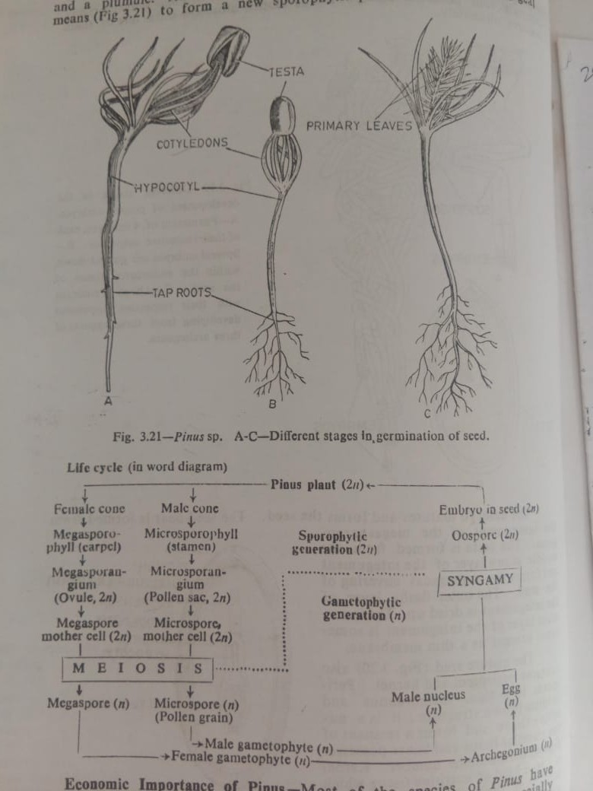

**Life cycle**



**Economic importance of *Pinus***

Most of the species of *Pinus* have economic value. The seeds of *P. gerardiana* are edible and commonly known as ‘chilgoza’. *P. roxburghii* and *P. wallichiana* are timber yielding plants; the timber is used for making furnitures, poles, match boxes, building materials etc. some species e.g. *P. roxburghii* and *P. insularus* are important sources of resin and turpentine.

**Morphology of the Ovuliferous scale of *Pinus***

Various morphological interpretations have been offered by different authors regarding the morphological nature of the ovuliferous scale of *Pinus*. Some of the interpretations given by different author are

1. Robert Brown (1827)- It is an exposed carpel developing in the axil of the bract and which bears two naked ovules.
2. Schleiden (1829)- interpreted the ovuliferous scale as an axil placenta which arises in the axil of the leafbearing two ovules. The scale is the true carpel
3. A. Brown (1842)- it represents the first two leaves of an axillary shoot which are fused by their posterior margins.
4. Baillon (1863)- it is regarded as an axillary shoot bearing two bicarpellary ovaries.
5. Eicher (1868)- bract is a carpel and the ovuliferous scale is a ligular outgrowth from the upper surface.
6. Sachs (1868)- regarded bract scale as a carpel and the ovuliferous scale as a ligular outgrowth on its surface.
7. Van Tiegham (1869)- the ovuliferous scale is the first and only leaf of an axillary shoot.
8. Von Mohl(1871)- the ovuliferous scale represents the first two leaves of an axillary shoot.
9. Stanzel (1876)- the ovuliferous scale is made up of the first two leaves of an axillary shoot.
10. Chelakovsky(1879)- ovuliferous scale is the representation of the axillary shoot.
11. Master ( 1892)- ovuliferous scale is an outgrowth, either from the bract or from the axis, in the nature of a cladode of the modified shoot.
12. Bessey(1892)- regarded the ovuliferous scale as a chalazal development of the ovules.
13. Chamberlain(1935)- the ovuliferous scale is modified shoot with or without leaves bearing the ovules.
14. Florin(1951)- the ovuliferous scale is not a sporophyll, it is a highly modified lateral dwarf shoot or flower.