Rreproduction of Gnetum
All species of Gnetum are dioecious. Flowers are unisexual. Male flowers are represented by microsporophylls (stamen) and female by megasporophylls (carpels). Male and female flowers are borne in clusters on male and female plants respectively forming respective cones equivalent to panicle type of inflorescence of angiosperms. Flowers are provided with simplest type of perianth. In a few cases bisexual flowers are also noted. Both types of cones i.e. inflorescences arise either singly in the axils of the leaves, or in fasciles at the apices of dwarf shoots.
Male cone
The male cones are compact and slender axis-like structures, which are upto 6cm in length. Each male cone is generally a panicle which is either solitary and axillary or fascicled at the apex (i.e. terminal of the dwarf shoot).
Each cone or inflorescence consists of a stout axis which bears two opposite and connate bracts, in the axil of this bract other cones may also arise. A little higher upon the cone-axis, whorls of circular connate bracts are present and they are arranged one above the other to form collars or cupules. In the axil of each collar, male i.e. staminate flowers (microsporophylls) are arranged in several definite rings, usually 3-6 in number. Above the male flowers, a single ring of abortive i.e. imperfect female flowers may also be present.
Each mature microsporophyll i.e. male flower consists of a stalk bearing two unilocular (one lobed) microsporangia i.e. anthers. The stalk is invested at the base by a sheath like perianth. In the young condition, the stalk bearing two anthers of a male flower remains enclosed in the sheath like perianth. With the maturity of anthers, the stalk elongates rapidly and pushes anthers through the slit (formed in the perianth) beyond the collars of the cone. Each microsporangium is oval and consists of a wall of single layer of cells.
During development of an anther (microsporangiun) outermost layer of the archesporium divides periclinally to form the parietal and the sporogenous cells. The parietal layer by another division produces an outer wall layer (jacket) and the tapetum. Sporogenous cells later differentiate into spore mother cells (2n). Many wingless haploid pollen grains i.e. microspores are formed meiotically from the spore mother cells. The pollen grains are liberated by the longitudinal dehiscence of the anthers.
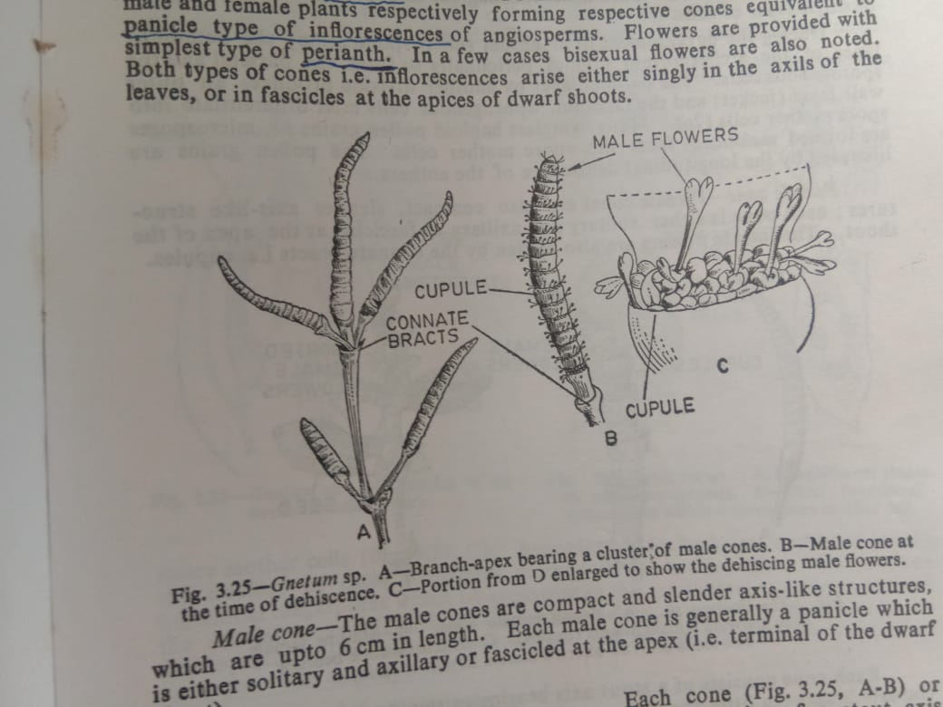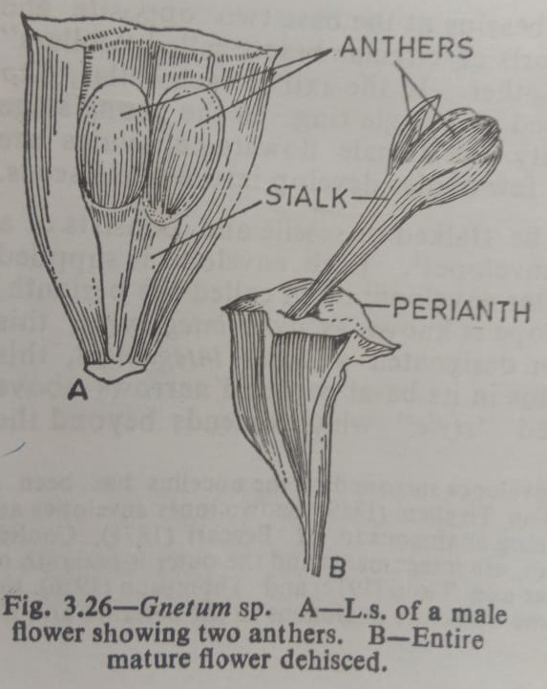

Female cone
Female cone are also compact, slender axis like structure, each cone is either solitary and axillary or fascicled at the apex of the shoot. The female flowers are also hidden by the connate bracts i.e. cupules.
Each cone consists of a stout axis bearing at the base of two opposite and connate bracts; a little above this, whorls of circular bracts called collar or cupules are present one above the other. In the axil of each collar 4-10 female flowers i.e. ovules are developed in a single ring. In the young stage female flowers are not visible, at maturity the female flowers i.e. ovules are visible as minute protuberances. Only a few ovules develop into mature seeds.
Each female flower i.e. ovule may be stalked or sessile and consists of a massive nucellus surrounded by three envelopes. Each envelope is supplied with a separate vascular bundle. The outer envelope, often called the perianth, is thick and fleshy. The middle envelope is known as outer integument, this is very thin; the inner envelope is often designated as inner integument, this inner envelope is fused with the nucellus in its basal part and narrows above to form the micropylar tube or so-called style which extends beyond the middle and outer envelopes. Nucellar beak is absent but a pollen chamber has been noted in various species of Gnetum at the time of pollination.
In Gnetum several sporogenous cells are differentiated from several hypodermal archesporial cells of the nucellar tissue. These sporogenous cells are arranged in longitudinal rows and later function as megaspore mother cells. The nucleus of each megaspore mother cell by meiosis gives rise to four functional megaspores which lie crosswise in the peripheral cytoplasm around the central vacuole. All the four megaspore take part in the development of female gametophyte. The female gametophyte is therefore tetrasporic like angiosperms.
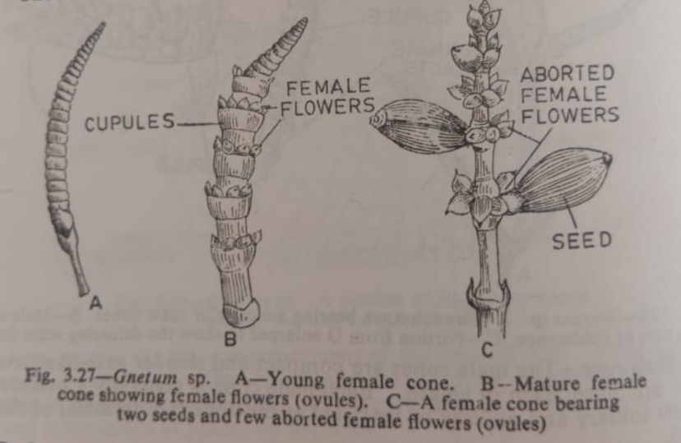
Pollination
Pollen grains are liberated from the sporangia at the three nucleate stages. Pollination takes place by the help of wind and insects. Pollen grains after pollination are caught within the micropylar tube by the help of a drop of a sweet fluid exuded at the tip of the micropylar tube. With the drying up of this fluid-drop, the pollen grains are sucked in within the pollen chamber.
Fertilization
Pollen tube is found to be lie close to one of the groups of eggs present in the upper part of the female gametophyte. Several pollen tubes after penetrating the nucellus reach the female gametophyte. Both the male cells (gametes) of a pollen tube can fuse with eggs, provided two eggs are present close to such a pollen tube. As a result of fertilization, several zygotes (oospores) are developed of which one matures ultimately and develops into an embryo.
Endosperm
Endosperm is cellular, although cell formation generally begins at the chalazal region of the gametophyte before fertilization but upper part (micropylar region) of the gametophyte remain free nuclear at the time of fertilization. This indicates that endosperm tissue formation takes place partly before and partly after fertilization.
Embryo and seed
Zygote becomes larger and densly cytoplasmic with a prominent nucleus. The mature embryo consists of a root protected by the large root cap, two cotyledons, the stem tip and large feeder. The feeder is developed from the hypocotyls-base. The phenomenon of polyembryony is noted in Gnetum.
Seeds are large, oval or elongate, green or red in colour. The seed is provided with a seed coat of three layers- an outer fleshy layer, a middle stony layer and an inner papery layer. Inside the seed there is a copious endosperm, the embryo is a dicotyledonous type-a feeder is formed from the base of the hypocotyls and this takes nourishment from the endosperm. The radical comes out first at the time of germination. The process of germination of seed is hypogeal.
Life cycle
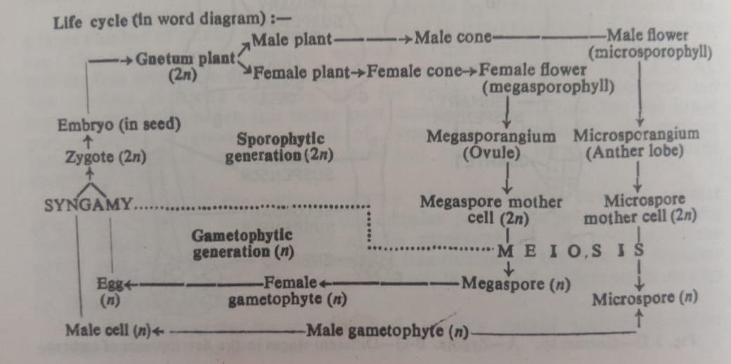
Angiospermic characters of Gnetum
Gnetum resembles angiospems in the following characters-
- In habit, Gnetum presents a remarkable resemblance to the dicityledonous plants like lianes, shrubs or small trees.
- The shoot apex of Gnetum is similar to that of angiosperms in having a tunica and corpus.
- Like dicot leaves, the leaves of Gnetum are broad with reticulate venation, and arranged in opposite decussate manner.
- Like angiosperms, the xylem of Gnetum is composed of true vessels (tracheae) in addition to tracheids with bordered pits.
- Cones of Gnetum look like the catkin type of inflorescence of some earlier angiosperms.
- In the presence of perianth in male and female flowers, Gnetum resembles angiosperms. The well developed micropylar tube (formed by the elongation of the inner envelope of the ovule) of the female flower is looked upon as the style of angiosperm flower.
- Megasporogenesis in Gnetum is like that of angiosperm. Female gametophyte is tetrasporic i.e. female gametophyte is develops from four functional megaspore nuclei.
- Like angiosperms, female gametophyte is without archegonia. Secondly, like angiosperms at least a portion of the upper part of the gametophyte remains free nuclear at the time of fertilization where differentiation of eggs takes place.
- Complete endosperm tissue formation takes place after fertilization – a character like those of angiosperms.
- Male gametophyte is much more reduced, and without stalk cell like angiosperms.
- Like angiosperms, the first division of zygote nucleus is accompanied by laying down a wall.
Gymnopermic characters of Gnetum
Gnetum resembles gymnosperms in the following characters-
- The composition of phloem of Gnetum is typically like that of gymnosperms.
- Presence of prothallial cell (one) in the male gametophyte.
- Free nuclear divisions in the feamale gametophyte.
- Presence of rudimentary pollen chamber at the nucellus tip.
- The nature of endosperm tissue and the formation of incipient type of endosperm tissue at chalazal region before fertilization
- Naked seeded condition.

