Gnetum
Classification (up to family)
Gnetum belongs to family Gnetaceae, order Gnetales and the division Coniferophyta of gymnospermae.
Distribution
The genus Gnetum is mainly confined in the tropical and humid regions of the world. There are about 30-40 species of Gnetum, all of which inhabit the tropical rain forest below an altitude of 1500m except G. microcarpum which occur at 2000 m. species of Gnetum are found to grow in North Eastern part of South America, Western Africa, India, South-East Asia and China.
In India five species of Gnetum are found, these are- Gnetum ula, G. montanum, G. latifolium, G. gnemon, G. contractum. Among these
- G. montanum – a robust climber with glabrous, slender, branches swollen at nodes-Sikkim, Assam, Sylhet (Bangladesh) and Orissa.
- G. gnemon var. griffithii – a shrub upto 2 m high- Sibsagar, Naga Hills and Kungaba areas of Assam.
G. gnemon var. brunonianum - A slender shrub - occurs in S. Lushai hills and Golaghat areas of Assam

Morphology
In its general habit Gnetum presents a great resemblance to a dicotyledonous angiospermic plant. Majority are woody climbers with twining stems i.e. lianes (Gnetum ula), while others are shrubs or trees as G. gnemon.
Stem
Stem is cylindrical and branched. Branches arise in the axil of leaves. In climbers, branches are of two kinds (i.e. dimorphic) viz. those of limited growth (dwarf shoots) and others of unlimited growth (long shoots). This difference is not marked in some species e.g. G. gnemon. Internodes are present also on the branches of limited growth. Stems in several species of Gnetum are jointed. The joints consist of two parts. One immediately above and other immediately below the node- these two are separated by an annular groove, thus each node of the stems appears to be swollen structure.
Root
These are normal tap roots, branched.
Leaves
Normally leaves are of one kind and they are borne only on unbranched dwarf shoots (in climbing). Leaves are simple, exstipulate and short petioled. The leaf blade (lamina) is oval, large and entire with the pinnately reticulate venation. Leaves (about 9 or 10) are arranged opposite decussate pairs on each branch. Scale leaves are also present on the long shoots in case of climbers. In general appearance the leaves look like those of dicotyledonous plants. In addition to normal axillary buds, some accessory buds are present in some species e.g. G. africanum.
Anatomy
Stem
Anatomically the stem resembles that of a dicotyledons, particularly structure. The young stem of Gnetum transverse section shows a more or less circular outline. The epidermis consists of a single layer of papillate and rectangular cells, with their outer walls thickened and heavily cuticled. Stomata are present in the epidermis. The cortex is 12-16 layered and is composed of thin-walled parenchyma cells. In older stems an irregular ring of parenchymatous cells becomes strongly lignified forming a distinct sclerenchymatous zone in the inner part of the cortex. Branched or unbranched pit-canals may be present in the cells of this sclerotic tissue which are referred to as the ring of spicular cells (stellate fibres). In young stem endodermis and pericycle are indistinct. The primary vascular bundles vary in number from 20-24, they are arranged in the form of a ring. Vascular bundles are collateral, open and endarch; they are separated from one another by broad medullary rays. The xylem is composed of a large number tracheids and a few vessels (tracheae); the phloem is composed of seieve cells and phloem parenchyma only. Pith is more or less circular in transverse section and is composed of thin-walled parenchyma cells. In older stem a few cells of the pith which lie toward the vascular rings may become lignified and pitted.
The stem undergoes secondary growth by the activity of the cambium ring as in typical dicotyledons. In tree types, e.g. G. gnemon secondary growth is of the normal type. But in climbing species e.g. G. ula secondary growth begins in a normal way but during lateral stages several successive rings of new cambia develop one after another at various points in the inner part of the cortex. Gradually these rings become incorporated into a continuous cylinder, producing a normally oriented ring of xylem and phloem separated into wedge –shaped vascular bundles by medullary rays. The growth of the first ring ceases at the commencement of the second one. Thus successive rings are formed one after another, some of which may become incomplete resulting in the eccentric position with regard to pith. Periderm in G. ula is thin and interrupted at places by lenticles.
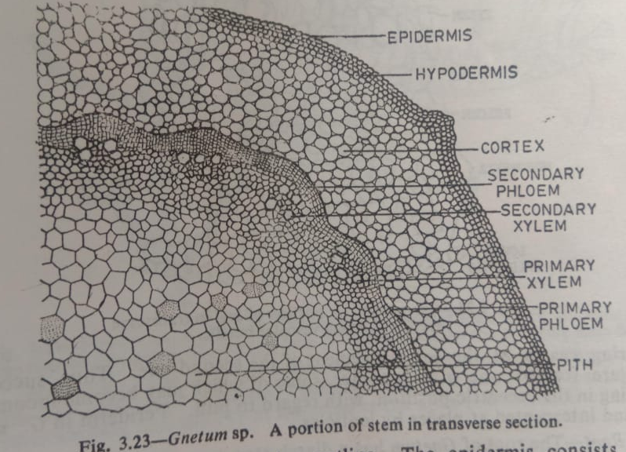
Root
The root of Gnetum has a diarch structure. The cortex is many layered and parenchymatous, the cells are generally large, polygonal and filled with starch grains. Numerous thick walled fibres also occur among the cortical cells. Single layered endodermis is present which encloses a multilayred pericycle. Vascular bundles are radial. The amount of primary xylem is very small and becomes indistinguishable after secondary growth. Xylem consists of tracheids possessing uniseriate bordered pits, phloem consists of sieve cells and phloem parenchyma. Secondary growth is normal.
Leaves
Gnetum leaf in transverse section shows a structure more or less like that of dicotyledonous leaf, because it is dorsiventral and possesses reticulate venation. The epidermal cells of both surfaces have undulate walls. The outermost wall of the upper epidermis is thickly cuticularised. On the lower epidermis a large number of stomata are present. The mesophyll tissue is differentiated into upper palisade and lower spongy tissues. The palisade tissue is composed of a single layer of short cells and spongy tissue is composed of many layers of well-developed, armed and loosely packed cells. Near the lower epidermis star-like branched sclereids with lignified walls occur. Fibres and latex tubes are also present in large numbers in the mesophyll tissue, specially in the midrib portion. In the midrib, vascular bundles are arranged in the form of a curve. Vascular bundles are collateral and endarch with xylem pointing towards the upper side of the leaf.
