Pinus
Classification (up to family)
Pinus belongs to the family Pinaceae, order Coniferales and division Coniferophyta of Gymnospermae.
Distribution
Pinus, the most dominant genus of the order Coniferales, is represented by about 90 species. The genus Pinus is widely distributed throughout the temperate and sub-alpine regions of the Northern hemisphere and forms an evergreen forest belt. It is widely distributed in the hills and is an important source of resin and timber. In India 6 species of Pinus are found to occur in the North-west and North-East Himalayas. These are, Pinus gerardiana, P. insularis, P. roxburghii, P. wallichiana, P. armandi, P. merkusii. Among these P. insularis (syn P. khasya), the khasi pine, a tree (upto 45 m), found in Eastern Himalayas, especially in the khasia and Jaintia hills at an altitude of 1000-2500m.
Morphology
A tall, evergreen and lofty tree with strong tap root system. The tree takes a pyramidal form due to development of racemose branching.
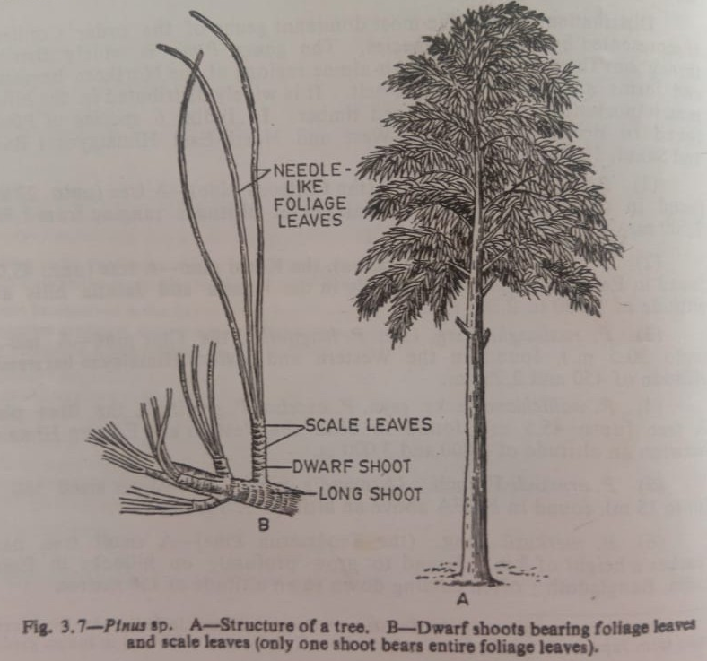
Stem
The stem is erect, stout, cylindrical and branched. The stem is covered with bark which is characteristic of different species. Branching is monopodial. Branches are two kinds viz. a) short branches of limited growth (dwarf or spur shoots) and b) long lateral branches of unlimited growth (long shoots). The dwarf shoots develop in the axils of scale leaves and are devoid of apical buds. These dwarf shoots possess scale leaves below and needle –like foliage leaves at their apices.
Root
Pinus has a strong tap root system, which may persist or may be associated with stronger adventitious roots. Root hairs are scanty and ectotrophic mycorrhiza occurs.
Leaves
Leaves are dimorphic i.e. i) brown, small, thin scale leaves and ii) needle-like green, simple, foliage leaves developing in cluster at the apex of dwarf shoot. The number of mature needle –like foliage leaves varies from 1-5 in different species. Scale leaves occur on long and as well as on dwarf shoots, and fall off as the branches attain maturity. But needle-like foliage leaves are borne only on dwarf shoots. The main photosynthetic function is performed by the needle-like leaves.

Anatomy
Stem
In transverse section the stem shows a thin cortex, a large zone of vascular tissue and a small pith. The stem is differentiated into outer cortex and stele i.e. central cylinder. Epidermis and pericycle are not very distinct. The pith is parenchymatous.
The pericycle is one cell layer thick and consists of tubular, close compact cells- the outer cortex is composed of parenchyma cells. Resin ducts are present in cortex. The vascular bundles are conjoint, collateral, open and endarch (i.e., protoxylem is directed towards pith). The primary permanent tissue and secondary tissue are developed in the same way as in dicotyledonous angiosperms.
The vascular bundles are composed of phloem, fascicular cambium and xylem. The xylem exclusivly consists of tracheids with bordrred pits and xylem rays. No vessels and wood fibres occur. Phloem consists of sieve tubes and phloem parenchyma; companion cells are absent. Stele is ectophloic dissected siphonostele. Cambium present in between xylem and phloem. The secondary wood contains special tracheidal rays i.e. the medullary rays. Secondary wood also contains tracheids; the medullary rays in the secondary bast or phloem consists of starch containing cells and albuminous matter containing cells. Resin ducts are also present in the secondary wood. Cork cambium appears successively in the cortex and in the outer part of the phloem.
Root
The root in transverse section shows an outermost piliferous layer (epiblema), a multilayered cortex composed of parenchyma and diarch to tetrarch vascular cylinder. There is a single layered endodermis which is followed by a pericycle; pericycle is several layers thick sometimes. Protoxylem is exarch, it is slightly forked in the form of Y. Resin canals, opposite to each protoxylem group often occur. Pinus root is mycorrhizal because of the presence of a fungus on the surface of the root forming ectotrophic mycorrhiza. Root hairs arise in young root but disappear ultimately.
Leaf
The leaf is needle shaped, the anatomical structure is peculiar. The anatomy of leaf shows xerophytic structure. In transverse section the leaf is somewhat semi-circular in outline i.e. the leaf in centric type. The outer walls of leaf-epidermis are heavily cuticularised.
The stomta are sunken. The vascular bundles are 2-3 in number, they are somewhat obliquely, the xylem facing towards the adaxial (upper) side and phloem towards the abaxial (lower) side. The xylem is endarch and consists of crushed protoxylem and metaxylem composed of variously thickened tracheids. The entire xylem parenchyma is more abundant. Some phloem parenchyma cells are rich in dense cytoplasm and such cells are known as albuminous cells.
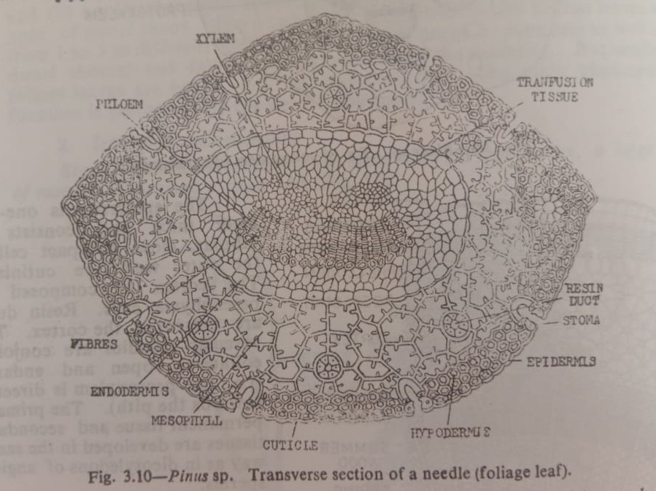
The most conspicuous feature is the presence of transfusion tissue surrounding the vascular bundles. Here the pericycle-cells are collectively called transfusion tissue. The transfusion tissue consists of two kinds of cells e.g. 1) thin-walled, non-lving lignified tracheids (tracheidal cells) whose function is translocation of food from mesophyll to the phloem and 2) living, non-lignified parenchymatous cells with cellulose cell walls (albuminous cells) whose function is conduction of water and dissolved mineral salts from xylem to mesophyll tissue. The parenchyma cells contain tannin, resin-like substances and starch. Towards the xylem the transfusion tracheids are elongated further away from the vascular bundle. They are short and parenchyma-like. The transfusion cells lying very close to phloem are similar to albuminous cells. The transfusion cells are auxillary conducting system helping the vascular bundle in coming close to mesophyll for physiological purpose. The mesophyll tissue is not usually differentiated into palisade and spongy cells. The cells of mesophyll have ridges on the walls projecting inside the cell-cavities known as arm palisade.
The leaf shows xerophytic structure as the epidermis is heavily cuticularised with stomata having sunken guard cells which are overtopped by subsidiary cells. Below the epidermis lies the sclerenchymatous hypodermis having fibre-like thick-walled lignified cells.

