Cycas
Classification (up to family)
Division- Cycadophyta
Order- Cycadales
Family- Cycadaceae
Distribution- The genus Cycas with at least 15 or 220 species is widely distributed. Its species are distributed abundantly in Australia, India, South China and South Japan.
In India 4 species of Cycas are found to occur- these species with their distribution are- Cycas circinalis, Cycas pectinata (, Cycas rumphii, Cycas beddomei. Besides these Cycas revoluta, in India is grown as an ornamental garden plant.
Morphology- Cycas is a small arborel tree, looking like palm trees or a tree-fern. Therefore, Cycas is also called ‘palm fern’.
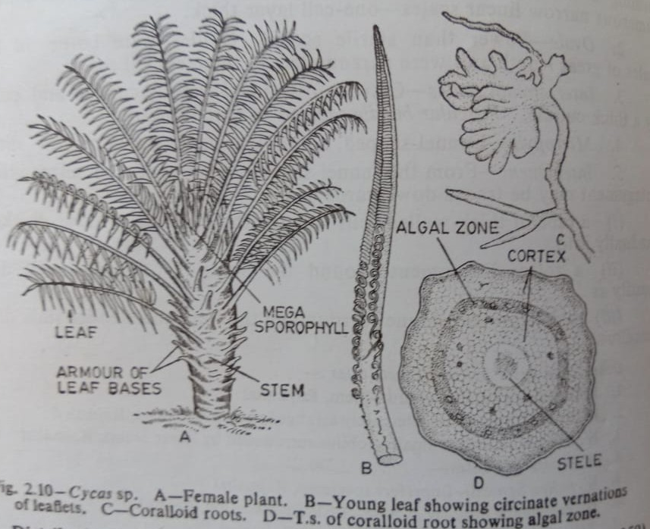
- Root- Cycas plants posses a normal tap root system in the beginning. This tap root system is short-lived and later on is replaced by a number of adventitious roots. The adventitious roots develop a few negatively geotropic lateral roots which come out of the soil surface. These roots get infected by bacteria members of blue- green algae, possibly Anabaena cycadacearum, within the root cortex- as a result, the infected roots become distorted producing a mass of exposed tubercles which look like a coral or knob. Hence such type of root is known as coralloid root or corallorhiza.
- Stem- The stem is stout, columnar, erect, unbranched and covered by armour of persistant leaf bases. They bear at the apex, a crown of large foliage leaves. The stem bears large adventitious buds carried with scales at the base often called bulbils, which helps in vegetative propagation.
- Leaves- Leaves are dimorphic i.e. i)brown scale leaves and ii) large green pinnately compound foliage leaves are arranged spirally at the top of the stem forming crown. The foliage leaves are very large. Each pinnate leaf bears on its rachis several closely set leaflets. Leaflets are tough and leathery, they are sessile with a narrow base each leaflet shows only a single midvein without lateral without lateral veins and veinlets.
Anatomy
Stem- In transverse section the stem of Cycas assumes an irregular outlinebecause of the presence of numerous armoured leaf bases. It shows in transverse section a relatively massive pith, extensive cortex and a scanty zone of wood between pith and cortex. The vascular cylinder i.e. is an endarch siphonostele (eustelic type) like that of a dicotyledonous type.
The vascular bundles are conjoint, collateral and open, primar xylem is endarch, in seedling stage xylem is mesarch. The vascular bundle is arranged in a ring around a massive central pith, pith is composed of parenchyma cells which contain starch and secretory ducts. Cortex is composed of thin walled parenchyma cells. Presence of leaf trace griddles in the cortex is another important feature of Cycas. A leaf trace often arising from the stellar cylinder generally does not enter into the nearest leaf directly, but the leaf trace form as a griddle or semicircle round the stem before entering the next leaf situated a little above. As those traces goes round the stem, so they are called girdling traces or indirect traces. Usually a number of leaf traces enter each rachis of a leaf. Both the cortex and pith contain numerous mucilage canals which are interconnected through leaf gaps. Medullary rays occur in between the vascular bundles.
Secondary increase in thickness in stem takes place but generally little amount of secondary wood is formed. The mode of secondary growth is anamolous.
In the comparatively older stem, there may be the formation of such 10-12 alternate rings of wood and bast. In addition to the rings of bundles, there may be developed accessory bundles both in pith and cortex resulting in the complicated arramngement of tissues in older stem. Periderm formation in cortex takes place.
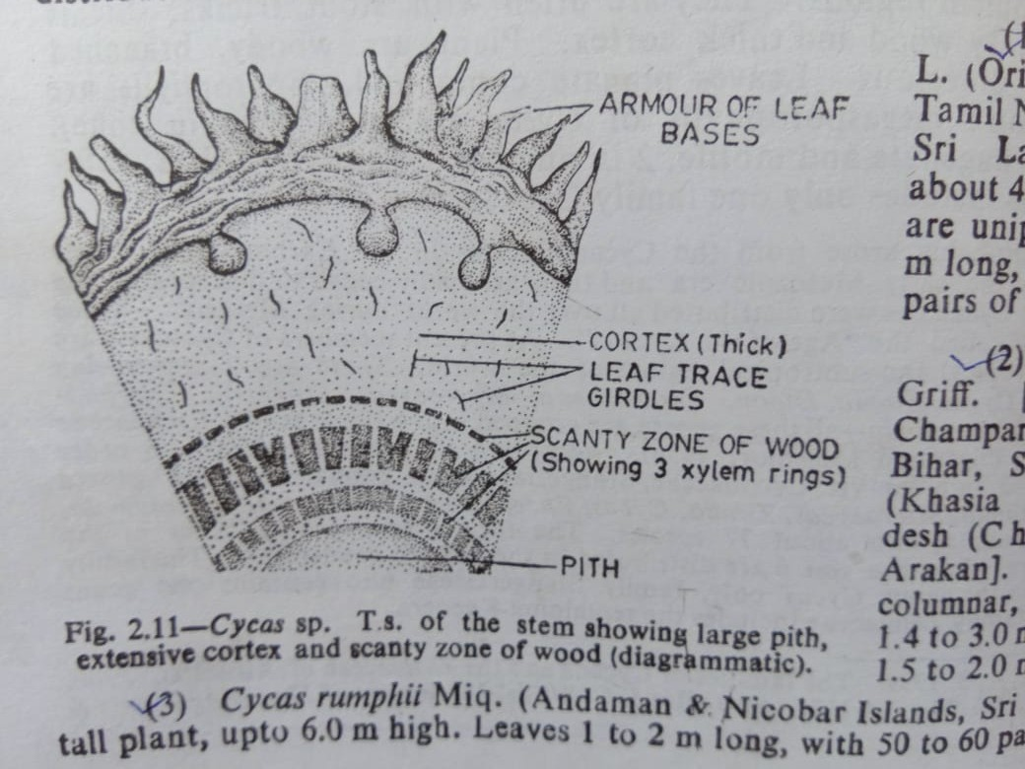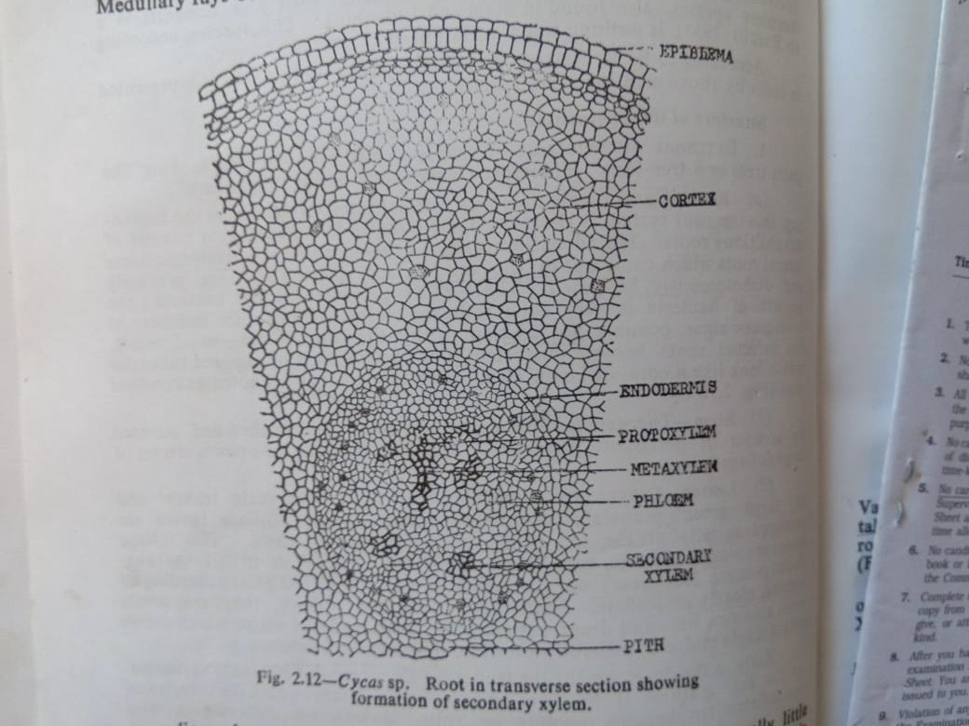
Root- In young stage, the root in transverse section shows an outermost thin layer called epiblema, a multilayered parenchymatous cortex containing mucilage canals and a central vascular cylinder i.e. stele. Cortex is internally limited by a single layered endodermis with companion strips. Pericycle is multilayered. Stele is tetrarch generally. Vascular bundles are radial, xylem is exarch. Secondary growth takes place early, but secondary wood formation is irregular. Coralloid roots have one or rarely more than one layered thick algal zone in the cortex.
Petiole- The petiole of the leaf in transverse section shows a large number of collateral bundles, often showing an inverted omega shaped arrangement. Xylem is situated on the upper side and the phloem below
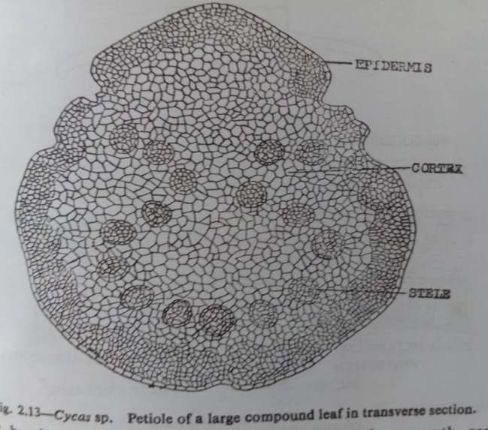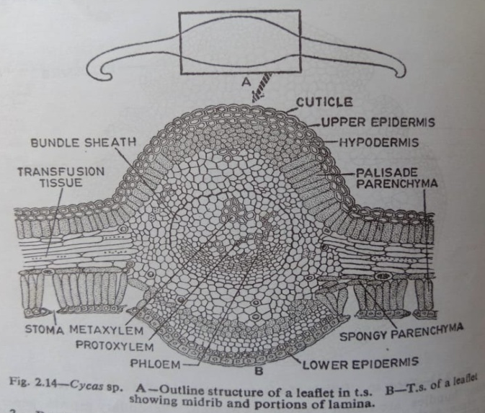
Leaflet-
The anatomy of the leaflet is interesting as it reveals xerophytic structure. The transverse section of a leaflet shows two cuticularised epidermal layers, one is upper and the other lower. The upper epidermis forms a continuous layer composed of oval or tubular cells. Beneath the upper epidermis, one or two layer of sclerenchymatous cells forming hypodermis is present. Beneath the hypodermis a row of palisade tissue consisting og elongated columner cells full of chloropalsts is present. Below the palisade tissue, scanty spongy parenchyma cells containing chloroplasts may or may not occur. Above the lower epidermis there lies spongy parenchyma tissue consisting of loosely arranged oval cells full of chloroplasts. Sunken stomata are present only in the lower epidermis. Lower epidermis may have palisade cells. Most important features of a Cycas leaflet is the presence of transfusion tissue in between upper pallisade and lower spongy layers. Transfusion tissue is arranged parallel to the epidermal layers. Transfusion tissue is composed of several layers of transversely elongated, thin-walled, colourless, short and wide cells, this tissue probably serves for lateral conduction.
There is only vascular bundle corresponding to the median vein (midrib) of the leaflet. The vascular bundle is encircled by sclerenchymatous sheath. Xylem is mesarch, it is directed towards the upper surface, phloem lies towards lower surface.

