TRANSPORT PROTEIN, CARRIERS, CHANNELS AND PUMPS
TRANSPORT PROTEIN
A membrane transport protein (or simply transporter) is a membrane protein involved in the movement of ions, small molecules, and macromolecules(another protein), across a biological membrane. Transport proteins are integral transmembrane protein and they exist permanently within and span the membrane across which they transport substances. The proteins may assist in the movement of substances by facilitated diffusion or active transport. The two main types of proteins involved in such transport are broadly categorized as either channels or carriers. The solute carriers (SLC) are secondary active or facilitative transporters in humans. Collectively membrane transporters and channels are transportome. Transportomes govern cellular influx and efflux of not only ions and nutrients but drugs as well.
Primary transporters use energy to transport ions such as Na ⁺, K⁺, and Ca²⁺ across a cells membrane and can create concentration gradients. This transport can use ATP as an energy source.
Transporters that use ATP convert the energy in ATP into potential energy in the form of a concentration gradient. They use the ATP to transport an ion from a low concentration to a higher concentration. Examples of proteins that use ATP are P-type ATPases that transfer Na ⁺, K⁺, and Ca²⁺ ions by phosphorylation, A-type ATPases that transfer anions, and ABC transporters (ATP binding cassette transporters) that transport a broad set of molecules. Examples of the P-type ATPase include Na⁺/K⁺-ATPase that is regulated by Janus Kinase-2 as well as Ca²⁺ ATPase which exhibits sensitivity to ADP and ATP concentrations P-glycoprotein is an example of an ABC transport binding protein in the human body.
Ion transporters can be regulated in a variety of different ways such as phosphorylation, allosteric inhibition or activation, and sensitivity to ion concentration. Using protein kinases to add a phosphate group or phosphatases to dephosphorylate the protein can change the activity of the transporter. Whether the protein is activated or inhibited with the addition of the phosphate group depends on the specific protein. With allosteric inhibition, the regulatory ligand can bind into the regulatory site and either inhibit or activate the transporter. Ion transporters can also be regulated by the concentration of an ion (not necessarily the ion it transfers) in solution. For example, the electron transport chain is regulated by the presence of H⁺ ions (pH) in solution

Porters (uniporters, symporters, antiporters), SLCs
Excitatory amino acid transporters (EAATs)
    - EAAT1
    - EAAT2
    - EAAT3
    - EAAT4
    - EAAT5
Glucose transporter
Monoamine transporters, including:
    - Dopamine transporter (DAT)
    - Norepinephrine transporter (NET)
    - Serotonin transporter (SERT)
    - Vesicular monoamine transporters (VMAT)
Adenine nucleotide translocator (ANT)
Nonribosomally synthesized porters, such as:
The Nigericin family
The Ionomycin family
Ion-gradient-driven energizers
P-P-bond-hydrolysis-driven transporters :
  - ATP-binding cassette transporter (ABC transporter), such as MDR, CFTR
  - V-type ATPase ; ( "V" related to vacuolar ).
  - P-type ATPase ; ( "P" related to phosphorylation), such as :
    - Na⁺/K⁺-ATPase
    - Plasma membrane Ca²⁺ ATPase
    - Proton pump
F-type ATPase; ("F" related to factor), including: mitochondrial ATP synthase, chloroplast ATP synthase1
- 3.B: Decarboxylation-driven transporters
- 3.C: Methyltransfer-driven transporters
- 3.D: Oxidoreduction-driven transporters
- 3.E: Light absorption-driven transporters, such as rhodopsin

Group translocators
The group translocators provide a special mechanism for the phosphorylation of sugars as they are transported into bacteria (PEP group translocation).

CARRIER

A carrier is not open simultaneously to both the extracellular and intracellular environments. Either its inner gate is open, or outer gate is open. In contrast, a channel can be open to both environments at the same time, allowing the molecules to diffuse without interruption. Carriers have binding sites, but pores and channels do not. When a channel is opened, millions of ions can pass through the membrane per second, but only 100 to 1000 molecules typically pass through a carrier molecule in the same time. Each carrier protein is designed to recognize only one substance or one group of very similar substances. Research has correlated defects in specific carrier proteins with specific diseases.
Electron carriers: The transmembrane electron transfer carriers in the membrane include two-electron carriers, such as the disulfide bond oxidoreductases (DsbB and DsbD in E. coli) as well as one-electron carriers such as NADPH oxidase. Often these redox proteins are not considered transport proteins.

CHANNELS
Channels are either in open state or closed state. When a channel is opened with a slight conformational switch, it is open to both environment simultaneously (extracellular and intracellular).
Types of channels
- α-helical protein channels such as voltage-gated ion channel (VIC), ligand-gated ion channels(LGICs)
- β-barrel porins such as aquaporin
- channel-forming toxins, including colicins, diphtheria toxin, and others
- Non-ribosomally synthesized channels such as gramicidin
- Holins, which function in export of enzymes that digest bacterial cell walls in an early step of cell lysis.
Facilitated diffusion occurs in and out of the cell membrane via channels/pores and carriers/porters.

PUMPS
Active transporters or ion pumps are transporters that convert energy from various sources—including Adenosine triphosphate (ATP), sunlight, and other redox reactions—to potential energy by pumping an ion up its concentration gradient. This potential energy could then be used by secondary transporters, including ion carriers and ion channels, to drive vital cellular processes, such as ATP synthesis
V Ion pumps are channels that use the ATP hydrolysis energy to transfer ions from one side of a membrane to the other against their electrochemical gradient (Harold, 1986; Laüger, 1991).
Pumps, also called transporters, are transmembrane proteins that actively move ions and/or solutes against a concentration or electrochemical gradient across biological membranes. Pumps generate a membrane potential by creating an electrochemical gradient across the membrane.
Ion pumps can be distinguished from ion channels on the basis that ion pumps actively transport ions against a concentration gradient, while ion channels allow ions to passively flow down a concentration gradient.
Pumps can be classified as either primary or secondary active transporters based on the method they use to move ions across the gradient.

.
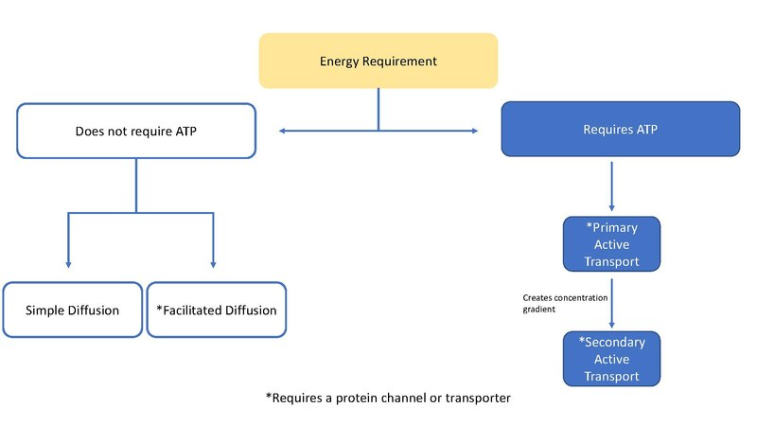

Secondary transporter
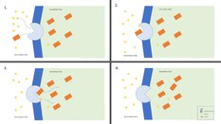
Na+ Glu Symporter
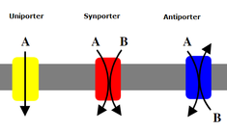
Secondary transporters also transport ions (or small molecules) against the concentration gradient – from low concentration to high concentration - but unlike primary transporters which use ATP to create a concentration gradient, secondary transporters use the potential energy from the concentration gradient created by the primary transporters to transport ions. For example, the sodium-dependent glucose transporter found in the small intestine and kidney use the sodium gradient created in the cell by the sodium potassium pump to help carry glucose into the cell. This happens as sodium flows down its concentration gradient which provides enough energy to push glucose up its concentration gradient back into the cell. This is important in the small intestine and the kidney to prevent them from losing glucose. Symporters such as the sodium-glucose symporter transport an ion with its concentration gradient, and they couple the transport of a second molecule in the same direction. Antiporters also use the concentration gradient of one molecule to move another up its concentration gradient but the coupled molecule is transported in the opposite direction.

IN SIMPLE MEANING
Primary active transporters are usually transmembrane ATPases, that hydrolyse ATP to produce energy in order to transport ions up a concentration gradient.
Secondary active transporters, also known as co-transporters, pump ions against the concentration gradient by using the electrochemical gradient created across the membrane by pumping ions in or out of the cell. There are two types of secondary active transporters, which are classified based on the direction that they move ions.
Antiporters pump two different ions or solutes in opposite directions across the membrane. One moves with the concentration gradient (high to low) which powers the movement of the other against the gradient (low to high). Examples: CLCN3, NHE3.
Symporters pump two different ions or solutes in the same direction, moving one with the concentration gradient (high to low), and the other against the concentration gradient (low to high). Examples: KCC2, NCC, NIS, NKCC2.

