What is Hydrolase?
Hydrolase, any one of a class of more than 200 enzymes that catalyse the hydrolysis of several types of compounds. Esterases include lipases, which break ester bonds (between a carboxylic acid and an alcohol) in lipids, and phosphatases, which act analogously upon phosphates; a narrower category comprise the nucleases, which are phosphatases that hydrolyse nucleic acids. Glycosidases sever bonds between sugar molecules in carbohydrates. Peptidases hydrolyse peptide bonds (between the carboxylic acid group of one amino acid and the amino group of another) within protein molecules. Specific hydrolases also catalyse reactions that break ether (C―O) bonds; carbon–nitrogen (C―N) bonds other than peptide bonds; acid anhydride bonds; carbon–carbon (C―C) bonds; or phosphorus–nitrogen (P―N) bonds.
What is an ester bond?
Carboxylic acid esters, formula RCOOR′ (R and R′ are any organic combining groups), are commonly prepared by reaction of carboxylic acids and alcohols in the presence of HCL or H₂SO₄, a process called esterification. In the reaction the hydroxyl group (OH) of the carboxylic acid is replaced by the alkoxy group (R′O) of the alcohol.
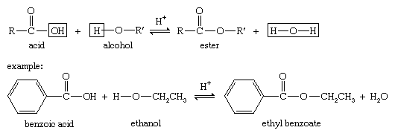

The reverse of the esterification reaction is an example of hydrolysis.
The hydrolysis of esters in the presence of alkalis such as potassium hydroxide (lye) or sodium—a reaction called saponification—is utilized in the preparation of soaps from fats and oils and is also used for the quantitative estimation of esters.
Carboxylic acid esters of low molecular weight are colourless, volatile liquids with pleasant odours, slightly soluble in water. Many are responsible for the fragrance and flavour of flowers and fruits; for example, isopentyl acetate is present in bananas, methyl salicylate in wintergreen, and ethyl butyrate in pineapples. These and other volatile esters with characteristic odours are used in synthetic flavours, perfumes, and cosmetics.
What is Ether?
Ether, any of a class of organic compounds characterized by an oxygen atom bonded to two alkyl or aryl groups. Ethers are similar in structure to alcohols and both ethers and alcohols are similar in structure to water. In an alcohol one hydrogen atom of a water molecule is replaced by an alkyl group, whereas in an ether both hydrogen atoms are replaced by alkyl or aryl groups.
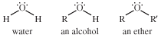
At room temperature, ethers are pleasant-smelling colourless liquids. Relative to alcohols, ethers are generally less dense, are less soluble in water, and have lower boiling points. They are relatively unreactive, and as a result they are useful as solvents for fats, oils, waxes, perfumes, resins, dyes, gums and hydrocarbons. Vapours of certain ethers are used as insecticides, miticides and fumigants for soil.

