**Michaelis – Menten equation,**

In an enzyme catalyzed reaction when there is large excess of substrate and the enzyme concentration is held constant, if substrate concentration in plotted against velocity (V) or reaction rate, a hyperbolic curve is obtained. This type of plot is also known as saturation plot. In the beginning, there is approximately direct proportionality between substrate concentration and reaction rate until the enzyme concentration becomes limiting and a steady state is obtained. In this situation addition of more substrate will not increase reaction rate because all the active sites of the enzyme are saturated with substrate molecules and the rate of reaction will increase only by addition of more enzyme.

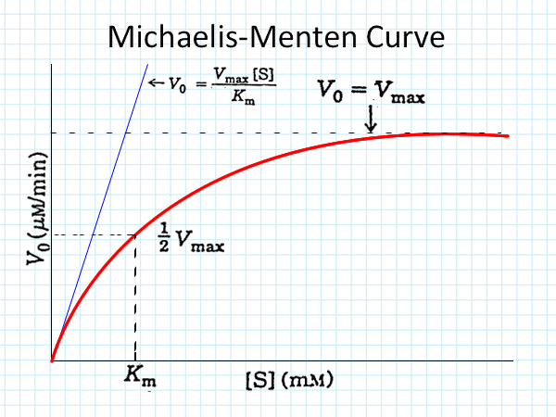

Michaelis and Menton (1913) while studying the hydrolysis of sugar by invertase evolved a theory on the **mode of enzyme action**. They considered that enzymes have certain active sites for the attachment of substrate molecule where an enzyme can form an intimate relationship with the substrate. According to the theory an enzyme forms a weakly bound compound with substrate which on hydrolysis decomposes into the reaction products.

In simple form theory can be represented as follows:

Enzyme + substrate Enzyme – substrate End products + enzyme complex.

They applied equation kinetics of enzyme while discussing about the mode of action. It can be explained as follows.



(Where E= enzyme, S= substrate, ES=enzyme-substrate complex, K1= velocity constant of the formation of ES and K2= velocity constant of dissociation of ES)

Or



(Where K3= velocity constant of decomposition of the complex and P = end product)

Considering these facts Michaelis and Menton derived the following formula

Km= K2-K3/K1

This Km is known as **Michealis constant**. Km value is characteristic for each enzyme substrate system and if the same enzyme attacks more than one substrate, its value gives useful comparison of the relative affinities for the different substrates. **Lower the Km value more the affinity**. When **velocity of reaction is half of the maximum velocity**, **Km is equal to the concentration of the substrate**. Substrate concentration is expressed in moles per litre.

Michealis and Menton theory has not been found universally true, though recently intermediate enzyme-substrate compound from the reaction mixture has been isolated.

The concentration of substrate required to half saturate the enzyme or in other words to cause half the maximal reaction rate (1/2 Vmax) is called **Michealis constant or Michealis and Menton constant**. Michealis constant is a reflection of the affinity of enzyme for its substrate and is characteristics of a particular enzyme-substrate system. **The smaller the value of Km, the more strongly the enzyme binds the substrate.** An enzyme that catalyzes a reaction between two or more different substrate has different Km value for each of the substrate.

Although Km values are more or less constants for particular enzyme-substrate system, but these may vary slightly with pH, temperature, ionic strength and also with types and amount of enzymes when required for the reaction.

The values of Km are measured in terms of **molarity**, typically, the values of Km for most enzyme studied so far range between 10-3 to 10-6 molar (1mM-1µM).

**Enzyme inhibition**

There are certain products which inhibits the enzyme activity e.g. presence of malonate (in krebs cycle) inhibits the activity of succinate dehydrogenase. These substances are called inhibitors and are following types

1. **Competitive inhibitors**- Competitive inhibitors usually have structure sufficiently similar to the substrate that they are able to compete for the active site of enzyme. The active site of enzyme is fitted with molecules of other substance which are similar to those of the substrate. So the activity of enzyme is lost. E.g. in case of succinic acid and malonic acid, either one can fit with enzyme-FAD.
2. **Non-competitive inhibitors**- in contrast to the competitive, these never compete with active sites of enzymes. In this case inhibitors react with either parts of enzymes not involved in catalytic or active site. These inhibitors do not show structural resemblances with the substrates. Toxic metal ions and compounds that destroy essential sulfohydryl groups (e.g. excess oxygen) are examples of non-competitive inhibitors.
3. **Allosteric modulation**- The activities of some enzymes are regulated internally. Some specific low molecular weight substances, such as products of another enzyme of the same metabolic pathway, act as inhibitors. Such substances bind with a specific site of the enzyme different from its substrate binding site, and thus alter the shape of the enzyme and decrease the enzyme action. Such enzymes are called allosteric enzyme, e.g. hexokinase which changes glucose-6-phosphate. Glucose-6-phosphate inhibits the hexokinase activity. It may also be called allosteric inhibition **or Feedback Inhibition**.

**Factors affecting enzyme activity**

There are several factors influencing enzyme activity. The best known factors are

1. **Temperature** – temperature is the most important factor which controls effectively the rate of enzymatic reactions. At 0°C, the rate of an enzymatic reaction is practically zero. Normally, the rate of the reaction increases with the rise in temperature but there is a limitation. The rate of the enzyme catalysed reactions do not, however, increase indefinitely as the temperature is increased. At a certain point the reaction is completely stopped, and thus, comes to an end. Thus happens because the high temperature destroys the catalytic function of the enzyme. The enzyme which is a protein becomes denatured (inactive) on heating.
2. **Hydrogen ion concentration** – Enzymes are very restricted in their activities by the change of hydrogen concentration (pH) of the medium in which they are working. The optimum pH is changeable from enzyme to enzyme. Generally, the pH values for the enzymatic reaction vary from pH 1.5 to 10.0.

An enzyme can perform its best activity at a particular pH value of the medium in which it is working. Its activity declines gradually on either side of the optimum range.

1. **Concentration of enzyme** – The rate of enzymatic reaction increases proportionally with increasing concentration of the enzyme provided the substrate is available in the medium and pH, temperature and other conditions are not limiting.
2. **Concentration of the substrate** – The increase in the concentration of the substrate causes an increase in the rate of reaction upto certain limiting value, beyond which there is no increase in the reaction.
3. **Concentration of the end products** – In the enzymatic reactions, the substrates are broken, catalysed into products but like all chemical reactions, the active accumulation of the end products will cause a decrease in this reaction rate. The rate of an enzymatic reaction, thus, depend with which the products are removed from the site of production.
4. **Co- Factors** - Some enzymes cannot act on their substrates unless there are certain assisting non-protein components called co-factors. These are activators of the enzyme. Eg. Mn, Ni, Mg.
5. **Inhibitors** – The substances which when present in the reaction site decrease the rate of enzymatic reaction are called inhibitors, Eg, Salts of heavy metal, trichloroacetic acid.

Inhibitors are of two types-

1. **Competitive inhibitors** – these inhibitors have structural analogue and hence compete with the normal substrate molecule.
2. **Non competitive inhibitors** – In case of non-competitive inhibitors, the inhibitor and the substrate are not structurally related, they can react with the enzyme, thus inactivating the enzyme- substrate- complex.