Industrial Revolution

Industrial Revolution, in modern history is the process of change from an agrarian and handicraft economy to one dominated by industry and machine manufacturing. This process began in Britain in the 18th century and from there spread to other parts of the world. Although used earlier by French writers, the term Industrial Revolution was first popularized by the English economic historian Arnold Toynbee (1852–83) to describe Britain’s economic development from 1760 to 1840. Since Toynbee’s time the term has been more broadly applied.
.
The main features involved in the Industrial Revolution were technological, socioeconomic, and cultural.
The technological changes included the following: (1) the use of new basic materials, chiefly iron and steel, (2) the use of new energy sources, including both fuels and motive power, such as coal, the steam engine, electricity, petroleum, and the internal-combustion engine, (3) the invention of new machines, such as the spinning jenny and the power loom that permitted increased production with a smaller expenditure of human energy, (4) a new organization of work known as the factory system, which entailed increased division of labour and specialization of function, (5) important developments in transportation and communication, including the steam locomotive, steamship, automobile, airplane, telegraph, and radio, and (6) the increasing application of science to industry. These technological changes made possible a tremendously increased use of natural resources and the mass production of manufactured goods.
There were also many new developments in nonindustrial spheres, including the following: (1) agricultural improvements that made possible the provision of food for a larger nonagricultural population, (2) economic changes that resulted in a wider distribution of wealth, the decline of land as a source of wealth in the face of rising industrial production, and increased international trade, (3) political changes reflecting the shift in economic power, as well as new state policies corresponding to the needs of an industrialized society, (4) sweeping social changes, including the growth of cities, the development of working-class movements, and the emergence of new patterns of authority, and (5) cultural transformations of a broad order. Workers acquired new and distinctive skills, and their relation to their tasks shifted; instead of being craftsmen working with hand tools, they became machine operators, subject to factory discipline. Finally, there was a psychological change: confidence in the ability to use resources and to master nature was heightened.

The first Industrial Revolution

In the period 1760 to 1830 the Industrial Revolution was largely confined to Britain. Aware of their head start, the British forbade the export of machinery, skilled workers, and manufacturing techniques. The British monopoly could not last forever, especially since some Britons saw profitable industrial opportunities abroad, while continental European businessmen sought to lure British know-how to their countries. Two Englishmen, William and John Cockerill, brought the Industrial Revolution to Belgium by developing machine shops at Liège (c. 1807), and Belgium became the first country in continental Europe to be transformed economically. Like its British progenitor, the Belgian Industrial Revolution centred in iron, coal, and textiles.
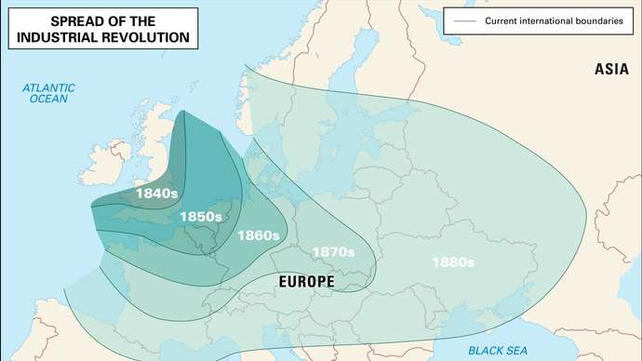
Industrial Revolution
A map depicting the spread of the Industrial Revolution through Europe in the 19th century.

France was more slowly and less thoroughly industrialized than either Britain or Belgium. While Britain was establishing its industrial leadership, France was immersed in its Revolution, and the uncertain political situation discouraged large investments in industrial innovations. By 1848 France had become an industrial power, but, despite great growth under the Second Empire, it remained behind Britain.

Understand the economic boom in Germany during 1870-71/
Overview of Germany's economic boom in 1870–71.

Other European countries lagged far behind. Their bourgeoisie lacked the wealth, power, and opportunities of their British, French, and Belgian counterparts. Political conditions in the other nations also hindered industrial expansion. Germany, for example, despite vast resources of coal and iron, did not begin its industrial expansion until after national unity was achieved in 1870. Once begun, Germany’s industrial production grew so rapidly that by the turn of the century that nation was outproducing Britain in steel and had become the world leader in the chemical industries. The rise of U.S. industrial power in the 19th and 20th centuries also far outstripped European efforts. And Japan too joined the Industrial Revolution with striking success.
The eastern European countries were behind early in the 20th century. It was not until the five-year plans that the Soviet Union became a major industrial power, telescoping into a few decades the industrialization that had taken a century and a half in Britain. The mid-20th century witnessed the spread of the Industrial Revolution into hitherto non-industrialized areas such as China and India.

The second Industrial Revolution

Despite considerable overlapping with the “old,” there was mounting evidence for a “new” Industrial Revolution in the late 19th and 20th centuries. In terms of basic materials, modern industry began to exploit many natural and synthetic resources not hitherto utilized: lighter metals, new alloys, and synthetic products such as plastics, as well as new energy sources. Combined with these were developments in machines, tools, and computers that gave rise to the automatic factory. Although some segments of industry were almost completely mechanized in the early to mid-19th century, automatic operation, as distinct from the assembly line, first achieved major significance in the second half of the 20th century.
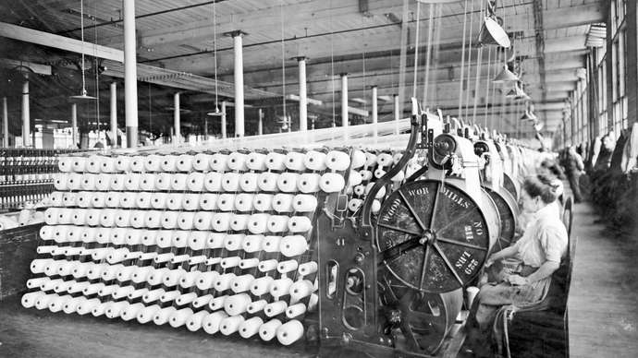
Women working machines at the American Woolen Company, Boston, c. 1912.

Ownership of the means of production also underwent changes. The oligarchical ownership of the means of production that characterized the Industrial Revolution in the early to mid-19th century gave way to a wider distribution of ownership through purchase of common stocks by individuals and by institutions such as insurance companies. In the first half of the 20th century, many countries of Europe socialized basic sectors of their economies. There was also during that period a change in political theories: instead of the laissez-faire ideas that dominated the economic and social thought of the classical Industrial Revolution, governments generally moved into the social and economic realm to meet the needs of their more complex industrial societies. That trend was reversed in the United States and the United Kingdom beginning in the 1980s.

Additional Reading:
The Industrial Revolution
Undergirding the development of modern Europe between the 1780s and 1849 was an unprecedented economic transformation that embraced the first stages of the great Industrial Revolution and a still more general expansion of commercial activity. Articulate Europeans were initially more impressed.

Mass production: The Industrial Revolution and early developments
The principle of the division of labour and the resulting specialization of skills can be found in many human activities, and there are records of its application to manufacturing in ancient Greece. The first unmistakable examples of manufacturing operations carefullY.

History of technology: The Industrial Revolution (1750–1900)
The term Industrial Revolution, like similar historical concepts, is more convenient than precise. It is convenient because history requires division into periods for purposes of understanding and instruction and because there were sufficient innovations at the turn of the 18th and 19th…

Imperialism played a part; Britain drew heavily on its colonies for the raw materials to lead the Industrial Revolution.
Between 1811 and 1813, a group of workers called Luddites were smashing equipment in protest of the machines' threat to their livelihoods.
Important inventions included the spinning jenny and the power loom of the textile industry as well as the steam engine.
Industry: group of productive enterprises or organizations that produce or supply goods, services, or sources of income. In economics, industries are generally classified as primary, secondary, tertiary, and quaternary; secondary industries are further classified as heavy and light.

North America: Industry
The industry of North America is its chief contemporary source of wealth. It first developed at Atlantic coast and Mississippi River ports.

Primary industry
This sector of a nation’s economy includes agriculture, forestry, fishing, mining, quarrying, and the extraction of minerals. It may be divided into two categories: genetic industry, including the production of raw materials that may be increased by human intervention in the production process; and extractive industry, including the production of exhaustible raw materials that cannot be augmented through cultivation.
The genetic industries include agriculture, forestry, and livestock management and fishing—all of which are subject to scientific and technological improvement of renewable resources. The extractive industries include the mining of mineral ores, the quarrying of stone, and the extraction of mineral fuels.

Primary industry tends to dominate the economies of undeveloped and developing nations, but as secondary and tertiary industries are developed, its share of the economic output tends to decrease.
Secondary industry: This sector, also called manufacturing industry, (1) takes the raw materials supplied by primary industries and processes them into consumer goods, or (2) further processes goods that other secondary industries have transformed into products, or (3) builds capital goods used to manufacture consumer and nonconsumer goods. Secondary industry also includes energy-producing industries (e.g., hydroelectric industries) as well as the construction industry.
Secondary industry may be divided into heavy, or large-scale, and light, or small-scale, industry. Large-scale industry generally requires heavy capital investment in plants and machinery, serves a large and diverse market including other manufacturing industries, has a complex industrial organization and frequently a skilled specialized labour force, and generates a large volume of output. Examples would include petroleum refining, steel and iron manufacturing (see metalwork), motor vehicle and heavy machinery manufacture, cement production, nonferrous metal refining, meat-packing, and hydroelectric power generation.

Manufacturing

Light, or small-scale, industry may be characterized by the nondurability of manufactured products and a smaller capital investment in plants and equipment, and it may involve nonstandard products, such as customized or craft work. The labour force may be either low skilled, as in textile work and clothing manufacture, food processing, and plastics manufacture, or highly skilled, as in electronics and computer hardware manufacture, precision instrument manufacture, gemstone cutting, and craft work.
Tertiary industry: This broad sector, also called the service industry, includes industries that, while producing no tangible goods, provide services or intangible gains or generate wealth. This sector generally includes both private and government enterprises.
The industries of this sector include, among others, banking, finance, insurance, investment, and real estate services; wholesale, retail, and resale trade; transportation; professional, consulting, legal, and personal services; tourism, hotels, restaurants, and entertainment; repair and maintenance services; and health, social welfare, administrative, police, security, and defense services.
Quaternary industry: An extension of tertiary industry that is often recognized as its own sector, quaternary industry, is concerned with information-based or knowledge-oriented products and services. Like the tertiary sector, it comprises a mixture of private and government endeavours. Industries and activities in this sector include information systems and information technology (IT); research and development, including technological development and scientific research; financial and strategic analysis and consulting; media and communications technologies and services; and education, including teaching and educational technologies and services.

