Viroids
Manash Pratim Dutta
In 1971, Theodor Diener, a pathologist working at the Agriculture Research Service, discovered an acellular particle that he named a viroid, meaning “virus-like”. Viroids consist only of a short strand of circular RNA which vary in length from 246 to 463 nucleotides and are found only in plants capable of self-replication. The first viroid discovered was found to cause potato tuber spindle disease, which causes slower sprouting and various deformities in potato plants (Figure 1). Like viruses, potato spindle tuber viroids (PSTVs) take control of the host machinery to replicate their RNA genome. Unlike viruses, viroids do not have a protein coat to protect their genetic information.
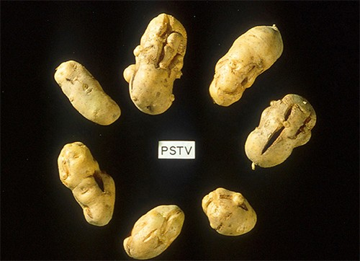
27 viroids characterized so far, 25 infect dicotyledonous plants and the other two infect monocotyledonous plants. The diseases caused by some of these viroids are of considerable agricultural importance.
Few names of viroids are:
- Tomato planta macho viroid (TPMVd) infects tomato plants, which causes loss of chlorophyll, disfigured and brittle leaves, and very small tomatoes, resulting in loss of productivity in this field crop
- Avocado sunblotch viroid (ASBVd) results in lower yields and poorer-quality fruit.
- The coconut cadang cadang viroid found in the Philippines, which consists of only 246 nucleotides kills most of the palms it infects.

